**How many samples?**

In two locations (A & B) many random quadrats of size 0.5m x 0.5m were placed in a 10m x10m area.

The number of a specific species of plants was counted in each area. The results are shown below.

1. Complete the tables filling in the cumulative numbers, the running mean at every 5 quadrats and then the population number based on that mean.
2. Plot a graph showing the number of quadrats against the mean at each 5 quadrats.
3. Answer the questions.

**Results for location A**

|  |  |  |  |  |
| --- | --- | --- | --- | --- |
| **Quadrat number** | **No. of individuals in the quadrat** | **Cumulative no.** | **Mean at each 5 quadrats** | **Estimate of total population** |
| 1 | 1 |  |  |  |
| 2 | 1 |  |  |  |
| 3 | 2 |  |  |  |
| 4 | 2 |  |  |  |
| 5 | 1 |  |  |  |
| 6 | 1 |  |  |  |
| 7 | 0 |  |  |  |
| 8 | 1 |  |  |  |
| 9 | 1 |  |  |  |
| 10 | 1 |  |  |  |
| 11 | 1 |  |  |  |
| 12 | 1 |  |  |  |
| 13 | 2 |  |  |  |
| 14 | 1 |  |  |  |
| 15 | 1 |  |  |  |
| 16 | 1 |  |  |  |
| 17 | 0 |  |  |  |
| 18 | 1 |  |  |  |
| 19 | 1 |  |  |  |
| 20 | 0 |  |  |  |
| 21 | 1 |  |  |  |
| 22 | 1 |  |  |  |
| 23 | 1 |  |  |  |
| 24 | 1 |  |  |  |
| 25 | 1 |  |  |  |
| 26 | 1 |  |  |  |
| 27 | 2 |  |  |  |
| 28 | 1 |  |  |  |
| 29 | 2 |  |  |  |
| 30 | 2 |  |  |  |
| 31 | 1 |  |  |  |
| 32 | 0 |  |  |  |
| 33 | 1 |  |  |  |
| 34 | 1 |  |  |  |
| 35 | 1 |  |  |  |
| 36 | 1 |  |  |  |
| 37 | 0 |  |  |  |
| 38 | 2 |  |  |  |
| 39 | 1 |  |  |  |
| 40 | 0 |  |  |  |

**Results for location B**

|  |  |  |  |  |
| --- | --- | --- | --- | --- |
| **Quadrat number** | **No. of individuals in the quadrat** | **Cumulative no.** | **Mean at each 5 quadrats** | **Estimate of total population** |
| 1 | 0 |  |  |  |
| 2 | 0 |  |  |  |
| 3 | 3 |  |  |  |
| 4 | 0 |  |  |  |
| 5 | 0 |  |  |  |
| 6 | 0 |  |  |  |
| 7 | 0 |  |  |  |
| 8 | 1 |  |  |  |
| 9 | 0 |  |  |  |
| 10 | 22 |  |  |  |
| 11 | 0 |  |  |  |
| 12 | 3 |  |  |  |
| 13 | 0 |  |  |  |
| 14 | 4 |  |  |  |
| 15 | 10 |  |  |  |
| 16 | 1 |  |  |  |
| 17 | 0 |  |  |  |
| 18 | 0 |  |  |  |
| 19 | 7 |  |  |  |
| 20 | 9 |  |  |  |
| 21 | 1 |  |  |  |
| 22 | 0 |  |  |  |
| 23 | 0 |  |  |  |
| 24 | 0 |  |  |  |
| 25 | 0 |  |  |  |
| 26 | 0 |  |  |  |
| 27 | 10 |  |  |  |
| 28 | 0 |  |  |  |
| 29 | 0 |  |  |  |
| 30 | 8 |  |  |  |
| 31 | 26 |  |  |  |
| 32 | 0 |  |  |  |
| 33 | 0 |  |  |  |
| 34 | 0 |  |  |  |
| 35 | 0 |  |  |  |
| 36 | 0 |  |  |  |
| 37 | 0 |  |  |  |
| 38 | 7 |  |  |  |
| 39 | 0 |  |  |  |
| 40 | 0 |  |  |  |

Graph to show the running mean values of orchid numbers counted at each 5 quadrats in location A

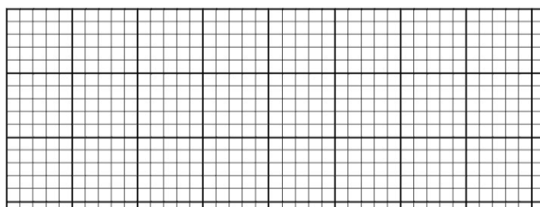

Graph to show the running mean values of orchid numbers counted at each 5 quadrats in location B



**Questions**

1. Explain how many quadrats do you think would be appropriate to use for the species in location A and B?

………………………………………………………………………………………………………………………………………………………………………………………………………………………………………………………………………………………………………………………………………………………………………………………………………………………………………………………………………………………………………………………………………………………………………………………………

1. How do you think the 2 species in the different locations was distributed from the data in the tables?

………………………………………………………………………………………………………………………………………………………………………………………………………………………………………………………………………………………………………………………………………………………………………………………………………………………………………………

1. If you did not have time to calculate the running mean or do a preliminary study, how many quadrats would be the minimum number that you should take when sampling?

………………………………………………………………………………………………………………………………………………

1. Why is it important to have the right number of samples in terms of the data you collect?

………………………………………………………………………………………………………………………………………………………………………………………………………………………………………………………………………………………………………………………………………………………………………………………………………………………………………………………………………………………………………………………………………………………………………………………………