**Residence time calculations**

The average length of time that water remains in a reservoir before moving to another reservoir is known as the *residence time*.

Residence time = volume in the reservoir

rate of transfer in or out of the reservoir

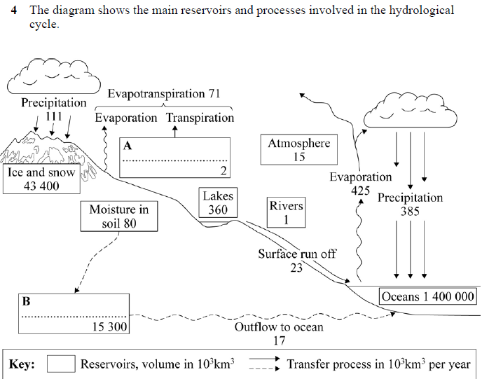

Use the formula above to calculate the average residence time of water in the atmosphere.

Show your working.

1. Average residence time of water in the atmosphere = ..............................................

(2 marks)

b) Calculate the residence time in the oceans. Show your working,

Average residence time of water in the oceans = .............................................. (2 marks)

**Q2**

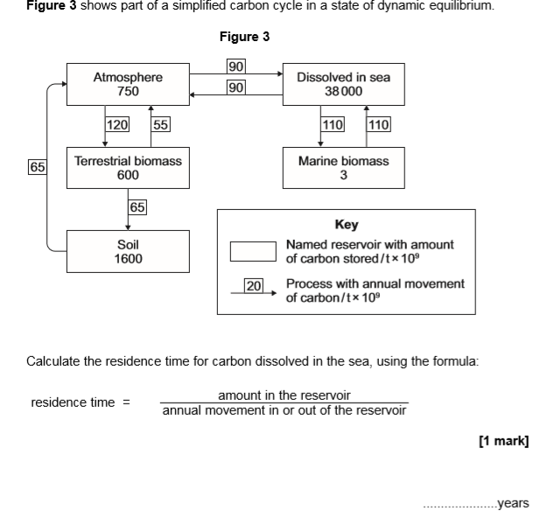

b. Calculate the residence time for the carbon in terrestrial biomass. Show your working

…………………..years

c. The amount of carbon in the soil is in dynamic equilibrium. Calculate the amount of carbon moved annually from the soil to the atmosphere.

………………../109 t