**[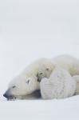](http://search.aol.co.uk/aol/imageDetails?s_it=imageDetails&query=wildlife+conservation&img=http://blogs.nwf.org/.a/6a00d8341ca02253ef01156f82b6fb970c-800wi&site=&imgsz=xxlarge&host=http://blogs.nwf.org/arctic_promise/2009/05/disappointing-decision-on-polar-bear-protection.html&width=99&height=150&thumbUrl=http://images-partners-tbn.google.com/images?q=tbn:eZ1czUjqz8-jdM:blogs.nwf.org/.a/6a00d8341ca02253ef01156f82b6fb970c-800wi&b=image?query=wildlife+conservation&page=2&s_it=topsearchbox.image&s_cs=-3797105531386704804&imgsz=xxlarge&s_dc=20)3.1.2 Conservation of biodiversity**

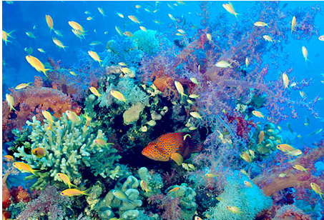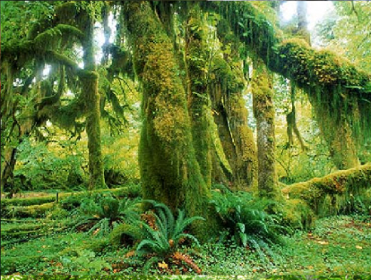

**Specification content**

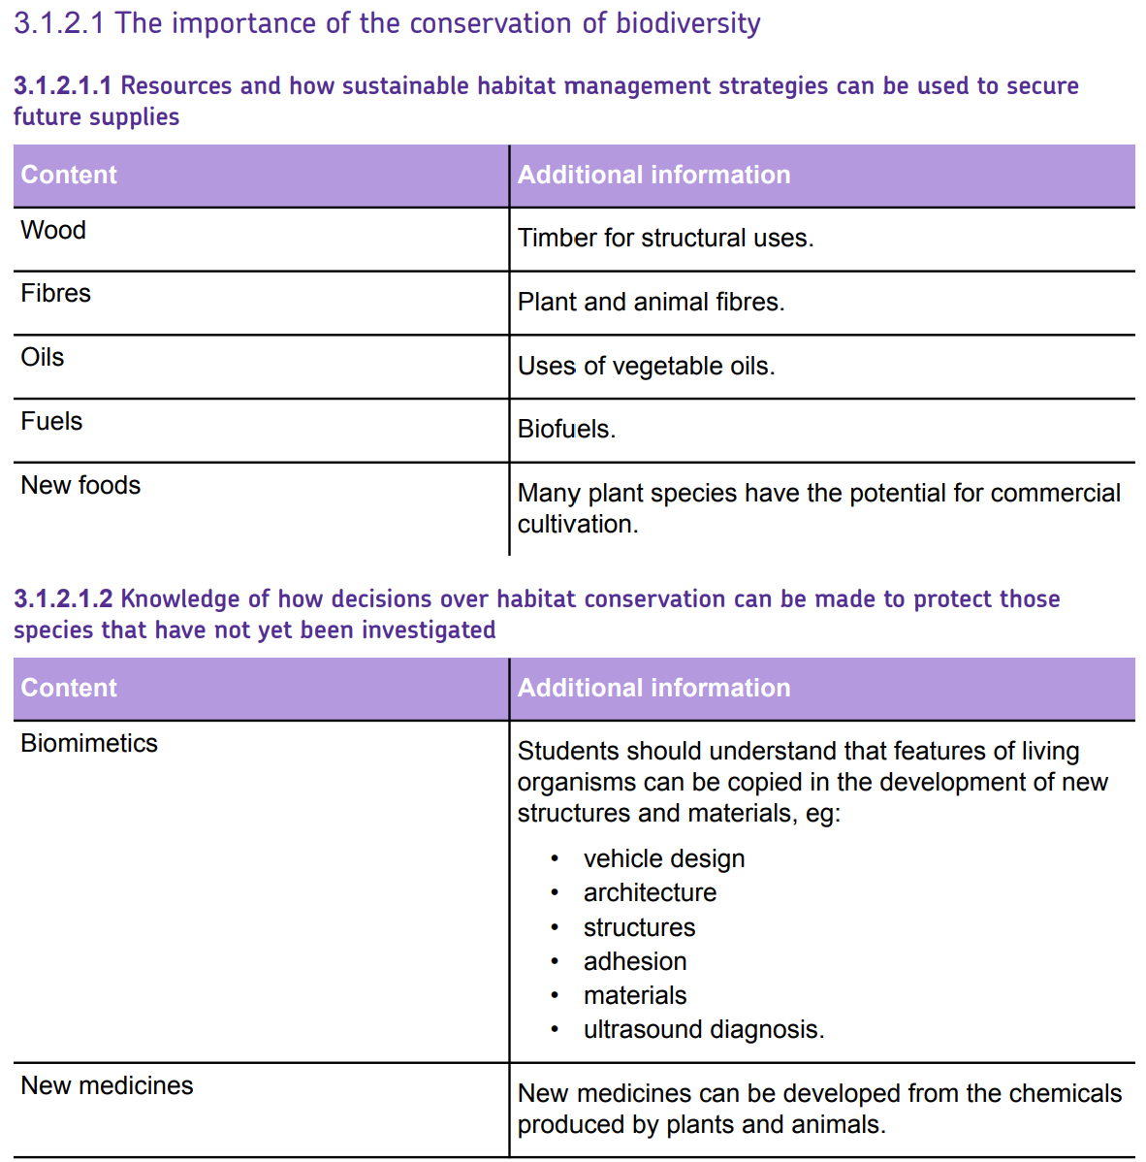

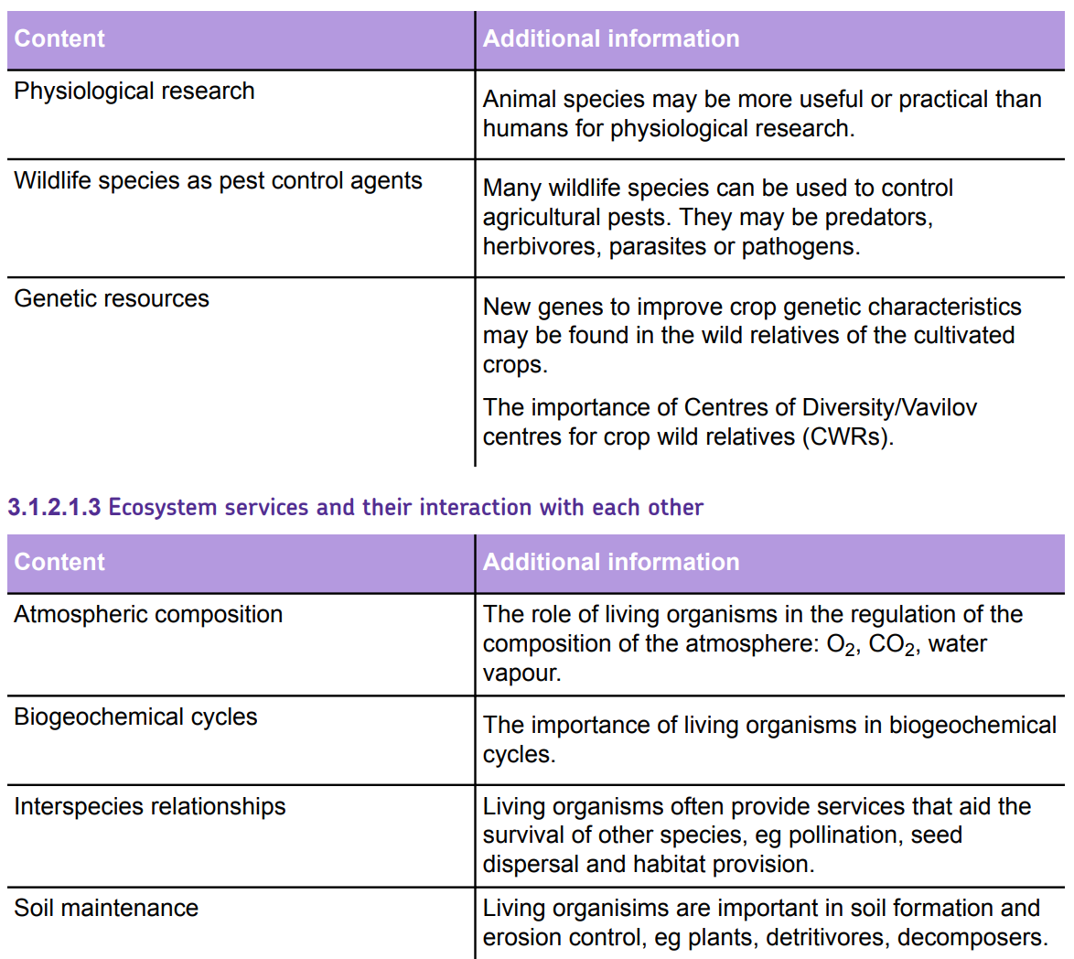



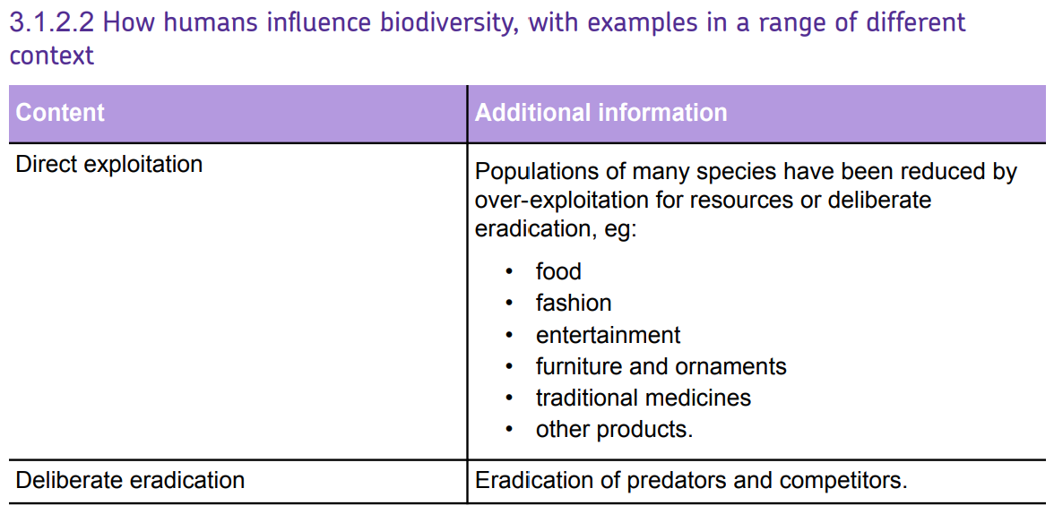

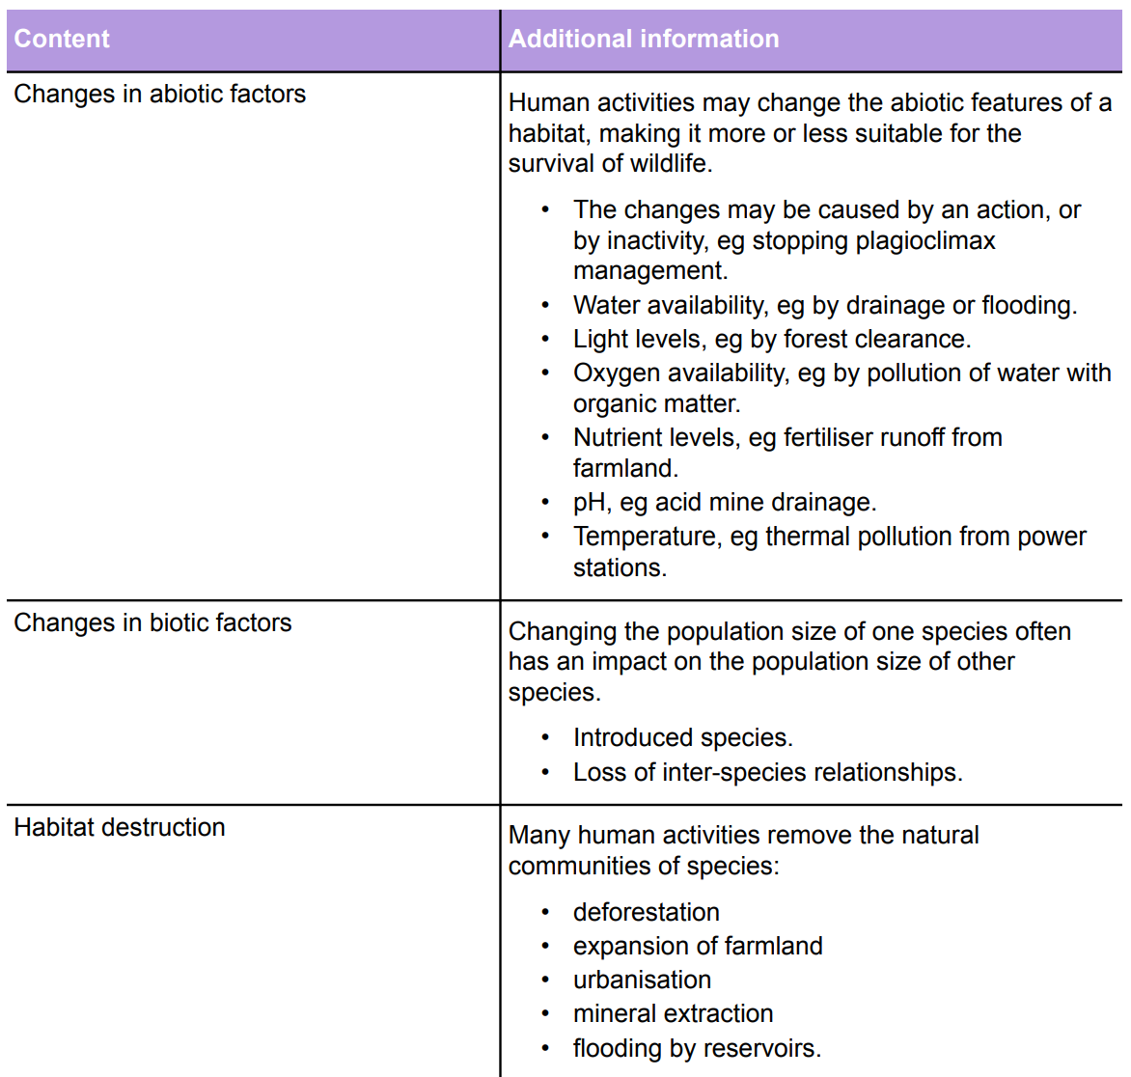

***What is Biodiversity?***

Biodiversity is a modern term which simply means "the variety of life on earth". This variety can be measured on several different levels.

**Genetic** - variation between individuals of the same species. This includes genetic variation between individuals in a single population, as well as variations between different populations of the same species.

**Species** - species diversity is the variety of species in a given region or area. This can either be determined by counting the number of different species present, or by determining number of different taxa present (taxa are the main categories of classification) present. High species biodiversity is not always necessarily a good thing. For example, a habitat may have high species biodiversity because many common and widespread species are invading it at the expense of species restricted to that habitat.

**Ecosystem** - Communities of plants and animals, together with the physical characteristics of their environment (e.g. geology, soil and climate) interlink together as an ecological system, or 'ecosystem'. Ecosystem diversity is more difficult to measure because there are rarely clear boundaries between different ecosystems. However, if consistent criteria are chosen to define the limits of an ecosystem, then their number and distribution can also be measured.

**3.1.2.1 The importance of the conservation of biodiversity**

**In pairs make a list of different materials collected from plants and animals and give details on how humans use these materials.**

|  |  |
| --- | --- |
| **Material** | **Examples of how this material is used** |
|  |  |
|  |  |
|  |  |
|  |  |
|  |  |
|  |  |

**New food species**

Relatively few of the known species of plant or animal are used for human food. Some of these are kept in areas to which they are not well adapted so productivity is reduced.

Indigenous species are usually better adapted, than introduced species, to local conditions such as climate, pests and soil conditions and therefore may have higher survival rates. Selective breeding may be needed to enhance desirable characteristics and eliminate undesirable ones.

Most of the species that are currently farmed were first cultivated a long time ago but there are attempts to domesticate new species.

Many plant species have the potential for commercial cultivation.

List some examples of these below:

Name some new animal species that could be domesticated and used for food:

**3.1.2.1.2 Knowledge and how decisions over habitat conservation can be made to protect those species that have not yet been investigated**

**Biomimetics**

Biomimetics involves the use of knowledge of adaptations of other species, to improve the designs of manufactured items.

All species have evolved over long periods of time, developing adaptations which increase their chances of survival.

Some of these involve structural features that help us to design improved engineering structures and equipment.

Find examples of animals which have been studies to use in each of the following areas and explain briefly how they have been used.

**Transport design**



**Infection control**

**Architecture**

**Adhesion**

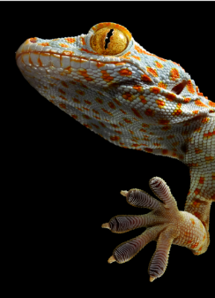

**Materials**

**Medicines**

* Plants need to protect themselves from herbivores. Some plants use thorns, spikes, and bad tastes. Others produce chemicals that are toxic to the animals that may eat them. Many of these chemicals are alkaloids.
* In carefully controlled amounts, these chemicals may have beneficial medical effects in humans.
* Only a very small proportion of the species that exist have been studied for the medicinal substances they may contain. This is a powerful argument for conserving the other species, or preferably entire habitats, for the medicines they may produce.

**List some examples of plants or animals that have been used for medicine:**

**Physiological research**

Some species have evolved to become adapted to specific environmental conditions.

Studying these could give a greater understanding of human health problems.

* Marsupials give birth to their young at a very early stage of development: they then develop in their mother’s pouch. Studying a developing Kangaroo or Wallaby in a pouch is easier than studying a human baby of the same age inside its mother’s womb. This has helped in understanding developmental problems in unborn babies.
* Hippopotamus skin secretes hipposudoric acid which is a natural sunscreen and antimicrobial agent. This is being studied to help improve the treatment of burns victims.
* Marine sponges produce proteins that prevent the rejection of grafts from other individuals. These proteins are being developed to prevent the rejection of human organs after transplant surgery.
* Embryos of the Purple Sea Urchin are used to test whether new medicines are teratogenic and could cause abnormal embryo development in humans. This does not threaten sea urchin populations as the sea urchin is a common species and a single female can produce half a million eggs. It is not ethically acceptable to carry out the tests directly on humans.
* Studying dolphins and bats that use high frequency sound to echo-locate their food has enabled the development of new ultrasound scanners that give better 3-D images for medical diagnosis.
* Human nerve cells are very small and difficult to study, particularly the sodium/potassium pump across cell membranes. Squid nerves are much larger and therefore easier to study. This has provided a better understanding of human heart disease, stroke, cancer, Alzheimer’s disease, and kidney disease.
* Armadillos are among the few animals that can catch the bacterial disease leprosy. They are used in the study of the disease and in producing the vaccine

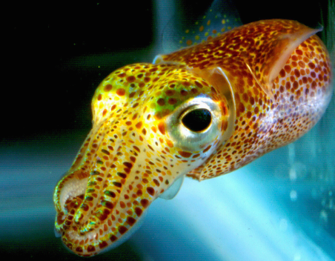 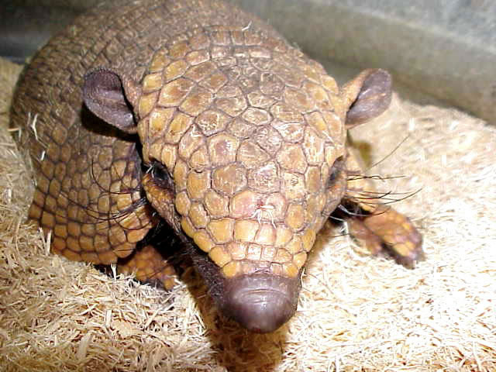

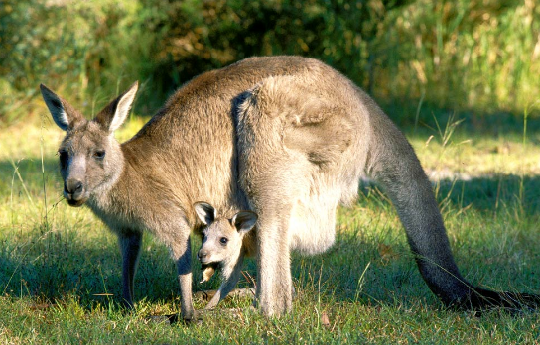

**Pest control**

**How can we use other species for pest control?**

**Genetic resources**

Many populations of wild plants have genetic characteristics that may be used in breeding programmes to improve cultivated crop varieties.

* Domesticated crops often lack genetic diversity because they have been produced from a limited number of original plants.
* The search for new characteristics that can be bred into the commercial crops focuses on wild plants of the same species or close relatives.
* These are often called Crop Wild Relative species (CWR).
* Many CWR species are naturally found in areas where environmental degradation threatens their survival, for example, the Middle East, Central America, and South East Asia.
* Traditional varieties, grown in subsistence farming areas, are also likely to hold desirable characteristics which are not found in the commercial varieties.

**Disease resistance**

Sugar cane has been protected from the sugar cane mosaic virus by crossbreeding with a wild sugar cane variety from Indonesia.

A single wild species of tomato has provided the genetic characteristics for resistance to nine major diseases of commercially grown tomato varieties.

**Salt-tolerance**

The introduction of salt-tolerant characteristics from wild varieties of rice and barley has led to the breeding of commercially cultivated varieties that can be grown in saline soil.

Sea kale is salt tolerant and has been studied for possible use in breeding programmes with closely related crop species.

**Resistance to drought**

Varieties of cacao, the source of chocolate, that are more drought-tolerant have been developed by cross-breeding with wild plants from the Amazon rainforest.

**High yield**

Oil palm yields have been increased by 25% by cross-breeding with wild varieties found in central Africa.

**Improved taste or appearance**

Selective breeding for characteristics such as post-harvest shelf life or appearance may result in the loss of other desirable qualities such as a good taste. These characteristics may be re-introduced by further selective breeding.

More attractive, sweeter pineapples with yellower flesh have been produced by selective breeding since the 1990s.

**Nutrient uptake**

Many recently developed wheat varieties do not form a strong link with mycorrhizal fungi in the soil. This reduces their ability to absorb nutrients, such as phosphates, from the soil. Breeding programmes with wild wheat are increasing nutrient uptake efficiency by forming better associations between the wheat plants and the mycorrhizal fungi.

**The importance of Centres of Diversity**

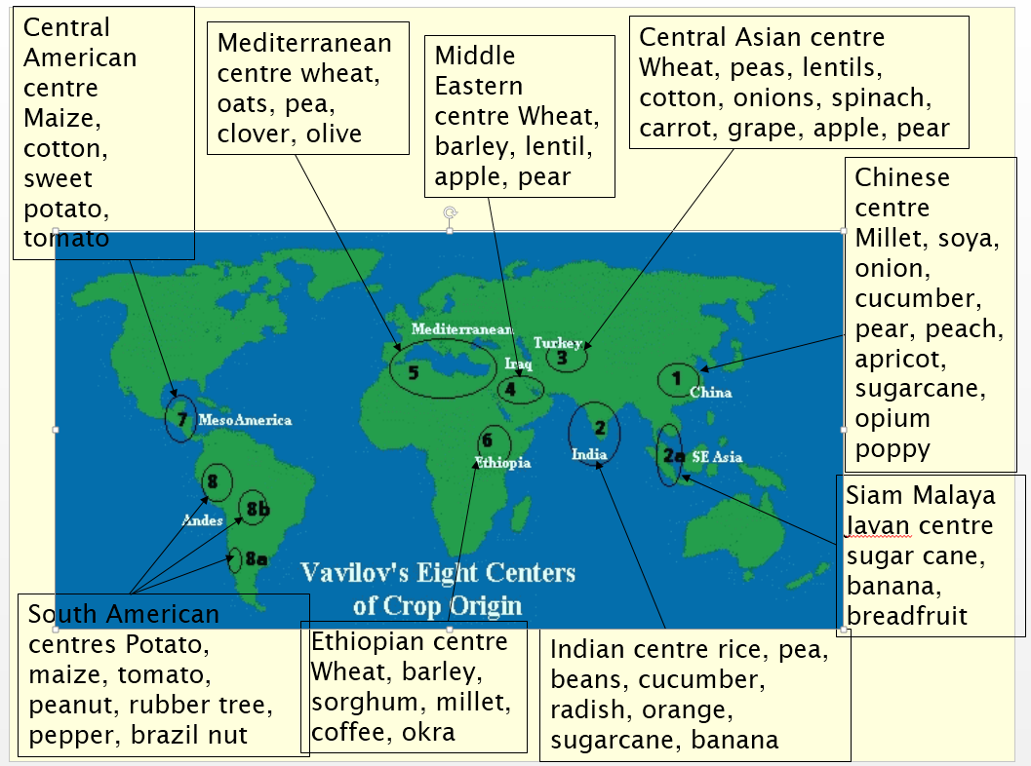

The Russian Biologist Nikolai Vavilov studied crop genetics in the early 1900s. He realised that some areas of the world had high concentrations of the close relatives of important crop species. These were named Centres of Diversity, Centres of Origin, or Vavilov Centres.

Unfortunately, many Vavilov Centres are in parts of the world where environmental degradation threatens the survival of wild plants. Using the map above list the main environmental threats to the Centres of diversity:

**Gene pool problems**

1. What do we mean by the term gene pool?
2. Does a large population always mean there will be a large gene pool?
3. What the problems associated with a small gene pool? Why is this especially a problem in domesticated species?
4. Why is it so important that threatened species are protected in all areas that they live?

**3.1.2.1.3 Ecosystem services and their interaction with each other**

Other species often influence the conditions on Earth that are beneficial to humans. The importance of their actions is often not appreciated so their conservation may be a low priority.

**How do other species affect the composition of the atmosphere?**

**How do other species affect the hydrological cycle?**

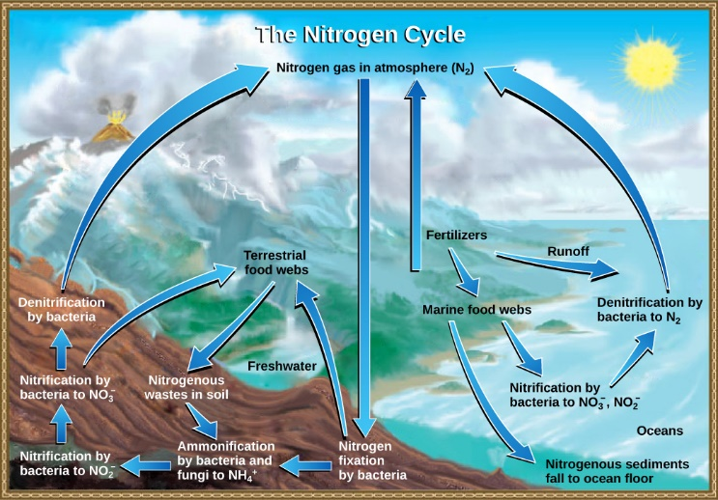

**Biogeochemical cycles**

Living organisms carry out many of the processes in the biogeochemical cycles such as the carbon, nitrogen, and phosphorus cycles. Many of these are carried out by microbes such as bacteria and fungi. Without these processes, waste products would build up and important resources would become depleted.

**Soil maintenance**

Soil is vital for the growth and survival of almost all plants, providing support, water, and nutrients. Soil also regulates the water cycle, producing a more even river flow, while reducing flooding. The processes involved in the breakdown and decomposition of dead organic matter involves invertebrate animals, fungi, and bacteria. The organic matter and humus produced help to hold the soil together. Decomposition produces organic acids which aid the weathering and breakdown of rocks, helping to produce more soil and release nutrients.

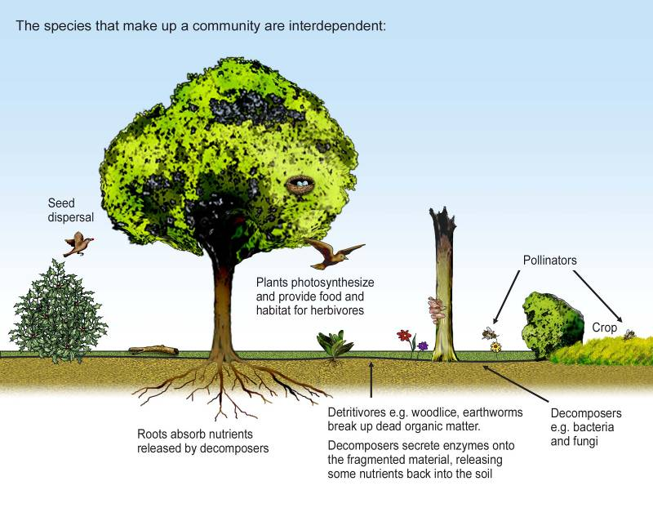**Interspecies relationships**

No species can live in ecological isolation because their survival relies on other species for a range of resources and ecological services.

Complete the table of species interdependence

|  |  |  |
| --- | --- | --- |
| Service provided | explanation | examples |
| Food supply |  |  |
| pollination |  |  |
| Seed dispersal |  |  |
| Habitat provision |  |  |

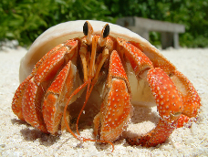

**3.1.2.2 How humans threaten wildlife**

**Direct exploitation**

The populations of many species have declined as they been exploited for a wide range of products, or because we consider them to be harmful. Some of these species now have legal protection although, in many cases, an illegal trade continues.

List the ways that humans deliberately exploit wildlife. Include examples.

|  |  |
| --- | --- |
| **Type of exploitation** | **Example** |
| Food |  |
|  |  |
|  |  |
|  |  |
|  |  |
|  |  |

**Eradication of predators and competitors**

Many species have been killed because they threaten humans or interfere with human activities.

List some examples below:

Human activities may change the abiotic features of a habitat, making it more or less suitable for the survival of wildlife.

**Changes in abiotic factors**

Human activities may alter a habitat so that it becomes unsuitable for species that are not adapted to the new conditions. The species that are most likely to be affected are those with very specialised habitat requirements. These are often species which were already rare before the habitat change took place. Although the habitat has not been destroyed, the conditions have changed so that they become outside their range of tolerance.

What is an abiotic factor?

Give some examples in the table below of how humans can change abiotic factors which affects biodiversity in an ecosystem.

|  |  |
| --- | --- |
| Abiotic factor | How changed and whats the impact? |
| **Water availability** |  |
| **Dissolved oxygen** |  |
| **Temperature** |  |
| **pH** |  |
| **Water turbidity** |  |
| **Physical damage** |  |

**Changes in biotic factors**

The survival of a species may be affected by changes in the presence and abundance of the other species in its habitat.

Make a mind map of the different ways in which species rely each other that we have already learnt about. Use a different colour pen to show how humans can change these relationships.

**Introduced species**

|  |  |
| --- | --- |
| **Introduced competitors** |  |
|  |  |
|  |  |
| **Introduced predators** |  |
|  |  |
|  |  |
|  |  |
|  |  |
| **Introduced pathogens** |  |
|  |  |
|  |  |
|  |  |

**Species that hybridise**

If an introduced species is very closely related to an indigenous species then crossbreeding may produce fertile hybrids. The natural gene-pool will be changed by the introduction of genes it would not naturally contain. For example, the Red Deer is indigenous to the UK but is threatened by hybridisation with the introduced Sika Deer.

Also, the Wildcat population in Scotland is threatened by hybridisation with domestic cats.

**Species that control abiotic factors**

Some species change habitats and produce abiotic features that other species need for survival. For example, African Forest Elephants create clearings and water-holes which many other species rely on for water. Beavers build dams, creating small lakes which are colonised by many aquatic species.

What are the main causes of habitat destruction?