**3.1.2.3 Methods of conserving biodiversity**

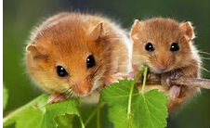

**Specification content**

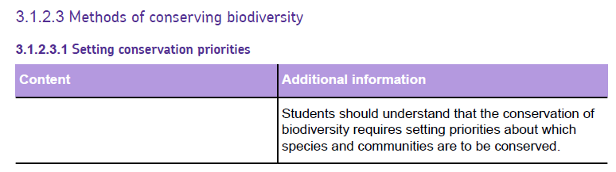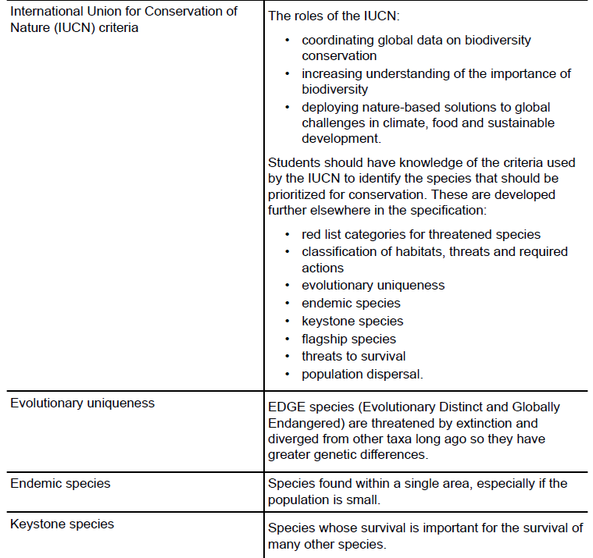

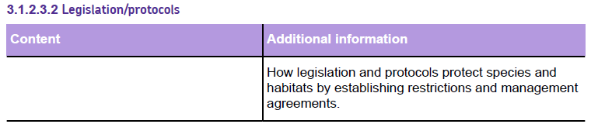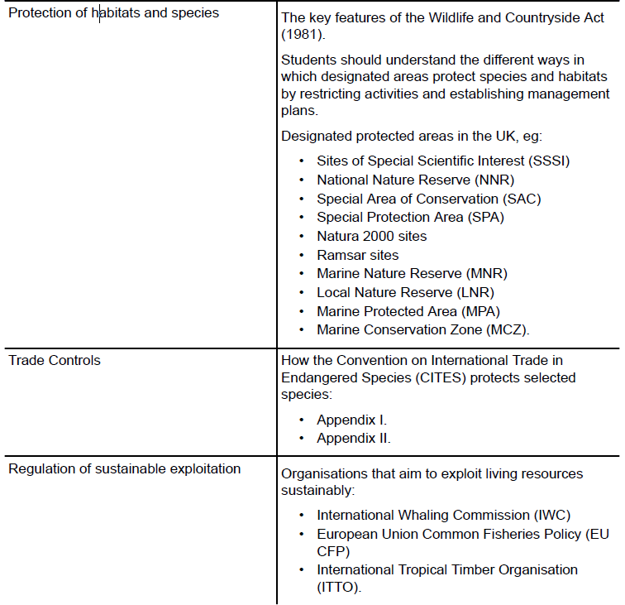

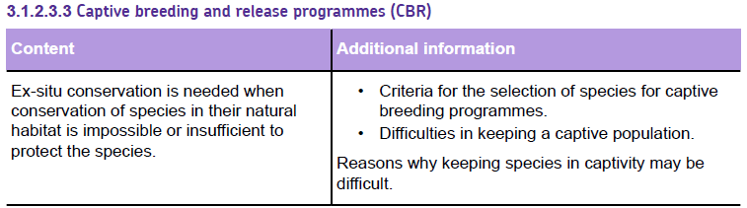

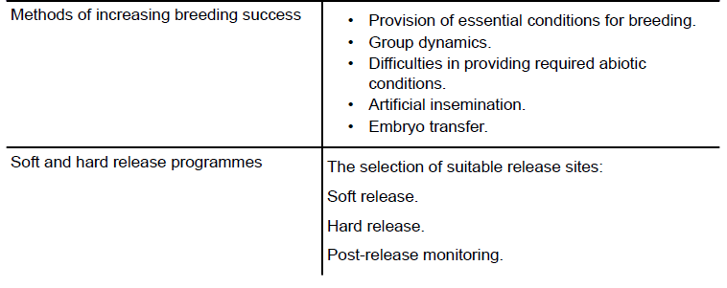

**3.1.2.3.1 Setting conservation priorities**

Wildlife conservation involves interfering in the habitats and populations of wild species in ways that are intended to be beneficial for conservation. This involves making choices and decisions that may be subjective and based on partial knowledge.

The following are questions that might be asked when deciding the best strategies to conserve wildlife.

* What is the current situation: species, populations, and current changes?
* Which species should be conserved? The conservation of one species may be beneficial or harmful to other species.
* What actions need to be taken to conserve the desired species?
* Can the outcomes be accurately predicted?
* Can the impacts be monitored accurately?

There are more species with declining populations than can be conserved with the level of support that is currently available. Some species/habitats/communities are perceived to be more important than others, so they may be prioritised.



**International Union for Conservation of Nature**

The roles of the IUCN:

• coordinating global data on biodiversity conservation

• increasing understanding of the importance of biodiversity

• deploying nature-based solutions to global challenges in climate, food and sustainable development.

The IUCN categorises species according to their vulnerability to extinction. This is known as the IUCN Red List.

* Extinct - no known individuals remain;
* Extinct in the wild - only survive in captivity;
* Critically endangered - extremely high risk of extinction in the wild;
* Endangered - high risk of extinction in the wild;
* Vulnerable - high risk of becoming endangered;
* Near threatened - likely to become endangered in the near future;
* Least Concern – at lowest risk of becoming endangered;
* Data-deficient – insufficient information for the species to be categorised.

Selected groups of species are reassessed each year and some species may be categorised for the first time.

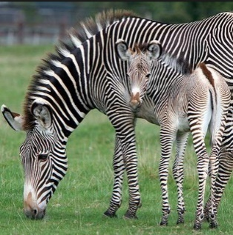**Species recategorised in 2016**

The Plains Zebra has been recategorised from Least Concern to Near Threatened because of its declining population, mainly caused by habitat loss.

**Species recategorised in 2015**

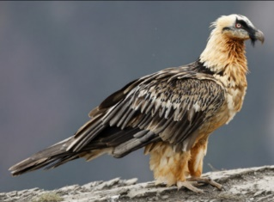Successful conservation of the Iberian Lynx has resulted in re-categorisation from Critically Endangered to Endangered. A captive breeding programme and the protection of two areas of suitable habitat have allowed its population to increase from about 100 in 2000 to over 300 by 2015.

The Tiger remains in the Endangered category, although three out of six sub-species are critically endangered. Its range continues to shrink.

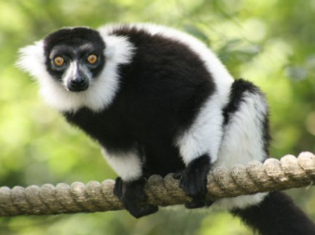The White-headed Vulture was Vulnerable, but has been re-categorised as Critically Endangered as there has been a sudden population decline caused by poisoning and persecution.

**Species assessed in 2014**

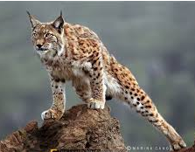There are about 100 species of lemur, all endemic to the island of Madagascar. Of these, 22 are critically endangered and 48 are endangered. Habitat loss and hunting for bushmeat are the major threats.

The population of the Bearded Vulture or Lammergeier is increasing in Europe but declining worldwide due to poisoning, competition for food and, increasingly, collisions with power lines. It has been re-categorised from Least Concern to Near Threatened.

The Fregate Island Beetle of Fregate Island in the Indian Ocean was categorised as Threatened. A programme to eradicate rats from the island has resulted in a population increase so it has been re-categorised as Vulnerable.

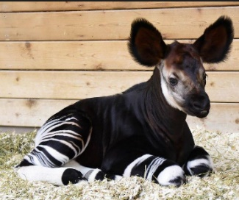

**Species assessed in 2013**

The Okapi is only found in forests in the Democratic Republic of the Congo in Africa. Its population has declined due to hunting, habitat loss and the difficulties in carrying out conservation programmes in areas with military conflict. It has been re-categorised from Near Threatened to Endangered.

How do scientists estimate the population of tigers/blue whales/elephants/bluefin tuna?

……………………………………………………………………………………………………………………………………………………………………………………………………………………………………………………………………………………………………………………………………………………………………………………………………………………………………………………………………………………………………………………………………………………………………………………………………………………………………………………………………………………………………………………………………………………………………………………………………………………………………………………………………………………………………………………………………………………………………………………………………………………………………………………………………………………………………………………………………………………………………………………………………………………………………………………………………………………

**Assessment of species**

A total of about 85,000 species have been assessed and categorised, which is a small proportion of the total number of species that exist. Because categorising a species involves a great deal of research, it is important to select species for categorisation carefully.

What is meant by a **key species**?

…………………………………………………………………………………………………………………………………………………………………………………………………………………………………………………………………………………………………………………………………………………………………………………………………………………………………………………………………………………………………………………………………………………………………………………………………………………………………………

What is an **EDGE species**?

…………………………………………………………………………………………………………………………………………………………………………………………………………………………………………………………………………………………………………………………………………………………………………………………………………………………………………………………………………………………………………………………………………………………………………………………………………………………………………

Why are **endemic species** so vulnerable to extinction?

…………………………………………………………………………………………………………………………………………………………………………………………………………………………………………………………………………………………………………………………………………………………………………………………………………………………………………………………………………………………………………………………………………………………………………………………………………………………………………

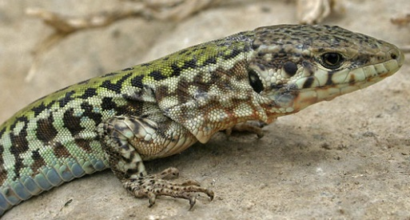

**Keystone Species**

This is a species that has much more important ecological functions within their ecosystem than their abundance might suggest.

**Give some examples below**

|  |  |
| --- | --- |
| **Keystone species** | **Role in the ecosystem** |
|  |  |
|  |  |
|  |  |

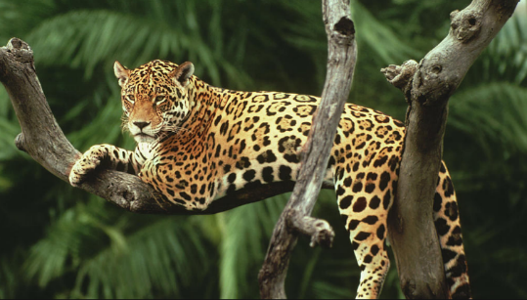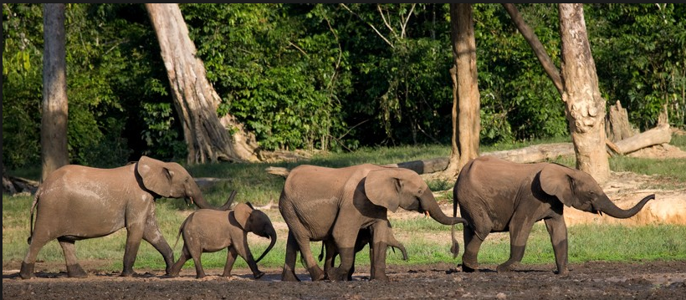

What is a **flagship species**? Give an example

………………………………………………………………………………………………………………………………………………………………………………………………………………………………………………………………………………………………………………………………………………………………………………………………………………………………………………………………………………………………………………………………………………………………………………………………………………………………………………………………………………………………………………………………………………………………………………………………………………………………………………………………………………………………………………………………………………………………

**Degree of population dispersal**

Where the global population of a species is fragmented into a number of isolated populations it is important to ensure that viable local populations are maintained.

The fragmentation of habitats may not reduce the total habitat area by much but it may produce a large number of non-viable populations that will each die out.

What are the problems associated with **fragmented populations**?

…………………………………………………………………………………………………………………………………………………………………………………………………………………………………………………………………………………………………………………………………………………………………………………………………………………………………………………………………………………………………………………………………………………………………………………………………………………………………………

…………………………………………………………………………………………………………………………………………………………………………………………………………………………………………………………………………………………………………………………………………………………………………………………………………………………………………………………………………………………………………………………………………………………………………………………………………………………………………

**3.1.2.3.2 Legislation/protocols**

Laws to protect endangered species are valuable but they are rarely the complete solution. Enforcing the law can be difficult and if the law is not advertised or understood then it may be broken through ignorance.

There are many laws that protect wildlife, but they fall into three main groups:

* Laws that protect species/habitats
* Laws that ban trade
* Laws that allow exploitation but aim to make it sustainable

1. **Legal protection of habitats and species**

**The Wildlife and Countryside Act (1981)** is a UK law which includes much of the legislation that protects wildlife in the UK.

It covers:

* designated Protected areas such as Sites of Special Scientific Interest and Marine Conservation Zones;
* protection of wild birds and their nests: most birds are protected except some ‘pest’ species and game birds that can be hunted;
* protection of mammal species, for example, otters, Hazel Dormouse, Red Squirrel, badgers and their setts (tunnels);
* uprooting of wild plants: this is generally illegal;
* bats: these may not be disturbed and woodworm treatment chemicals, used in
* roofs where bats are present, must not be toxic to bats.

**Designations that protect areas**

Designations are put in place and help protect areas in the following ways:

* Protection of specific species
* Protection of habitats
* Restricting activities within or outside the protected area
* Managing agreements between landowners and designation organisations
* Access restrictions
* International cooperation

Below is a list of some of the designated protected areas in the UK

Sites of Special Scientific Interest (SSSI)

National Nature Reserve (NNR)

Special Area of Conservation (SAC)

Special Protection Area (SPA)

Natura 2000 sites

Ramsar sites

Marine Nature Reserve (MNR)

Local Nature Reserve (LNR)

Marine Protected Area (MPA)

Marine Conservation Zone (MCZ).

**Task: designation flash cards**

1. Research your designation and make brief notes. Ensure you have answered the questions below.

* Who is the designating body?
* What/who is the designation designed to protect i.e. particular species/habitat/ecosystem?
* What restrictions are there in the area?
* What agreements are there with landowners?
* Give a specific example of the designation.

1. Complete your revision card for the designation and submit to your teacher.
2. **Trade controls**

Some species are caught or killed in one country but sold in another country. It may be difficult to control the collection of the species but, if moving them out of the country can be stopped, there would be no point collecting them.

**CITES**

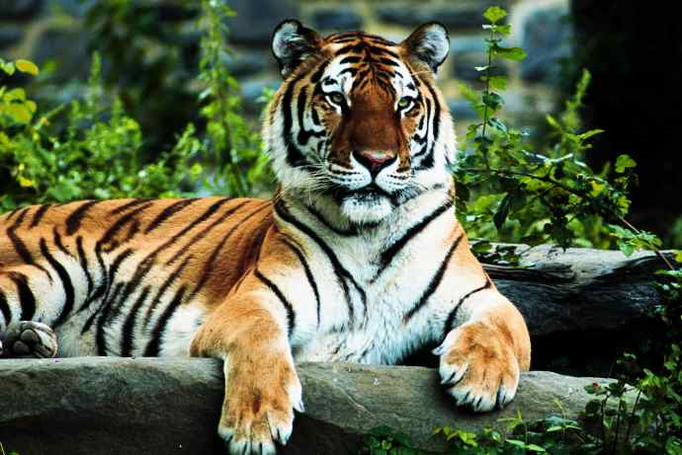The main international agreement that regulates the international trade in wildlife is **CITES: the Convention on International Trade in Endangered Species**.

Selected species are grouped in lists called appendices.

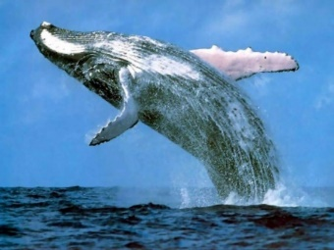Appendix I: this includes species that are threatened with extinction, **so all international trade is banned** except movement for conservation breeding programmes, for example, Chimpanzee, all the big cats, all rhinos, Blue Whale;

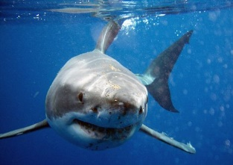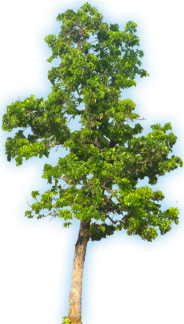Appendix II: this includes species that may be threatened with extinction if trade is not closely controlled. **Trade is permitted from countries where the species populations are relatively well protected** so limited exploitation does not threaten their survival, for example, Honduras Mahogany, Common Hippopotamus, Green Iguana, Great White Shark, Basking Shark, Venus Fly Trap.

1. **Organisations which aim to achieve sustainable exploitation**

A range of international organisations focus on specific wildlife groups that are exploited commercially.

**Have a look the website for the following organisations. Write notes on how they are trying to ensure the exploitation of specific wildlife groups is done so sustainably.**

**International Whaling Commission (IWC):**

…………………………………………………………………………………………………………………………………………………………………………………………………………………………………………………………………………………………………………………………………………………………………………………………………………………………………………………………………………………………………………………………………………………………………………………………………………………………………………

…………………………………………………………………………………………………………………………………………………………………………………………………………………………………………………………………………………………………………………………………………………………………………………………………………………………………………………………………………………………………………………………………………………………………………………………………………………………………………

**Common Fisheries Policy of the European Union (EU CFP):**

…………………………………………………………………………………………………………………………………………………………………………………………………………………………………………………………………………………………………………………………………………………………………………………………………………………………………………………………………………………………………………………………………………………………………………………………………………………………………………

………………………………………………………………………………………………………………………………………………………………………………………………………………………………………………………………………………………………………………………………………………………………………………………………………………………………………………………………………………

What is meant by ‘Maximum sustainable yield’?

…………………………………………………………………………………………………………………………………………………………………………………………………………………………………………………………………………………………………………………………………………………………………………………………………………………………………………………………………………………………………………………………………………………………………………………………………………………………………………

**International Tropical Timber Organisation (ITTO)** …………………………………………………………………………………………………………………………………………………………………………………………………………………………………………………………………………………………………………………………………………………………………………………………………………………………………………………………………………………………………………………………………………………………………………………………………………………………………………

………………………………………………………………………………………………………………………………………………………………………………………………………………………………………………………………………………………………………………………………………………………………………………………………………………………………………………………………………………

**3.1.2.3.3 Captive breeding and release programmes**

**Captive breeding programmes**

For some endangered species, *in situ* conservation will not ensure their survival. Therefore *ex-situ* conservation may be required. This involves conservation away from where they would normally live. It often involves the breeding of species in captivity so that some of the young produced can be released to boost the wild population.

There are more species that need help than can be supported by *ex-situ* conservation projects. So, choices must be made about the species that will be supported by these programmes.

**Factors that influence decisions about captive breeding and release programmes.**

* Is the wild population threatened?
* Is there a genetically diverse captive population?
* Is *in-situ* conservation being successful?
* Is keeping a captive population realistic?

**Keeping species in captivity**

Many species have such specific habitat requirements that make it difficult to keep them in captivity.

**Why can it be difficult to keep some species in captivity?**

|  |  |
| --- | --- |
| **Issue** | **Explanation** |
| habitat size |  |
| food requirements |  |
| species interrelationships |  |
| financial constraints |  |

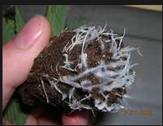

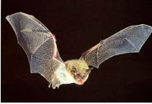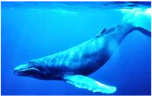

**Captive breeding programmes**

Many of the species that can be kept in captivity have not bred successfully.

There are number of factors which inhibit success.

**Conditions for breeding**

For many species, precise timing of breeding is vital to increase the survival chances of the young.

Breeding is often triggered by environmental stimuli such as day length, light level, temperature, amount of food, amount of stored body fat.

If these essential conditions are not known and are not provided, then they will not breed.

**Population interactions and breeding success**

In the wild, breeding pairs of many birds may choose isolation while nonbreeding individuals live elsewhere.

In captivity, the mixing of breeding and non-breeding individuals may cause conflict and reduce the survival of eggs and chicks.

Some species breed most successfully if pairs stay together away from other adults.

Other species breed most successfully if there is a choice of possible partners.

**Breeding habitat**

Why are mirrors used to encourage flamingos to breed?

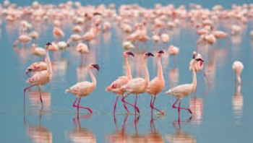……………………………………………………………………………….……………………

……………………………………………………………………………………….……………

……………………………………………………………………………………….……………

……………………………………………………………………………………………….……

…………………………………………………………………………………………….………

**Gene pool size**

Most captive breeding populations have small gene pools which increases the risk of inbreeding.

Harmful recessive genes may be common in the population but they can only be ‘expressed’ and cause undesirable characteristics in the off spring if both parents carried the gene and passed it on to their off spring.

Most recessive disadvantageous genes are rare so it is unusual for both parents to carry them unless they are closely related. In captive breeding programmes it is often impossible to use individuals that are not closely related.

For example, the Hawaiian Goose became very rare due to hunting, habitat loss, and introduced predators. A captive breeding programme has successfully increased the wild population, but the captive population started with just seven individuals.

Inbreeding produced some goslings with thin, hair-like feathers which insulate poorly so gosling survival can be low. A ‘stud book’ can be used to keep records of family trees which helps to ensure breeding takes place between individuals that are as unrelated as possible. The stud book is usually managed by a zoo that specialises in keeping that particular species.

**Why do captive populations of Hawaiian Geese have such a small gene pool?**

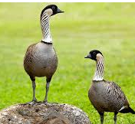……………………………………………………………………………….…………………………..………………

……………………………………………………………………………….…………………………..………………

……………………………………………………………………………….…………………………..………………

……………………………………………………………………………….…………………………..………………

……………………………………………………………………………….…………………………..………………

**What problems have resulted from this small gene pool?**

………………………………………………………………………………………………………………………………………………………………………………………………………………………………………………………………………………………………………………………………………………………………………………………………………………………………………………………………………………

**How can these problems be reduced?**

………………………………………………………………………………………………………………………………………………………………………………………………………………………………………………………………………………………………………………………………………………………………………………………………………………………………………………………………………………

**Hybridisation**

A species in the wild includes individuals that naturally interbreed to produce fertile off spring.

In captivity, individuals may inter-breed (hybridise) with closely related species or varieties that would not have naturally met in the wild.

This can be prevented with animals if they can be kept apart but it is a particular problem with plants where pollen can be carried between plants.

The managers of early zoos did not understand the need to keep sub-species apart. The off spring produced, by breeding between populations that would not naturally have inter-bred, will have a combination of characteristics that would not be found in any individuals produced by natural breeding. These individuals probably have no conservation value. If hybridisation occurs, then the off spring will be different from the wild population and may not be as well adapted for survival. The Lion species has two distinct sub-species: the African lion and the Asiatic Lion.

Which two closely related species bred to produce these hybrid animal?

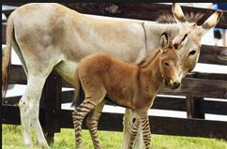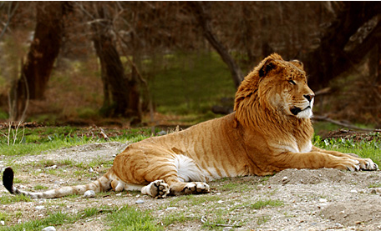

Why do these hybrids have no conservation value?

…………………………………………………………………………………………………………………………………………………………………………………………………………………………………………………………………………………………………………………………………………………………………………………………………………………………………………………………………………………………………………………………………………………………………………………………………………………………………………

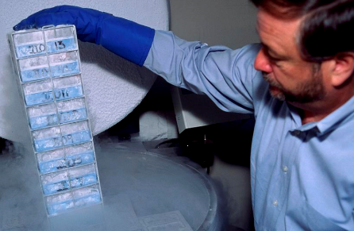**Methods of increasing breeding success**

Species kept in captivity do not always breed as successfully as they might in the wild. A range of techniques may be used to increase breeding success.

Why does San Diego have a **Frozen Zoo?**

…………………………………………………………………………………………………………………………………………………………………………………………………………………………………………………………………………………………………………………………………………………………………………………………………………………………………………………………………………………………………………………………………………………………………………………………………………………………………………

………………………………………………………………………………………………………………………………………………………………………………………………………………………………………………………………………………………………………………………………………………………………………………………………………………………………………………………………………………

What is AI?

………………………………………………………………………………………………………………………………………………………………………………………………………………………………………………………………………………………………………………………………………………………………………………………………………………………………………………………………………………

How does this technique increase breeding success?

…………………………………………………………………………………………………………………………………………………………………………………………………………………………………………………………………………………………………………………………………………………………………………………………………………………………………………………………………………………………………………………………………………………………………………………………………………………………………………

**Embryo transfer**

Some mammal captive breeding populations have very few breeding females. This slows the rate at which off spring can be produced because the duration of pregnancy can be long.

However, for some species, there may be a closely related species with a larger number of females in captivity which can be used.

List the main stages in embryo transfer.

1. ………………………………………………………………………………………………………………………………………………………………………………………………………………………………………………………………………………………………
2. ………………………………………………………………………………………………………………………………………………………………………………………………………………………………………………………………………………………………
3. ………………………………………………………………………………………………………………………………………………………………………………………………………………………………………………………………………………………………
4. ………………………………………………………………………………………………………………………………………………………………………………………………………………………………………………………………………………………………
5. ………………………………………………………………………………………………………………………………………………………………………………………………………………………………………………………………………………………………

**Micropropagation**

Add your own notes to the diagram below to explain this technique of producing new plants.

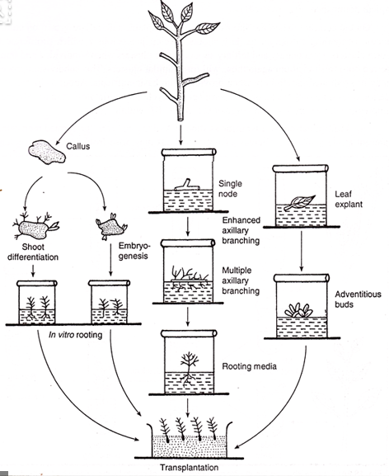

**Cloning**

This has been used with limited success in livestock breeding but not yet with wild animal species.

Cloning involves the production of embryos by transferring the nucleus from a stem cell of the endangered species into an empty egg cell of a closely related species.

The egg is implanted into a female of the closely-related species, eventually producing a baby animal of the endangered species. The success rate with wildlife species is very low.

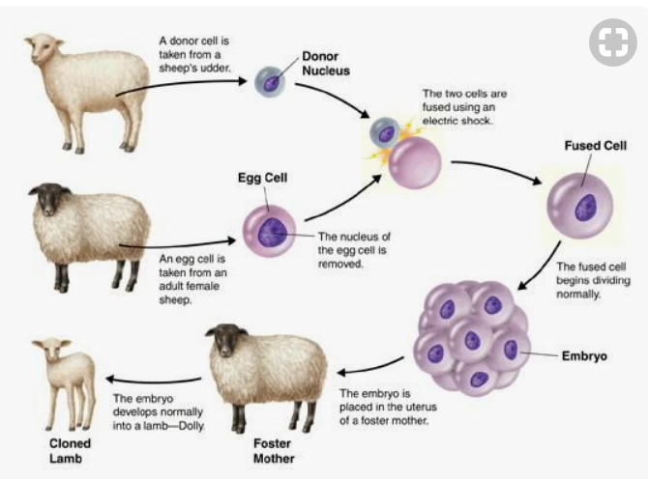It is possible that deep frozen stem cells could be used to produce clones in the future even if the living population has died out.

Experiments are continuing and one day may allow the production of young from species that do not currently breed, for example, the Northern White Rhinoceros

**Cloning in plants**

Cloning is important in some plant breeding programmes where cuttings of a mature plant can be cultivated to produce many genetically identical plants.

The indigenous subspecies of the Atlantic Black Poplar in the UK is rare.

Its future survival is threatened because their flowers can be pollinated by the pollen of other introduced subspecies, producing hybrid plants.

To maintain the population, cloning is used to produce many young plants that are genetically identical to the parent plants.

**Release programmes**

The successful release of captive-bred animals into the wild requires careful planning.

The number of individuals released must be sufficient to establish a viable population.

Suitable release sites must be available. These need to provide:

1. ………………………………………………………………………………………………………………
2. ………………………………………………………………………………………………………………
3. ………………………………………………………………………………………………………………
4. ………………………………………………………………………………………………………………
5. ………………………………………………………………………………………………………………
6. ………………………………………………………………………………………………………………
7. ………………………………………………………………………………………………………………

The survival chances of individuals bred in captivity can vary widely between species. There are different forms of release.

What is the difference between a hard release and a soft release program?

…………………………………………………………………………………………………………………………………………………………………………………………………………………………………………………………………………………………………………………………………………………………………………………………………………………………………………………………………………………………………………………………………………………………………………………………………………………………………………

………………………………………………………………………………………………………………………………………………………………………………………………………………………………………………………………………………………………………………………………………………………………………………………………………………………………………………………………………………

What problems may animals face when they are released from captivity back into the wild?

1. ………………………………………………………………………………………………………………
2. ………………………………………………………………………………………………………………
3. ………………………………………………………………………………………………………………
4. ………………………………………………………………………………………………………………
5. ………………………………………………………………………………………………………………

Captive-bred predators are often born to parents that were born in captivity so they do not have good hunting skills to teach to their young. They are unlikely to have had the chance to learn hunting skills in captivity with live prey.

Monitoring the movements and survival of released individuals is useful in monitoring the success of the project and it helps in improving future release plans.