**3.1.2.3.4 Habitat Conservation**

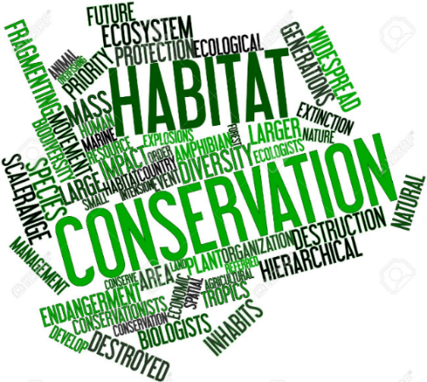

**Specification content**

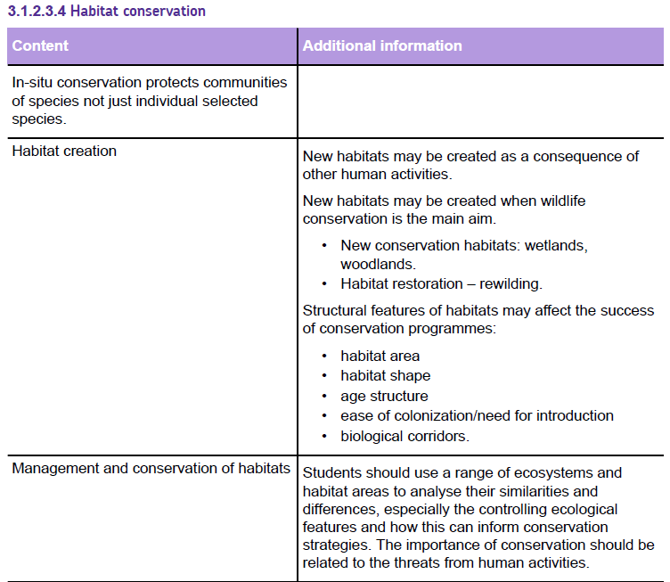

**Habitat conservation**

*In situ* conservation is the most important method of conserving wildlife, as the wildlife species are still living where the conditions for survival are appropriate and the entire community of species are present together.

Establishing a protected area, or nature reserve, makes it easier to prevent damaging influences within the area itself but it does not protect it from damaging external influences (for example, air pollution).

There are several general approaches to habitat conservation:

* land ownership;
* designated protected areas;
* habitat creation and management.

**Land ownership**

Many wildlife conservation organisations purchase areas to protect the species that already live there, or will do so once the conditions have been changed so they are suitable, for example, RSPB, National Trust, Woodland Trust. These have the opportunity to manage the habitat to benefit wildlife.

Individual landowners may also make management decisions for the benefit of wildlife.

**Designated protected areas**

Designating a protected area establishes the legal status of the protection.

The owners of the habitat that needs protection may not wish to manage their land for the benefit of wildlife in the same way that the statutory authorities do.

Establishing a legally designated protected area should ensure that the habitat is protected.

In the UK, there are many different types of designated areas. Very few are state-owned. They are protected by legal restrictions and management agreements.

You need to learn each of these designations including the key features.

|  |  |
| --- | --- |
| Designated area | Key feature |
| Sites of Special Scientific Interest (SSSI) | Designated by UK legislation.  SSSIs protect areas with the best examples of the UK’s flora, fauna, geological, or physiographical features.  A management plan is agreed with the owner, who must inform the governmental conservation organisation if they wish to carry out an ‘OLD’ – an Operation Likely to Damage. These vary between sites but often include: ploughing, use of pesticides or fertilisers, drainage, burning, or tree planting/removal. |
| National Nature Reserves (NNRs) | Designated by UK legislation.  NNRs are the best examples of SSSIs and usually cover the best examples of complete communities of species or habitat types. |
| Special Areas of Conservation (SACs) | Designated under the EU Habitats Directive.  Each member state in the EU must identify the habitats within its country that are of international importance, then protect them. The habitat types vary widely between different countries. |
| Special Protected Areas (SPAs) | Designated under the EU Birds Directive.  Each member state in the EU must identify the places within its country that are of international importance for birds, then protect them. The bird species involved vary widely between different countries. |
| Ramsar sites | The Ramsar Convention is an intergovernmental agreement that protects wetland.  Most countries in the world are signatories.  It was originally intended primarily to protect important waterfowl habitats. The Convention has broadened its scope to cover all aspects of wetland conservation and wise use, recognising wetlands as ecosystems that are extremely important for biodiversity conservation in general and for the well-being of human communities. |

**Voluntary Agri-environmental schemes**

Managing habitats for the benefit of wildlife can be expensive. Landowners may join voluntary governmental schemes which provide the financial support needed.

Agri-environmental schemes recognise that much of the British landscape (and its wildlife habitats) was produced by farming and can only be conserved by the continuance of appropriate farming practices. Increasingly intensive farming methods, especially since the 1950s, have caused a lot of damage, often removing the habitats that are most important for wildlife such as hedgerows and hay meadows, or by using harmful pesticides.

These changes took place in response to the need for increased food output to provide national food security.

In recent years, the need to conserve the farming landscape, repair damage, and enhance its wildlife value have been more fully appreciated. Many of these projects involve a lot of effort, financial investment, and possibly reduced incomes for farmers.

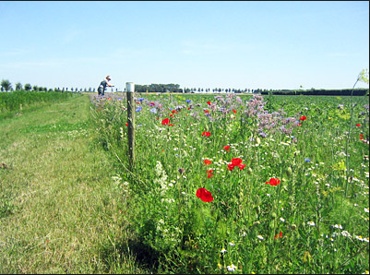Since the improvements they produce will benefit everyone it seems fair that some of the costs should be paid by society through central funding.

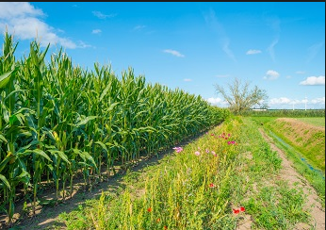

Agri-environmental schemes provide financial support to farmers to reward and encourage environmentally beneficial developments. The Single Farm Payment replaced previous schemes, such as Environmentally Sensitive Areas (ESA) and the Countryside Stewardship Scheme (CSS), with the **Environmental Stewardship Scheme (ESS).** There are now a new agricultural policy called Environmental Land Management Schemes (**NELMS**)

What are the aims of the Environmental Stewardship Scheme?

1. ………………………………………………………………………………………………………………………………………………

………………………………………………………………………………………………………………………………………………

2. ………………………………………………………………………………………………………………………………………………

………………………………………………………………………………………………………………………………………………

3. ………………………………………………………………………………………………………………………………………………

………………………………………………………………………………………………………………………………………………

4. ………………………………………………………………………………………………………………………………………………

………………………………………………………………………………………………………………………………………………

An annual payment is made for farming with an environmentally beneficial management plan. Points are awarded for individual features of the farm with environmental benefits.

In the table below state the environmental benefit of each feature.

|  |  |
| --- | --- |
| Feature | Environmental benefit |
| Beetle banks |  |
| Hedgerows, stone wall and ditch management |  |
| Field buffer strips |  |
| Wild bird seeds |  |
| Low input grassland |  |
| Protected archaeological sites |  |
| Management to reduce soil erosion |  |
| Protection of in-field trees |  |

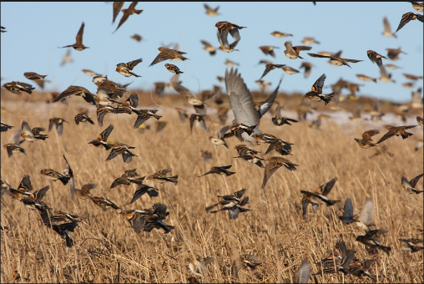

If a target points total is reached then payments are made for five years, then a new application must be made.

Higher payments are made for organic farms or farms with extra schemes such as:

* wildflower-rich grass field margins;
* unharvested conservation field headlands for winter bird food;



* restoration of wet grassland for waders and wildfowl;
* 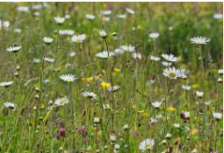water meadow restoration;
* maintenance or restoration of saltmarsh, sand dunes, hedgerows, moorland,
* traditional orchards, ponds, woodlands;
* public access.

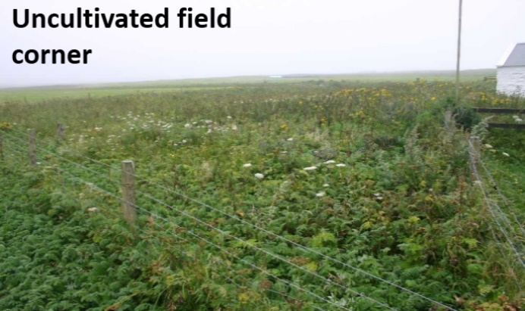**Habitat creation and management**

Management and creation of habitats is increasingly important part of managing the physical environment and any potential development. While some habitat creation is unplanned, increasingly habitat creation is a planned part of restoring diversity and managing for conservation.

**Unintentional habitat creation**

Human activities have always created new habitats that may be unsuitable for the species that used to live there, but are suitable for new wildlife species which may colonise the area.

Some of these actions were carried out with no intention of creating wildlife habitats while others were deliberately intended to aid wildlife conservation.

Habitats that have been created as a consequence of other activities include reservoirs, flooded sand and gravel pits, roadside verges, hedgerows, ornamental gardens.

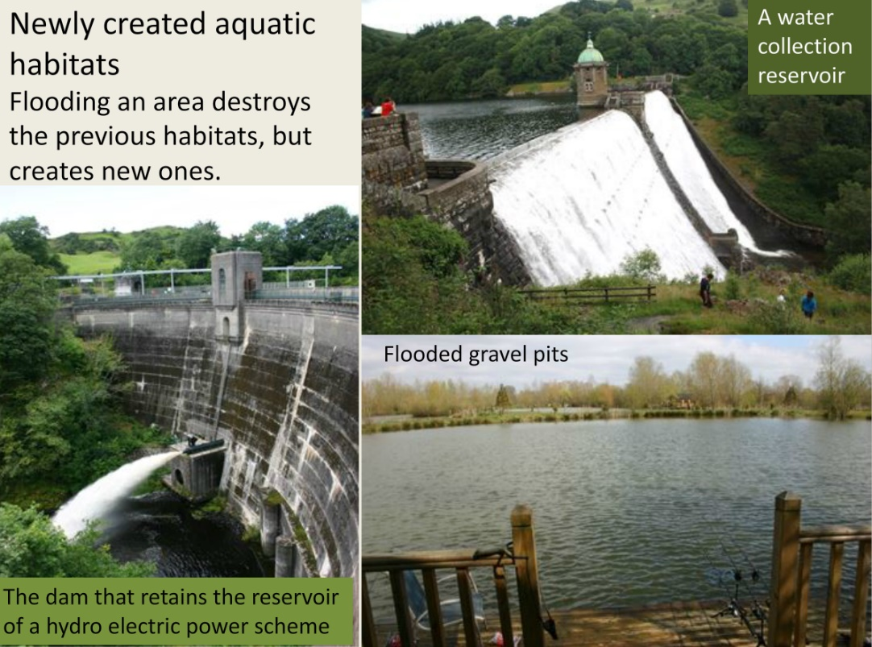

**Planned habitat creation**

*In-situ* conservation will only be successful if there are suitable habitats for the species that will live there. These may already exist or it may be necessary to alter and manage a habitat that is currently unsuitable.

This requires an understanding of the abiotic and biotic habitat features that the species require.

Many species that are not present initially will colonise as conditions become suitable. This is easiest for mobile species such as birds and many insects. If the habitat is isolated from other similar areas, then natural colonisation may be more difficult. Some species may need to be deliberately introduced by humans.

Habitats that have been created deliberately for wildlife conservation include wetlands, planting of new woodlands, wildflower meadows, artificial coral reefs, and many nature reserves. Lakenheath and Wallasea Island RSPB reserves were both areas of arable farmland before wildlife habitat creation began.

**Habitat design**

Write a list of features that would need to be provided for a specific habitat:

……………………………………………………………………………………………………………………………………………………………………………………………………………………………………………………………………………………………………………………………………………………………………………………………………………………………………………………………………………………………………………………………………………………………………………………………………………………………………………………………………………………………………………………………………………………………………………………………………………………………………………………………………………………………………………………………………………………………………………………………………………………………………………………………………………………………………………………………………………………………………………………………………………………………………………………………………………………

**Habitat design**

Once an area has been selected, its abiotic and biotic features can be planned to maximise its suitability for the species to be supported. The habitat area must be **large enough to support viable populations**. The breeding population must not drop so low that the reproduction rate is too low to maintain the population and the gene pool must not be so small as to cause inbreeding. **How large this area needs to be depends upon the species**.

In general, species that are higher up food chains have lower population densities, so a larger habitat area may be needed to support a viable population. The territory of a single tiger can range from 20 to 100 km2, so a very large area is needed to support a viable population.

An area that is too small, to support populations of less abundant species, may eventually become unsuitable for other species if the absent species provided important interspecies services, for example, many rainforest monkeys eat fruit from trees.

Different tree species produce fruit at different times of the year, so food will always be available as long as the forest area is large enough to have enough trees of a sufficient range of trees to support the monkeys that eat their fruit. A smaller area may lack some essential trees so there would be time periods when there would not be enough food. If these periods are too long, then the monkeys may die out.

Some species benefit from small habitats. Frogs, toads, and newts breed more successfully in ponds that are too small to support the predatory fish that would eat their eggs and tadpoles.

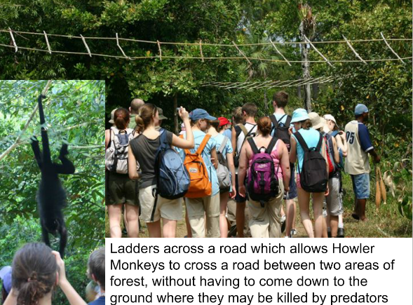**Biological Corridors**

Why are biological corridors important when planning a new habitat?

………………………………………………………………………………………….

………………………………………………………………………………………….

………………………………………………………………………………………….

………………………………………………………………………………………….

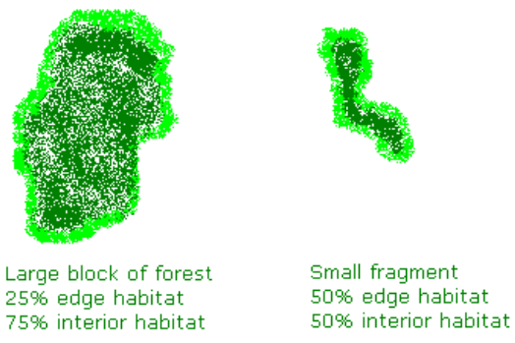**Habitat shape**

The perimeter of a habitat will have a strip where the conditions are a combination of the two neighbouring habitats. Some species benefit from the different conditions, for example, higher light levels at the edge of a wood, but they may not be suitable for the species that require the core habitat conditions.

**Habitat diversity**

Natural habitats are rarely uniform and usually have local variations in conditions, producing a greater range of possible niches. This increases biodiversity as different species colonise the areas to which each is best adapted.

**Light levels**

The shading effect of trees can be reduced by selectively felling individual trees to create suitable conditions for smaller plants that need more light.

**Water depth**

Many of the plants and animals that live in aquatic habitats will colonise areas with particular water depths. The dominant plants are those that can absorb most sunlight.

Plants with emergent vegetation can only support their weight in shallow water where their roots can get a firm hold in the sediments. As the water depth increases the plant community changes as root anchorage and nutrient absorption from the sediments becomes more difficult. This explains the plant community changes that happen in a hydrosere during ecological succession

**Provision of abiotic habitat features**

The survival of a species may rely on suitable abiotic conditions. These can be provided to increase the diversity of a habitat.

|  |  |
| --- | --- |
| **Abiotic feature** | **Reason to be controlled** |
| **Water** | Providing water, such as a pond will allow birds and mammals to drink, amphibians to breed and provide a habitat for aquatic plants and animals. |
| **Dissolved oxygen** |  |
| **Temperature** |  |
| **Light levels** |  |
| **pH** |  |
| **Mineral nutrients** |  |
| **Salinity** |  |

**Control of biotic habitat features**

Many plants and all animals can only survive where other species they rely upon are also present. Alternatively, survival may only be possible if certain species are absent.

|  |  |
| --- | --- |
| **Biotic feature** | **Reason to be controlled** |
| **Food** |  |
| **Control of predation** |  |
| **Control of competitors** |  |
| **Pollination** |  |
| **Seed dispersal** |  |
| **Control of pathogens** |  |

**Task**

Design a new habitat. Use examples of other man made habitats or restored habitats.

Think about the abiotic features your habitat will provide and why.

Think about the particular species you may find in your habitat and what features you may need to include.

**Species re-introduction**

Some habitats have been changed by human activities but still retain many of their original features. It may be possible to restore the habitat by re-creating more natural conditions. Many species will colonise these habitats naturally, especially the more mobile species such as flying insects and birds. Other species that are less mobile may fail to colonise and may have to be re-introduced. It is particularly important to re-introduce any absent keystone species.

Explain the effects of re-introducing wolves to Yellowstone national park

……………………………………………………………………………………………………………………………………………………………………………………………………………………………………………………………………………………………………………………………………………………………………………………………………………………………………………………………………………………………………………………………………………………………………………………………………………………………………………………………………………………………………………………………………………………………………………………………………………………………………………………………………………………………………………………………………………………………………………………………………………………………………………………………………………………………………………………………………………………………………………………………………………………………………………………………………………………………………………………………………………………………………………………………………………………………………………………………………………………………………………………………………………………………………………………………………………………………………………………………………………………………………………………………………………………………………………………………………………………………………………………………………………………………………………………………………………………………………………………………………………………………………………………………………………………………………………………………………………………………………………………………………………………………………………………

**Re-wilding in Scotland**

Most of Scotland used to be covered in a mixed forest including pine, oak, birch, and rowan trees. These were largely cleared for fuel and replaced with grazed moorland with sheep and deer.

The removal of the grazing animals and replanting will allow the recovery of populations of species such as the Capercaillie. European Beavers have been reintroduced and there are proposals to reintroduce Eurasian Lynx and Grey Wolves.

Many species that have been successfully reintroduced to some areas in the UK include the Red Kite, White-tailed Eagle, Eurasian Otter, Common Crane, European Beaver, Great Bustard, and the Large Blue Butterfly.

**Control of ecological succession – plagioclimax maintenance**

Successful conservation of wildlife habitats does not just involve establishing a suitable habitat area and protecting it from damaging external influences. The natural changes that take place during ecological succession may reduce its value for the species that are present during an individual stage of succession.

**Succession is the gradual change in the structure and composition of species of a community in an area of land over time as the abiotic factors become modified (and made less harsh) by previous communities of organisms.**

In the UK, there are very few areas that are completely natural. Most areas have been changed by human activities. Sometimes the activities have carried on for such a long time that the habitat produced has become so familiar that it may be thought to be natural.

A wide variety of wildlife species may have colonised the habitat creating a semi-natural habitat of great conservation value. In many areas, the activities that disturbed the climax community are carried out regularly so a new community of species develops. This is called a plagioclimax community.

Many plagioclimax communities are important for humans, for example, grazed farmland, heathland, and coppiced woodland. They are maintained as plagioclimaxes for human use but they are also colonised by wildlife species, for example, the wildflowers that live in hay meadows.

Conservation programmes that aim to protect species living in plagioclimax communities often involve carrying on the activities that traditionally maintained the plagioclimax.

Explain how the following activities carried out by humans maintain plagioclimaxes

**1.Grazing**

…………………………………………………………………………………………………………………………………………………………………………………………………………………………………………………………………………………………………………………………………………………………………………………………………………………………………………………………………………………………………………………………………………………………………………………………………………………………………………

Which plagioclimaxes do sheep maintain?

…………………………………………………………………………………………………………………………………………………………

Which plagioclimaxes do horses maintain?

…………………………………………………………………………………………………………………………………………………………

Which plagioclimaxes do cattle maintain?

…………………………………………………………………………………………………………………………………………………………

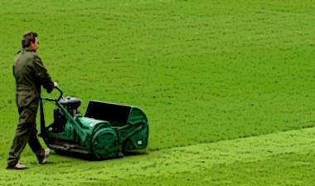**2. Mowing**

……………………………………………………………………………………………………..

……………………………………………………………………………………………………..

……………………………………………………………………………………………………..

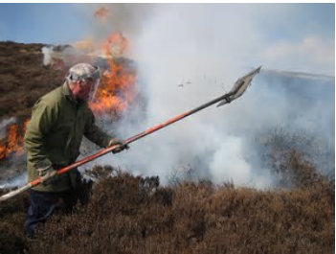**3. Burning**

……………………………………………………………………………………………………..

……………………………………………………………………………………………………..

……………………………………………………………………………………………………..

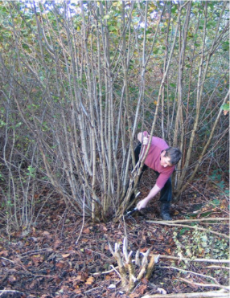**4. Coppicing**

……………………………………………………………………………………………………..

……………………………………………………………………………………………………..

……………………………………………………………………………………………………..

**5. Pollarding**

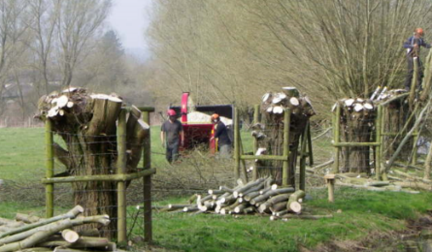……………………………………………………………………………………………………..

……………………………………………………………………………………………………..

……………………………………………………………………………………………………..

**Population control**

It may be necessary to actively control the populations of selected species either by increasing or reducing them, depending on which species are desirable or not. The release of captive-bred individuals will boost the wild population and help to support the population if the population size is low, the breeding rate is low, or the mortality rate is high.

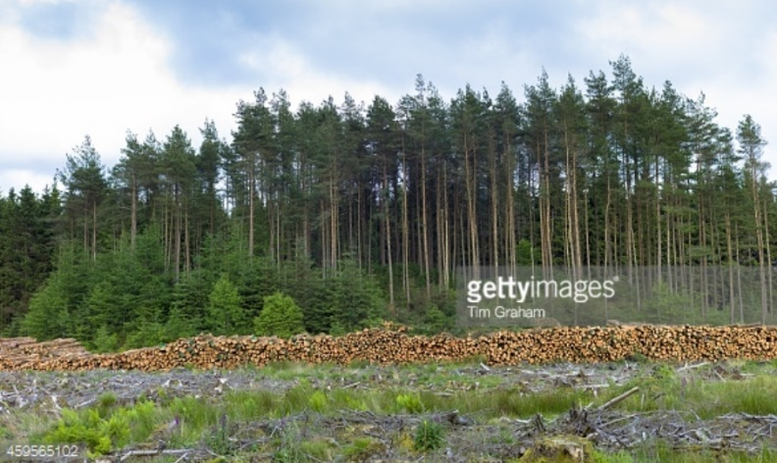The population of undesirable species may be controlled to reduce predation or competition. The animals may be culled, or trapped and removed. Restoration and maintenance of a valuable wildlife habitat often involves the removal of unwanted species. Some undesirable species may be a part of a natural ecological succession. Others may be invasive introduced species.

Conifer plantations are removed from the New Forest to re-establish heathland for Sand Lizards and Smooth Snakes.