**Antarctica**

Antarctica is an unusual area with extreme and fluctuating abiotic conditions. These have produced a unique community of species.

**Ecological features**

Antarctica is the last pristine continent; it has unique features and is vital in maintaining conditions across the Earth. These factors have driven the campaign to preserve it.

Antarctica is the only polar land mass. It is a large continent surrounded by an ocean, while the Arctic is an ocean surrounded by land. Antarctica’s unique features:

* its large landmass – almost 60 times the size of the UK;
* ice and snow, 4.8km deep, cover ninety-eight per cent of its surface;
* at an average temperature of -49C it is the coldest continent on Earth;
* it has the Earth’s largest desert;
* it has low precipitation with snow falling mainly near the coast;
* high average altitude;
* little terrestrial life including no permanent human inhabitants;
* 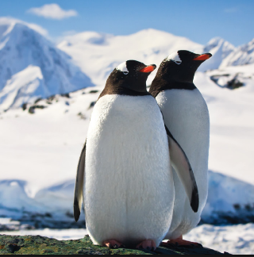abundant marine life surrounds it.

**Antarctica’s wildlife**

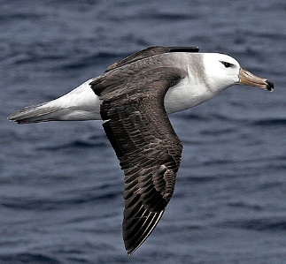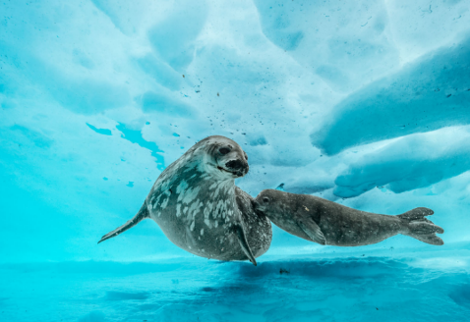Few terrestrial plants or animals can survive its harsh climate with its low air temperatures and long Antarctic winter. The sea is warmer than the land, with temperatures ranging from -1.8 oC to +3.5oC. Most of the animals found in Antarctica get their food from the sea, for example, penguins, seals, and albatrosses.

The stormy conditions and ocean currents around Antarctica disturb the seabed and lift nutrients up to the water surface where they stimulate the growth of algae. This supports a very rich food web including fish, penguins, seals, squid, and whales.

Although it is dark during the winter, it is sunny 24 hours a day during the summer allowing very productive photosynthesis.

A lot of the krill rely on the sea ice because they shelter from predators in cracks under the ice where they feed on algae.

**Importance of Antarctica**

Antarctica is important in providing a range of ecological services, resources, and opportunities for human activities.

**Control of natural cycles** - The ice on land is a huge store of water with 70 per cent of the Earth’s fresh water present as ice on Antarctica. This long-term storage of water has kept global sea levels relatively low.

Ice has a high albedo so most sunlight is reflected away, reducing its warming effect. If the area of ice was reduced, then temperatures would rise.

Much of the carbon present in the algae that are eaten by krill, sinks to the seabed in krill faeces.

This carbon sequestration helps to reduce carbon dioxide concentrations in the atmosphere.

**Resources** - Harvested biological resources include krill and three fish species.

Exploitation of the mineral resources of Antarctica is currently illegal but it is known that there are reserves of gold, silver, nickel, titanium, uranium, coal, oil, and others potentially exploitable resources.

**Research** - Antarctica is a unique location for scientific research.

It is the most isolated place on Earth so human influences are small.

It is a good place for astronomical research as there is little pollution interference from light, infra-red, or radio waves. There is also little cloud cover to block observations.

The climate is relatively stable and predictable so it is a good place for climate research.

The unique wildlife makes it an important place for ecological research.

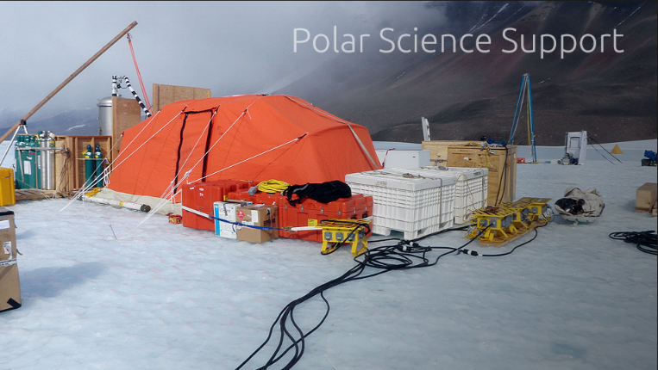

**Threats**

**Global climate change:** the rises in temperature and sea level caused by global

climate change are having significant impacts, especially around the coast and on the Antarctic peninsula which extends further north than the rest of the Antarctic land mass. Although the rise in global temperatures caused by climate change is unlikely to melt much of the ice in Antarctica because it is so cold, if any ice did melt it is likely it would impact the remaining ice significantly. Glaciers could move more rapidly towards the ocean caused by lubrication from released water. At the same time, ice shelves in the coastal waters which block the seaward movement of glaciers could break up as the seas heat up, enabling the glaciers to move towards the sea more easily. The sea level rise may also cause an ice shelf to lift off the seabed on which it was grounded. It may then break up into icebergs and float away, removing the barrier to land ice behind it which could then flow towards the sea.

Despite the rising temperature of the air and sea around Antarctica, the area of sea ice that forms each winter shows an upward trend. The exact causes for this are not fully understood but there are several possible explanations:

• stronger winds may be spreading the ice further;

• warmer air can hold more water vapour which may cause more snow to fall. This increased snow and the slush ice on which it falls may freeze together to form ice;

• ice on land that melts and flows into the sea may produce a layer of floating fresh water which freezes more easily than sea water.

The long-term trend may be for a reduction in the extent of sea ice. This would

affect the marine food web as the decline in the populations of algae and krill that live under the sea ice would affect the species that rely on them for food.

The ice on land in Antarctica has a mean thickness of 1,800m, so there will be no significant reduction in the area of land ice for a very long time even if melting increases. However, sea ice is only one to two metres thick, so warming could cause a reduction in sea ice area. This would reduce the albedo of the area and allow further warming as more sunlight is absorbed.

**Ozone depletion:** raised UV levels caused by ozone depletion has had little

impact on the organisms that live on land because there are few of them and the animals that are present often have thick feathers or fur. Planktonic organisms in surface waters are more vulnerable to raised levels of UV, for example, algae, krill, and the larvae of fish and sea urchins.

**Tourism:** unregulated tourism could threaten Antarctic wildlife through

disturbance and the introduction of non-indigenous species and pathogens from humans. Pollution caused by fuel, sewage, and wastes could also increase. The number of tourists visiting Antarctica is increasing rapidly although there have been proposals for a cap on numbers. Most people visit by ship as there is no tourist accommodation on Antarctica. Most tourists visit a small number of landing sites which reduces the wider impact but increases the dangers for these sites.

Disposal of wastes, oil spills, and the disturbance of wildlife are all potential

problems. There are also concerns that pathogens may spread from humans to

wildlife.

**Scientific research**: research in itself is not a threat to Antarctica but carrying it out increases the risk of impacts such as pollution events and wildlife disturbance.

Strict regulations are in place to minimize the impacts.

**Overfishing:** the sea around Antarctica has many species that have been overexploited in the past, leading to dramatically reduced populations, for example, some whale species and fur seals. Current fishing for krill threatens the species that feed on it including whales, albatrosses, and penguins. Overfishing of Patagonian toothfish threatens the food supply of sperm whales and elephant seals. Longlining for toothfish also threaten albatrosses as they can be caught on the hooks and drown.

**Future mineral exploitation:** Antarctica has deposits of minerals such as coal, oil, iron, copper, chromium, and platinum. The pressure to exploit these will increase as reserves elsewhere are depleted. Although mineral exploitation is currently banned, Antarctica has deposits of many minerals that are becoming scarce elsewhere in the world. The legal protection and difficulties of operating in such an extreme environment mean that mining is unlikely in the foreseeable future.

**Conservation efforts**

**The Antarctic Treaty:** the Antarctic Treaty (1959) aims to protect Antarctica and has been signed by 52 countries, including all the countries active in the area.

**Conservation of living organisms:** fishing is regulated by the Commission for

the Conservation of Antarctic Marine Living Resources (CCAMLS). Krill and some fish species are exploited but fisheries are closed if populations become over-exploited.

No mammal species can be exploited commercially.

**Control of tourism**: the impact of tourism is controlled by:

• having no holiday accommodation on land so wastes are produced and kept on the cruise ships used by the tourists;

• allowing only one cruise ship at any site at one time, with a maximum of 100

visitors ashore;

• tourists having to be accompanied by trained guides;

• requiring tourists to stay at least five metres from wildlife and leave no litter;

• wearing protective clothing to prevent the introduction of pathogens and

non-indigenous species; the protective clothing is cleaned before another site is visited.

**Waste management: this is managed by:**

• controlling and removing wastes;

• ensuring that the only long-term residents on Antarctica are research scientists and support staff;

• any waste materials that are produced being removed, for example, fuel containers, batteries, toxic wastes, plastics, used lubricating oil;

• ensuring that sewage is only discharged into the sea where currents will disperse and dilute it so that microbes in the sea can break it down;

• the removal of wastes produced before the introduction of these regulations,

unless it would cause more environmental damage to do so.

**No military activities:** none are allowed (except when supporting scientific research) and no nuclear explosions are permitted nor the dumping of radioactive waste.

**No resource exploitation:** no commercial mineral exploitation is allowed.