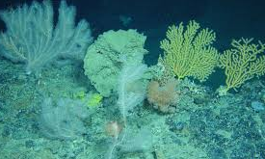**Deep water coral reefs**

These are coral reefs that are found in water where sunlight does not reach them. They are also called cold water coral reefs. Neither name is perfect as some are found in shallow water while others are found where the water is relatively warm. The common feature is the lack of sunlight to support photosynthetic algae.

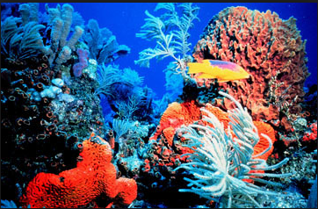**Ecological features**

The coral polyps that form deep water coral reefs do not have the symbiotic

photosynthetic algae that are found in tropical coral reefs so they have much less food energy available and grow much more slowly than shallow-water tropical coral reefs.

The slow rate of deep water coral growth means that reefs recover much more slowly from damage than tropical coral reefs.

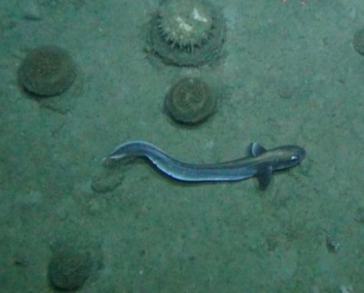

**The importance of deep water coral reefs**

Deep water coral reefs have only been discovered since the 1970s, with many being found since 2010, so there has been little time for research into their importance, their ecological roles, or the resources they may contain.

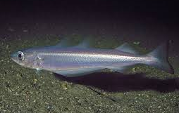Deep water coral reefs often support a large biomass of fish but these are often slow-growing species with a low reproductive rate so it is easy to over-exploit the populations.

The Roundnose Grenadier , Blue Whiting, and Orange Roughy are deep water species that have been commercially fished.

The Orange Roughy was not exploited on a large commercial scale until 1980 but, by 1990, the global catch was declining because the population had been over-exploited. Fishing of some populations has been banned in an attempt to let them recover.

What are the threats to Deep water coral reefs?

________________________________________________________________________________________________________________________________________________________________________________________________________________________________________________________________________________________________________________________________

How are Deep water coral reefs being conserved?

________________________________________________________________________________________________________________________________________________________________________________________________________________________________________________________________________________________________________________________________