**Mangroves**

Mangroves are coastal forests that grow in saline, oxygen-deficient soils, usually in tropical areas. They provide a range of important resources and ecological services.

**Ecological features**

Mangroves are tropical forests dominated by halophytic trees that live in inter-tidal areas with saline water. They are adapted to survive conditions that are saline, anaerobic and stormy. Inter-tidal habitats also have extremes in conditions such as temperatures and the availability of water.

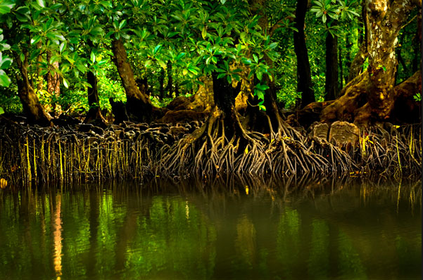

**Importance of mangroves**

**Biodiversity:** mangroves provide a habitat for a wide variety of species, including crabs, lobsters, shrimps, sponges, fish, molluscs, reptiles, and birds.

**Coastal erosion protection:** the vegetation and prop roots of mangroves absorb the energy of waves, reducing the impact of storms and hurricanes on more vulnerable coastal areas behind the mangroves. The 2004 tsunami that caused devastation in South East Asia did least damage where communities still had intact mangroves.

**Fisheries:** mangroves are important nursery grounds for fi sh that spend their adult lives in the open sea or on coral reefs. The dense roots protect the young fish from larger predators.

**Protection of coral reefs:** reefs are damaged by suspended solids carried by rivers that sink onto the coral polyps and kill them. River water that flows through mangroves slows down and the suspended solids are deposited before they reach the reefs. The mangroves also absorb nutrients from farmland which then can’t cause the growth of algae on the coral reef which would threaten the survival of the coral polyps.

**Resources:** mangroves provide timber for construction and fuel.

**Medicinal resources:** many mangrove plants have been used in traditional

herbal medicines. The extracts of the leaves of some mangrove trees are being

researched as antimicrobial medicines to treat antibiotic-resistant bacteria such as MRSA. A blue-green alga from Caribbean mangroves is used to treat small-cell lung cancer.

**Threats**

Although mangroves are often important to local communities, the growth of human populations and the expansion of economic developments such as aquaculture, urban developments, and ports cause large-scale destruction.

**Conservation efforts**

In regions where protecting the mangroves is seen as important surviving mangroves may be designated as protected areas. Seventy-five per cent of the mangroves of Sri Lanka have been lost but the remaining areas were legally protected in 2015.

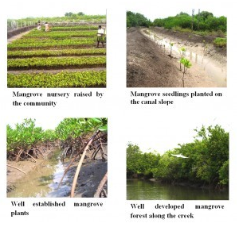

In areas where mangroves have been lost, natural recolonisation or replanting by people may take place. Natural regeneration can be very quick because mangrove trees produce seeds that germinate before they fall off the parent tree, into the sea where they are carried by water currents. If the sprouted shoot touches the sand, then roots are produced which anchor the young plant to the seabed.