**Oceanic islands**

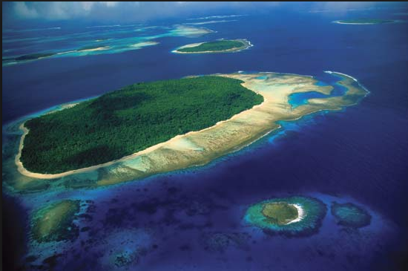These are islands that are sufficiently isolated from major land masses so it is difficult for species to colonise. This often produces unusual communities of species.

**Ecological features**

**Isolation and biodiversity**: most oceanic islands were formed by volcanic eruptions or the build-up of sand from nearby coral reefs. Their isolated positions make it difficult for most continental species to colonise. Marine species and seabirds can colonise relatively easily as can plants with floating seeds. Some species may have colonised by chance such as tortoises carried on drifting logs, or terrestrial birds carried by strong winds.

The species that succeed in colonising will gradually evolve to occupy the available ecological niches. Evolution has produced unique species on different islands because the conditions that affected selection pressure, and the characteristics that provide survival advantage, are different on different islands.

The **biodiversity of isolated islands may be low** because they are difficult to colonise, so some taxa may be absent or have few original colonists, such as mammals, land birds, reptiles, amphibia, and land plants. The local evolutionary processes may produce **many endemic species** with small ranges and small populations that make them vulnerable to extinction.

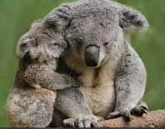**Lack of mammal predators**: it is difficult for mammals to colonise isolated islands. Seals and bats may do so but not terrestrial mammals. Some larger islands still have mammal species from when they were attached to larger continents but they have evolved into unique species, for example, the marsupials of Australia or the lemurs of Madagascar.

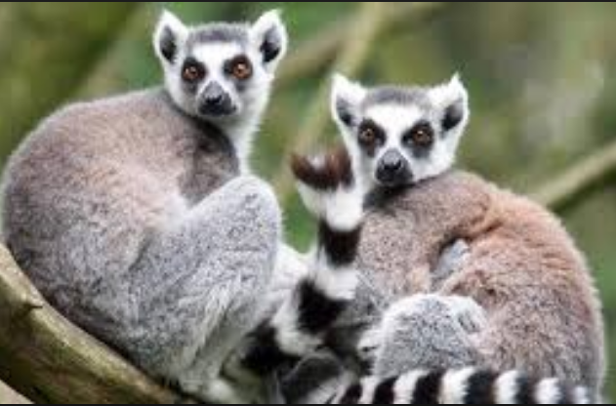**1**

**Importance of oceanic islands**

The high proportion of endemic species increases the possibility of the discovery of unique medicines or features that could be used in biomimetics.

**Threats**

What are the main threat to Oceanic islands?

________________________________________________________________________________________________________________________________________________________________________________________________________________________________________________________________________________________________________________________________________________________________________________________________________________________________________________________________________________________________________________________________________________________________________________________________________________________________________________________________________________________________________________________________________________________________________________________________________________________________________________________________________________________________________________________________________________________________________________________________

What are the main conservation efforts? ________________________________________________________________________________________________________________________________________________________________________________________________________________________________________________________________________________________________________________________________________________________________________________________________________________________________________________________________________________________________________________________________

