**Summary of specific habitats.**

**Key principles**

* Wildlife species provide a wide range of ecological services that help to maintain a stable biosphere.
* The resources provided by wildlife species are important in supporting human lifestyles.
* Many human activities threaten wildlife species and habitats
* A range of different strategies can be used to conserve biodiversity.
* 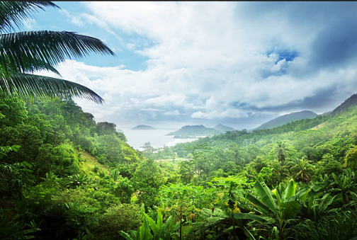The study of selected important ecosystems helps in understanding the importance of biodiversity and how it can be conserved.

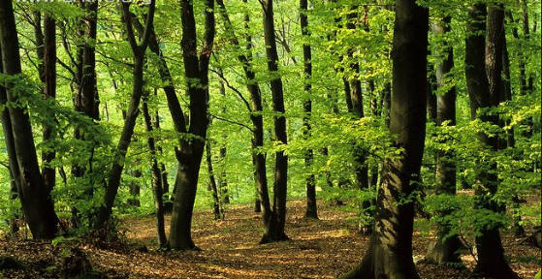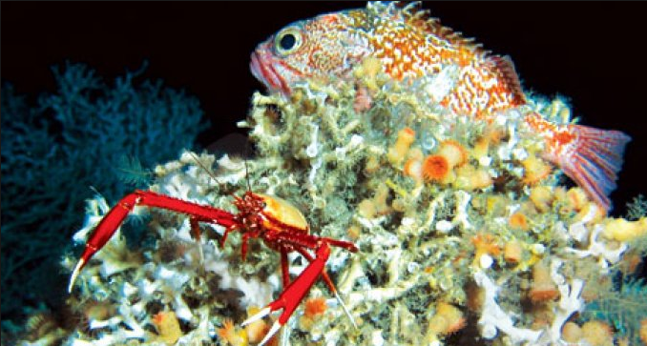

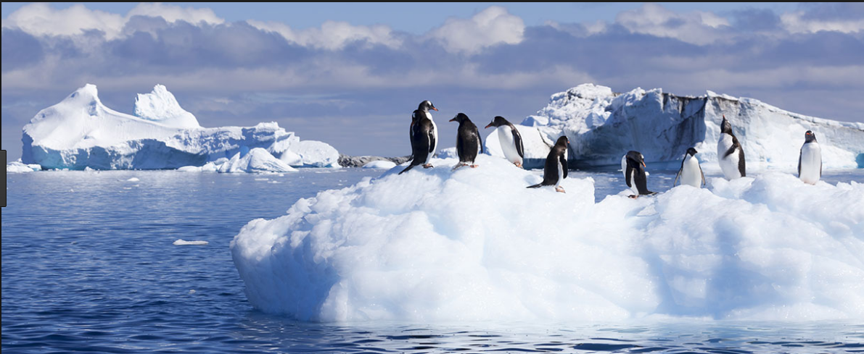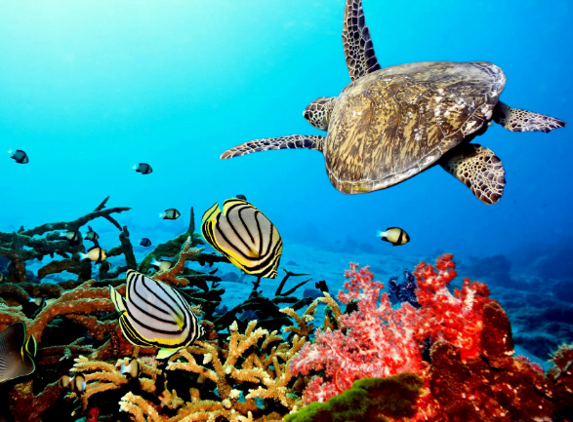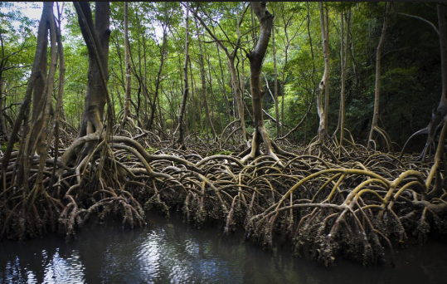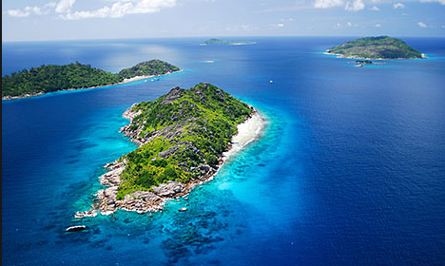

**Temperate broadleaf woodland**

|  |  |  |
| --- | --- | --- |
| Features: | • regular water supply  • summers not very hot  • winters not very cold  • seasonality. |  |
| Importance: | • high biodiversity  • resources  • climate control  • soil erosion control  • recreation. |  |
| Threats: | • deforestation for other land uses  • fragmentation of remaining woodland  • management change. |  |
| Conservation efforts: | • designated protected areas  • legal protection of ancient woodland in the UK  • conservation management. |  |

**Tropical rainforest**

|  |  |  |
| --- | --- | --- |
| Features: | • warm/hot  • high rainfall  • high light levels  • inter-species relationships  • low seasonality. |  |
| Importance: | • high biodiversity  • resources  • carbon sequestration  • hydrological cycle  • soil erosion control. |  |
| Threats: | • fuelwood collection  • timber for construction and furniture  • agricultural expansion  • mineral extraction  • reservoirs  • global climate change  • exploitation of individual species. |  |
| Conservation efforts: | • establishment of protected areas  • debt for Nature Swaps  • sustainable exploitation. |  |

**Tropical coral reefs**

|  |  |  |
| --- | --- | --- |
| Features: | • cnidarians  • nutrition systems  • high light levels  • warm, stable temperatures  • low turbidity  • constant salinity. |  |
| Importance: | • fisheries  • erosion protection  • medicinal discoveries  • climate control  • tourism. |  |
| Threats: | • physical damage caused by human  activites  • souvenir collection  • sedimentation  • climate change  • pollution  • fishing  • introduced species. |  |
| Conservation efforts: | • control of damaging activities  • establishment of protected areas. Deep-water coral reefs. |  |

**Deep-water Coral reefs**

|  |  |  |
| --- | --- | --- |
| Features: | • cold and dark  • slow coral growth. |  |
| Importance: | • research  • fisheries. |  |
| Threats: | • trawling  • oil and gas exploration  • ocean acidification. |  |
| Conservation efforts: | • establishment of protected areas  • control of damaging activities. |  |

**Oceanic islands**

|  |  |  |
| --- | --- | --- |
| Features: | • isolation  • few or no indigenous mammal predators  • endemic species. |  |
| Importance: | * endemic species. |  |
| Threats: | • species exploitation  • introduced species  • habitat change/destruction  • sea level rise. |  |
| Conservation efforts: | • eradication of introduced species  • control of developments and visitors. |  |

**Mangroves**

|  |  |  |
| --- | --- | --- |
| Features: | • tropical climates  • halophytic trees  • low oxygen availability. |  |
| Importance: | • coastal erosion protection  suspended solids.• fisheries  • timber supplies  • trap |  |
| Threats: | • clearance for urban development/  aquaculture  • coral reef destruction  • pollution  • global climate change. |  |
| Conservation efforts: | • reforestation  • control of damaging activities  • establishment of protected areas. |  |

**Antarctica**

|  |  |  |
| --- | --- | --- |
| Features: | • very low temperatures  • low precipitation  • high albedo  • high levels of marine nutrients  • large variations in ice cover  • extreme seasonal changes. |  |
| Importance: | * water store * ice albedo * carbon sequestration * resources * research. |  |
| Threats: | * global climate change * ozone depletion * tourism * overfishing * future mineral exploitation * scientific research. |  |
| Conservation efforts: | * The Antarctic Treaty (1959) * fisheries control * waste management * tourism control. |  |