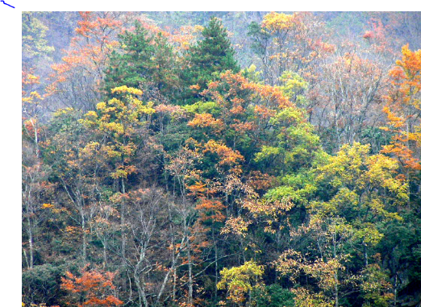**Temperate broadleaf woodland**

Most temperate broadleaf woodland is found in the northern hemisphere, in Europe, eastern North America, and East Asia. Most trees in temperate broadleaf woodlands are deciduous trees that lose all their leaves each year.

A wide range of tree species live in temperate broadleaf woodlands. The dominant tree species depend upon the soil conditions, for example, the dominant tree species in British broadleaf woodlands are:

beech – on moist soils, for example, clay;

ash – on alkaline soils, for example, limestone;

oak – wide range of tolerance.

**Ecological features**

Temperate broadleaf woodlands do not have major temperature extremes.

* There is no pronounced dry season – water is available all year.
* The soils are usually deep and fertile. The trees play an important part in the formation of soil with dead organic matter and its retention by vegetation cover and root binding.
* 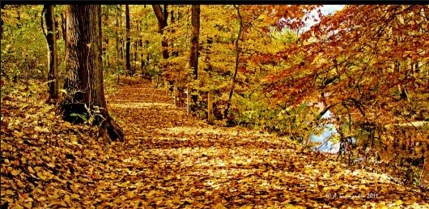The tree canopy layer is present from spring until autumn, so the growth of plants under the canopy is more difficult because they are shaded during the time when the temperatures are best for growth. Many woodland floor plants overcome this by growing early in spring, for example, British bluebells, snowdrops, Lesser Celandine.
* The lack of available food during the winter causes many animals to become less active, store food, hibernate, or migrate.

**High biodiversity**

Having a high biodiversity creates a higher ecological stability. No species are dominant so a change in the population of one species will have a relatively small impact on the overall community of species.

**Woodland resources**

Temperate broadleaf woodland was historically important for a wide range of resources.

Wood was used for:

1.______________________________________

2.______________________________________

3.______________________________________

4.______________________________________

5.______________________________________

6.______________________________________

**Recreation**

In what ways are many woodlands important for public recreation?

______________________________________________________________________________________________________________________________________________________________________________________________________________________________________________________________________________

**The hydrological cycle**

What role do trees play in the hydrological cycle?

______________________________________________________________________________________________________________________________________________________________________________________________________________________________________________________________________________

**Carbon sequestration**

What is this and how are plants involved?

_____________________________________________________________________________________________________________________________________________________________________________________________________________________________________________________________________________

______________________________________________________________________________________________________________________________________________________________________________________________________________________________________________________________________________

**Threats**

What are the main threats to a broadleaf woodland? ______________________________________________________________________________________________________________________________________________________________________________________________________________________________________________________________________________

______________________________________________________________________________________________________________________________________________________________________________________________________________________________________________________________________________

______________________________________________________________________________________________________________________________________________________________________________________________________________________________________________________________________________

______________________________________________________________________________________________________________________________________________________________________________________________________________________________________________________________________________

______________________________________________________________________________________________________________________________________________________________________________________________________________________________________________________________________________

How can broadleaf woodlands be conserved?

1._________________________________________________________

2._________________________________________________________

3._________________________________________________________

What designations can be applied to woodlands? Find some local examples

Research the main methods of woodland management and make notes below. Here are some documents that should help.

<https://www.woodlandtrust.org.uk/mediafile/100088528/Sustainable-management-brochure.pdf>

<https://www.woodlandtrust.org.uk/mediafile/100088528/Sustainable-management-brochure.pdf>

<https://www.forestry.gov.uk/pdf/so-you-own-a-woodland.pdf/$file/so-you-own-a-woodland.pdf>

<https://www.forestry.gov.uk/PDF/fcpg003.pdf/$FILE/fcpg003.pdf>

____________________________________________________________________________________________________________________________________________________________________________________________________________________________________________________________________________________________________________

___________________________________________________________________________________________________________________________________________________________________________________________________________________________________________________________________________________________________________

___________________________________________________________________________________________________________________________________________________________________________________________________________________________________________________________________________________________________________

___________________________________________________________________________________________________________________________________________________________________________________________________________________________________________________________________________________________________________

___________________________________________________________________________________________________________________________________________________________________________________________________________________________________________________________________________________________________________

___________________________________________________________________________________________________________________________________________________________________________________________________________________________________________________________________________________________________________

___________________________________________________________________________________________________________________________________________________________________________________________________________________________________________________________________________________________________________

___________________________________________________________________________________________________________________________________________________________________________________________________________________________________________________________________________________________________________

__________________________________________________________________________________________________________________________________________________________________________________________________________________________________