**Tropical rainforest**

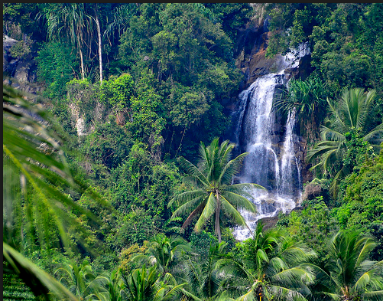

* Tropical rainforests are the most biodiverse terrestrial ecosystems.
* They have not been fully researched but the relative ease with which new species can be discovered suggests that over half of all terrestrial species live in tropical rainforests, although the rainforests only cover about ten per cent of the Earth’s land area.

**Ecological features**

The tropical climate has been **relatively stable over long time periods**, compared with regions further away from the equator. This has given rainforest species a long time to evolve and become adapted to local abiotic and biotic factors. This has produced a **huge number of different species**, although many are relatively rare and may have small ranges.

Being adapted to relatively stable conditions can make species vulnerable to extinction as a small change in environmental conditions may move them outside their range of tolerance.

**High light levels allow photosynthesis rates to be high**, providing a lot of food energy to support a rich food web.

**Constant warm temperatures and regular high rainfall** allow plants to grow throughout the year without the seasonal changes that occur in higher latitudes.

This ensures **reliable food supplies** are available to animals throughout the year.

Populations rarely have the seasonal collapse found in higher latitudes and there is no need to hibernate or migrate to more favourable areas.

Migratory species found in tropical rainforests have normally come from other areas that have fluctuating conditions and have migrated to the rainforests because they are so stable.

Because the abiotic conditions have been relatively stable for a long time and do not fluctuate seasonally, there is probably little need for most species to evolve further and become better adapted to abiotic factors.

The main survival pressure is produced by biotic factors: getting food, avoiding being eaten, and evolving better inter-species relationships.

Although there are high light levels, there is also **a lot of competition for light**. Plants that have evolved to grow a tall trunk will have better access to light but must invest a lot of energy over a long time to produce it. Smaller plants may need to evolve methods of utilising lower light levels, such as denser chlorophyll or additional pigments to absorb other wavelengths of light. Plants that are epiphytes have greater access to light without being tall but may have less reliable water and nutrient supplies.

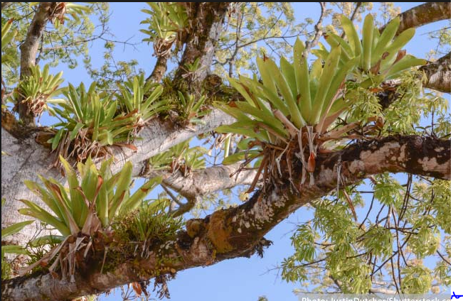

With **no distinct seasons**, plant species do not have to flower or produce seeds and fruit at the same times as each other. So plants have less competition for the services of animals to pollinate flowers or spread seeds. Food in the form of nectar, seeds, or fruit is available to animals throughout the year, which increases animal survival.

Most trees are deciduous and shed their leaves every year but different species do so at different times of year. So animals that feed on vegetation do **not have long periods when there is no food**, as is the case in temperate broadleaf woodlands.

**High biodiversity**

Why is the fact that the rainforest have such high biodiversity make this such an important area to humans?

__________________________________________________________________________________________________________________________________________________________________________________________________________________________________________________________________________________________________________________________________________________________________________________________________________________________________________________________________

**Forest resources**

Rainforests are important to the people that live in or near the forests. As long-distance transport became possible, forest resources also became important in other areas such as Europe.

|  |  |
| --- | --- |
| Resource | Uses |
|  |  |
|  |  |
|  |  |
|  |  |
|  |  |

**Climate maintenance**

Tropical rainforests are very important for increasing downwind rainfall. Over half the rainfall in the Amazon rainforest results from transpiration elsewhere in the forest rather than coming directly from the evaporation of seawater.

As with temperate broadleaf woodland and all trees, carbon sequestration by photosynthesis stores large amounts of carbon in tropical rainforests which helps to reduce the natural greenhouse effect.

**Soil maintenance**

The warm, moist conditions make dead vegetation decay very rapidly so nutrients are re-absorbed by trees very quickly. Because of this, soils in tropical rainforests are often very shallow. The vegetation cover and tree roots are important in preventing the soil that is present from being eroded, as the foliage protects the soil from heavy rain and the roots hold the soil together. Forest clearance can lead to serious soil erosion.

**Threats**

What are the main threats to a tropical rainforest?

|  |  |
| --- | --- |
| Threat | Details |
| Firewood collection |  |
| Timber harvesting |  |
| Land clearance |  |
|  |  |
| Mineral extraction |  |
| Climate change |  |
| Tourism |  |

How can rainforests be conserved?

____________________________________________________________________________________________________________________________________________________________________________________________________________________________________________________________________________________________________________

___________________________________________________________________________________________________________________________________________________________________________________________________________________________________________________________________________________________________________

___________________________________________________________________________________________________________________________________________________________________________________________________________________________________________________________________________________________________________

___________________________________________________________________________________________________________________________________________________________________________________________________________________________________________________________________________________________________________

___________________________________________________________________________________________________________________________________________________________________________________________________________________________________________________________________________________________________________

___________________________________________________________________________________________________________________________________________________________________________________________________________________________________________________________________________________________________________

___________________________________________________________________________________________________________________________________________________________________________________________________________________________________________________________________________________________________________

___________________________________________________________________________________________________________________________________________________________________________________________________________________________________________________________________________________________________________

_________________________________________________________________________________________________________________________________________________________________________________________________________________________________