**Colombia’s ‘cocaine hippo’ population is even bigger than scientists thought**

**The most comprehensive census yet reveals that there could be twice as many of the invasive animals than previous estimates indicated.**

* [Luke Taylor](https://www.nature.com/articles/d41586-023-01818-z?utm_source=Nature+Briefing&utm_campaign=cadab83fe1-briefing-dy-20230605&utm_medium=email&utm_term=0_c9dfd39373-cadab83fe1-45754234#author-0)



Wild descendants of the hippo population introduced in Colombia by Pablo Escobar.Credit: Raul Arboleda/AFP via Getty

Colombia’s invasive hippo population is even larger than researchers had thought, according to [the most thorough census of the animals conducted yet](https://www.minambiente.gov.co/wp-content/uploads/2023/04/DA_PROCESO_22-22-34390_132001000_113971031.pdf). Scientists [were already concerned about the hippos](https://www.nature.com/articles/d41586-023-00606-z) — considered the largest invasive animal in the world — threatening native plants and animals in the country, and had been calling for drastic measures to reduce the population. The census results have only heightened that fear.

](https://www.nature.com/articles/d41586-023-00606-z)](https://www.nature.com/articles/d41586-023-00606-z)

A few years ago, researchers estimated how fast the animals were reproducing, to project that about 98 hippos were living along the country’s Magdalena River and its tributaries in 2020[1](https://www.nature.com/articles/d41586-023-01818-z?utm_source=Nature+Briefing&utm_campaign=cadab83fe1-briefing-dy-20230605&utm_medium=email&utm_term=0_c9dfd39373-cadab83fe1-45754234#ref-CR1). But the new study, for which a research team counted the animals in person, by drone and using other tracking methods, estimates that there are 181–215 of them residing in Colombia.

“Before, one argument against dealing with the hippos was that our information was limited and our arguments theoretical,” says ecologist Rafael Moreno, who participated in the study while at the Alexander von Humboldt Biological Resources Research Institute in Bogotá. “But we have put that argument to bed now. This study shows that this is a real issue, and that the state must act urgently.”

**By drone and on foot**

Colombia’s ‘cocaine hippos’ are all descendants of three females and one male illegally imported by drug-cartel leader Pablo Escobar. After he died in the 1993, the hippos (*Hippopotamus amphibius*) escaped from his estate and established themselves in the Magdalena River. Without the natural predators or droughts of their native Africa to keep them in check, the giant herbivores have bred rapidly to form the largest population of the animals outside that continent.

Colombian officials have struggled to manage the hippos. After they ordered an aggressive male to be killed in 2009, a photo of soldiers posing with the corpse sparked outrage and halted efforts to rein them in. Some communities now depend on the tourism the hippos bring, whereas others — particularly fishing communities — live in fear of the highly territorial animals, which can weigh 3 tonnes and can tear off a person’s limbs or trample them.

](https://www.nature.com/articles/d41586-021-03527-x)](https://www.nature.com/articles/d41586-021-03527-x)

Colombia’s environment ministry commissioned the census to get a better picture of the problem and how to manage it. Completing it was challenging: despite the hippos’ large size, it is difficult to find and count them accurately. They are nocturnal, immerse themselves in water for 16 hours a day and roam large distances.

Comprising researchers at the National University of Colombia in Bogotá, the Humboldt Institute and Cornare, an environmental body managing an area where the hippos live, the team made various trips in 2021 and 2022 by car, boat and on foot to count the hippos. In locations where the animals could not be reached safely, they used drones to count them or footprints to estimate the population.

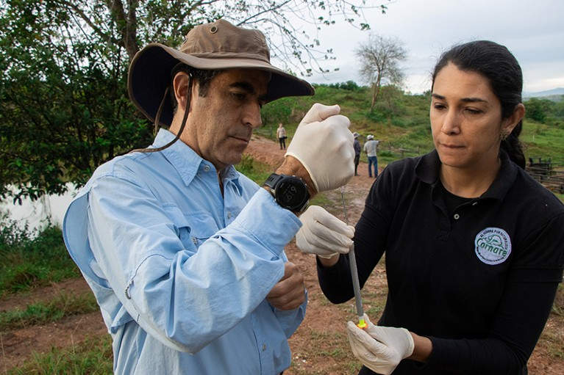

One way of managing the hippo population is by contraception, administered using a dart.Credit: Cornare via Reuters

The researchers found that 37% are juveniles, indicating that the animals are breeding rapidly. One hypothesis for this is that the hippos are reaching sexual maturity earlier than they do in Africa owing to the lush conditions in Colombia. Another is that the animals are having greater reproductive success because there are fewer fights among them for territory and resources, Moreno says. But evidence is needed to confirm the actual cause.

While counting the hippos, the team documented the myriad ways in which the animals are damaging Colombia’s ecosystems. As they waddle their huge bodies to and from rivers, the hippos are eroding riverbanks and carving out muddy paths that divide forests. Moreover, they are outcompeting other animals for habitat and resources, with the West Indian manatee (*Trichechus manatus*), neotropical otter (*Lontra longicaudis*) and capybara (*Hydrochoerus hydrochaeris*) most under threat.

**Exploring solutions**

With serious attacks on humans in 2020 and 2021, and a car crash leaving a hippo dead on the highway in April, solutions are needed, scientists say.

One strategy currently being tried is to administer contraceptives to the animals by dart. That might eventually get rid of the hippos by preventing their reproduction, but it is slow, costly and hasn’t been tested on hippos on such a scale before. A modelling study published in April[2](https://www.nature.com/articles/d41586-023-01818-z?utm_source=Nature+Briefing&utm_campaign=cadab83fe1-briefing-dy-20230605&utm_medium=email&utm_term=0_c9dfd39373-cadab83fe1-45754234#ref-CR2) estimated that this method could eradicate the hippos in 45 years at a cost of at least US$850,000.

](https://www.nature.com/articles/d41586-021-02088-3)

Another strategy — capturing, anaesthetizing and transporting the hippos by helicopter to a facility to be castrated — would cost at least $530,000 and take up to 52 years for eradication, the study found. Both calculations are underestimates, given that the models were fed earlier, lower estimates of the hippo population, before the census results had been released.

Meanwhile, the regional agency responsible for dealing with the hippos is strapped for funding and relying on donations of contraceptives from the United States. Agency officials are negotiating with countries, including India and Mexico, to export some of the animals to sanctuaries abroad. But this would cost $3.5 million, according to those working on the strategy.

There is no single best solution, says Olga Montenegro, a biologist at the National University who worked on the census. The hippos live in various groups, some of which might be easily relocated, but others are well established and are breeding quickly.

Many researchers advocate culling the animals. They say it is the swiftest, most humane thing to do and that it would solve the problem before it becomes impossible to fix. The cost of killing the hippos must be weighed against that of losing native flora and fauna in Colombia — the second-most biodiverse country in the world — they add.

*Nature* asked the environment ministry how it would manage the growing hippo population, given the new findings, but it did not comment.

“There is a moral weight to the decision to cull a hippo. But the weight of the other decision — inaction — is far greater,” Moreno says. “I hope this is something the politicians will understand.”

*doi: https://doi.org/10.1038/d41586-023-01818-z*

**References**

1. Castelblanco-Martínez, D. N. *et al.* *Biol. Conserv.* **253**, 108923 (2021).

[**Article**](https://doi.org/10.1016%2Fj.biocon.2020.108923)[**Google Scholar**](http://scholar.google.com/scholar_lookup?&title=&journal=Biol.%20Conserv.&doi=10.1016%2Fj.biocon.2020.108923&volume=253&publication_year=2021&author=Castelblanco-Mart%C3%ADnez%2CD.%20N.)

1. Subalusky, A. L. *et al.* *Sci. Rep.* **13**, 6193 (2023).

[**Article**](https://doi.org/10.1038%2Fs41598-023-33028-y)[**PubMed**](http://www.ncbi.nlm.nih.gov/entrez/query.fcgi?cmd=Retrieve&db=PubMed&dopt=Abstract&list_uids=37062768)[**Google Scholar**](http://scholar.google.com/scholar_lookup?&title=&journal=Sci.%20Rep.&doi=10.1038%2Fs41598-023-33028-y&volume=13&publication_year=2023&author=Subalusky%2CA.%20L.)