**The Evolving Atmosphere**

**Conditions for life on Earth**

**[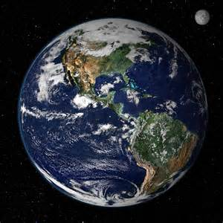](http://www.bing.com/images/search?q=life+on+earth&view=detailv2&&id=DFB0BA84D72D5EBE8DCD45ACBAF468DE48322813&selectedIndex=0&ccid=Eq8IFbUD&simid=608033036566792486&thid=OIP.M12af0815b503982f4a02a395d70522e2o0)**

**Specification content**

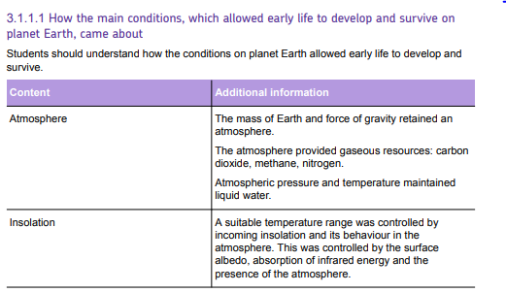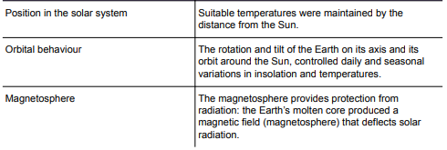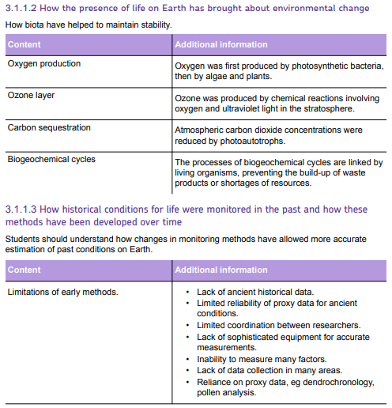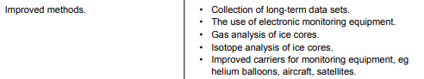

**Features of the Earth that created suitable conditions for life.**

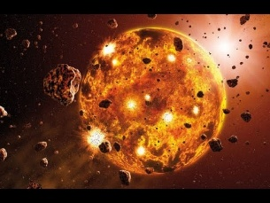The physical features of Earth made it suitable for the development of life by controlling the abiotic factors that are needed by living things. The Earth was formed 4.6 billion years ago as gravity pulled rock fragments in space together. Below is a table that summarises the features of the structure position and behaviour of Earth the made the development of life possible.

|  |  |
| --- | --- |
| **Mass** |  |
| **Atmosphere** |  |
| **Distance from sun** |  |
| **Axis of rotation** |  |
| **Speed of rotation** |  |
| **Magnetosphere** |  |

**Development of life on Earth**

After the formation of Earth conditions became suitable for life to develop. The following features made Earth suitable for the development of life.

1. **Presence of liquid water**
2. **Temperature range**
3. **The atmosphere**
4. **Solar insolation**

These are controlled by features of the planet itself and by its position in the solar system.

**Presence of liquid water**

Liquid water enables living organisms to survive on Earth. All living things require water for survival as it performs essential physiological functions and controls many environmental conditions

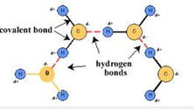

**These functions and properties include**:

* Universal solvent
* Transport within organisms
* Temperature control
* Anomalous expansion on freezing
* High specific hear capacity
* Aquatic habitats – oceans, seas, lakes, marshes
* Absorption of UV radiation

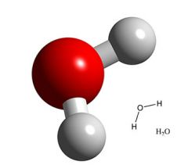

**Structure of water**

* Water is a POLAR molecule (hydrogen is slightly positive and oxygen slightly negative in charge)
* So, water molecules attract each other and form hydrogen bonds between each other.
* The hydrogen bond give water a higher boiling point so, water is a liquid at normal environmental temperatures.
* Hydrogen bonds are continually forming and breaking. If a single water molecule is at the water surface, then it may escape as a molecule of water vapour. This allows water to evaporate and turn to gas without having to be heated to its boiling point.

**Properties of water circus analysis**

**STATION 1 – Water is the universal solvent.**

**Comprehension questions**

1. Define mixture.

2. Define solvent.

3. Why is water considered the greatest solvent on Earth?

**Analysis questions**

1. Describe and explain the appearance of the test tube with oil and salt.

2. Describe and explain the appearance of the test tube with water and salt.

3. Up to 60% of living organisms are made up of water. Describe the significance of water being a universal solvent.

**STATION 2 – Anomalous expansion of water**

**Comprehension questions**

1. Why can solid ice float on liquid water?

2. When a lake freezes, how does the density of water prevent all of the living organisms in the lake from freezing as well?

**Analysis question**

1. Imagine a world where ice was more dense than liquid water. What would this world be like? What would the consequences be for life in your local freshwater streams and lakes?

**STATION 3 – Strong surface tension and cohesion**

**Comprehension questions**

1. What is cohesion?

2. How does water hold up materials that is heavier than itself?

3. What property of water gives it a high surface tension?

**Analysis questions**

1. What property of water allows the paper clips to be attracted to the plain water?

2. Explain why this property of water is essential for organisms like water bugs.

**STATION 4 – High specific heat capacity**

**Comprehension questions**

1. Define high specific heat capacity.

2. How does a high specific heat capacity enable fish to survive?

**Analysis questions**

1. What was the temperature of the water and sand in the experiment?

2. What do the results tell you about the specific heat capacity of sand?

3. If water had a low specific heat capacity what would happen to aquatic organisms?

**Other Water Properties**

**Temperature control**

* Water has a high latent hear of vaporisation. This means, evaporation of water absorbs heat, causing temperature to decline. This can help the cooling of animals e.g., sweating in humans, panting in dogs

**Absorption of UV radiation**

* Before the ozone layer developed, water absorbed UV radiation and protected aquatic animals.

**Temperature range**

* Most areas of Earth have temperatures between 0oC and 35oC.
* This ensures that there is enough liquid water for organisms to use. Also, proteins such as enzymes that catalyse reactions within living organisms do not denature.

**Atmospheric gases**

* Water vapour will contribute to the water cycle
* Oxygen and carbon dioxide allow aerobic respiration and photosynthesis respectively.
* Nitrogen is used for protein synthesis

**Solar insolation**

Insolation is the term used to describe the amount and duration of incoming solar radiation. Sunlight provides the energy for photosynthesis. The heat produced by the absorption of sunlight provides the energy to drive the water cycle and warms the Earth’s surface and the oceans

**How life has changed the Earth**

|  |  |
| --- | --- |
| **Early Atmosphere** | **Today’s Atmosphere** |
| **Major Gases:**  Carbon Dioxide (86 %)  Ammonia (10 %)  Methane (4 %)  **Minor Gases:**  Nitrogen (< 1%)  Water Vapour | **Major Gases:**  Nitrogen (78 %)  Oxygen (21 %)  Noble Gases (1%)  **Minor Gases:**  Carbon Dioxide (0.04%)  Methane (< 1%)  Ozone |

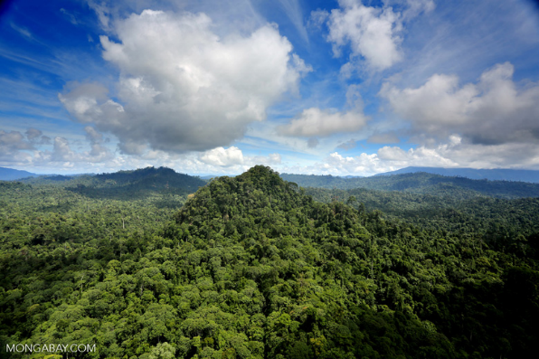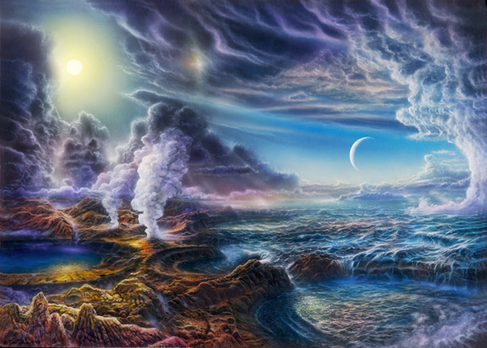

**Evolution of the Earth**

On the page below construct a timeline outlining the main events that have occurred in Earths evolution.

**Timeline showing the main events of the evolution of earth**

**Today**

**0.5 bya**

**1.0 bya**

**1.5 bya**

**2.0 bya**

**2.5 bya**

**3.0 bya**

**3.5 bya**

**4.0 bya**

**4.6 billion years ago**

**How life on Earth brought about changes in environmental conditions**

All processes on Earth are interconnected. The conditions that are seen on Earth today are a result of lots of natural processes that are in a dynamic equilibrium. In a dynamic system there are lots of fluctuations, but an overall balance is maintained.

Explain what dynamic equilibrium means.

In the table below, summarise the changes that life on Earth have brought to the environmental conditions.

|  |  |
| --- | --- |
| **Oxygen production** |  |
| **Ozone layer** |  |
| **Carbon sequestration** |  |
| **Biogeochemical cycles** |  |
| **Water cycle** |  |

**Monitoring conditions on Earth: Past and Present**

**Research task: In the boxes provided, complete the information to explain which conditions are measured and how this is done.**

[](https://uk.images.search.yahoo.com/images/view;_ylt=A2KLj.uCo.RZoxIAHmue3olQ;_ylu=X3oDMTIyaGR2MmRwBHNlYwNzcgRzbGsDaW1nBG9pZAM3N2FmMDkwNDg3ZmE0ODBkYzllNmQ3MDE3YzdkYTE4OQRncG9zAzgEaXQDYmluZw--?.origin=&back=https%3A%2F%2Fuk.images.search.yahoo.com%2Fyhs%2Fsearch%3Fp%3Ddendrochonology%2Bexplained%26type%3Dzxy_a28f3ce2b9111b23a6%26fr%3Dyhs-arh-001%26fr2%3Dpiv-web%26hsimp%3Dyhs-001%26hspart%3Darh%26tab%3Dorganic%26ri%3D8&w=940&h=627&imgurl=mizzoumag.missouri.edu%2Fwp-content%2Fuploads%2F2013%2F05%2Ftree-rings-0019_web.jpg&rurl=http%3A%2F%2Fimgarcade.com%2F1%2Ftree-rings%2F&size=618.6KB&name=Gallery+For+%26gt%3B+Tree+Rings&p=dendrochronology+explained&oid=77af090487fa480dc9e6d7017c7da189&fr2=piv-web&fr=yhs-arh-001&rw=dendrochronology+explained&tt=Gallery+For+%26gt%3B+Tree+Rings&b=0&ni=21&no=8&ts=&tab=organic&sigr=112dves5a&sigb=15ahomrmi&sigi=129m3lggt&sigt=10rm75tqq&sign=10rm75tqq&.crumb=8JurRHYMgU0&fr=yhs-arh-001&fr2=piv-web&hsimp=yhs-001&hspart=arh&type=zxy_a28f3ce2b9111b23a6)

**Historical records** from when humans evolved include written accounts of droughts, floods, especially frigid winters, unusually hot summers, and storms as well as timing and quality of harvests and timing of seasonal changes. Such accounts **lack the numerical precision** of modern instrumental records but span a much longer period of time.

**Proxy data – explain what this means.**

**Dendrochronology**

**Monitoring conditions on Earth from the past**

**Fossil pollen**

**Ice core analysis**

**The thickness of an ice layer**

* **Air pockets**

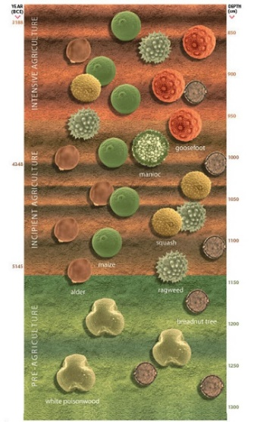

**Sediments from lakes beds and seafloors**

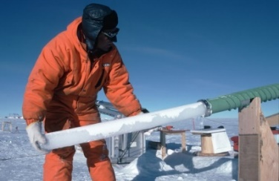

The past 140 years we have relatively precise, quantitative, direct measures of climate such as temperature, precipitation, and wind speeds.

**Improved methods of ice core analysis.** Gas and isotope analysis of ice cores.

**Beryllium-10 concentrations**:

**The ratio of concentrations of two isotopes of oxygen:**

[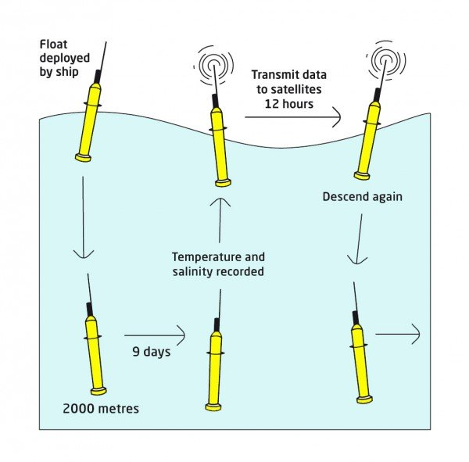](https://maas.museum/event/ecologic/files/2011/12/Argofloat.jpg)

**Monitoring conditions on Earth today**

**Argo floats.**

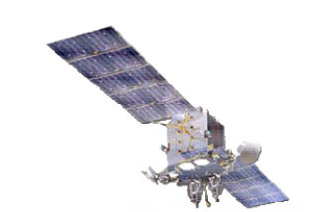

**Satellites.** Hundreds of climate satellites send data to organisations such as the [World Meteorological Organisation](http://www.wmo-sat.info/oscar/satellites), [NASA](http://climate.nasa.gov/nasa_role/missions/), [NOAA](http://noaasis.noaa.gov/NOAASIS/ml/genlsatl.html) and elsewhere that drive climate change modelling.

**Specific example of a satellite and how it works.**

[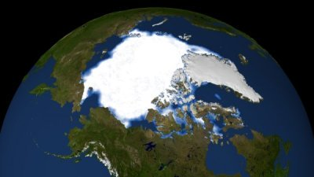](https://maas.museum/event/ecologic/files/2011/12/Sea-ice-1983.jpg)

This satellite images show how much less summer sea ice there was in 2007 compared with the amount in 1983.

[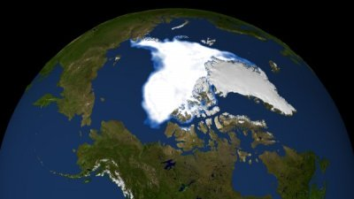](https://maas.museum/event/ecologic/files/2011/12/Sea-ice-2007.jpg)

**Atmospheric measurements.** Baselineair pollution stations around the world (Cape Grim in Tasmania, Mauna Loa Observatory in Hawaii)

Changes in monitoring methods have allowed scientists to access more accurate estimations of past conditions on Earth.

**Limitations of early methods:**

• Lack of ancient historical data.

• Limited reliability of proxy data for ancient conditions.

• Limited coordination between researchers.

• Lack of sophisticated equipment for accurate measurements.

• Inability to measure many factors.

• Lack of data collection in many areas.

• Reliance on proxy data, e.g., dendrochronology, pollen analysis.

**Improved methods:**

• Collection of long-term data sets.

• The use of electronic monitoring equipment.

• Gas analysis of ice cores.

• Isotope analysis of ice cores.

• Improved carriers for monitoring equipment, e.g., helium balloons, aircraft, satellites.

**Glossary of terms**

|  |  |
| --- | --- |
| **Atmosphere** |  |
| **Abiotic factors** |  |
| **Archaea** |  |
| **Anomalous expansion** |  |
| **Carbon sequestration** |  |
| **Specific heat capacity** |  |
| **Ozone** |  |
| **Insolation** |  |
| **Dynamic equilibrium** |  |
| **Transpiration** |  |
| **Magnetosphere** |  |
| **Biogeochemical cycle** |  |

**Conditions for Life on Earth Exam Question**

**1**

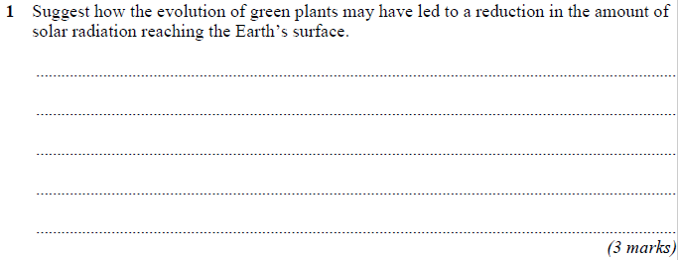

**2**

**4**

**4**



**4**