**The Evolving Atmosphere**

**The Atmosphere, Global Climate Change and Ozone Depletion**

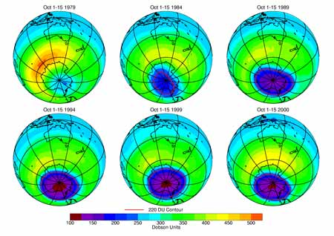[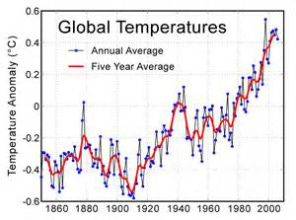](https://www.bing.com/images/search?q=global+climate+change&view=detailv2&&id=0F73F6A6CC1C1B0E702567ECD66E908841F93756&selectedIndex=71&ccid=l9X5Y2kX&simid=608014705835772152&thid=OIP.l9X5Y2kXO3VLXh5_UpNP2gEsDf)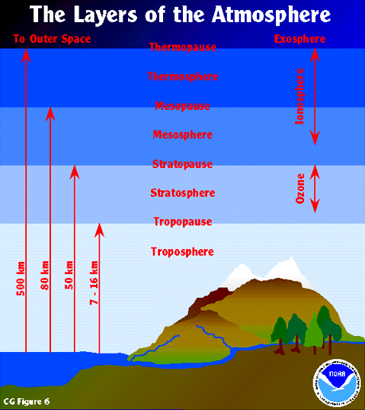

**Specification content**

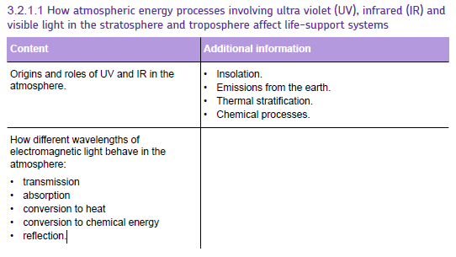

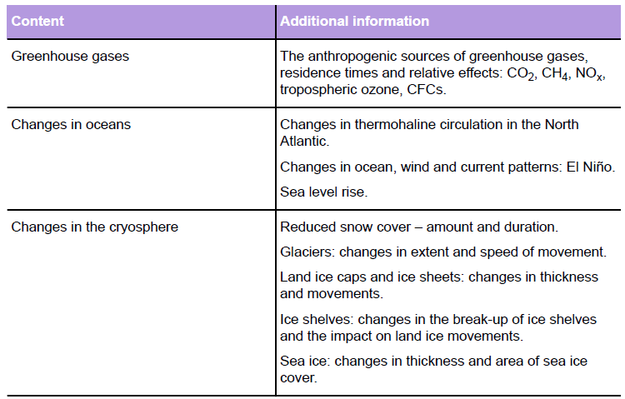



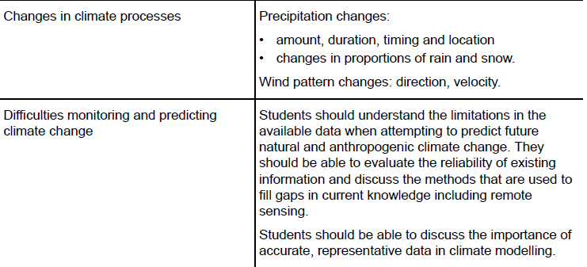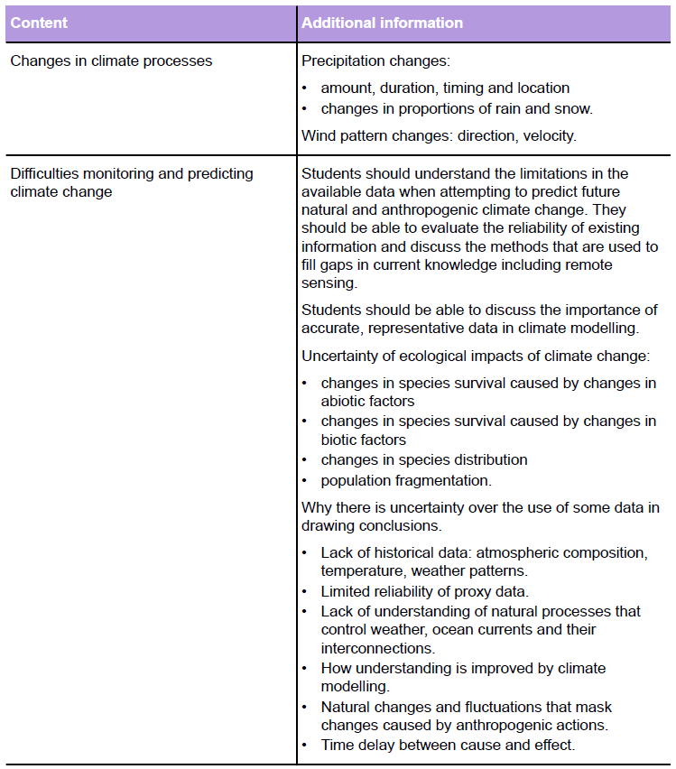

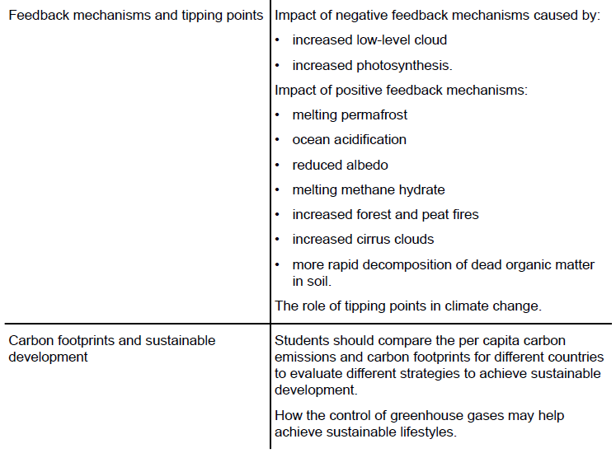





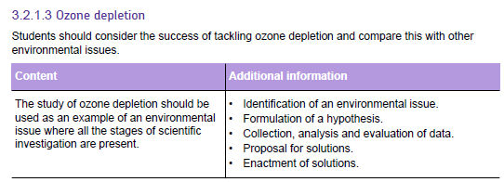

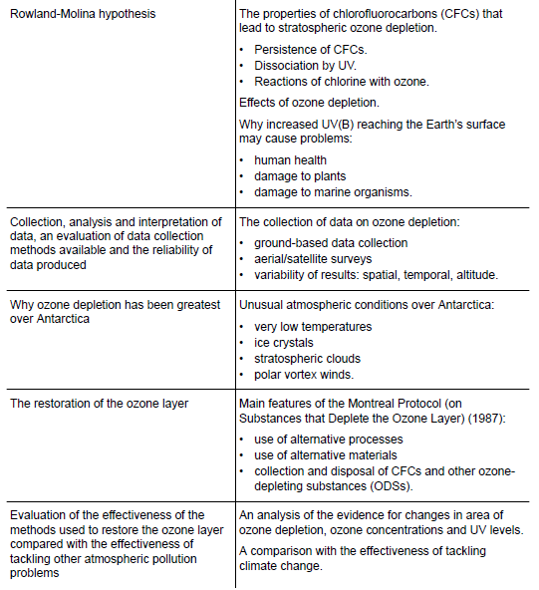



**Cop26 may could well be one of the most important milestones in the fight against climate change.**

**TASK:**

Summarise what has been achieved in Glasgow this year, and evaluate whether it is enough to avoid the disastrous consequences of climate change

* Use the internet to find news reports outlining the major achievements
* Use a *range* of sources (BBC, newspapers, journals etc.)

Focus on explaining the following points:

What has been agreed?

How this will fight climate change

Who has and who hasn’t signed up to these deals

What has *not*been achieved – are there any missed opportunities from COP26?

You also need to give your view on how successful the conference has been:

Is there enough action?

Are the targets ambitious enough?

Are they achievable?

You can summarise your research in any one of the following ways:

* A written report /news article (structure it like it’s in a paper – give it a headline, keep it concise)
* A powerpoint
* A video presentation (use screen-cast-o-matic to record yourself talking over your presentation, max length 15 minutes which should be more than enough). **To submit a video, save it to your Onedrive and share the link with me (you can always upload to your own youtube account if you have one and share that link)**

**The Atmosphere**

The atmosphere is a thin layer of gases surrounding the Earth, held in place by gravity. The atmosphere is essential to life on Earth as it provides vital life support systems such as protection from solar radiation, gas resources and aiding the transport of energy and water around the globe.

**Composition of the atmosphere**

The natural composition of atmosphere is fairly constant.

Variations occur due to regular cycles that fluctuate around ‘normal’ values

Human activities cause the composition to change by:

1.

2.

3.

|  |  |  |  |  |  |
| --- | --- | --- | --- | --- | --- |
| **Gas** | **Normal atmospheric concentration %** | **Natural process that increases atmospheric concentration** | **Natural process that affect concentration** | **Human activities that affect atmospheric concentration** | **Industrial use** |
| **Nitrogen** |  |  |  | **No significant impact** |  |
| **Oxygen** |  |  |  | **No significant impact** |  |
| **Carbon dioxide** |  |  |  |  |  |
| **Rare gases e.g. Helium, Neon** |  | **No significant processes** | **No significant processes** | **No significant activities** |  |
| **Water vapour** |  |  |  |  |  |
| **Methane** |  |  |  |  |  |
| **Ozone** |  |  |  |  |  |

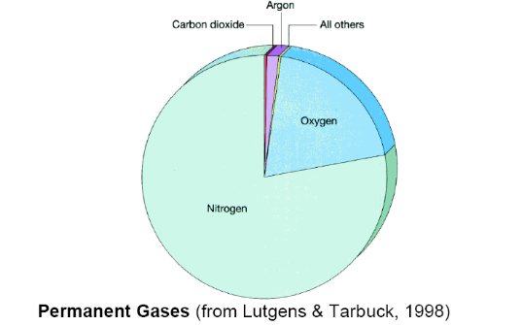

**The Atmosphere and Dynamic Equilibrium**

Explain how dynamic equilibrium is balanced in our atmosphere.

Many of the processes that aﬀect the atmosphere are interconnected. So, if one process is changed it can change other processes. This is important because it means that human actions can trigger a sequence of events where an action changes one process which causes other processes to alter as a direct result of the ﬁrst change. There is a lot that is yet to be discovered and understood about how atmospheric processes work so it is not possible to accurately predict the eﬀect of a human activity on speciﬁc atmospheric processes.

**Structure of the atmosphere**

Many features of the atmosphere change with altitude:

1. Temperature
2. Atmospheric pressure
3. Composition
4. Types of electromagnetic radiation absorbed

Draw a graph below showing the structure of the lower atmosphere.

Atmospheric pressure changes in the atmosphere. Label the zones of the atmosphere on the graph

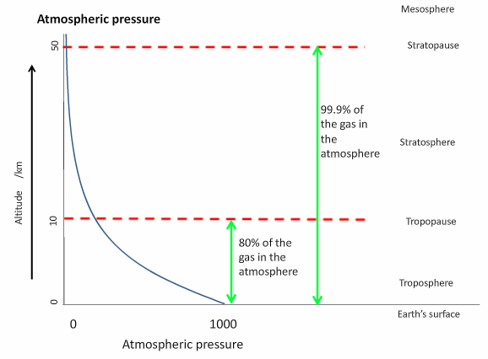

**Thermal Stratification in the Atmosphere**

Draw a graph below showing the changes in temperature within the atmosphere.

**Energy processes and the atmosphere**

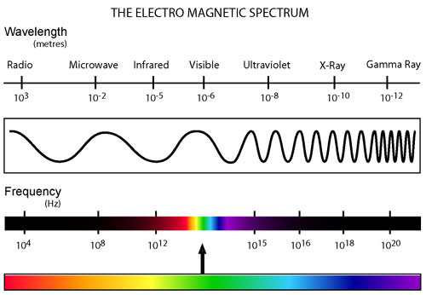The solar energy arriving at Earth and the energy being radiated to space are generally in a dynamic equilibrium. The wavelengths of electromagnetic radiation arriving are mainly ultraviolet, visible light, and near infrared.

The wavelengths of radiation leaving Earth mainly involve long wavelength and far infrared radiation. This energy, and the processes it drives, controls factors such as the climate, ocean currents, the hydrological cycle and therefore the distribution of species. Any human activities that aﬀect the movement of energy could aﬀect any of these factors and thus the survival of living organisms.

**Heating the Stratosphere**

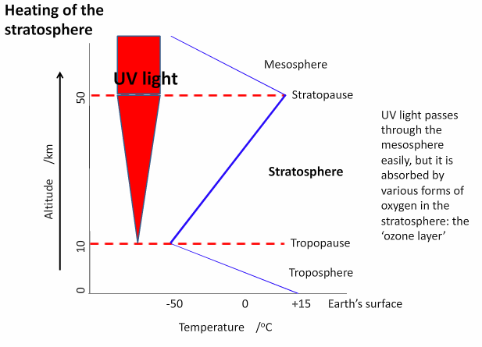

**Heating the Troposphere**

Add the annotations on the diagram below to explain how the troposphere is heated

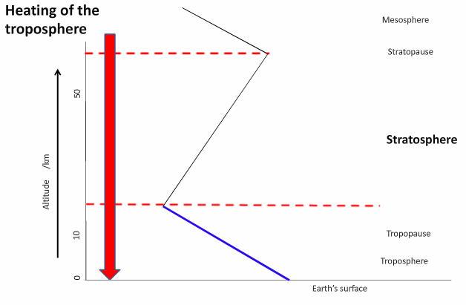

* All layers in the atmosphere are heated by energy that came from the sun.
* Different layers are heated in different ways
* The stratosphere is heated by UV light coming directly from the Sun
* The troposphere is heated by infrared energy radiated by the warm Earth’s surface, which was heated by visible light from the sun.

**Insolation**

Insolation is the term used to describe the amount and duration of incoming solar radiation

Complete the diagram below to summarise the energy budget on Earth due to incoming solar radiation.

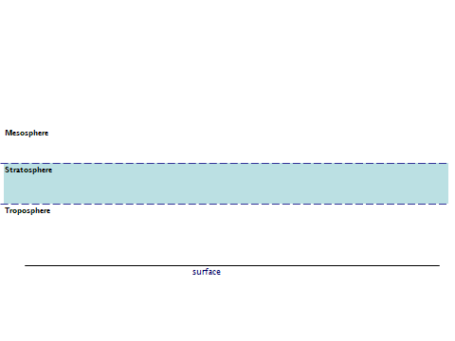

**Solar Radiation and the atmosphere**

Energy from the sun is generated through nuclear fusion.

THE SUN comprises of % hydrogen (H) and % helium (He)

Explain nuclear fusion below.

**Environmental importance of radiation in the atmosphere**

|  |  |  |
| --- | --- | --- |
| **Type of radiation** | **Wavelength** | **Environmental importance** |
| Ultraviolet  Radiation  (UV) | UVB  280-320nm  UVC  100-280  UVA  320-400nm | UVB  Prolonged exposure 🡪 sunburn, skin cancer (malignant melanomas). DNA mutations and stimulates cataracts, damages crops, marine organisms and materials    UVC  Kills bacteria and viruses.  Plants reflect UV radiation off their flowers to attract insects to pollinate them    UVA  Not absorbed by the ozone but human skin produces vitamin D (tanning) as a protection |
| Visible | 100-700nm | Plants and animals use colour for mating and defence  Photosynthesis uses the energy in visible light to fix CO2 into chemical energy |
| Infrared | 1mm-1cm | The Earth’s surface absorbs EMR and is heated up  Re-radiation is emitted from the surface in the form of infrared radiation, which heats the atmosphere as gases and particles absorb the radiation (Greenhouse Effect) |

**Albedo**

What is Albedo?

**Greenhouse effect**

The greenhouse effect is the natural phenomenon that controls the energy and heat balance of the earth’s surface and the atmosphere. The infra-red radiation emitted by the Earth’s surface is partly absorbed by gases in the atmosphere.

Human activities are increasing the concentration of gases that absorb IR, which is causing the atmosphere to warm up. This is the **enhanced greenhouse effect**.

**Table of main greenhouse gases and their sources**

|  |  |  |
| --- | --- | --- |
| **Gas** | **Human source** | **Natural source** |
| **CO2**  **(carbon Dioxide)** |  |  |
| **CH4 (Methane)** |  |  |
| **N20**  **(Oxides of nitrogen)** |  |  |
| **CFCs**  **(Chlorofluorocarbons)** |  |  |
| **O3**  **Tropospheric ozone** |  |  |

***Remember: Oxygen, Nitrogen and Sulfur dioxide are NOT greenhouse gases***

|  |  |
| --- | --- |
| **Gas** | **Approximate relative effect per molecule** |
| **Carbon Dioxide (CO2 )** |  |
| **Methane (CH4 )** |  |
| **Nitrous oxide (N20)** |  |
| **Ozone (O3) (troposphere)** |  |
| **CFCs** |  |

**Answer the following questions**

1. 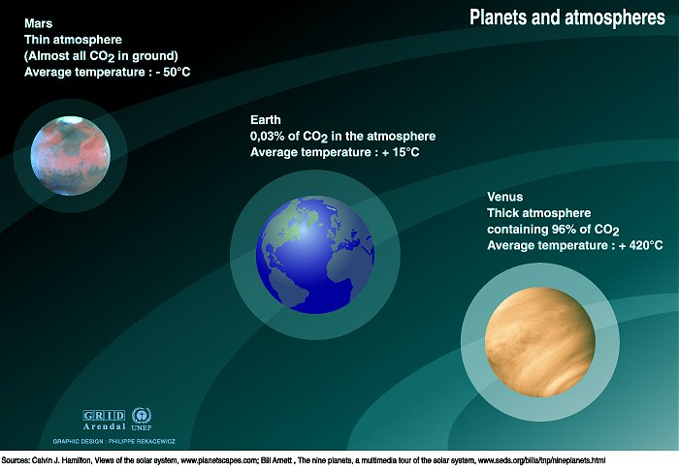What keeps the carbon dioxide in the atmosphere?
2. Describe the relationship between carbon dioxide in the atmosphere and mean temperature as shown in these planets.
3. What is the other major factor determining temperature?

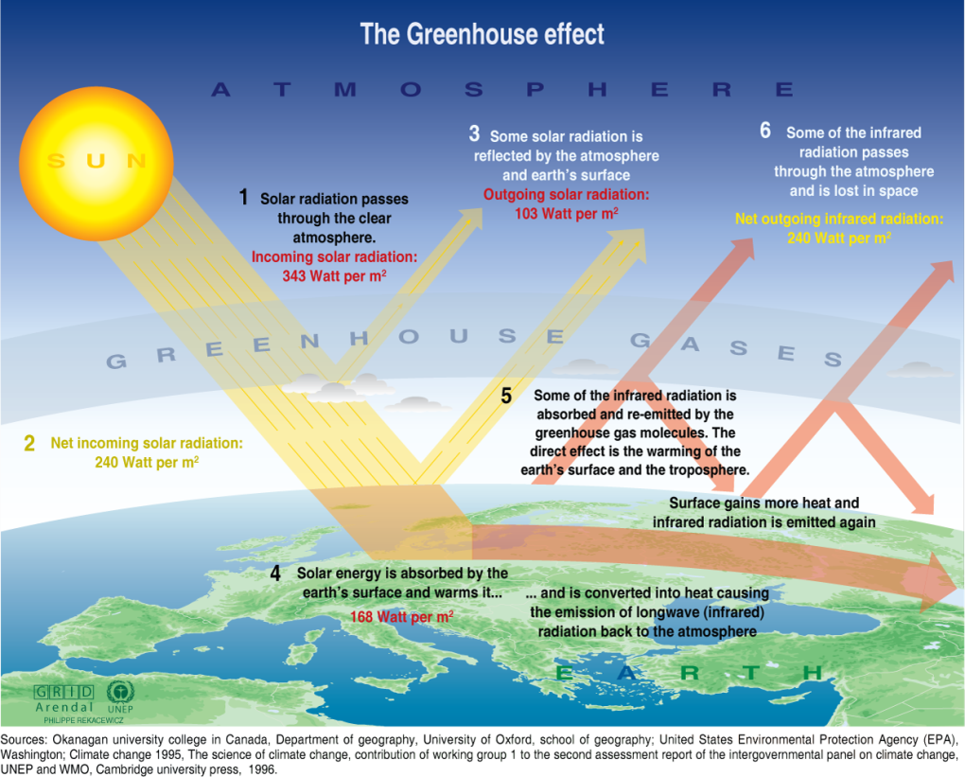

1. What is the difference between the radiation emitted from the surface of the Sun and that emitted from the surface of the Earth?
2. Why are they different?
3. Roughly what proportion of the incoming radiation from the Sun is actually absorbed by the Earth’s surface?
4. What has happened to the rest?
5. What is the effect of radiation when it is absorbed?
6. The Earth keeps receiving radiation from the Sun but it does not get hotter and hotter. Why?

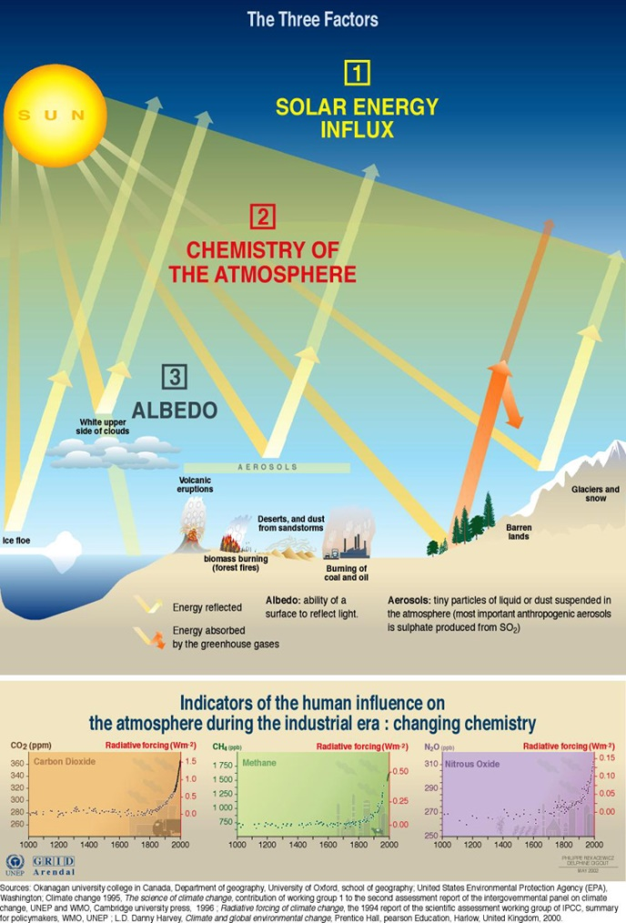

1. Why is the energy reflected by aerosols or glaciers and snow not absorbed by greenhouse gases?
2. Explain why an increase in the Earth’s albedo would reduce the IR radiation being emitted.
3. Explain why major volcanic eruptions usually lead to reduction in average global temperatures for a year or two.
4. Water is found in the atmosphere both as clouds and as water vapour, an important greenhouse gas. Explain how these two different forms of water have opposite effects on the emission of energy back into space.

**Consequences of Global Warming**

Using the research that has been done in your group make notes on each consequence of global warming. Use specific examples and include data/graphs/diagrams where relevant. (Reference Pg. 90-100 text book)

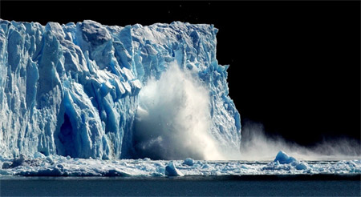

**Changes in the Cryosphere & Seal Level Rise**

Topics to include:

* Reduction in snow cover
* Loss of ice shelves
* Changes in ice thickness
* Ice lakes
* Ice & snow-fed rivers
* Thermal expansion of seawater (sea level rise)
* Melting land ice (sea level rise)

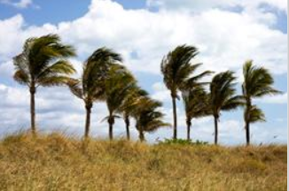**Changes in climatic processes**

Topics to include:

* Changes in rainfall
* Wind pattern changes

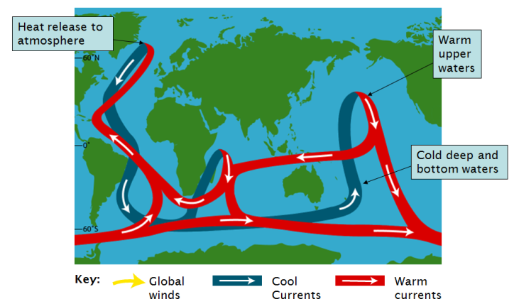**Changes in ocean current**

Topics to include:

* North Atlantic conveyor
* El Nino and La Nina
* Global impacts of El Nino events

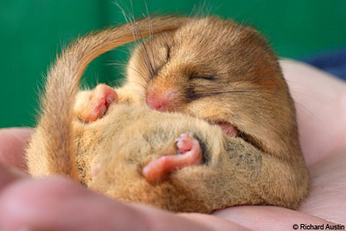**Ecological changes**

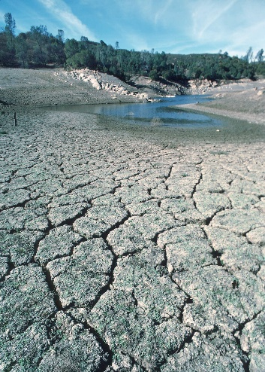**Impacts on Human Society**

Topics to include:

* Health
* Water supplies
* Food supplies
* Impacts on infrastructure

**Feedback mechanisms in global climate change**

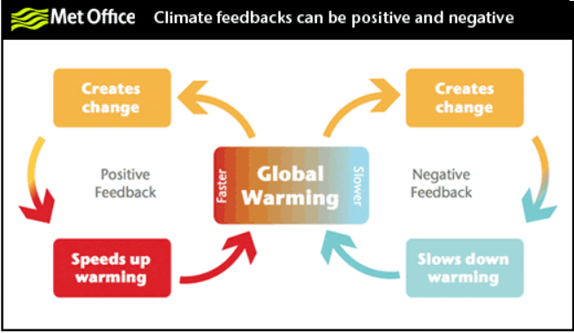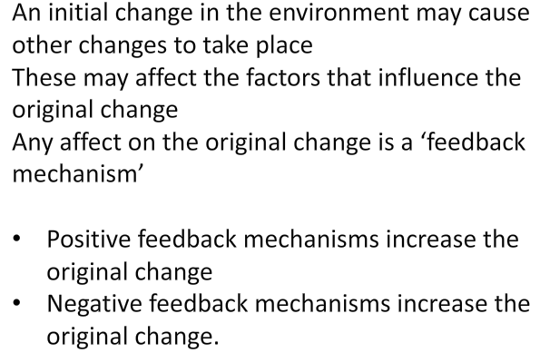

**Negative Feedback Mechanisms**



**Positive feedback mechanisms**



**Examples of Feedback Mechanisms**

In the space below outline different feedback mechanism and indicate whether they are positive or negative

**Runaway Climate Change**

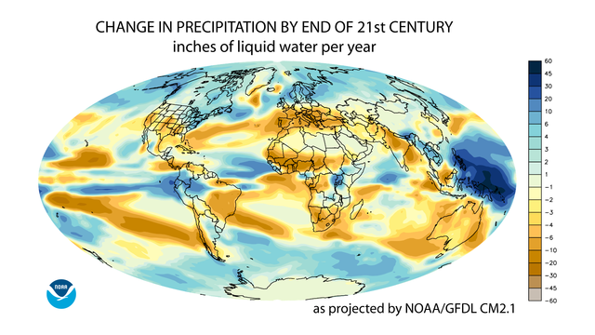**Predicting Global Climate Change**

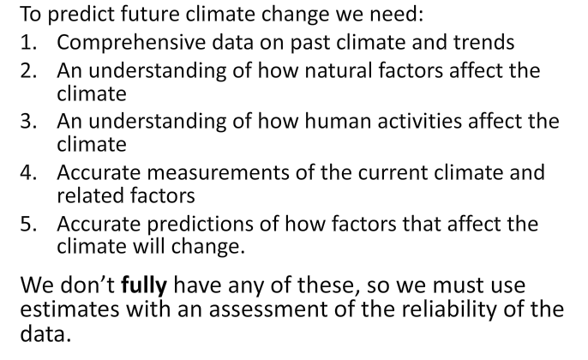

**Table to explain why it is so difficult to predict global climate change and why there are gaps in our knowledge about the processes involved.**

|  |  |
| --- | --- |
| **Gap in knowledge** | **Notes** |
| **Lack of understanding of natural processes** | Need quantitative data and know how large changes will be caused |
| **Lack of historical data** | Collection of climate data only in last 100 years  Most data collected in MEDCs  some data is unreliable (cities that grown and are urban heat islands)  some data nothing to do with global climate  Historical data is estimated using proxy data e.g. plankton sediment analysis, pollen grains and tree rings. |
| **Interaction of factors with different rates of change** | Rises in temp can produce different reactions which could lead to contradictory predictions  e.g.   * rapid change – warmer atmosphere * Slower changes – Greenland ice melting – North Atlantic Conveyer slows – much colder weather in UK |
| **How natural fluctuations occur** | Natural climate changes can occur due to:   * Short or long term changes in solar output * Impact of volcanic eruptions * Changes in the orbit of the Earth around the sun   We need understand how the Earth is changing naturally before analysing the human impact. |
| **Regional differences in change** | Different areas respond to changes at different rates e.g.   * Range edges – organisms living close to their limit of range of tolerance are more likely to be affected by small changes * Ice melting – ice which is only just below 0oC is more likely to melt than ice in areas such as Antarctica |
| **Secondary impacts & feedback mechanisms** | Even if we predict the direct consequences of an event, indirect consequences are harder e.g.   * How will stormier weather affect CO2 dissolving in the oceans? * How may changes in precipitation patterns alter vegetation growth? * How may changes in plant transpiration affect humidity and cloud cover? |

**Data Collection**

For each of the methods of collecting data below, research and explain how the data is collected and any limitations of collecting data in this way.

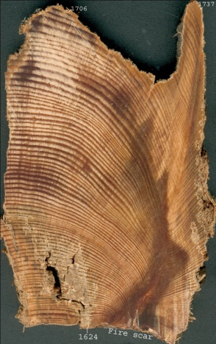

**Proxy Data:**

Dendrochronology

Coral species with large heads showing annual rings

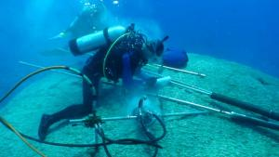

Scientists obtain coral cores from the largest known coral head on Earth at Ofu Island November 2011. Image Credit: [*Dr. Rob Dunbar.*](http://www.ted.com/talks/rob_dunbar.php)

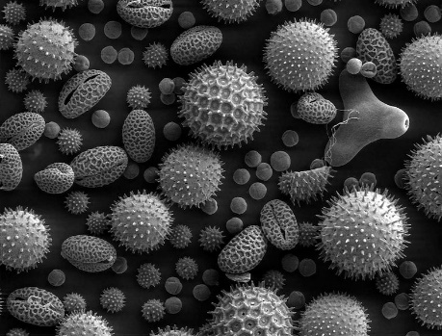Pollen grain preserved in sediment

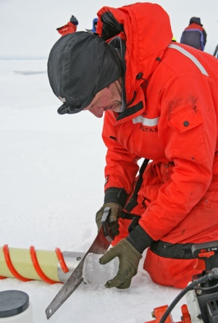**Ice core Data:**

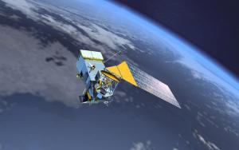**Satellite Data**

Artists’ concept of National Polar-Orbiting Operational

Environmental Satellite System (NPOESS) satellite. Image Credit: [*NOAA*](http://www.noaanews.noaa.gov/stories2008/images/npoess.jpg)

**Monitoring ocean currents**

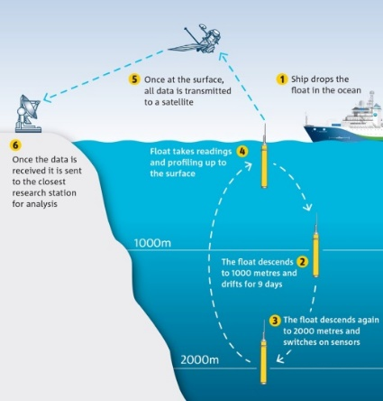

**Computer models**

**Control of global climate change**

**Strategies for controlling greenhouse gases**

There are two ways of approaching control of global climate change.

1. Through legislation/international agreements to protect climate e.g. Kyoto Protocol, Paris Agreement
2. Though reduction in emissions of anthropogenic greenhouse gases.

**Kyoto Protocol (1997)**

* An international agreement to reduce emissions of carbon dioxide and other greenhouse gases
* MEDCs sign up to treaty to reduce emissions of six greenhouse gases by 5.2% of 1990 emissions.
* 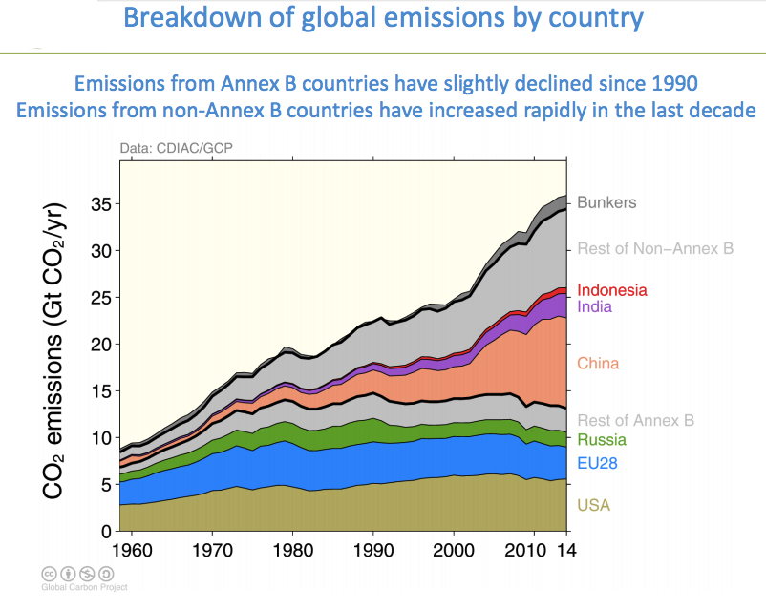LEDCs do not have legally binding emission limits
* Countries which sign agree to reduce their greenhouse gas emissions
* Gases covered include CO2, CH4, N2O, HFCs, PFCs, SF6

Each country has developed its own method to meet its target. The EU has identified

12 000 factories and power stations which have been given a carbon dioxide quota.

If they exceed this they can purchase extra allowances or pay a financial penalty. If they fall below the amount they can sell the extra quota.

**Why was Kyoto Abolished?**

The US refused to ratify the Kyoto protocol treaty as they argued that China didn't have to restrain its pollution at all and that US factories would just move overseas. George W. Bush formally withdrew from Kyoto in 2001. Later on, Canada failed to hit its targets and also withdrew, with no penalty.

Europe, Japan, and New Zealand did stay in the treaty, although it turned out to make little difference. In subsequent years, those poorer "non–Annex B" countries like China and India grew so fast and burned so much coal that global emissions soared. In the chart below, it's hard to see that Kyoto had any impact whatsoever.

**Paris Agreement (2015)**

This was a different approach as making lots of legally binding rules can make countries reluctant to join.

The deal was hammered out over weeks of tense negotiations in December 2015 and weighs in at [31 pages](http://chrome-extension/oemmndcbldboiebfnladdacbdfmadadm/http:/unfccc.int/resource/docs/2015/cop21/eng/l09.pdf). 196 countries have signed this agreement

Donald Trump has pulled the USA out of the Paris Agreement.

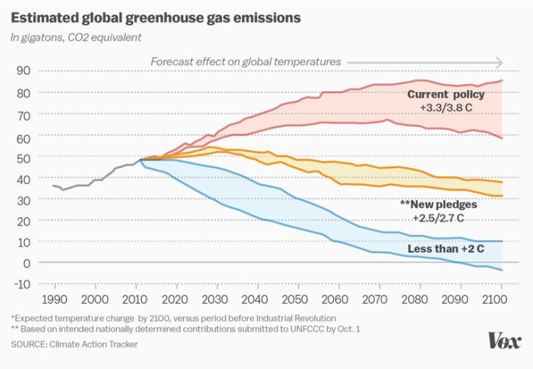**Key Elements of Paris Agreement**

1. To keep global temperatures "well below" 2.0C (3.6F) above pre-industrial times and "endeavour to limit" them even more, to 1.5C
2. To limit the amount of greenhouse gases emitted by human activity to the same levels that trees, soil and oceans can absorb naturally, beginning at some point between 2050 and 2100
3. To review each country's contribution to cutting emissions every five years so they scale up to the challenge
4. For rich countries to help poorer nations by providing "climate finance" to adapt to climate change and switch to renewable energy.

**COP26, Glasgow (2021)**

See your research on COP26

**Methods of reducing greenhouse gas levels**

|  |  |
| --- | --- |
| **Greenhouse gas** | **Method** |
| Carbon dioxide |  |
| Methane |  |
| Oxides of nitrogen |  |
| Chlorofluorocarbons |  |
| Tropospheric ozone |  |

**Carbon Storage**

**Carbon Sequestration –** afforestation will sequester carbon in wood through photosynthesis

**Carbon Capture & Storage** – technological processes that remove CO2 produced in industrial processes

Capture CO2 or removal of carbon from fuel

Transport by road tanker, ship or pipeline

Store in depleted oil fields, gas fields, aquifers

**Geoengineering** – untried technologies that might control processes to reduce greenhouse effect. But they could cause environmental damage.

Painting roofs white to increase albedo

Adding nutrients to seas to encourage plankton growth

Putting solar shields in orbit to reduce sunlight reaching the Earth

**Strategies to cope with climate change**

Climate change may require changes in lifestyle, infrastructure service and land use.

* Building design to cope with raised temperature or increase in storms
* Different crop species to cope with drier conditions
* Flood control
* Coastal erosion control
* Managed retreat
* Urban drainage control
  + Permeable urban surfaces
  + River flow management
  + Raised buildings
  + 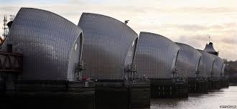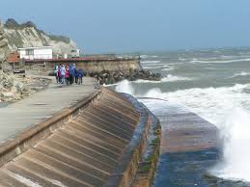Floating homes

**Ozone Depletion Assignment**

**Task:**

1. Research ozone depletion and make ***research notes*** under the headings below.
2. ***Produce a resource*** that you can use to revise from. (poster/presentation/podcast/article/revision cards)

You must ensure that the following topics are covered.

1. How is ozone formed? Include chemical equations.
2. How is ozone destroyed? Include chemical equations.
3. What are the effects of different types of UV on reaching Earth’s surface?
4. What is the Rowland-Molina hypothesis?
5. CFC’s: What are they? What are they used for? What is their role in ozone depletion (include chemical equations)?
6. What is the evidence for ozone depletion? Outline how the different methods of measuring data as evidence.
7. Why is ozone depletion greatest over Antarctica?
8. How has ozone depletion been restored? Give details of the Montreal protocol and its role in CFC reduction, including alternatives to CFC’s.
9. Evaluate the effectiveness of methods used to restore the ozone layer. Include a discussion on the successes and drawbacks to ozone restoration methods. Use data to support your arguments.

**Suggested links**

* National geographic - <https://www.nationalgeographic.com/environment/global-warming/ozone-depletion/>
* Environmental Protection Agency (USA) - <https://www.epa.gov/ozone-layer-protection>
* <http://www.s-cool.co.uk/a-level/geography/environmental-hazards/revise-it/ozone-depletion>
* DEFRA information on ozone - <https://uk-air.defra.gov.uk/research/ozone-uv/moreinfo?view=antarctic-ozone-hole>
* The ozone hole history – <http://theozonehole.com/ozoneholehistory.htm>
* National Science Foundation - <https://www.nsf.gov/about/history/nsf0050/arctic/ozonehole.htm>
* NASA – <https://www.nasa.gov/ozone>
* <http://www.ausetute.com.au/cfcozone.html>