**The Evolving Atmosphere**

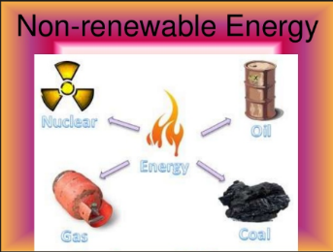**3.3 Energy Resources**

# 

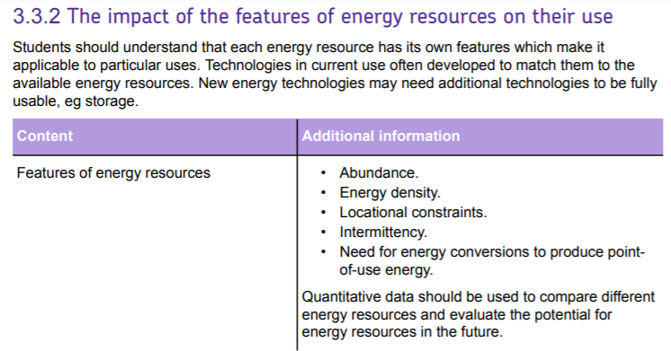

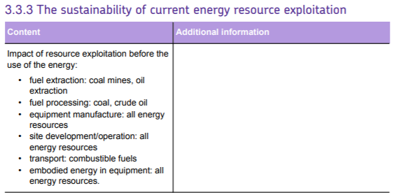

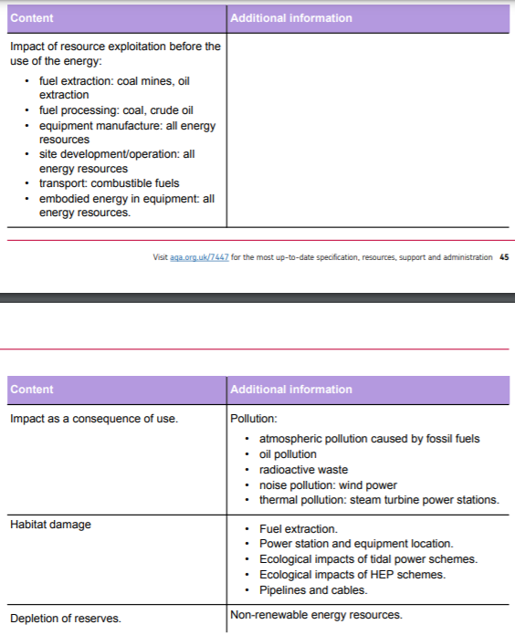

### INTRODUCTION TO ENERGY

#### The importance of energy supplies in the development of society

What were the early forms of energy used by humans?

|  |  |
| --- | --- |
| Source of energy | Use |
| Fire | Making pottery, clearing woodland |
|  |  |
|  |  |
|  |  |
|  |  |
|  |  |

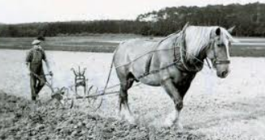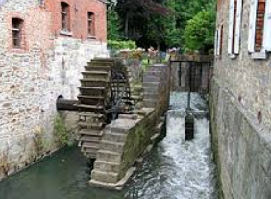

##### Factors affecting energy use

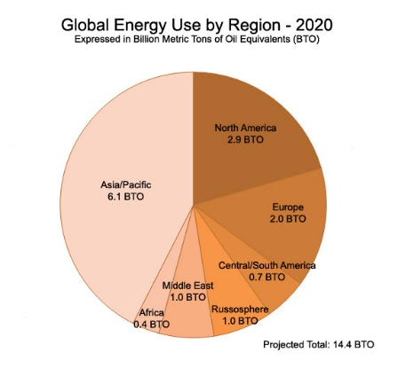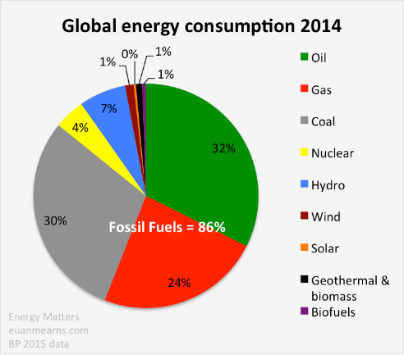Study the graph and pie diagrams below and then answer the questions below.

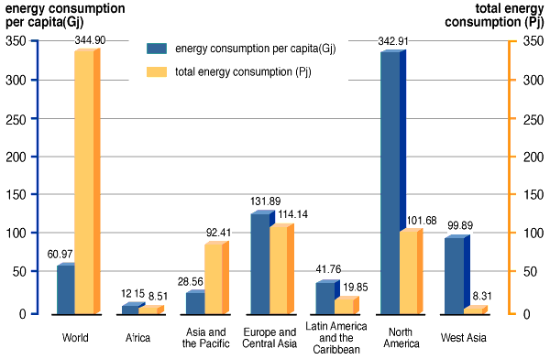

1. State two conclusions that you can reach from studying the graphs on world energy consumption?
2. What does per capita energy consumption mean?

#### Use the internet and your own ideas to help you answer the following questions

1. Why does an increase in per capita electricity consumption increase GDP (Gross domestic product – this is used to determine economic performance of a country)?

__________________________________________________________________________________________________________________________________________________________________

__________________________________________________________________________________________________________________________________________________________________

__________________________________________________________________________________________________________________________________________________________________

1. Why do you think **mortality rates reduce and overall health** in a country increases with an increase availability of electricity?

__________________________________________________________________________________________________________________________________________________________________

__________________________________________________________________________________________________________________________________________________________________

____________________________________________________________________________________________________________________________________________________________________________________________________________________________________________________________________________________________________________________________________

1. Why do you think levels of **education** in a country increases with an increase availability of electricity?

__________________________________________________________________________________________________________________________________________________________________

___________________________________________________________________________________________________________________________________________________________________________________________________________________________________________________

1. Why would an increase in energy availability increase agricultural production?

__________________________________________________________________________________________________________________________________________________________________

____________________________________________________________________________________________________________________________________________________________________________________________________________________________________________________________________________________________________________________________________

1. How does availability of energy affect national security?

__________________________________________________________________________________________________________________________________________________________________

____________________________________________________________________________________________________________________________________________________________________________________________________________________________________________________________________________________________________________________________________

**Factors which cause per capita energy consumption to change.**

Use the following headings to explain the factors which cause per capita energy consumption to change and give examples to illustrate your answer?

**Affluence**

………………………………………………………………………………………………………………………………………………………………………………………………………………………………………………………………………………………………………………………………………………………………………………………………………………………………………………………………………………

**Relative cost of energy**

……………………………………………………………………………………………………………………………………………………………………………………………………………………………………………………………………………………………………………………

**Type and level of industry**

…………………………………………………………………………………………………………………………………………………………………………………………………………………………………………………………………………………………………………………………………………………………………………………………………………………………………………………………………………………………………………………………………………………………………………………………………………………………………………

|  |  |  |
| --- | --- | --- |
| **Type of industry** | **Examples** | **General level of energy use per unit of economic output** |
| Primary industry | Agriculture, mining, raw material extraction | High |
| Secondary industry | Heavy manufacturing industry e.g. metal smelting, chemical industry  Light manufacturing industry e.g. car assembly | High  Medium |
| Tertiary industry | Services e.g. transport, finance, retail, recreation | Low |
| Quaternary industry | Information and IT | Very low |

**Social and environmental awareness**

……………………………………………………………………………………………………………………………………………………………………………………………………………………………………………………………………………………………………………………………………………………………………………………………………………………………………………………………………………………………………………………………………………………………………………………………………………………………………………………………………………………………………………………………………………………………………………………………………

**Climate**

………………………………………………………………………………………………………………………………………………………………………………………………………………………………………………………………………………………………………………………………………………………………………………………………………………………………………………………………………………

**How is energy used?**

1. How has increased mechanization increased productivity?

………………………………………………………………………………………………………………………………………………………………………………………………………………………………………………………………………………………………………………………………………………………………………………………………………………………………………………………………………………

1. How has energy increased fishing catches and made processing easier?

.………………………………………………………………………………………………………………………………………………………… …………………………………………………………………………………………………………………………………………………………

…………………………………………………………………………………………………………………………………………………………

1. How has energy allowed the extraction and processing of materials and what is the role of energy in service industries?

………………………………………………………………………………………………………………………………………………………………………………………………………………………………………………………………………………………………………………………………………………………………………………………………………………………………………………………………………………

1. Why is energy important to treat water for use?

.………………………………………………………………………………………………………………………………………………………… …………………………………………………………………………………………………………………………………………………………

…………………………………………………………………………………………………………………………………………………………

1. How is energy used in transport?

.………………………………………………………………………………………………………………………………………………………… …………………………………………………………………………………………………………………………………………………………

…………………………………………………………………………………………………………………………………………………………

1. In what ways do we use energy domestically?

.………………………………………………………………………………………………………………………………………………………… …………………………………………………………………………………………………………………………………………………………

…………………………………………………………………………………………………………………………………………………………

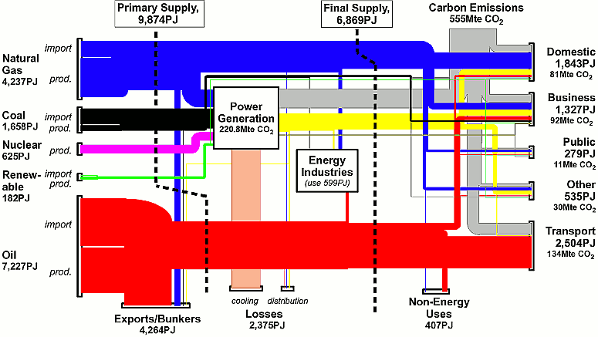**ENERGY USE UK 2007**

**LEFT HAND SIDE OF THE ABOVE CHART**

The above diagram shows the types of each energy source, the total amount of energy of each source in numbers as PJ and as size of each coloured energy bar across the page. An indication of how much of each source is Imported or produced is also given.

**RIGHT HAND SIDE OF CHART**

This shows what each of the fuels are finally used for.

**CARBON DIOXIDE EMMISSIONS**

Values for each fuel source are given with each use.

**READING FROM LEFT TO RIGHT ACROSS THE CHART**

This shows initially which sources and how much of each are used to create power ie electricity – see power generation box and where energy is lost through energy industry use, cooling and distribution and also some oil is exported.

**Answer the following questions**

1. Which energy source do we use the most?

……………………………………………………………………………………………………………………………………………………

1. What is this fuel used for?

……………………………………………………………………………………………………………………………………………………

1. Calculate the percentage of the primary fuels supplied by non-renewable energy sources?

……………………………………………………………………………………………………………………………………………………

……………………………………………………………………………………………………………………………………………………

……………………………………………………………………………………………………………………………………………………

……………………………………………………………………………………………………………………………………………………

1. Which fuels are used for the generation of power (electricity)?

……………………………………………………………………………………………………………………………………………………

……………………………………………………………………………………………………………………………………………………

1. Calculate the percentage of energy used in power generation that is lost as waste heat energy during this energy conversion.

……………………………………………………………………………………………………………………………………………………

……………………………………………………………………………………………………………………………………………………

……………………………………………………………………………………………………………………………………………………

……………………………………………………………………………………………………………………………………………………

1. Which energy use produces the most amount of carbon dioxide?

……………………………………………………………………………………………………………………………………………………

#### Why would a country’s per capita and total energy use change?

#### Think about industry/affluence and population size. How would changes in these factors affect energy use?

………………………………………………………………………………………………………………………………………………………………………………………………………………………………………………………………………………………………………………………………………………………………………………………………………………………………………………………………………………

………………………………………………………………………………………………………………………………………………………………………………………………………………………………………………………………………………………………………………………………………………………………………………………………………………………………………………………………………………

…………………………………………………………………………………………………………………………………………………………………………………………………………………………………………………………………………………………………………………………………………………………………………………………………………………………………………………………………………………………………………………………………………………………………………………………………………………………………………

Global energy use continues to rise as population and per capita use both increase. The slow growth or comparative stability of energy use in MEDCs may be misleading as the high energy use of the primary industry needed to support their economies may have moved to LEDCs.

A true assessment of per-capita energy use will include all uses of energy by the individual and the energy used in producing all the goods and services they use.

#### How would a shortage in energy resources affect a community?

………………………………………………………………………………………………………………………………………………………………………………………………………………………………………………………………………………………………………………………………………………………………………………………………………………………………………………………………………………

………………………………………………………………………………………………………………………………………………………………………………………………………………………………………………………………………………………………………………………………………………………………………………………………………………………………………………………………………………

…………………………………………………………………………………………………………………………………………………………………………………………………………………………………………………………………………………………………………………………………………………………………………………………………………………………………………………………………………………………………………………………………………………………………………………………………………………………………………

………………………………………………………………………………………………………………………………………………………………………………………………………………………………………………………………………………………………………………………………………………………………………………………………………………………………………………………………………………

**The impact of the features of energy resources on their use**

**Features of Energy resources**

Using the presentation off GOL, the text book or your own research, summarise the meaning of these features of energy resources

|  |  |
| --- | --- |
| **Feature** | **Explanation** |
| **Renewable/non-renewable** |  |
| **Depletable/non-depletable** |  |
| **Abundance** |  |
| **Locational constraints** |  |
| **Intermittency** |  |
| **Predictability** |  |
| **Energy density** |  |
| **Resource availability** |  |
| **Energy conversion to increase usefulness** |  |
| **Applicability to specific uses** |  |
| **Ease of storage** |  |
| **Ease of transportation** |  |
| **Technological development** |  |

**Political Influences**

Governments may decide to provide assistance to the energy industry using:

* to support the development costs of a new technology, e.g. grants for developing new renewable energy technologies;
* to increase national energy security, e.g. grants or tax reduction for oil exploration;
* to reduce environmental impacts, e.g. EU grants for low carbon technologies.

Research and complete the table below for each of the different energy resources. Use the tables of information in the presentation on GOL to help you fill in this table.

|  |  |  |  |  |
| --- | --- | --- | --- | --- |
| Property | Coal | Oil | Natural gas | Nuclear |
| How is the resource formed |  |  |  |  |
| How is the energy harnessed |  |  |  |  |
| Abundance globally |  |  |  |  |
| Locational constraints |  |  |  |  |
| Intermittency |  |  |  |  |
| Property | **Coal** | **Oil** | **Natural gas** | **Nuclear** |
| Predictability |  |  |  |  |
| Energy density |  |  |  |  |
| Ease of storage |  |  |  |  |
| Ease of transportation |  |  |  |  |

**The impact of the features of energy resources on their use**

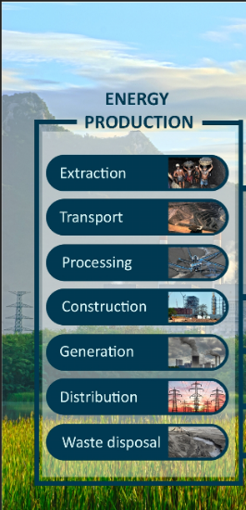

**Resource depletion**

Fossil fuels provide most global energy supplies but they are non-renewable. Their availability must decline in the future as reserves deplete.

New technologies and increased market prices may convert more of the resource into reserves so that they can be exploited, but the principle of resource depletion is still a controlling factor that must eventually restrict supplies.

**Environmental impacts**

All energy resource exploitation has an environmental impact but there are differences in the scale, type, and timing of the impacts.

Many environmental impacts are temporary, local or small, so they do not affect global sustainability. However, the combination of these impacts may be significant.

New technologies may be developed that will reduce environmental impacts, such as the ability to capture CO2 emissions, but it would be risky to commit to further large-scale fossil fuel use before the technique has been proven.

In the table below summarise the environmental impacts caused by different energy resources in the following categories for non-renewable energy resources

|  |  |
| --- | --- |
| **Impacts of non-renewable energy sources before they are used** | |
| **Process** | **Examples of energy resource and details of environmental impact** |
| Fuel extraction |  |
| Fuel processing |  |
| Site development |  |
| Transport |  |
| Waste disposal |  |
| **Impacts of non-renewable energy as a consequence of use of energy sources.** | |
| **Pollution** | |
| Atmospheric pollution |  |
| Oil pollution |  |
| Radioactive waste |  |
| Noise pollution |  |
| Thermal pollution |  |
| **Habitat damage** | |
| During extraction of the  energy resource |  |
| Power station and equipment  Location |  |
| Pipelines and cables |  |

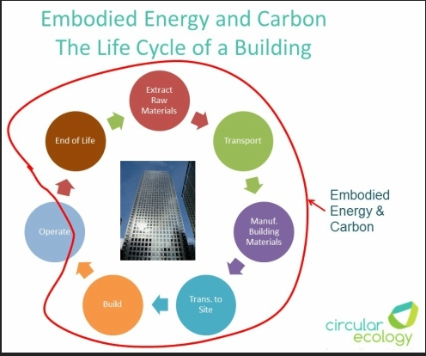**Embodied energy**

What does embodied energy mean?

Research a construction/building of your choice and list and explain the embodied energy in producing it.

_________________________________________________________________________________________________________________________________________________________________________________________________________________________________________________________________________________________________________________________________________________________________________________________________________________________________________________________________________________________________________________________________________________________________________________________________________________________________________________________________________________________________________________________________________________________________________________________________________________________________________________________________________________________________________________________________________________________________________________________________________________________________________________________________________________________________________________________________________________________________________________________________________________________________________________________________________________________________________________________________________________________________________________________________________________________________________________________________________________________________________________________________________________________________________________________________________________________________________________________________________________________________________________________________________________________________________________________________________________________________________________________________________________________________________________________________________________________________________________________________________________________________________________________________________________________________________________________________________________________________________________________________________________________________________________________________________________________________________________________________________________________________________________________________________________________________________________________________________________________________________________________________________________________________________________________________________________________________________________________________________________________________________________________________________________________________________________