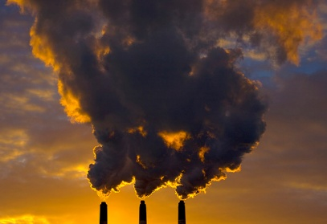3.4 Environmental Pollution

Atmospheric Pollution

**Syllabus content:**

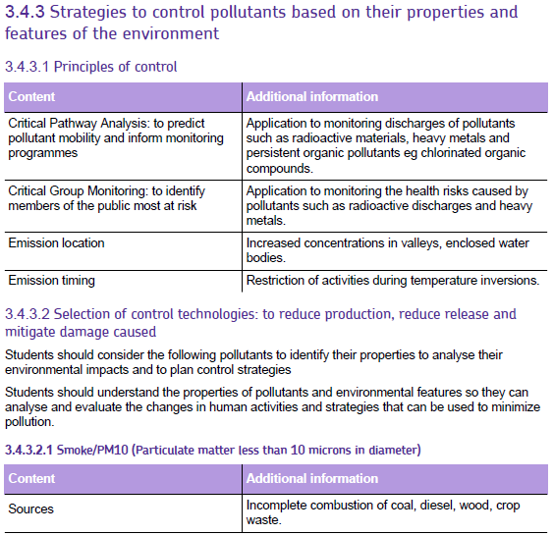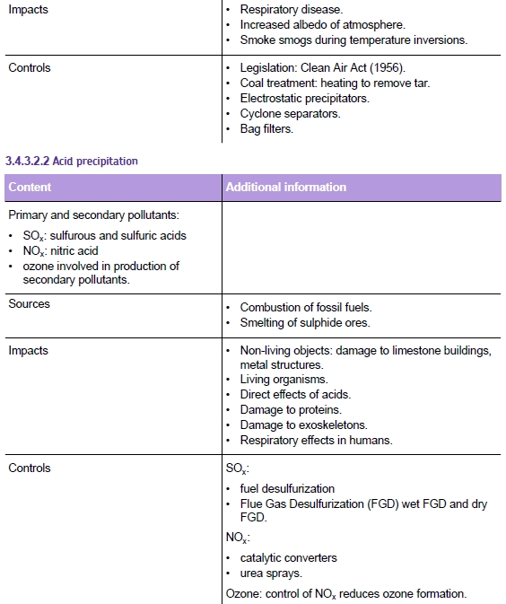

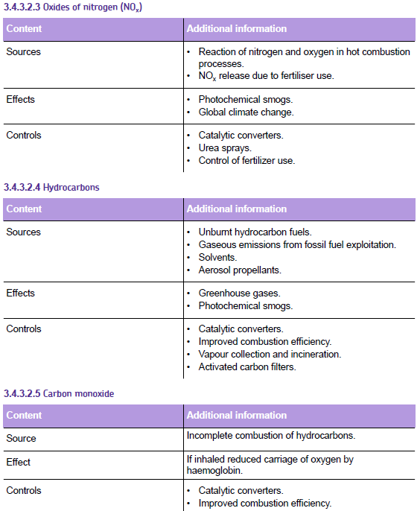

**Atmospheric Pollution**

Atmospheric pollution behaves very differently to water or ground pollution as it moves very rapidly by the wind and so can be carried over large areas; can interact with electromagnetic radiation from the sun; can interact with Infrared radiation from the earth.

**Acid Rain**

**Natural acidity of rain**

Normal unpolluted rainfall is *naturally acidic* (pH 5.6) as carbon dioxide will dissolve to produce a dilute solution of carbonic acid.

Acid rain includes snow, sleet, fog, cloud water and dew.

**Enhanced Acidity**

Acid rain usually refers to enhanced acidity produced by human activities. The table below summarise the main causes of acid rain.

|  |  |  |
| --- | --- | --- |
| **GAS** | **ACTION** | **MAJOR SOURCES** |
| Sulfur dioxide (gas) | Dissolves to form sulfurous acid (weak) | Combustion of coal & oil |
| Sulfur trioxide (gas) | Dissolves to form sulfuric acid (strong) | Oxidation of sulfur dioxide by ozone |
| Oxides of nitrogen (gas) | Dissolves to form nitric acid (strong) | High temperature combustion in power stations & petrol and diesel combustion engines. |
| Ozone (tropospheric) | Secondary pollutant that oxidises sulfur dioxide to sulfur trioxide | Photochemical reactions involving oxides of nitrogen & oxygen |
| Hydrogen chloride (gas) | Dissolves to form hydrochloric acid | Combustion of coal and incineration of wastes containing chlorine (e.g. PVC plastic waste) |

**Task:**

**Research the effects on acid rain and summarise your findings on a poster. Ensure that you indicate whether you effects are direct or indirect. Attach the poster to this booklet.**

**General strategies to control Pollution**

**Critical pathway analysis**

Used to predict the movement of pollutants and to plan monitoring programmes. It can’t be assumed that any discharge will be diluted and dispersed. In the atmosphere and water it can become re-concentrated. (Think & link – water cycle)

Mainly used for movement of radioactive materials released from a nuclear power station or waste processing site. Ensures that sites at most risk are sampled

**Factors to take into account:**

State of pollutant (s,l,g)

Properties of the pollutant

Density

Solubility in water/lipids

Chemical stability

Wind speed and direction

Geology – porosity /permeability

Features of the environment

Effect of pH and O2 on solubility

Temperature

**Ctitical group monitoring**

____________________________________________________________________________________________________________________________________________________________________________________________________________________________________________________________________________________________________________________________________

**Emission control strategies**

Control of emission location

* + Some choices may affect the severity of the pollution caused:
    - Marine discharges where water currents will dilute and disperse emissions.
    - Emissions downwind of urban areas
    - Not discharging waste onto permeable rock above an aquifer

Control of emission timing

* + Tidal cycle
    - emissions into incoming tide will carry upstream. Emission into outgoing tide will disperse them
  + Temperature inversions
    - Atmospheric emissions in a temperature inversion will not disperse. Restrict emissions in cities where temperature inversions are common

**Principles of pollution control**

**The polluter pays principle:**

____________________________________________________________________________________________________________________________________________________________________________________________________________________________________________________________________________________________________________________________________

**The precautionary principle:**

____________________________________________________________________________________________________________________________________________________________________________________________________________________________________________________________________________________________________________________________________

**Selection of control**

|  |  |
| --- | --- |
| **Control method** | **Example** |
| Production prevention | Desulfuristion of fossil fuels |
| Prevention of release | Electrostatic precipitators for smoke control  Catalytic converters for NOx, CO and hydrocarbons |
| Post-release prevention | Oil spill clean-up methods  Phytoremediation of land contaminated with heavy metals |
| Alternative processes | Use of electric vehicles instead of diesel or petrol  Using pyrethroid pesticides instead of more polluting organochlorides (e.g. DDT)  Using renewable energy sources |

**Efficiency of pollution control**

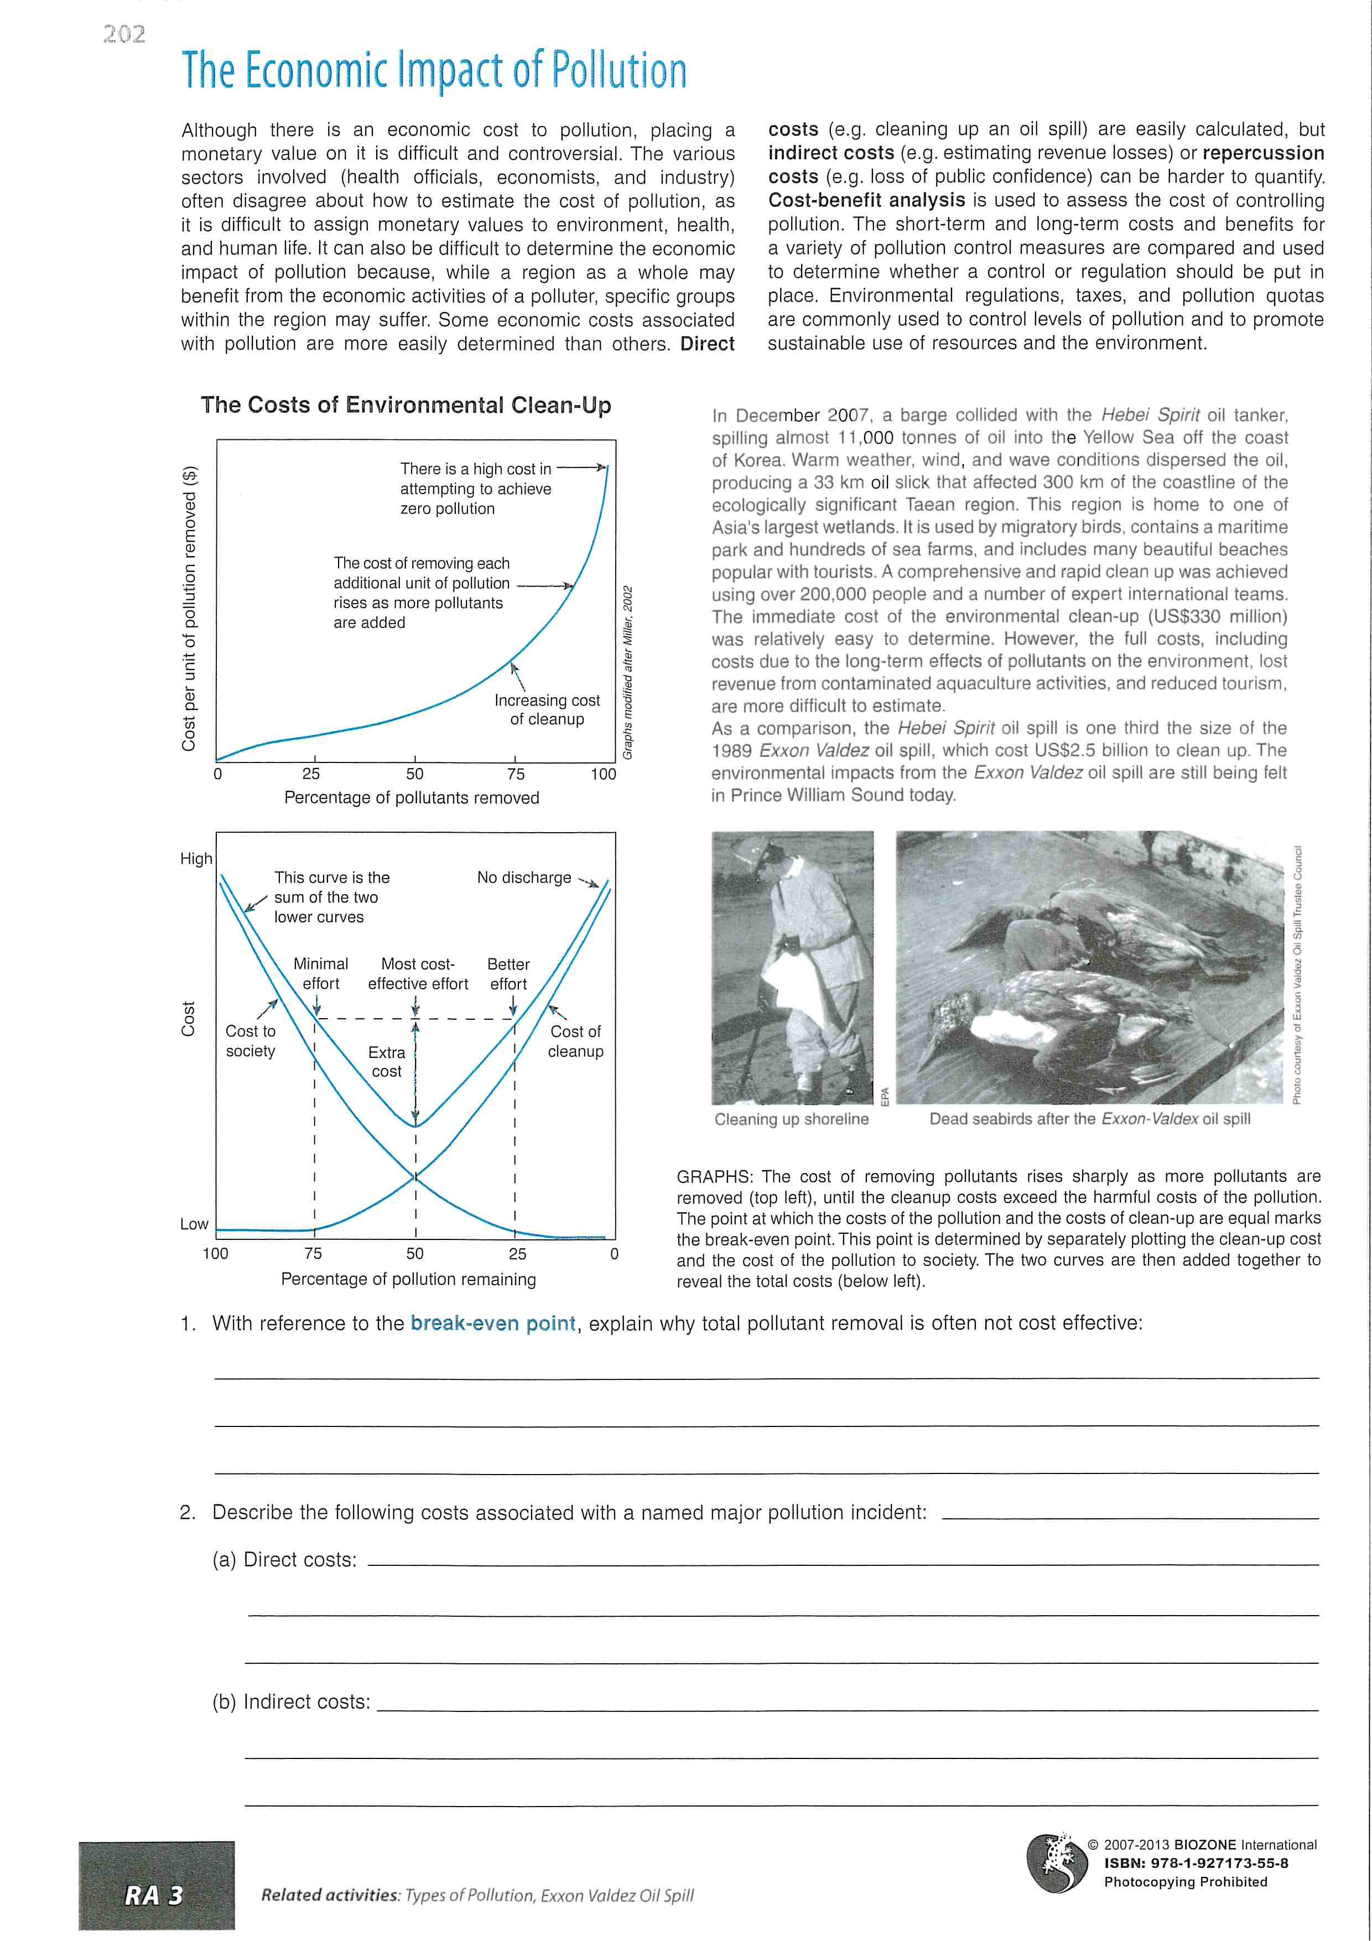Explain the economic principle behind the cost of removing pollutants using the graph.

______________________________________________________________________________________________________________________________________________________________________________________________________________________________________________________________________________________________________________________________

**Control of Acid Rain**

**Control of oxides of sulfur**

Ways to reduce sulfur dioxide in waste gases. For each method explain how it works and include any relevant equations

1. **Natural gas desulfurisation:**
2. **Crude oil desulfurisation:**
3. **Coal desulfurisation:**
4. **Dry flue-gas deslfurisation (dry FGD)**

Label the diagram below.

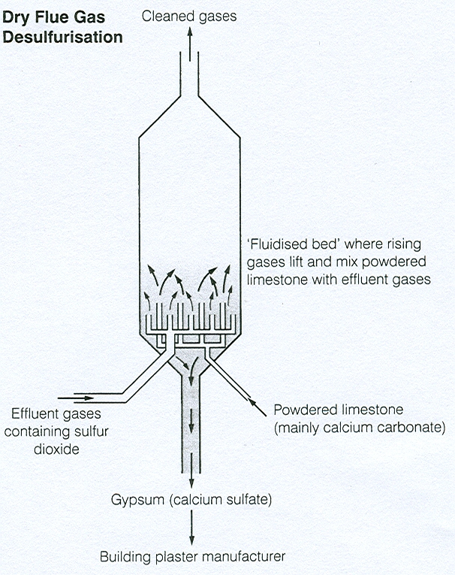

What waste product is produced by dry flue gas desulphurisation and can it be used for?

1. **Wet flue-gas desulfurisation (wet FGD)**

Explain the basic details of wet flue gas desulphurisation and label the diagram below.

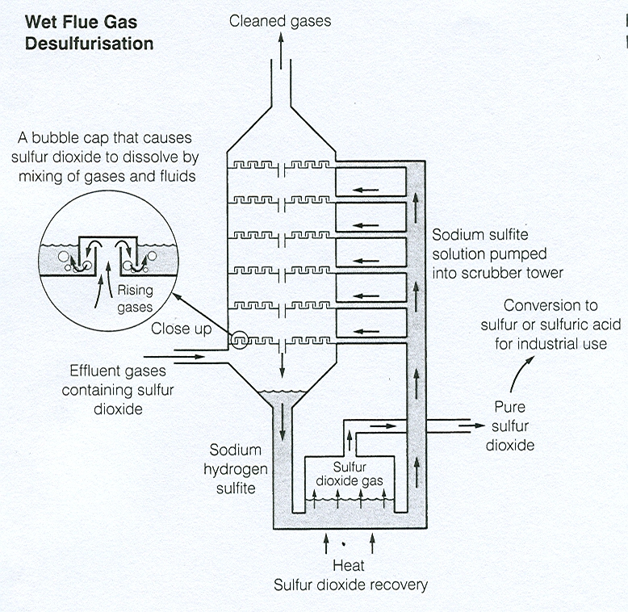

What waste product is produced by dry flue gas desulphurisation and can it be used for?

**Control of oxides of nitrogen**

Ways to reduce nitrogen oxides (NOx) in waste gases. For each method explain how it works and include any relevant equations

1. **Low temperature combustion**
2. **Catalytic converters**
3. **Urea sprays**

**Smoke Pollution and Smogs**

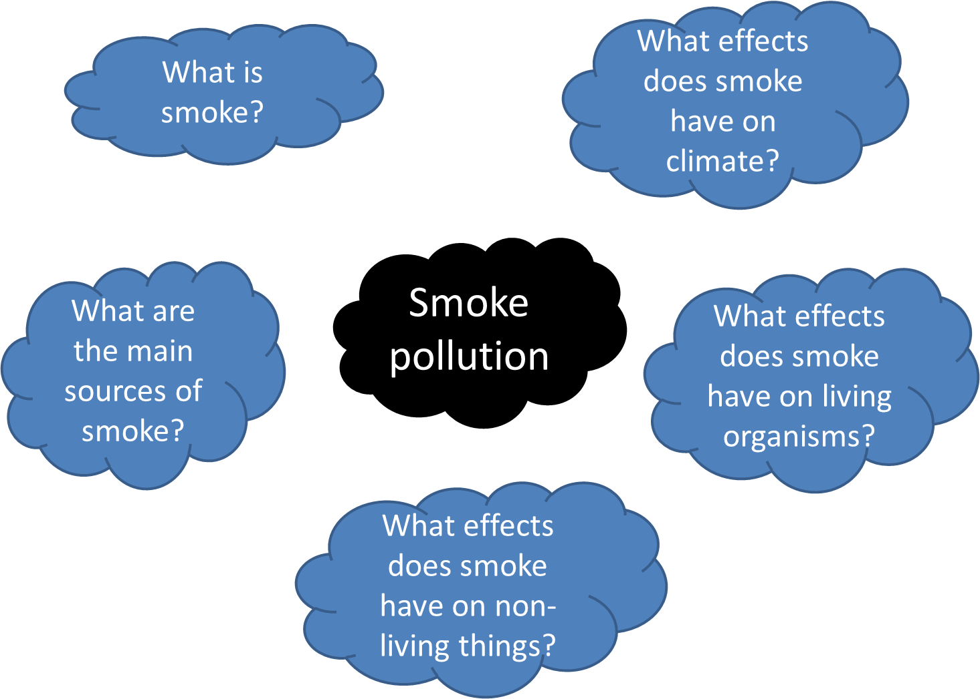

**Smoke Smogs**

Smog is an interaction between smoke and fog.

Fog is formed when moist air is cooled so water vapour condenses forming a layer of airbourne droplets of water.

**Fog + smoke = Smog**

**The great London smog of 1052 – Case Study**

* During the smog in London in 1952 over 4000 people died of respiratory problems in a single week. This led to the Clean Air Act (1956) being introduced.
* This allowed local authorities to ban the release of excessive smoke and the burning of smokey fuel in urban smokeless zones where smoke control orders had been made.

Watch the video about the great London smog and in the space below make notes on the causes and effects during this time.

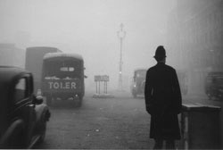

**Control of Smoke Pollution**

Ensure you have explained how each of the following control measures reduce smoke pollution:

**Legislation:**

____________________________________________________________________________________________________________________________________________________________________________________________________________________________________________________________________________________________________________________________________

**Domestic sources:**

____________________________________________________________________________________________________________________________________________________________________________________________________________________________________________________________________________________________________________________________________

**Transport sources:**

____________________________________________________________________________________________________________________________________________________________________________________________________________________________________________________________________________________________________________________________________

**Industrial sources:**

**Electrostatic precipitator:**

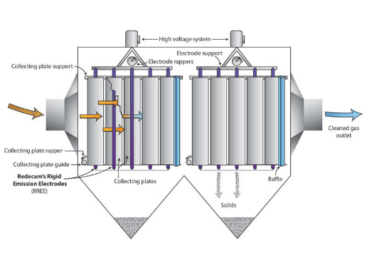

____________________________________________________________________________________________________________________________________________________________________________________________________________________________________________________________________________________________________________________________________

__________________________________________________________________________________________________________________________________________________________________

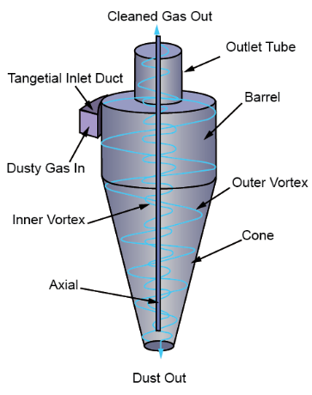**Cyclone separator:**

________________________________________________________________________________________________________________________________________________________________________________________________________________________________________________________________________________________________________________________________________________________________________________________________________________________________________________________________

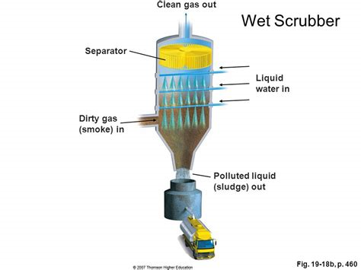**Scrubber:**

________________________________________________________________________________________________________________________________________________________________________________________________________________________________________________________________________________________________________________________________________________________________________

**Coal treatment:**

____________________________________________________________________________________________________________________________________________________________________________________________________________________________________________________________________________________________________________________________________

**Bag filters:**

____________________________________________________________________________________________________________________________________________________________________________________________________________________________________________________________________________________________________________________________________

**Tropospheric ozone and Photochemical Smogs**

Photochemical smogs involve a wide variety of reactions between primary and secondary pollutants in the presence of sunlight including UV light

**Tropospheric ozone**

Tropospheric ozone is a secondary pollutant produced by chemical reactions with primary pollutants released due to human activities

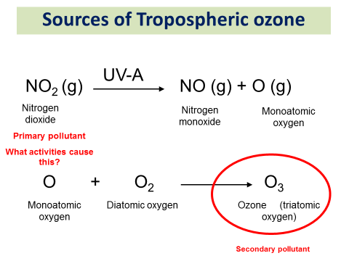

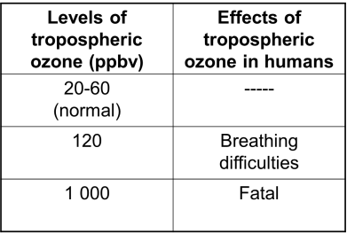**Effects of ozone:**­­­­­­­­­­­­­­­­­­­­­­­­­­­____________________________________________________________________________________________________________________________________________________________________________________________________________________________________________________________________________________________________________________________­­­­­________

**Photochemical smog**

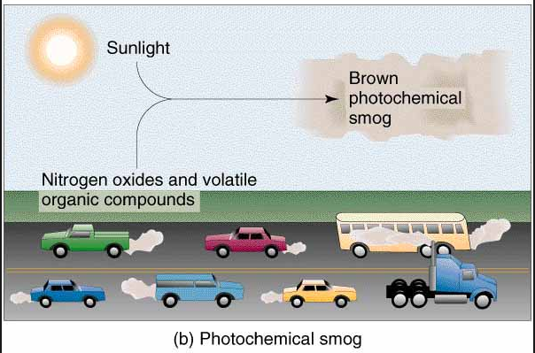

Like smoke smogs, these are caused by a build up of atmospheric pollutants, often when there is a temperature inversion. They involve the chemical reactions of vehicle exhaust emissions during *sunny* conditions, usually with a *temperature inversion* that causes the pollutants to become more concentrated. The word ‘smog’ is misused here are photochemical smogs do not involve smoke or fog.

**Formation of photochemical smogs**

Write the equation below that are involved in producing PANs and explain how they occur:

**Equations**

Explanation of how PANs are formed:

________________________________________________________________________________________________________________________________________________________________________________________________________________________________________________________________________________________________________________________________________________________________________________________________________________________________________________________

**Effects of PANs**

________________________________________________________________________________________________________________________________________________________________________________________________________________________________________________________________________________________________________________________________________________________________________________________________________________________________________________________

**Control of photochemical smogs**

Summarise below the main ways in which photochemical smogs can he reduced.

________________________________________________________________________________________________________________________________________________________________________________________________________________________________________________________________________________________________________________________________________________________________________________________________________________________________________________________________________________________________________________________________________________________________________________________________________________________________________________________________________________________________________________________________________________________________________________________________________________________________________________________________________________________________________________

________________________________________________________________________________________________________________________________________________________________________________________________________________________________________________________________________________________________________________________________________________________________________________________________________________________________________________________

**Research**

* + Which cities tend to be affected? What do they have in common?
  + What are the effects on people and living things?
  + Can you find a news story to illustrate these ideas?

**Lichens as Biotic Indicators of Pollution**

**Research:**

* What are lichens?
* What basic types of lichen are there?
* What is a biotic index?
* What features of a species are needed to be a good biotic indicator?
* How can lichens be used to measure pollution?

