**Our smartphone addiction is costing the Earth**

By [David Nield](https://www.techradar.com/author/david-nield) August 04, 2015

The phone ads aren't telling you everything

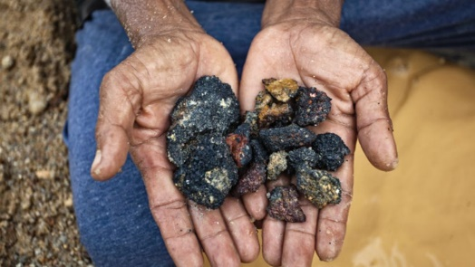What's inside your handset?

It never leaves your side. Your whole life is contained in its circuits. You researched its purchase more thoroughly than anything you've bought apart from your house or car. But how much do you actually know about your smartphone?

From graphite in the battery to the silicon of the processor, there are dozens of of metals, minerals and compounds inside every phone.

Some of them are only present in tiny quantities (for example, the very thin layer of indium tin oxide that makes your screen work as a touchscreen) but all of them have to be extracted from the Earth before being assembled into your handset.

The mining and manufacturing processes have very real environmental consequences. As our appetite for new mobiles grows, so too does the impact on the world and its occupants.

And these are finite resources, meaning that the more we want, the less we have. So what exactly goes into a smartphone, and how do we get it? How much of it is left, and what happens when we run out?

**What goes into your smartphone**

Building up a definitive list of every material inside your smartphone is difficult due to tightly protected trade secrets and variations between makes, models and manufacturers, but it's possible to build up a general picture.

Overall, a smartphone handset consists of around 40% metals (predominantly copper, gold, platinum, silver and tungsten), 40% plastics and 20% ceramics and trace materials.

According to the Minerals Education Coalition, a baby born in the US today will use up 539 lbs of zinc, 903 lbs of lead and 985 lbs of copper during his or her lifetime, not just in phones but in other gadgets and appliances too. In terms of environmental drain from every smartphone that's made, you can add the oil used to produce plastics, the sand used to produce glass, and so on.

Calculating the environmental cost of a smartphone isn't easy (Source: Friends of the Earth)

Of the 83 stable and non-radioactive elements in the periodic table, at least 70 can be found in smartphones. According to the best available figures, a total of 62 different types of metals go into the average mobile handset, with what are known as the rare Earth metals playing a particularly important role. Of the 17 rare Earth metals, 16 are included in phones.

Neodymium, terbium and dysprosium, for example, are three of the rare Earth metals: they give your phone the power to vibrate, so smartphones could be made without them – but you'd have to rely on your ringtone. Terbium and dysprosium are also used in tiny quantities in touchscreens to produce the colours of a phone display.

In this case, "rare" doesn't necessarily mean in short supply, but they aren't plentiful either – they're spread out in small reserves in many different places on the planet, and extracting them can be tricky and time-consuming. And once they've been extracted, that's it: we only have a finite amount of them, and there are no adequate replacements.

Phones are getting faster and bigger, but at what cost?

In 2013, [academics at Yale University looked at the 62 metals and metalloids inside smartphones, and rated their possible replacements](http://news.yale.edu/2013/12/02/metals-smartphone-age-no-plan-b): not a single replacement was "just as good" and 12 had pretty much no effective replacement at all.

"We all like our gadgets; we all like our smartphones," said study co-author Barbara Reck at the time. "But in 20 or 30 years, will we still have access to all the elements necessary to provide the particular functions that make a smartphone so great? Based on our findings, it is unlikely that substitution alone can solve potential supply restrictions for any of the metals on the periodic table."

Smartphone production as we know it isn't about to grind to a halt for a few decades yet, but the Yale findings are a shot across the bows of the industry.

Improvements are needed in opening up new resources, recycling existing materials and researching alternatives if we're to avoid a return to low-tech handsets without the features we've come to rely on.

Dysprosium reserves, for example, might last as long as 2050 – but it's also possible that they'll run out by 2020. And if they do, then the 2019 iPhone might have to last you longer than you think.

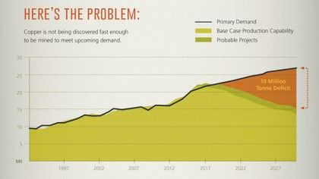The crunch on copper supplies (Source: Visual Capitalist)

A whole host of factors need to be taken into account when making these predictions – prices, demand, mining technologies, new reserves – but some of the estimates are alarming: we could be low on copper by 2050 and low on gold even earlier.

"One can anticipate increased pressure on metal supplies over the next few decades," says Professor Thomas Graedel of Yale, one of the academics looking closely at metal production and future approaches to the way we use it as a society. "Criticality constraints are thus multifaceted, and evolving."

In other words, supplies of smartphone materials depend not only on how much of the stuff is buried in the Earth, but also on how great the demand for it is and the technology available to extract it – and those factors are changing constantly.

That's why you can read about a metal being in short supply one year and abundantly available the next. As Graedel puts it: "Corporations, national governments, and resource sustainability experts have different goals, different perspectives, and different time scales."

This means no one has a definitive answer on how long our reserves of these materials are going to last – but most agree we need to be doing something about it.

## Mining processes and their impact

Some metals, like iron and aluminium, are available in such large quantities that there's no squeeze on their availability. For others, the problem is potentially more acute – copper is among the three most-used metals in the world, essential for smartphones, desktop computers, industrial machinery, green energy initiatives and much more.

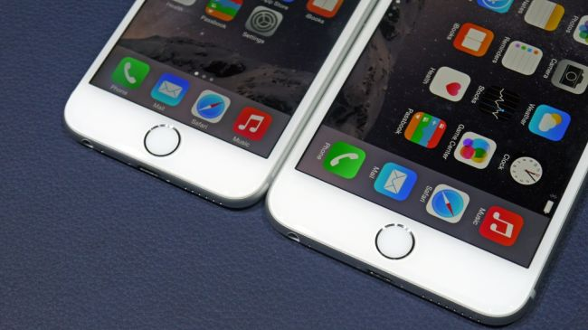Copper wiring is used in most electronic gadgets

Unfortunately, copper isn't being discovered fast enough to keep up with demand. The lead time for a new copper mine stands at around 20 years due to the difficulty of exploring new sites, fluctuations in the price (and therefore commercial viability) of mining the metal, various regulatory restrictions from local governments, and several other factors.

The quality of copper extracted from some of the major mines in the world is falling off rapidly, and it may be some time before the price rises high enough for other mines to be commercially viable – for the last year the copper price has been fairly flat as it bubbles under the $3 per pound mark, but experts estimate it needs to get up to $3.50 before there's enough financial incentive to create new mines (and it's difficult to predict when this will be).

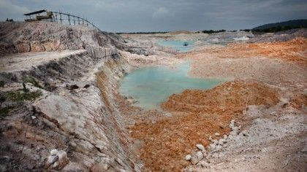Once you start investigating the metals and minerals that go into your smartphone, there's more to consider than just how much of this stuff is left underground. The way it's extracted, the impact of the mining, the wage of the workers and the way the mining profits are used all have an influence on production and thus the cost and environmental footprint of your smartphone.

Mining can leave a scarred landscape in its wake (Source: Friends of the Earth)

For example, copper is mined in Chile, the United States, Peru, Australia, Russia, Indonesia, Canada, Zambia, Poland, Kazakhstan, Mexico and China – in fact a lot of smartphone materials are sourced in China, via companies that have traditionally been reticent to reveal too much about their methods.

That means many different people, organisations and governments are involved in just the first step of the supply chain.

On top of that you can add manufacturers, logistics firms, high street retailers and many other agencies. The pressures on all these companies affect the final product you get in your hand – how much it costs, which materials were chosen, and the environmental impact production.

In Friends of the Earth's 2013 [Make It Better](http://www.foe.co.uk/what_we_do/make_it_better_about_37804) campaign, the charity looked at some of the environmental and social impacts of tin mining across the world. In Bangka, Indonesia, excessive tin mining was found to have dramatically changed the natural landscape, leaving acidic craters in place of lush forests and making clean drinking water harder to come by.

"In general refurbishing and recycling phones is a good 'mining prevention strategy'," Evert Hassink from Friends of the Earth tells us. "The problem is that most [smartphone metals] can be found but at higher financial, ecological and social cost."

We ask for supply chain transparency to motivate brands to feel responsible for the materials and components they purchase," he says. "We would like to see electronics that can be repaired and upgraded... And as mining is here to stay, it is also important for governments and companies to impose strict regulations, even if this makes metals and minerals more expensive."

Phone makers are increasingly being asked to take accountability for their supply chain, and that usually means a rise in prices – ensuring a fair wage for workers, reducing environmental impact, and expanding accountability programmes all cost money.

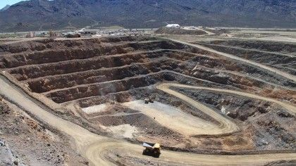The Molycorp mine in California (Source: Molycorp)

Firms such as Molycorp have worked to mine rare Earth metals in as green a way as possible, "maintaining workplaces that are safe, efficient and managed with environmental sustainability in mind," in the company's own words - but, in a sign of how difficult the whole process is, the firm's mine in California hasn't proved to be economically viable.

Trying to put together a responsible mining process means looking at everything from dealing with waste products to following the profits trail.

This can lead to some troubling and violent places, in the case of conflict minerals – that is, minerals mined in conditions of armed conflict and human rights abuses, and sold or traded by armed groups.

This is an issue particularly associated with the Democratic Republic of Congo, where the various parties in the longstanding civil war have commandeered resources to fund their violent activities.

Increased consumer and government interest means the big names are now taking these issues very seriously indeed, [as we reported last year](https://www.techradar.com/news/world-of-tech/ethical-electronics-how-apple-intel-and-more-are-stamping-out-conflict-minerals-1227728). Laws are being passed, organisations are being established, and steps are being taken to make sure rare Earth metals and other smartphone materials are sourced with environmental and ethical responsibility in mind.

## Changing approaches

There are several approaches to easing some of the strain that smartphone production puts on the Earth: making sure each phone lasts longer is a key one, as is improving the efficiency of recycling processes so we can get more of the raw materials back.

Modular phones such as Google's Project Ara could ease the pressure on natural resources

Initiatives such as the [Project Ara](https://www.techradar.com/news/phone-and-communications/mobile-phones/project-ara-your-next-smartphone-is-one-you-ll-build-yourself-1242390) modular smartphone aren't just quirky experiments. They could make a real difference to the life cycle of each phone, because outdated components can be swapped out and recycled rather than thrown away.

Apple is the brand shouting the loudest about its environmental credentials. Its suppliers aren't all certified as conflict-free, but the company is working on it: currently nine out of every 10 smelters in Apple's supply chain have been verified as conflict-free or are undergoing audits, and the number is growing. In 99% of the countries where Apple sells goods, there's an [official recycling programme](https://www.techradar.com/news/computing/apple/apple-will-now-recycle-all-your-old-dead-apple-swag-1244188) too.

Other companies have made similar commitments, though the situation is still far from perfect, and a commitment doesn't always equate to a reality. HTC, Samsung, LG, Sony and Motorola all have environmental policies, which they have published online.

Working with non-profits like the EICC (Electronic Industry Citizenship Coalition), all have signed up to meet certain standards in worker rights, environmental impact and transparency.

These moves are certainly an added cost for manufacturers, and may delay the process of getting a smartphone from the drawing board to your pocket, but keep them within internationally-agreed limits on how phones are produced: the EICC guidelines cover everything from greenhouse gas emissions to the use of bribes.

The majority of these guidelines are voluntary, though some legislation is involved - the Dodd-Frank Act in the US requires that firms "make efforts" to determine the source of their gold, tin, tungsten and tantalum.

Apple provides details about where its materials come from (Source: Apple)

One of the loudest voices on the topic is also one of the smallest companies: Fairphone began life as an awareness campaign in 2010, but eventually realised the best way to make a difference would be to build its own devices. The Fairphone 2 comes out later this year.

Fairphone doesn't want to sell a bucketload of handsets, but it does want to change the way the big companies think about smartphone manufacture in four key areas: mining, design, manufacturing and life cycle.

"We're really trying to influence and inform customers... and trying to look at changing behaviour," says Fairphone's Tessa Wernink. "I think the last couple of decades have been instrumental in shaping our world from a technology point of view, but then we've come to a point where we're able to see some of the mess that has been created along the way."

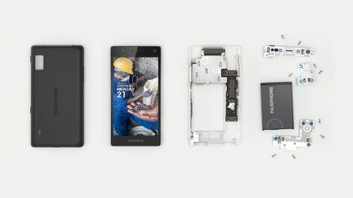

The Fairphone 2 is an ethical alternative to standard smartphones (Source: Fairphone)

Even for an organisation as committed to change as Fairphone, tracing materials through the supply chain isn't easy, and involves approaching it from both ends of the process: the mining of raw materials and the finished smartphone.

"We're currently in the process of mapping the whole supply chain for the four conflict materials – tin, tantalum, tungsten, and gold," Fairphone's Bibi Bleekemolen tells us.

"Going further, of course there's copper, there's cobalt, there's aluminium, there's silver. You name it. There's so many things used in these very small components. By combining top-down and bottom-up approaches, we try to map our own supply chain and improve it."

A more transparent system won't necessarily alter the construction of your phone, but it would mean that every component is accounted for – from where it was mined to its impact on the environment. That data would help governments, charities and phone manufacturers to ensure that our gadget addiction becomes a sustainable and stable enterprise.

Right now, there's no choice when it comes to what goes into your smartphone: handsets all rely on the same set of minerals and rare Earth metals, and all of these are becoming more scarce.

But what you can do is ask questions about where these metals come from and think about what's going to happen to your handset once it's time for an upgrade – there are plenty of organisations who will recycle your old mobile for you and make sure that we get as much copper, gold, tin and other elements back.

It's time to think not only about what our smartphones can do for us, but also about what we're doing to the world with our smartphones.