**Romania's unsolved communist ecological disaster**

Geamana was once a picturesque village in the Carpathian Mountains. Today, the village has almost entirely been engulfed in toxic copper waste laced with cyanide and other chemicals from the nearby Rosia Poieni copper mining pit.

[Raluca Besliu](https://www.opendemocracy.net/en/author/raluca-besliu/)

19 March 2015

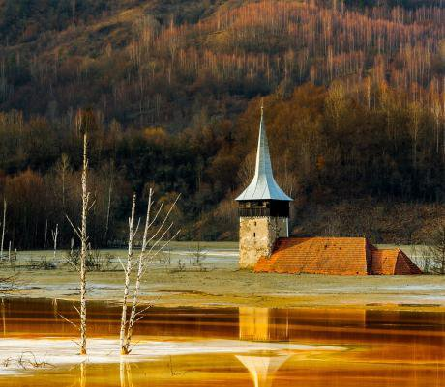

*Geamana, Romania. Flickr/Sergiu Bacioiu. Some rights reserved.Geamana was once a peaceful picturesque village in a valley of Romania’s Apuseni branch of the Carpathian Mountains. Today, the village has almost entirely been engulfed in toxic copper waste laced with cyanide and other chemicals from the nearby Rosia Poieni copper mining pit. Only the old church’s tower and a few houses preserve the memory of a village long ago erased from Romania’s official map. Soon enough, the tower and remaining houses will disappear under the toxic sludge, which, once entering rivers, could lead to catastrophic environmental consequences of transnational proportions, as, to this day, Romanian authorities have taken no measures to end the Geamana ecological disaster.*

The beginning of the end started for Geamana in 1978, when the government of Romanian communist dictator Nicolae Ceasescu [forced](http://adevarul.ro/locale/alba-iulia/foto-geamana-satul-apuseni-furat-sterilul-mina-cupru-rosia-poieni-1_5191fa31053c7dd83f984ab3/index.html) around 400 household owners to leave their homes, in order to make way for the toxic waste. The communist regime started [exploiting](http://www.wseas.us/e-library/conferences/2009/brasov/EG/EG27.pdf) the Rosia Poieni mine, containing the biggest copper reserves in Romania with an estimated one billion tons of cope ore, which at that time was also the [largest](http://www.primanatura.ro/geamana-satul-acoperit-de-un-iaz-de-decantare/?lang=en) one known in Europe. The surrounding valley became a decantation basin, into which the contaminated waste could flow. Several other villages, apart from Geamana, were wiped out of existence as well. The decantation basin is currently over 130 hectares long, [with](http://www.wseas.us/e-library/conferences/2009/brasov/EG/EG27.pdf) over 27 million tons of waste deposited over the year.

The tailings contain a high [quantity](http://www.wseas.us/e-library/conferences/2009/brasov/EG/EG27.pdf) of pyrite. When exposed to oxidizing decomposition, it generates sulfuric acid and trivalent iron, which activate the leaching process of all the tailings in the dam. Many toxic substances have already infiltrated the groundwater in the region. The more considerable concern is that, soon enough, the Aries River could be significantly [polluted](http://www.wseas.us/e-library/conferences/2009/brasov/EG/EG27.pdf) by heavy metal cations and sulfuric acid, wiping out its flora and fauna. As the Aries is the largest of the Mures River’s right-side tributaries, this means that the toxic pollution could continue to spread beyond Romania’s borders, since the latter river flows in Hungary, where it joins the Tisza River. The Tisza flows into the Danube in Serbia, expanding the potential reverberations of the brewing Geamana environmental disaster.

While this situation is well-known to the Romanian authorities, no measures have been taken to rehabilitate the site. The Ministry of the Environment has estimated that the cleanup costs for the region [would](http://adevarul.ro/locale/alba-iulia/foto-geamana-satul-apuseni-furat-sterilul-mina-cupru-rosia-poieni-1_5191fa31053c7dd83f984ab3/index.html) amount to around $15 million. The integrated environmental authorization issued by the Sibiu Regional Environmental Protection Agency for Geamana’s decantation basin and tailings expired at the end of 2011. This legal document [established](http://www.apm-bihor.ro/Form.Reglementari/autorizmediu.htm) the conditions and/or operational parameters of any activity with a potentially significant environmental impact.

However, in 2014, the state company operating the Rosia Poieni mine managed to obtain an [environmental](http://miningwatch.ro/stiri/prima-ancheta-dna-pentru-fapte-de-coruptie-la-eliberarea-avizelor-de-mediu-pentru-un-proiect-minier/) authorization allowing it to continue mining in the Apuseni Mountains from the Alba Agency for Environmental Protection (AAEP). In response, the Romanian National Anti-Corruption Agency (DNA) has recently launched an investigation on [corruption](http://miningwatch.ro/stiri/prima-ancheta-dna-pentru-fapte-de-coruptie-la-eliberarea-avizelor-de-mediu-pentru-un-proiect-minier/) and abuse of power for three Agency leaders, responsible for the granting of the 2014 license. The search is motivated especially, by the fact that the company had not made any investments in rehabilitating its decantation basins, including the Geamana one, although it was one of the requirements for Romania’s Accession Treaty to the European Union (EU).  Eliminating corrupt individuals from the decision-making process regarding the mine and decantation basins may mark a first step toward solving the problem.

Until a decision is reached by the DNA, however, the situation is only getting worse. This would not be the first time that Romanian authorities have allowed a massive environmental disaster to occur. In 2000, the East European country was responsible for the largest ecological [catastrophe](http://politicsinspires.org/romanias-rosia-montana-mining-project-another-example-of-the-policy-pitfalls-of-resource-extraction/) in Europe after Chernobyl, resulted from a cyanide spill at Baia Mare, where a poorly-built dam broke, spilling 100,000 cubic meters of cyanide-contaminated water in the Somes River. The toxic substances caused the death of 1,240 tons of fish and enormous health problems for the locals. The spill has a transnational impact, as the [contaminated](http://politicsinspires.org/romanias-rosia-montana-mining-project-another-example-of-the-policy-pitfalls-of-resource-extraction/) waters travelled into the Tisza, reaching the Danube and the Black Sea.

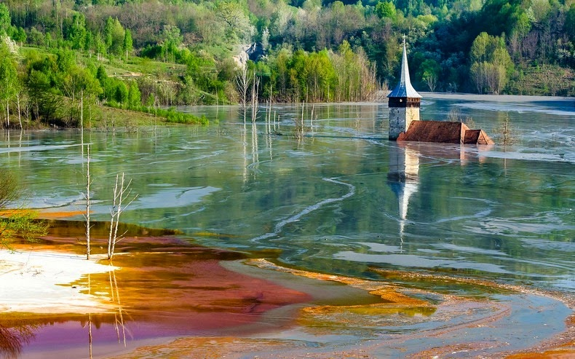

The Romanian government never assumed responsibility and did not invest funds into cleanup and environmental rehabilitation. Romania was also never held accountable at the European level for the transnational damage caused through the Baia Mare cyanide spill. It only received an unsubstantial, symbolic fine from the European Court. In the end, the affected ecosystems were left to recover naturally, while local residents hoped for the best.

Despite these previous disasters, the Romanian government has been flirting with other environmentally-hazardous economic ventures, whose potentially devastating ecological impact it could not handle. At the moment, Romania is still considering a Canadian mining project for Rosia Montana gold mine. The project would use 40 tons of cyanide a day to [extract](http://politicsinspires.org/european-commission-wrong-romanias-rosia-montana-mining-project/) over 300 tons of gold. It would create a decantation basin of 363 hectares of cyanide-filled waste, meaning the potential for a spill is enormous.

Regardless of the hazards, a draft law regarding the project was [approved](http://ireport.cnn.com/docs/DOC-1030279) last year, causing massive protests throughout Romania and in the diaspora. The project is currently on hold, though the Canadian company has yet to announce its withdrawal from the country.

The Romanian government’s desire to rush into the Rosia Montana mining project indicates that it has learned little from its previous environmental mistakes.

In the case of Geamana, immediate intervention is imperative. Given Romania’s track record of passiveness in this case and the transnational consequences, it falls on the EU to push the Romanian government into commencing the region’s cleanup and rehabilitation. The EU could launch infringement proceedings against Romania for breeching many of the 2006 EU Mining Waste Directive provisions. This Directive specifically emphasizes that Member States are obliged to “take the necessary [measures](http://europa.eu/rapid/press-release_IP-14-1149_en.htm) to prohibit the abandonment, dumping or uncontrolled depositing of mining waste, even after the closure of a waste facility, taking every precaution to limit risks to public health and the environment related to the operation of mining waste processing facilities.”

In October 2014, the European Commission took Romania to the Luxembourg Court for a failure to comply with EU legislation on mining waste, regarding the toxic Bosneag tailing pond, an abandoned “102-hectare tailing pond that [holds](http://europa.eu/rapid/press-release_IP-14-1149_en.htm) waste extracted from copper and zinc mines in Moldova Noua.” According to the Commission, “the pond is a major [source](http://europa.eu/rapid/press-release_IP-14-1149_en.htm) of pollution, spreading toxic dust that poses significant risk for human health and the environment.”

In this particular case, the Commission first opened infringement proceedings against Romania in 2012 and provided a reasoned opinion in February 2014. Romania failed to take adequate measures on the matter. Regarding Geamana, the Commission should consider providing financial and technical support to Romania, as it may lack the funding and capacity to undertake such an initiative.

Were Romania not to comply with the Commission’s demands, the latter could launch a case against the Member State at the Court of Justice of the EU. Adequate, long-term efforts could unbury the old church of Geamana and restore it and the village around it to its former splendor.

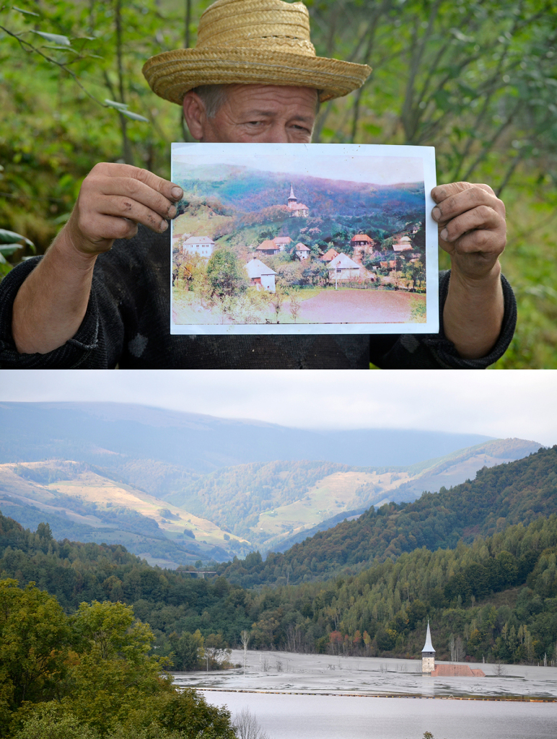



Drone photo awards – Photographer Gheorghe Popa