**Land take**

Mineral extraction may cause conflicts with other local land uses.

For most human activities there are choices of location such as where to build a port, road, airport, or housing development.

However, minerals can only be exploited where they were deposited. This makes land use conflicts more likely as there is a limited choice of locations that can be exploited.

The land area that is required to access the mineral is larger than the area of the mine void (hole) itself. Land is required for associated buildings, access routes, overburden dumping and possibly a buffer zone between the mine and neighbouring areas. Open cast mining causes much more habitat loss than deep mining.

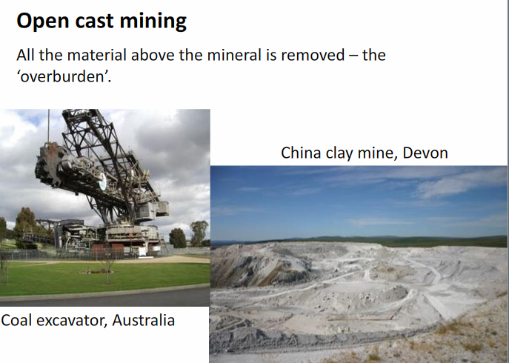

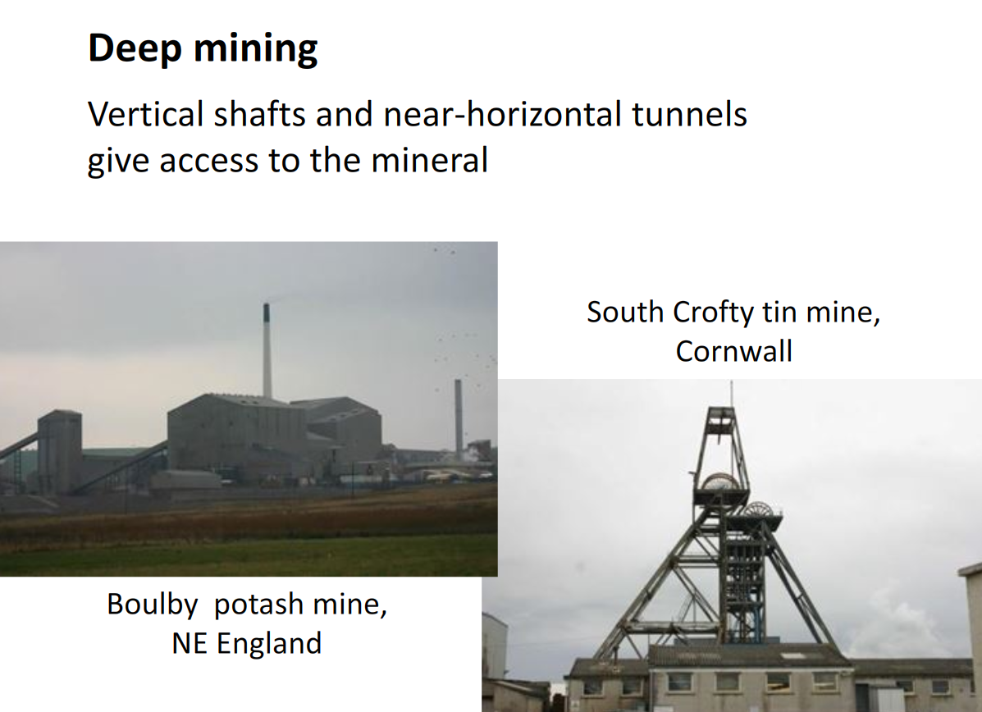

**Habitat loss**

The loss of species where the mineral is to be extracted is unavoidable as the surface habitat must be removed.

Removing wildlife by capturing animals and transplanting plants to move them to unthreatened habitats has been attempted but it is rarely completely successful. This is especially true for species that cannot be caught or found easily, as well as those with habitat requirements that are unknown or hard to create.

Habitat restoration, when mining has ended, is often carried out. Or new habitats may be created such as a wetland nature reserve in the mine void. In many countries including the UK such restoration can be a requirement of the planning permission given for the mine to be developed. In some cases, the newly created habitat may have greater wildlife value than the habitat that was present before mining started.

About 25% of the sand and gravel used in the UK is dredged from the seabed. To reduce the damage to benthic organisms (those that live on the ocean floor), dredging is usually undertaken where strong currents move the sediments around so few organisms have and can colonise.

**Negative effects of exploitation**

Mining can have serious impacts on the environment, although these are often localised and can be minimised by good mine management.

**Loss of amenity**

Mining changes the landscape and can create aesthetic problems for local communities. These effects may be reduced by landscaping and tree planting. When the mine closes it can be turned into a community resource so the long term amenity value may be greater than that of the area before mining took place.

**Dust**

Blasting and vehicle movements creates dust which moves up into the atmosphere. Water sprays can be used to limit the dust released

**Noise**

Mine vehicles and rock blasting are the two main sources of noise. Embankments or ‘baffle mounds’ built around the mine help absorb and deflect noise.

Blasting in mines does not usually take place day and night but it can be disturbing to local communities, especially if it is unexpected. The disturbance can be mitigated by blasting at set times so the noise is predictable and by restricting blasting times to daytime hours.

**Turbid drainage water**

Suspended solid particles in mine drainage water can reduce light penetration into rivers and lakes. Sediments can also cover and kill plants and animals.

The turbidity of drainage water can be reduced by using sedimentation lagoons in which the water stands still for long enough for the solids to sink, so the outflow water has low turbidity.

**Spoil disposal**

Spoil is the solid waste material left behind by mining. It can include overburden material, unwanted material extracted with the mined mineral, and solid wastes from the chemical processing of the mineral. Spoil needs to be managed and disposed or carefully. Spoil disposal can cause a variety of problems:

* aesthetics: spoil heaps can damage the scenic beauty of an area. Landscaping can make the spoil heap look more natural and blend in with the surrounding area;
* stability: a lack of surface compaction can reduce surface stability and lead to erosion. Instability and erosion can be reduced by landscaping to reduce gradients and by adding soil, nutrients, and by planting with trees or other vegetation. If a spoil heap becomes waterlogged it may become unstable, leading to landslides.

This happened in Aberfan, South Wales in 1966 when a coal mine soil heap slid into a village, killing 144 people, mainly children in the primary school. The risk of landslides can also be reduced by spoil heap drainage;

* leachate: rainwater percolating through spoil can dissolve toxic metals and sulphides that produce acidic leachate solutions. Toxic metals that are normally insoluble when inside the rock may be dissolved and become mobile. Many toxic metals are more soluble under acidic conditions. To manage this mine drainage water can be passed through a filter bed of crushed limestone to immobilize the metal and prevent it being carried into rivers.

**Mine site restoration**

New uses may be found for sites that have previously been used for mining and mineral processing.

The use of the site after mining will depend on its location, access, topography and any residual problems such as spoil heaps containing toxic wastes.

Many sand, gravel and clay pits have been flooded and developed as wetland wildlife reserves.

Urban development on mine sites may be possible if the ground is stable. If metal wastes are present, the site may be more suitable for industrial use than for housing.

Agricultural use may be possible if the landscape is not too steep or uneven, no toxic materials are present, and the soil is sufficiently fertile.