Forests & Water Resources

5.2 Forest Resources

**Specification**

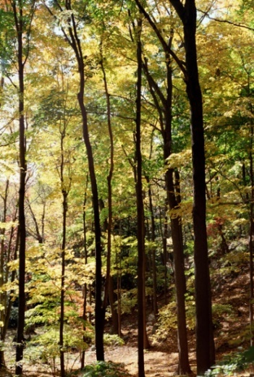 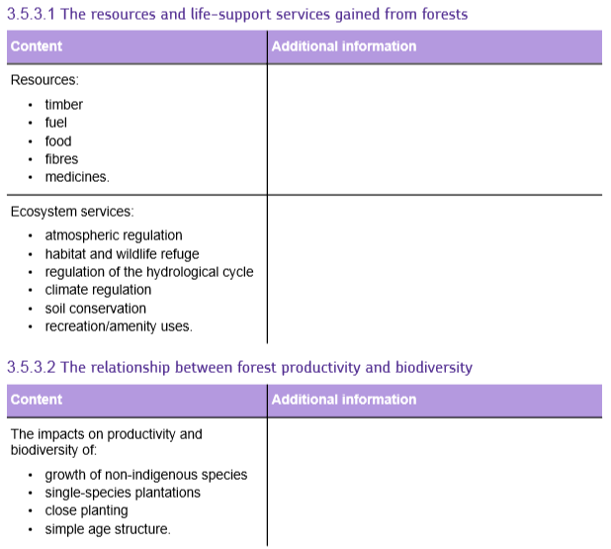

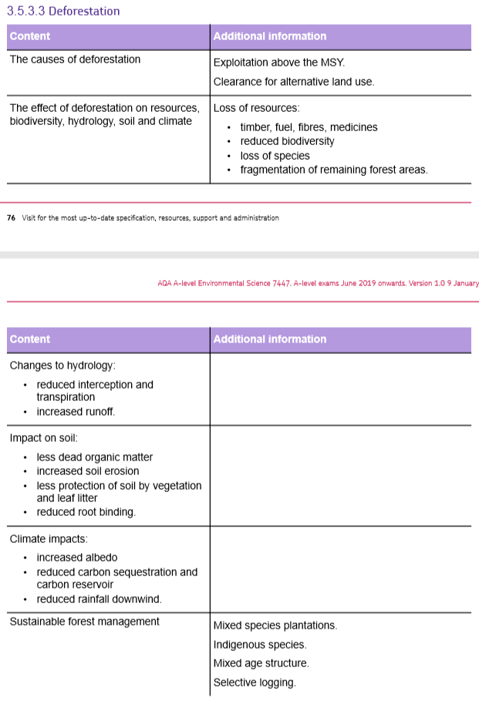

**Forest Resources**

Forests cover about 30% of the Earth’s land area. They are often a climax community in ecological succession and are found wherever conditions are suitable. The temperature determines the type of forest. The distribution of the different types of forest is controlled by the climate.

Forests are important for human survival because they provide ecological services and resources we need.



**Importance of forests**

A wide variety of resources are gained from forests. Some extracted from existing natural forests but most are produced by cultivated plantations of species that were discovered in forests. The loss of wild forests may result in the loss of valuable species that become extinct before their importance is understood, or even before they gave been discovered.

|  |  |
| --- | --- |
| **Forest resource:** | **Details / examples** |
| **Timber** |  |
| **Fibres** |  |
| **Fuels** |  |
| **Food:** |  |
| **Medicines:** |  |

**Ecosystem services**

Forests provide a range of ecosystem services that work as ‘life-support’ mechanisms on Earth.

* **Atmospheric regulation:**
* **Hydrological cycle**:
* 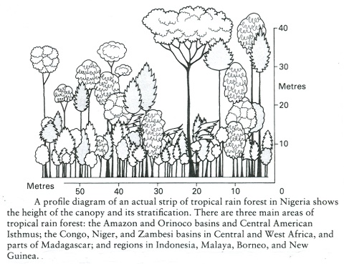**Forest microclimate**:

The diagram above illustrates stratification

* **Habitat & wildlife**:
* **Soil conservation**:
* **Amenity use:**

**Forest exploitation and management**

Forests can produce resources either as wild (or wild-managed) communities *or as* plantations:

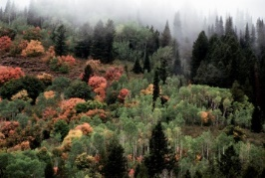

Research the difference between the traditional forest management and modern commercial forestry.

**Traditional forest management – semi-natural forests/woodland**

Include information on: Different species and their products

Management methods – standard trees, coppicing and pollarding

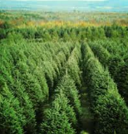**Modern commercial forestry – plantations**

Include information on: Cultivation of non-indigenous species

Examples of non-indegenous forest plantations

Single-species plantations, close planting and simple age structure

**Deforestation**

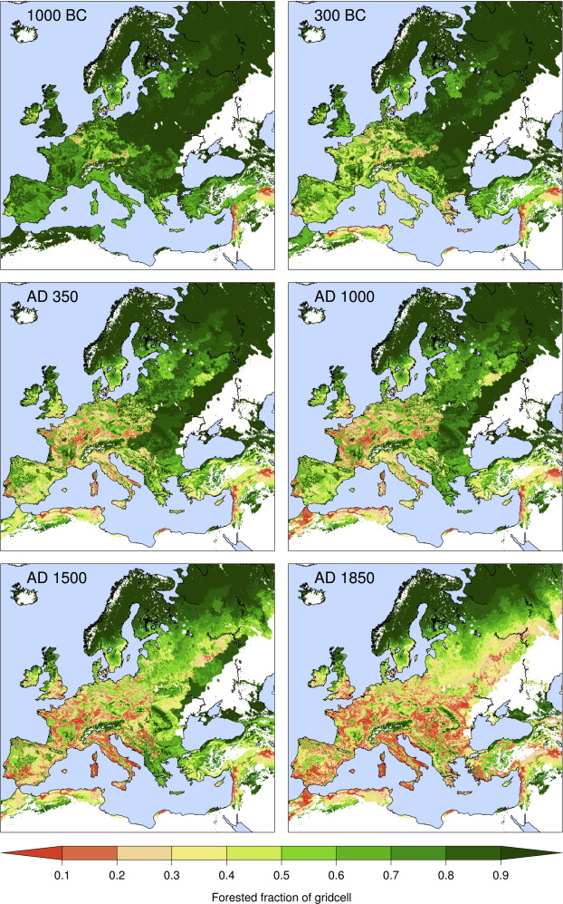



**Deforestation occurs when the rate of removal of trees exceeds rate of recovery**

There are two causes of deforestation:

1. Deliberate removal of forests to make space for other land use e.g. agriculture, urban development
2. Unsustainable exploitation i.e. exploitation above the MSY

**Maximum Sustainable Yield**

* Trees grow until they reach maturity.
* Once mature, branches fall off and new growth occurs
* Trees that die create clearings and young trees get a chance to grow
* Removing trees may be sustainable as the gaps recolonise in the same way (larger clearings may need active planting)
* Deforestation = rate is clearance is faster than max rate of regrowth

**Increasing MSY**

List the ways in which you could increase the MSY

**Causes of Deforestation**

|  |  |
| --- | --- |
| **Cause & Explanation** | **Example** |
| **Agriculture** |  |
| **Urbanisation** |  |
| **Mineral extraction** |  |
| **Reservoirs and HEP** |  |
| **Roads** |  |

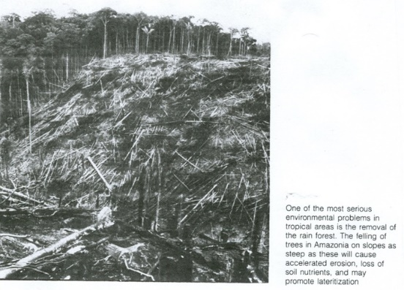**Unsustainable exploitation**

**Timber resources**

Softwood produced by conifers (pine, spruce, fir) are produced sustainably with replanting to replace harvested areas – often in Scandinavia and Canada

Hardwood species (teak, mahogany) grow more slowly than conifers so it is more difficult to commercially manage hardwood plantations as it takes longer to get a saleable crop. This means lots of this wood comes from mixed forests that are clear felled and may not be replanted

**Fuel**

Many people rely on wood as their fuel source and people in LEDC’s can’t afford alternative energy.

In towns and cities there may be a greater demand for charcoal that produces less smoke and this process used more wood and increases the rate of forest clearance

**Livestock Fodder**

It is unusual for forest areas to be cleared for livestock food however in LEDCs, where there is areas of mixed woodland and grassland, farmers may cut off branches of trees if there is a shortage of ground level grazing. If cutting exceeds growth then the forest could degrade and disappear.

**Consequences of deforestation**

**Loss of Forest resources:**

**Ecological impacts:**

**Changes in hydrology:**

**Impact on Soil:**

**Climate impacts:**

**Sustainable Forest Management**

Forests can be exploited sustainably if harvesting rate and environmental impacts are carefully managed.

Environmentally beneficial methods used in traditional forest management balanced with commercially productive methods of modern plantation forestry

**Features of sustainably managed forests**

1. **Harvesting rates**
2. **Mixed species plantations**
3. **Indigenous species**
4. **Mixed age structure**
5. **Selective logging**

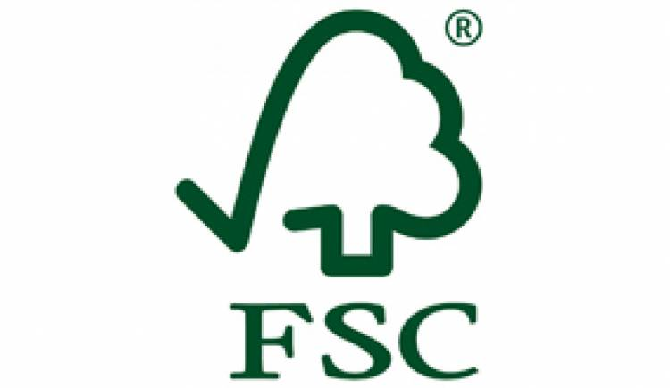**Forest Stewardship Council**

FSC runs a global forest certification system with two key components:

* Forest Management
* Chain of Custody

FSC also licenses retailers and other end users to promote FSC labelled products, without holding FSC certification.

This system allows consumers to identify, purchase and use wood, paper and other forest products produced from well-managed forests and/or recycled materials.

Use the factsheets to summarise what the forest management and chain of custody are in the forest stewardship council in the space below:

**Case Study: Programme for Belize**

Describe how the Programme for Belize is managing its forests sustainably