**NEWS** 18 SEPTEMBER 2020

**Microscopy illuminates charcoal’s sketchy origins**

A large volume of charcoal sold in Europe comes from tropical forests and is often incorrectly labelled, raising questions about whether it was logged illegally.

[**Aisling Irwin**](javascript:;)

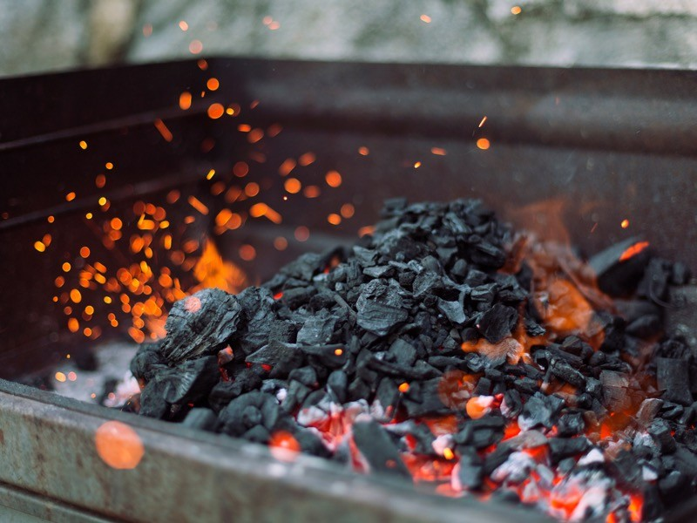

Most charcoal sold in Europe is used for barbecues — but its provenance is not always clear.Credit: Getty

Nearly half of the barbecue charcoal bought in Europe contains wood from tropical and subtropical forests, with little of it certified sustainable, raising fears that some of it is illegally logged.

The finding comes from an analysis[1](https://www.nature.com/articles/d41586-020-02672-z#ref-CR1) of thousands of charcoal samples, using a pioneering microscopy technique. Scientists also found that many bags of charcoal incorrectly labelled the type of wood inside or failed to mention it at all, lending weight to concerns about their true origin.

“This is just an overview but it’s absolutely enough to cause alarm, because we found so much tropical timber,” said Volker Haag, a wood anatomist at the Thünen Institute of Wood Research in Hamburg, Germany, who led the work.

The researchers harnessed [developments in microscopy](https://www.nature.com/articles/d41586-019-01035-7) that are transforming attempts to probe the opaque, multimillion-dollar international charcoal business. Campaigners think that up to two million tonnes of illegally harvested tropical wood might enter Europe as charcoal each year.

The European Union imported some 750,000 tonnes of charcoal in 2019. Source countries include Nigeria (20%) and Paraguay (7%), which are known for widespread illegal deforestation. But once any wood charcoal enters Europe, it can be sold legally, because it is not covered by the European Timber Regulation (EUTR), legislation that prohibits firms from placing on the EU market timber that has been logged illegally.

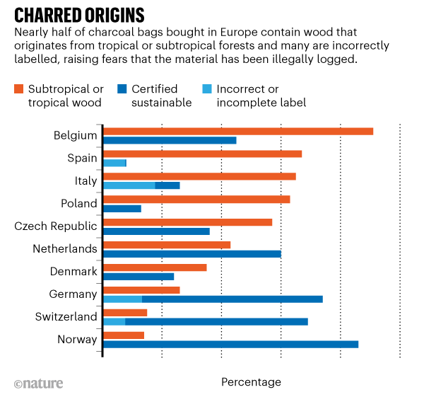

Charcoal is tricky to analyse because the original wood has lost many of its signature features, such as colour and smell, and it crumbles easily. But Haag has developed a 3D-reflected-light microscopy technique that digitally reconstructs sections of charcoal from irregular lumps to create images from which the parent wood can be identified — often to genus level. This is enough to disprove many claims about a wood’s origin.

Haag’s team analysed 4,500 samples from 150 charcoal bags bought in 11 countries in 2019 and 2020. Some 46% included wood from subtropical and tropical forests, which have the highest deforestation rates in the world. In Spain, Italy, Poland and Belgium, this figure was more than 60% (see ‘Charred origins’). Of these, only one-quarter of bags bore the logos of sustainable-certification organizations such as the Forest Stewardship Council (FSC).

In addition, only one-quarter of the bags specified the species or origin of the wood — and only half of these declarations were correct. The work was published in *IAWA Journal*, a publication of the International Association of Wood Anatomists.

“If you find a product with the wrong species inside, it’s a very strong indicator for illegality,” says co-author Johannes Zahnen, a forest-policy specialist with the Berlin-based wildlife charity WWF Germany. “Combining it with the knowledge that most tropical charcoal is coming from Nigeria and Paraguay, there’s a high likelihood of illegality.”

Zahnen calls for the EUTR to be extended to charcoal, and for authorities to compel suppliers to label their bags.

Phil Guillery, director of supply-chain integrity at the FSC, which is headquartered in Bonn, Germany, says the study shows that when sustainability certification is used, it is largely accurate. Since 2017, the FSC has been using another microscopy technique to verify origin claims on charcoal bags in an effort to stop wood ‘laundering’. “The ability to test charcoal has had a huge impact,” says Guillery.