**NEWS FEATURE** 03 APRIL 2019

**Tree sleuths are using DNA tests and machine vision to crack timber crimes**

Scientists are optimistic that innovative techniques can pinpoint the true origin of timber.

[**Aisling Irwin**](javascript:;)

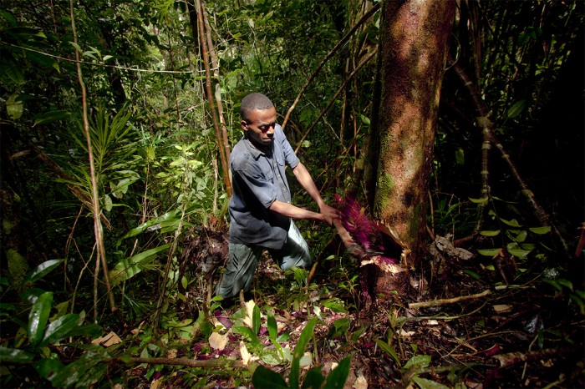

In 2016, the CITES treaty banned trade in many types of rosewood — including species from Madagascar. Credit: Toby Smith/EIA

When 420 tonnes of deep crimson logs arrived at a Sri Lankan port in April 2014, customs officers cast a suspicious eye over them. The wood was en route from Zanzibar in Tanzania to Hong Kong, where it would probably be crafted into expensive furniture for the Chinese market. However, a tip-off from international police organization Interpol alerted Sri Lankan officials to the fact that the 3,669 rosewood logs were from Madagascar, which had banned such exports in 2010.

To prove the origin of the rosewood, Sri Lankan authorities sent samples to a laboratory in Oregon that was testing a new weapon in the fight against illegal logging — a US$200,000 mass spectrometer. In mere seconds, scientists at the US Fish and Wildlife Service Forensics Lab in Ashland determined that the wood bore the distinct chemical signature of a Madagascan species of rosewood — and not one of wood legal to export.

After a drop in the early 2000s, the trade in illegally logged timber is rising again. Interpol estimates that between 15% and 30% of the global timber trade violates either national law or international treaty. In some tropical countries, such as the Democratic Republic of the Congo, Laos and Papua New Guinea, illegal timber could account for more than 70% of the nation’s production. This market is worth between $10 billion and $100 billion a year, according to a 2016 report from the International Union of Forest Research Organizations in Vienna.

Some high-income countries — including the United States, South Korea and those in the European Union — have banned the import of illegally sourced wood and products made from it, and forced importers to prove their supplies are bona fide. The Convention on International Trade in Endangered Species of Wild Fauna and Flora (CITES), an international agreement signed by 183 countries, forbids or restricts trade in the most threatened species. In 2016, it added to the list all the rosewoods belonging to the genus *Dalbergia*.

Such efforts suggest that illegal timber imports are thriving — in part because the crime is so difficult to uncover. From Brazil and Madagascar to Europe’s Carpathian Mountains, trees move from forest to living room through serpentine routes, with twists and turns where illegal wood can be hidden. A single piece of plywood can contain 18 different tropical timbers. An illegally harvested oak tree from Russia can voyage to Vietnam to become a table, and by the time it reaches a US retailer, its origin has mysteriously changed.

The global paper trail that accompanies timber is notoriously easy to manipulate. So those tasked with fighting illegal trade — and the companies now compelled to crack down on it — are turning to technologies that can spot the signatures of illicit timber. Scientists are developing a suite of tools that can identify the species and the country, and even the region, it came from. Thanks to advances in chemical and genetic fingerprinting, it is now possible to determine where a tree grew — sometimes down to a particular patch of forest. Some of these tools are already being used to catch criminals.

A few formidable obstacles are keeping these techniques out of routine use, one of the biggest of which is a lack of reference samples against which to compare suspect timber. But there are signs of progress towards developing a library of the world’s forests. In February, the US government and various international partners said that they would plough resources into collecting and curating thousands of georeferenced tree samples.

“I’m convinced that in five, ten years — with any wood product — you’ll be able to know exactly where it came from,” says Phil Guillery, head of supply-chain integrity at the Forest Stewardship Council (FSC), a voluntary certification body in Bonn, Germany, and one of the forces behind the library effort. “You can’t fake the science.”

## Anatomy of a crime

A giant eucalyptus tree dominates the view from Peter Gasson’s office in London’s Royal Botanic Gardens, Kew. The lab of the wood anatomist is strewn with curiosities: ‘oak’ blinds that turned out to be softwood and a millefeuille of plywood from China with a suspicious veneer. In a cabinet are 36,000 microscope slides, each containing a sliver from Kew’s vast collection of wood samples. The microscope picks out more than 100 features that betray the sample’s identity.



Reference samples at Kew Gardens and other locations can help in identifying suspect wood.Credit: Tolga Akmen/AFP/Getty

Two kinds of wood lie beneath a tree’s bark. An outer sapwood layer holds vessels called xylem tubes that siphon water and minerals up the plant. In the inner layer, of heartwood, resin blocks much of the xylem. A horizontal section of the wood reveals the rings; a vertical section exposes the long lines of vessel elements, giving the familiar grain of the wood. Depending on the genus, vessels can lie in neat, concentric rings or can be dispersed through the trunk.

Gasson’s lab has hundreds of obscure guides to wood anatomy, “but mostly it’s all in here”, he says, pointing to his head. It’s taken 30 years to understand the quirks of the world’s 30,000 or so tree species, so that knowledge is precious. But, after staff cuts, Gasson is Kew’s sole wood anatomist, and one of just 131 members of the International Association of Wood Anatomists.

Yet wood anatomists are more in demand than ever. “Now, is as sexy as being a wood anatomist will ever be,” says Alex Wiedenhoeft, Gasson’s counterpart at the US Forest Products Laboratory in Madison, Wisconsin.

Gerald Koch at the Thünen Centre of Competence on the Origin of Timber in Hamburg, Germany, has helped to push wood anatomy to new heights, using it to expose a far-reaching scandal involving European charcoal supplies. In 2017, the wildlife charity WWF in Germany approached Koch over concerns that Germans were unwittingly using charcoal that had been made from protected forest wood.

Charcoal is too brittle to slice into the thin sections that wood anatomists ordinarily analyse under a microscope — “If you cut it with a knife, you just get a powder,” Koch says. So his team worked out a way to digitally reconstruct such sections from irregular lumps of charcoal, using an €80,000 (US$90,500) 3D reflected-light microscope — the first application of the technology to wood anatomy.

Koch’s analysis provided enough information for Johannes Zahnen, a specialist in forest policy at WWF Germany, to deduce that 40% of the samples of barbecue charcoal he had submitted to Koch had come from tropical countries.

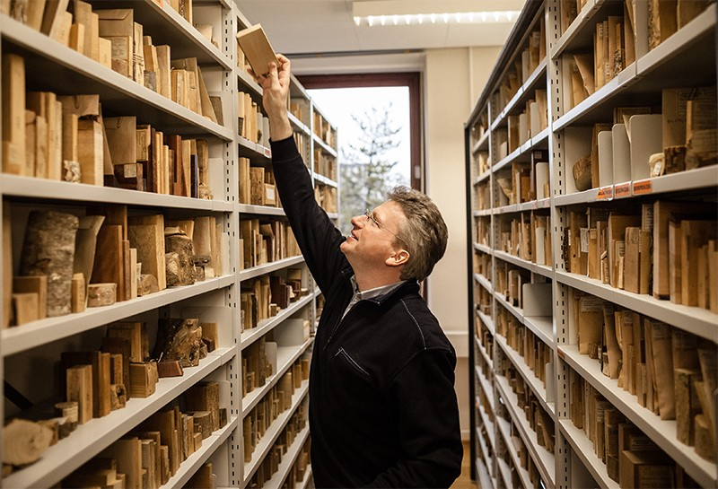

Gerald Koch has access to a library of 35,000 samples from around 12,000 wood species.Credit: lja Hendel/Thünen Inst. of Wood Research

“That was a surprise to everybody,” says Zahnen. Armed with this and other questionable claims of provenance exposed by Koch, he traced a large proportion of Germany’s charcoal back to Paraguay and Nigeria, two countries where illegal logging is rife. The investigation triggered others in Europe and, ultimately, helped to expose a major logging fraud in Ukraine.

The dearth of wood anatomists has inspired some to turn to machines. At the Forest Products Laboratory, Wiedenhoeft and engineer John Hermanson have invented the XyloTron, which they hope will be used as a field screening tool that can alert inspectors to timbers that merit further, forensic analysis. The machine, which is currently in field trials, consists of a customized camera and a computer loaded with a reference collection of images that allow the device to identify wood types.

## CSI timber

But even with technology such as the XyloTron and Koch’s 3D microscope, anatomists cannot usually pinpoint the exact origin of a tree, or its species — important details because legality might hinge on where a particular species was sourced.

That was the information the Washington DC-based Environmental Investigation Agency (EIA) needed for an inquiry several years ago. The non-profit organization suspected that Mongolian oak (*Quercus mongolica*) was being plundered from forests in eastern Russia, and not from legal stocks in China, before being purchased by a US hardwood-floor retailer, Lumber Liquidators.

The EIA contacted Agroisolab, a firm based in Welburn, UK, and Jülich, Germany, to see whether it could pinpoint the origin of the wood. The company uses a technique called stable isotope ratio analysis, which probes variations in the proportions of several non-radioactive isotopes of oxygen, hydrogen and nitrogen. These ratios differ across landscapes depending on geology and weather patterns, and leave their imprint in a tree’s tissues as it absorbs water and nutrients.

Applying the technique to trees has been tricky, says Roger Young, chief executive of Agroisolab, because its success relies on having a map of the isotopic ratios of the relevant plant across all regions of interest. And such reference samples need to be collected with great care, says Bernd Degen, head of the Institute of Forest Genetics in Grosshansdorf, Germany. Geographical factors, such as proximity to a river, can influence the isotopic ratio. Even the annual rings in a tree can vary isotopically, depending on the environment during each year of growth.

EIA investigators tracking Lumber Liquidators’ supply chain retrieved wood from Russian sawmills and Chinese flooring factories, and sent them to Agroisolab. However, they hit a problem: although the lab had oak reference samples from other parts of the world, it lacked them for Russia and China, where the wood was suspected to have come from. So investigators from the WWF, which was collaborating with the EIA, travelled to eastern Russia to collect samples from 50 sites. And the isotopes in those showed a clear correlation: the oak flooring pieces had come from Russia, not China.



Microscopic details of charcoal can help researchers to determine the type of wood it’s from.Credit: Volker Haag/Thünen Inst. of Wood Research

The EIA shared its results with US federal prosecutors, who were also investigating Lumber Liquidators’ oak supplies. The isotopic data confirmed evidence, such as company documents, that the federal investigators had already gathered. The firm pleaded guilty in 2016 and agreed to pay a $13-million penalty — the largest ever levied in the United States for trafficking illegal timber.

The stable-isotope analysis didn’t win the case, but had the technology been available when the investigation began, the US Department of Justice said in a press release, “perhaps Lumber Liquidators could have been flagged for violation years ago, thus averting the flow of money back to China and Far East Russia in support of illegal logging”.

That case transformed the field by showing that it was possible to determine where a tree had been logged, says Meaghan Parker-Forney, a geneticist at the World Resources Institute in Washington DC. The US government’s endorsement, she adds, showed people that “this stuff is actually potentially really valuable to combat the trade and maybe we should be pursuing this”.

## Pine profiles

The aroma of agarwood incense and the telltale colours of rosewood are the result of the timbers’ chemical make-up, which varies with genetics and environment. At the Fish and Wildlife Service Forensics Lab, these chemical fingerprints can now be revealed using a sophisticated technique known as direct analysis in real-time, time-of-flight mass spectrometry. The technique bombards toothpick-sized wood samples with a stream of high-temperature helium ions. These skim molecules off the surface, ionize them and propel them towards the mass spectrometer, where they pass through electric and magnetic fields that separate the ions according to mass, creating a unique spectrum. If the reference collection is good enough, two species indistinguishable by anatomists can be discerned “like night and day”, says Cady Lancaster, a chemist at the lab.

Lab chemist Edgard Espinoza, who co-pioneered the application of the technique to wood, has been examining suspicious items for US customs since 2013, including the Sri Lankan rosewood shipment. He and Lancaster are building up a reference collection of thousands of samples from around the world. It already includes all the commercially traded species listed under CITES.

Genetic fingerprinting is another technique showing promise in timber investigations. The approach analyses the unique genetic make-up of individual trees, and has already had some successes. During the hunt for the people who illegally chopped down big leaf maple (*Acer macrophyllum*) in Gifford Pinchot National Forest in Washington in 2015, investigators used the technique to match planks seized at a sawmill in the state to the exact stumps in the forest from which the timber had come.

Such clear-cut conclusions are rare because of the global nature of illegal logging. So researchers are hoping to use genetic variation to match suspect wood to local or regional populations of a tree species. That way, a sample from a mahogany shipment purporting to come from Brazil might be proved to carry the genetic profile of trees from adjacent Colombia.

To do this, as well as to apply the other approaches, will require a georeferenced library of the world’s forests. Most of the hundreds of thousands of wood samples already collected lack data about their precise origins. So researchers are fanning out across the world’s forests to collect samples.

## A library of trees

It wasn’t the humidity or the biting insects of the French Guianan rainforest that bothered Niklas Tysklind, an ecological geneticist with the French National Institute for Agricultural Research in Paris. It was the botanists who accompanied him on his expedition in 2014.

Tysklind was trying to obtain wood and leaf samples from *Manilkara huberi*, one of the tree species commonly known as balatá, for the LargeScale Project, an endeavour led by the Thünen Institute to develop genetic reference data for trees in Africa and Latin America.

However, the botanists were finding that balatá was not one species, but possibly dozens. When the number of species reached 16, “I started losing hope”, says Tysklind. It is tasks such as these that make creating reference maps and databases a gargantuan undertaking.

Now, the FSC is trying to help such efforts. Together with Kew, the US Forest Service, Agroisolab and others, it is creating the Global Timber Reference Project. This effort will collect samples from the FSC’s network of 1,500 certified forests in such a way that they can meet the technical needs of the different identification techniques. Each sample will be precisely geolocated and will travel from tree to filing cabinet in a manner sufficiently secure for any evidence to be admissible in court.

One database won’t stop illegal logging. But law enforcers, investigating non-government organizations and scientists have a new, if fragile, optimism that they can start to turn the tide on the illegal timber trade. “Once the industry — the traders — begin to see there’s a method that works, it’s the equivalent of a policeman on the block,” says Young. “The chance of them being caught now is no longer zero.”

*Nature* **568**, 19-21 (2019)