3.4.3 Monitoring Water Pollution

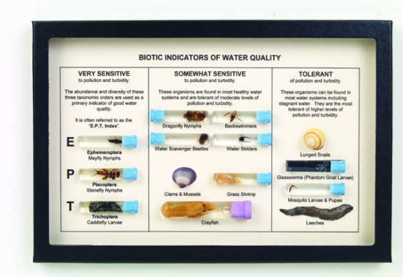

**Monitoring Water Pollution**

Water quality can be measured in different ways – either physical, chemical or biological methods can be used.

Physical methods:

Chemical methods:

Biological methods:

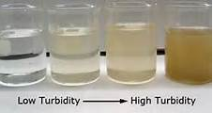**Physical Tests - Turbidity**

Measured as …………………………………….

Units ………………….

**Questions**

1. What land use activity might cause turbidity (suspended sediments) in a river (give a couple of land use examples)?
2. Draw a secci disc and explain how you would use it to measure turbidity.
3. What other piece of equipment could be used to measure turbidity? Explain how this works.

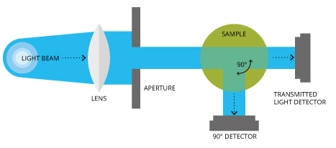

**Chemical Tests – Measuring pH**

1. What ways can you measure pH?
2. Why is it better to use an electronic meter than a paper test such as universal indicator paper?
3. What pH is neutral?
4. What type of solutions have a pH of less than 7?
5. What type of solution have a pH of more than 7?

**Testing Nitrate Level**

The concentration of many substances can be estimated using a colorimeter.

A standard volume of test solution is taken and standard volume of test reagent is added. Any nitrate present reacts with the reagent producing a coloured solutions.

The colorimeter measure the amount of light of the appropriate colour that passes through the solutions which is a measure of the original amount of nitrate that was present.

Simple colorimetric method can be used for a wide variety of ions e.g. ammonia and phosphates

**[Nitrate-NitraVer5 colorimetric assay](http://archive.iorodeo.com/sites/default/files/imagecache/product_full/img_2375.jpg)**

**B.O.D. (Biological or biochemical Oxygen Demand):**

|  |
| --- |
| ***If there is organic matter in water then bacteria will use this material as ‘food’ (for respiration) and in so doing they use up oxygen in the water.*** |

**Task 1:**

***Read:*** Genn p. 274

Fact Sheet ‘Biological Oxygen Demand’

***Questions***

1. Name some sources of organic pollution that would raise the B.O.D. of a water sample:
2. What are the *units* that B.O.D. is measured in?
3. Outline the **7 steps that would need to be taken to measure B.O.D.** 
   1. **.**
   2. **.**
   3. **.**
   4. **.**
   5. **.**
   6. **.**
   7. **.**
4. Why is the BOD water sample kept in the **dark** for the *5 days that it is left*?

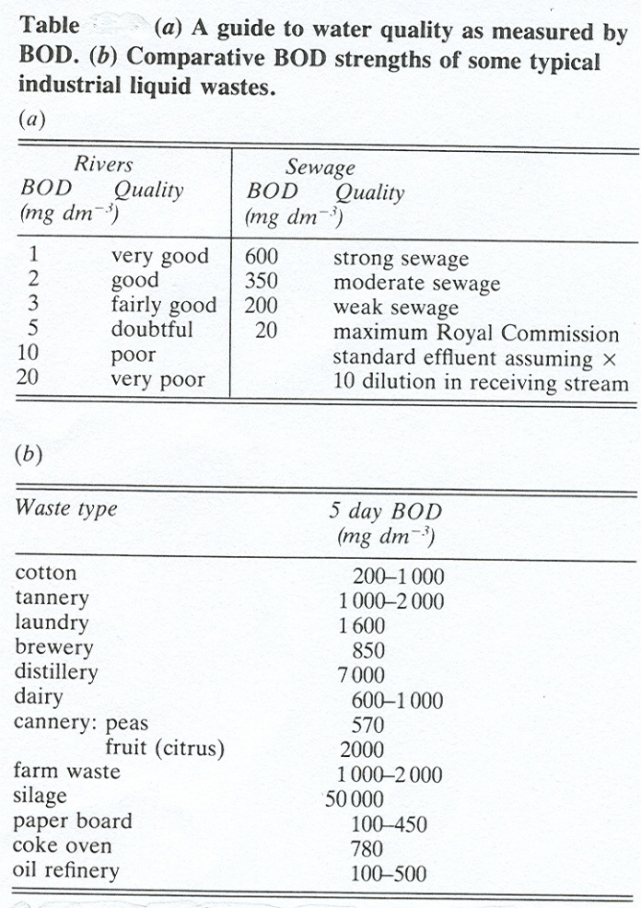

***Study the BOD data tables above and then answer the following questions:***

1. How much greater is the BOD of water quality described as ***strong sewage*** compared to ***fairly good water***?
2. Which type of waste (of those given) has **the *highest* BOD**?
3. Which type of waste (of those given) has the ***lowest mean BOD***?

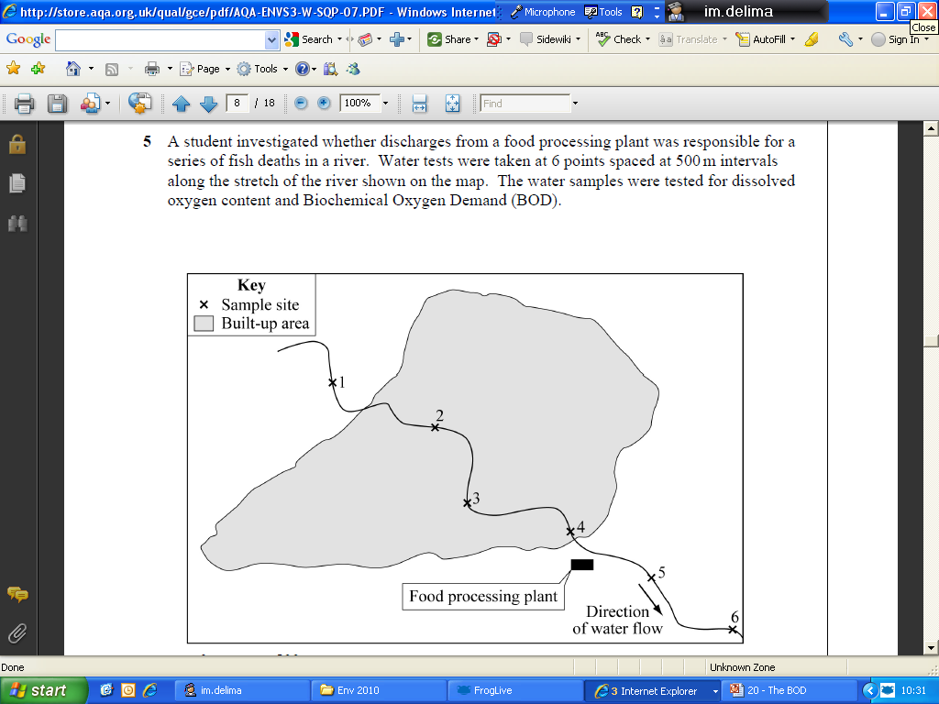**Exam Question**

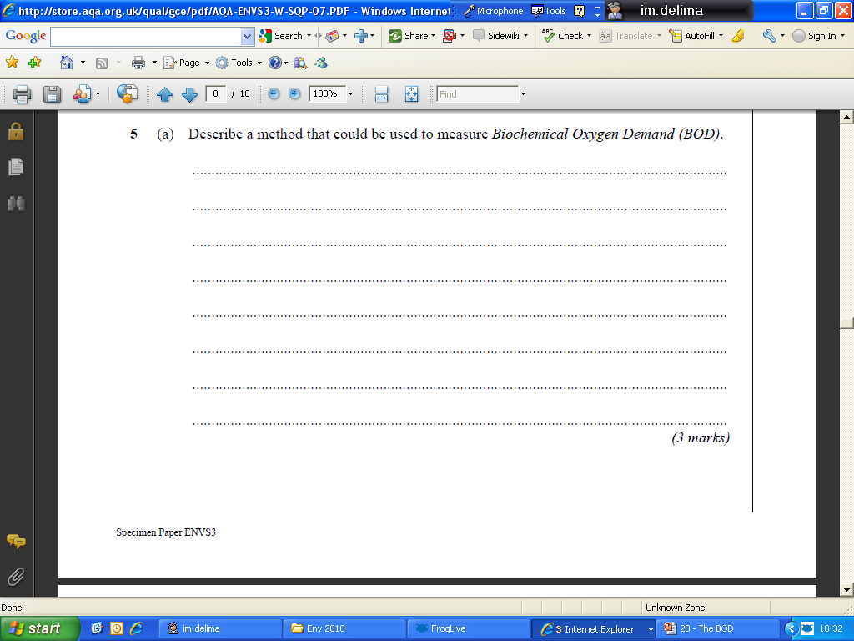

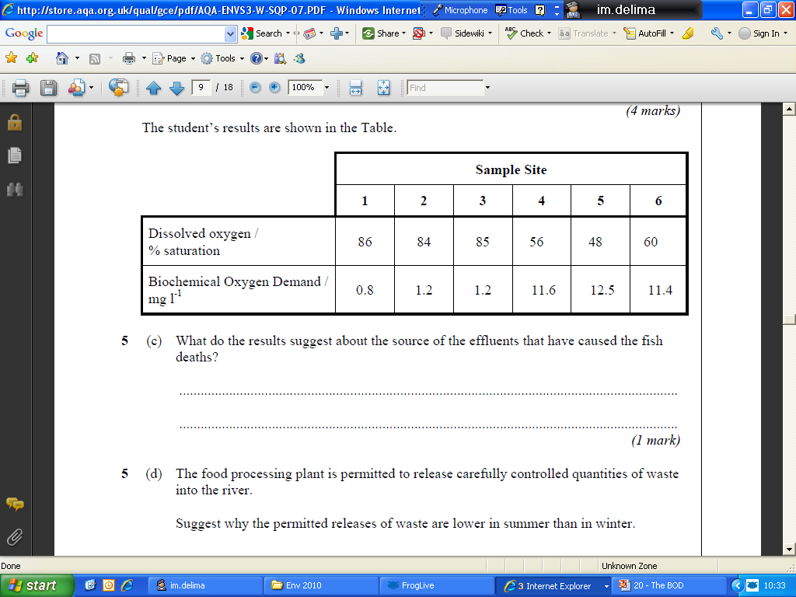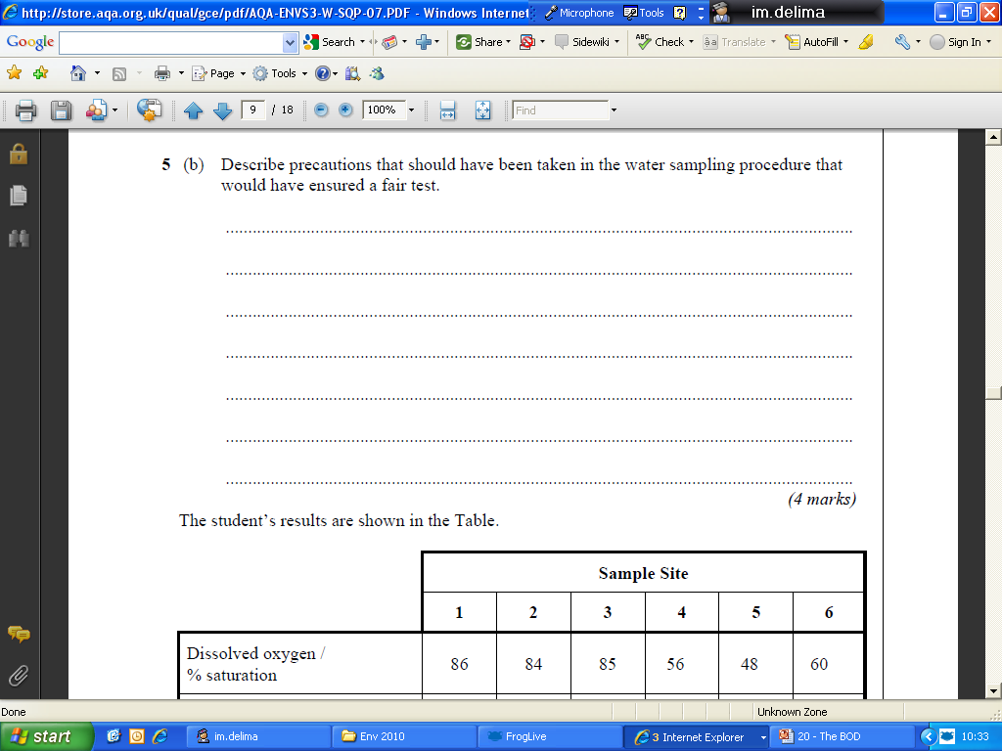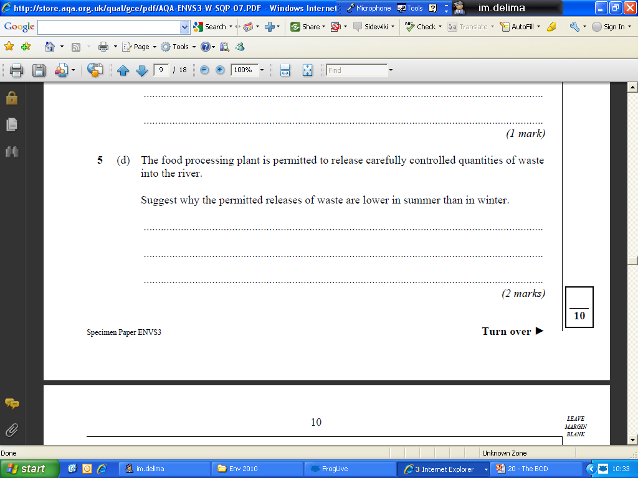

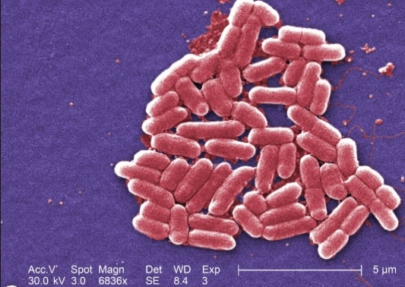**Biological Tests – Coliform Counts**

*E.coli* is a common gut bacteria. Many strains are harmless but their presence is proof of faecal contamination. The number of bacteria will indicate how serious the contamination and therefore the health risk.

This is a better technique than monitoring the presence of pathogens such as typhoid that would not be present all the time and whose absence would not prove the water to be uncontaminated.

**Biotic Indices**

A biotic index is a method of monitoring environmental conditions by either presence/absence, state of health/growth and abundance/diversity of species that would normally be present.

Species that make good indicators are:

1.

2.

3.

4.

5.

6.

Commonly used biotic indices are:

1.

2.

|  |
| --- |
| Some freshwater species are **very sensitive** to even slight levels of organic pollution, others are **moderately tolerant** whilst a few can survive (and even thrive in large numbers) in **very polluted conditions**. As a result of these very different sensitivities a selection of freshwater species can be used as **pollution indicators** (**biotic indices**). |

**Task:**

Using Pg. 275 of text book list the advantages and disadvantages of using biotic indices.

|  |  |
| --- | --- |
| **Advantages** | **Disadvantages** |
|  |  |
|  |  |
|  |  |
|  |  |
|  |  |

Study the simplified diagram and table below, which gives a very simplified idea of how the presence of different species can make them good pollution indicators.

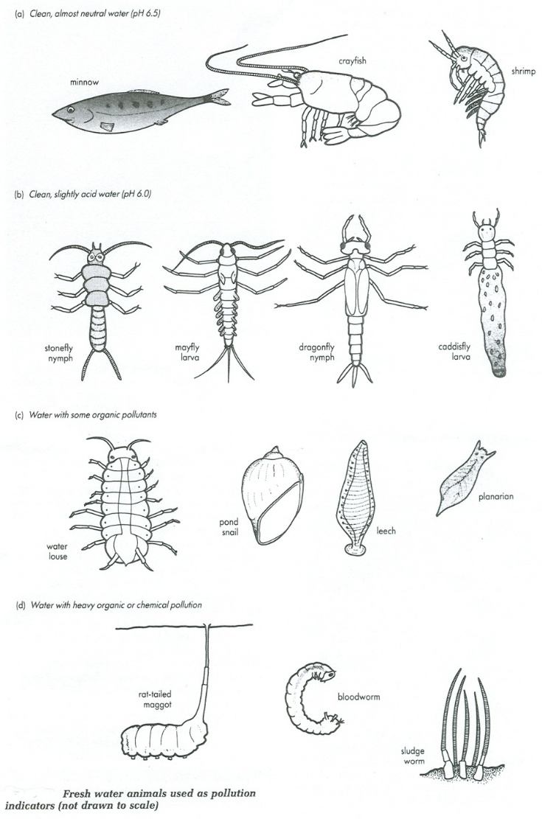

* Name two species found in clean water that is close to neutral in pH:
* Name two species found in slightly polluted water:
* Name two species found in heavily polluted water:
* What is it about sewage that causes these effects?

