C:\Documents and Settings\mjw\Local Settings\Temporary Internet Files\Content.IE5\OE7PTEF2\MCj02876120000[1].wmf

3.4.3.2 Water Pollution

3.4.3.2.9 Nutrient pollution

**Syllabus content**

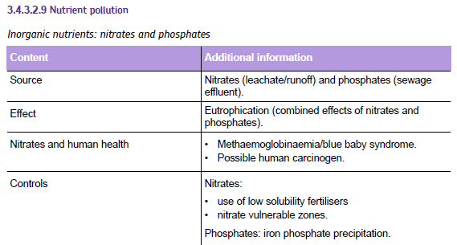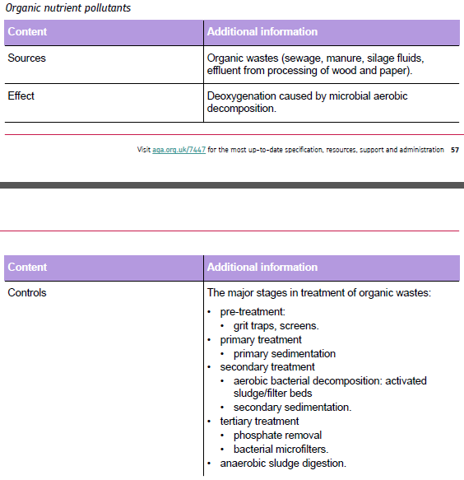

**Factors influencing water pollution concentration**

Many pollutants end up in water bodies. They often become the final SINK for the pollutant (*what does that mean?*

List the areas where you are more likely to find water pollution and examples of each one

1.

2.

3.

4.

5.

**Factors affecting concentration of water pollution**

1. **Factors affecting the water body**
   1. **Size of emission**:
   2. **Volume of water**:
   3. **Residence time of water**:
2. **Degradation**:

|  |  |
| --- | --- |
| **Examples of biodegradable pollutants** | **Examples of non- biodegradable pollutants** |
|  |  |
|  |  |
|  |  |
|  |  |
|  |  |
|  |  |

1. **Removal rate of pollutant**:
2. **Dispersal**:

**Nutrient pollution**

What are nutrients?

**Inorganic nutrients :**

**Organic nutrients :**

**Inorganic Nutrients**

|  |  |  |
| --- | --- | --- |
|  | **Nitrate** | **Phosphate** |
| **Source of pollution:** | | |
|  |  |  |
| **Effects:** | | |
|  |  |  |

**Eutrophication**

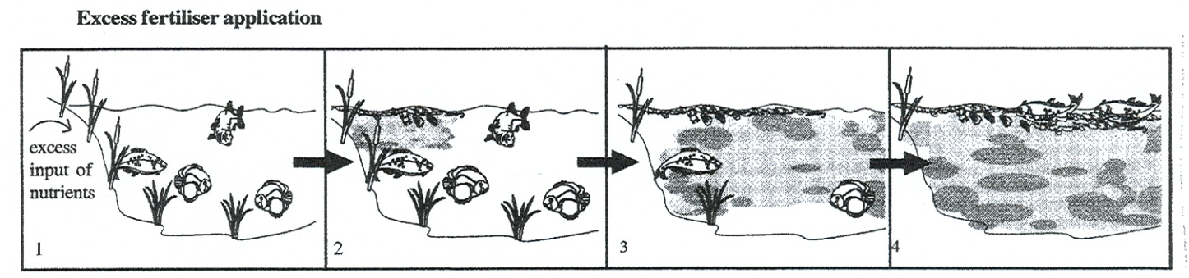

In the space below, make notes on eutrophication then draw a flow chart of the process.

**Control of Inorganic Nutrients**

List as many ways as you can think of reducing inorganic nutrients

* .
* .
* .
* .
* .
* .
* .
* .

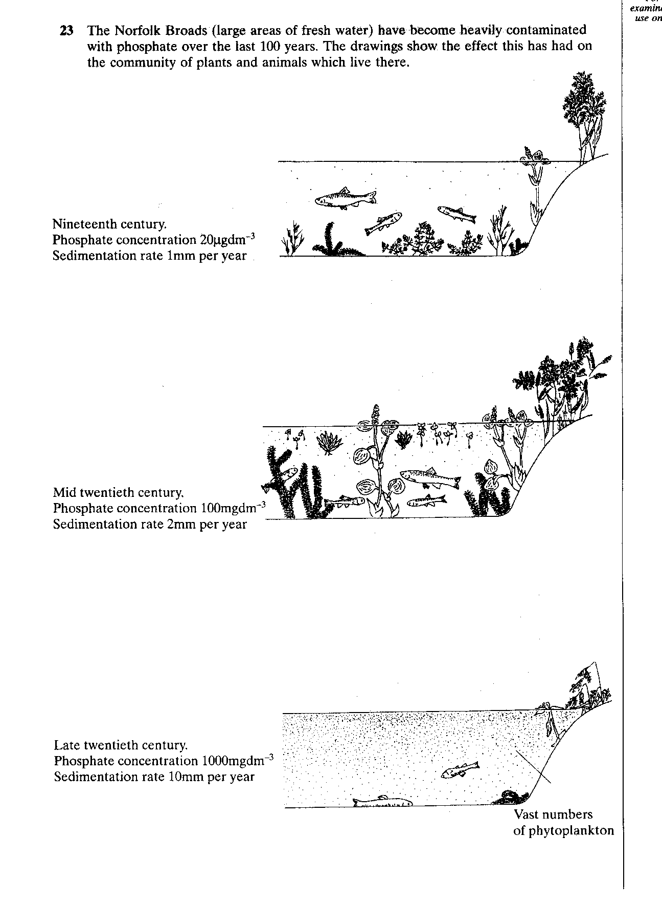

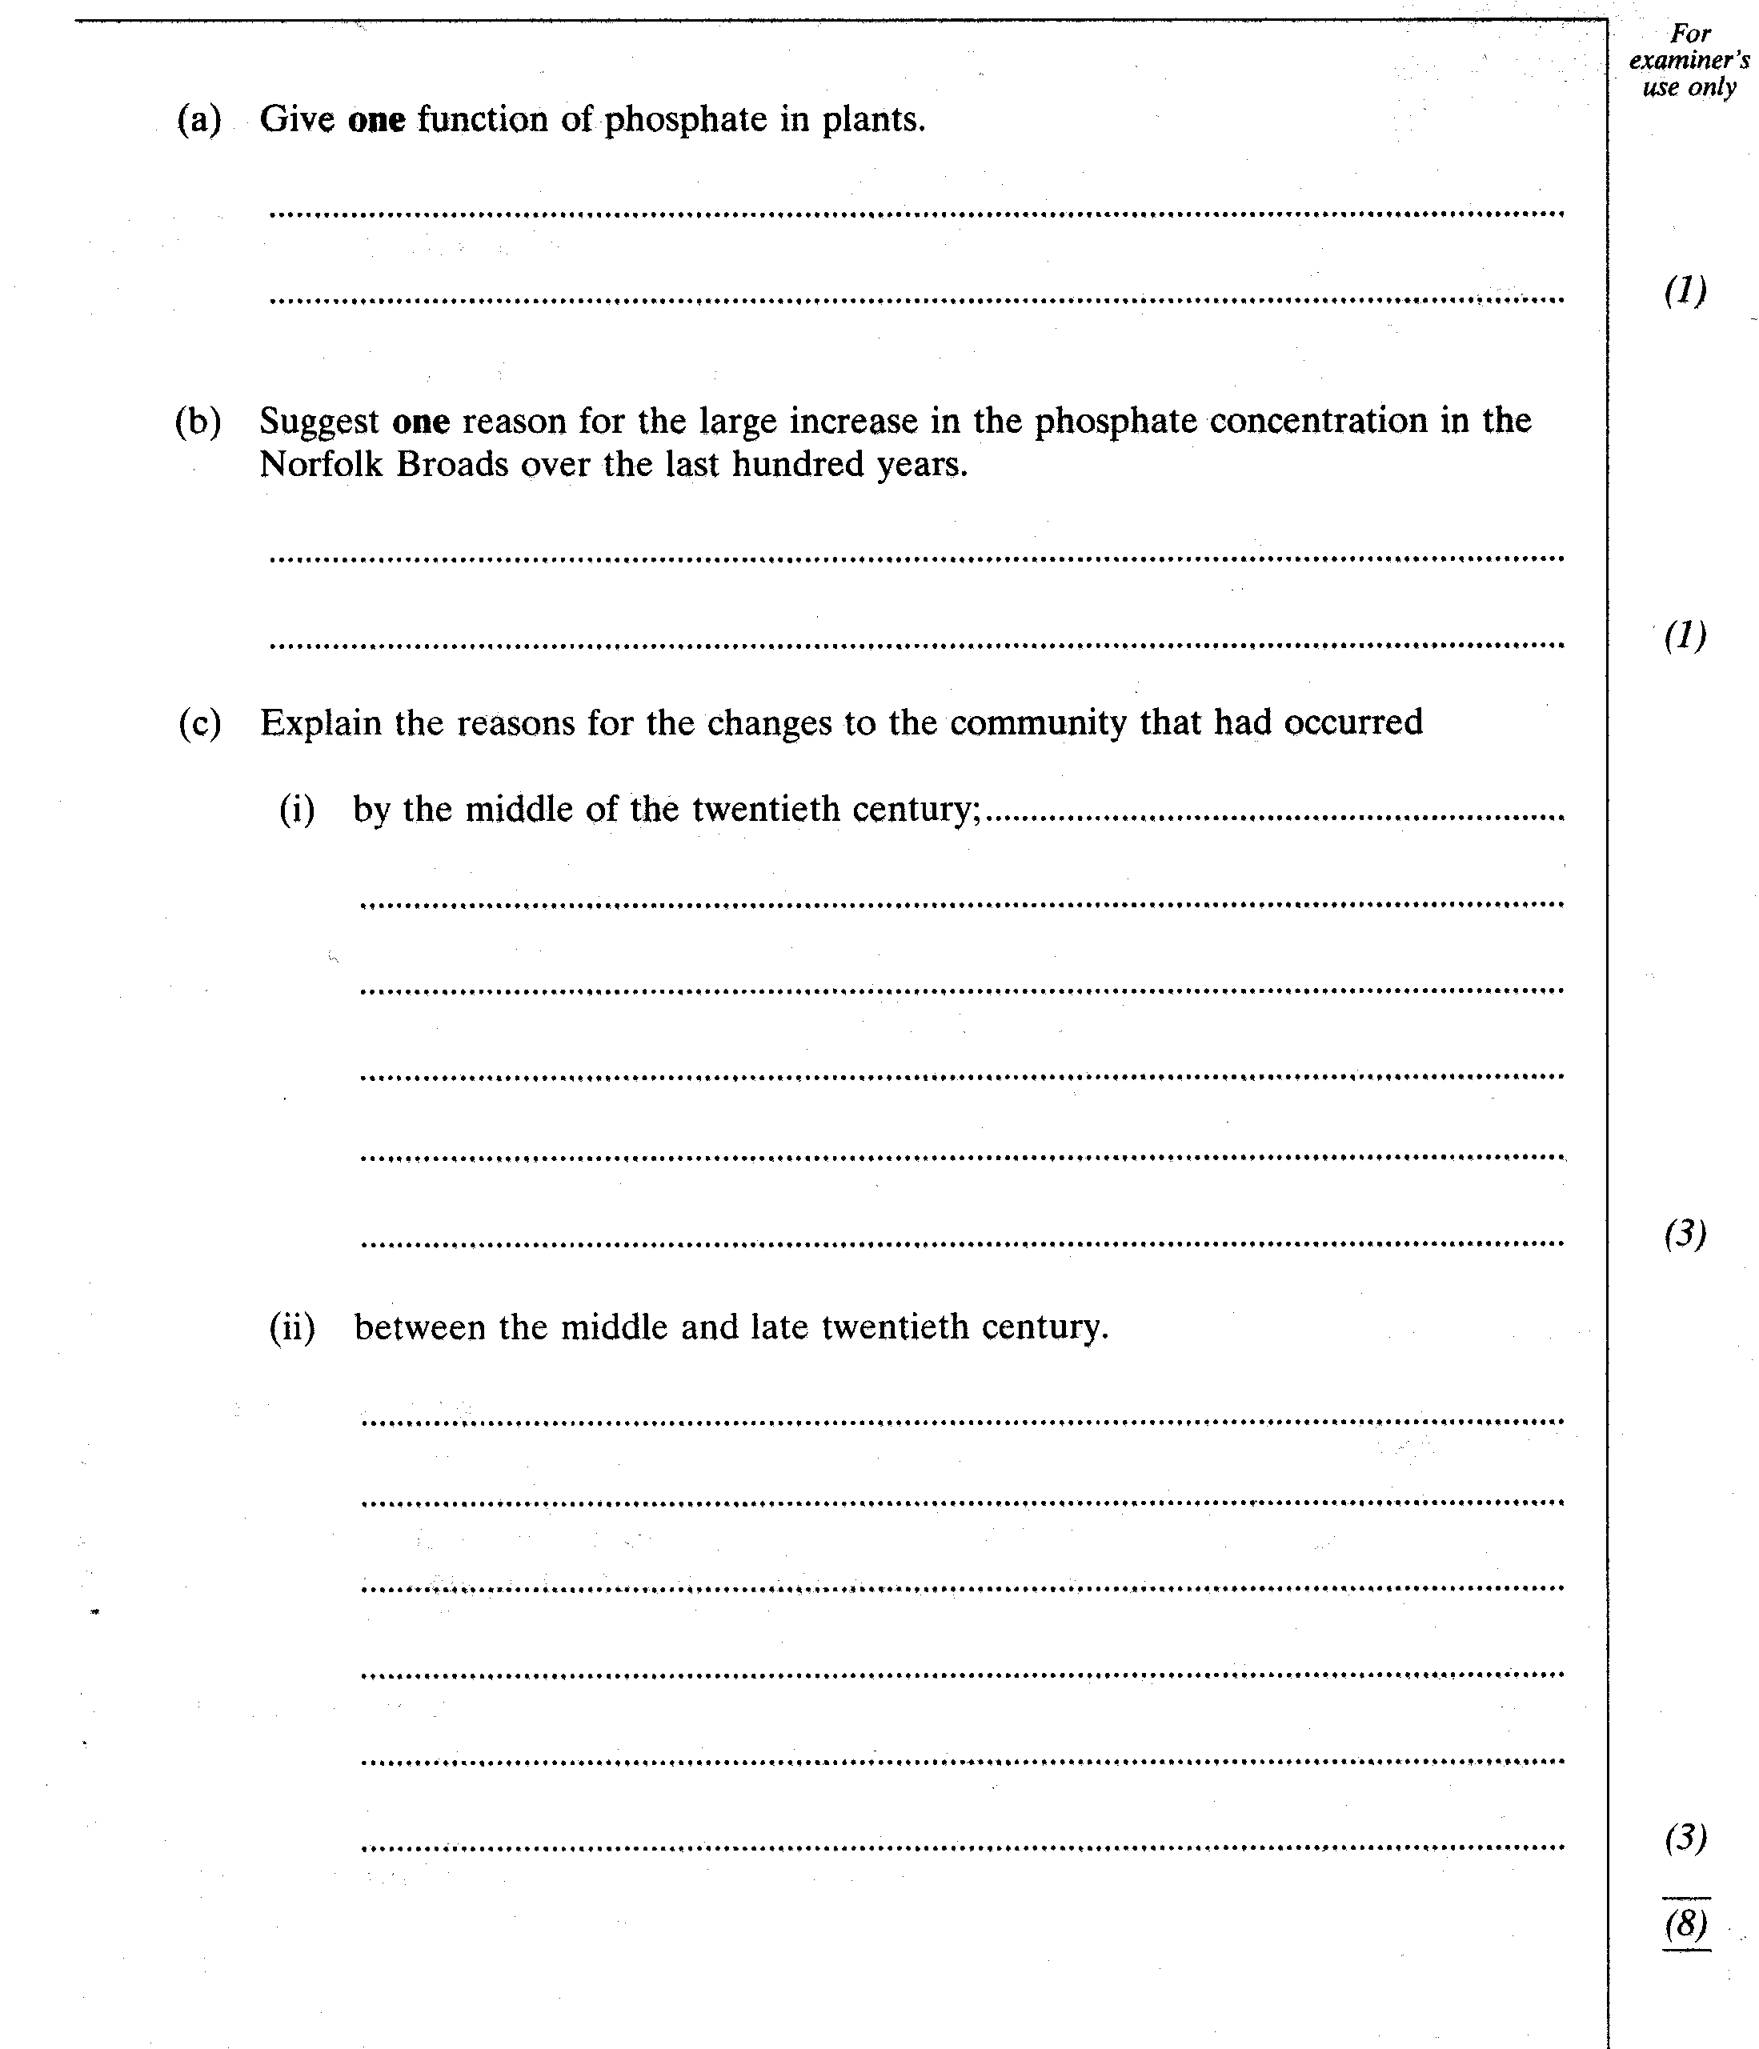

**Organic pollutants**

What are organic pollutants?

What are the 3 main effects of organic pollutants?

1.

2.

3.

**Excessive organic matter and oxygen.**

Write a flow chart to explain what is happening within an aquatic ecosystem when there is excessive organic matter.

Effect of excess matter

Effect of low oxygen levels

Oxygen depleted waters

Oxygen replenishment

Recovering ecosystem

**Sewage Treatment**

Research sewage treatment

* Make notes on
  + Activated sludge treatment
  + Pre-treatment
  + Primary treatment
  + Sludge disposal
  + Secondary treatment
  + Tertiary treatment

Draw a diagram of the sewage treatment works and annotate with the key information from your research.