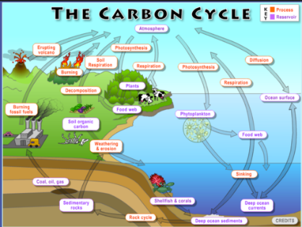

**6.1 Aquatic Resources and Nutrients**

**Biogeochemical Cycles**

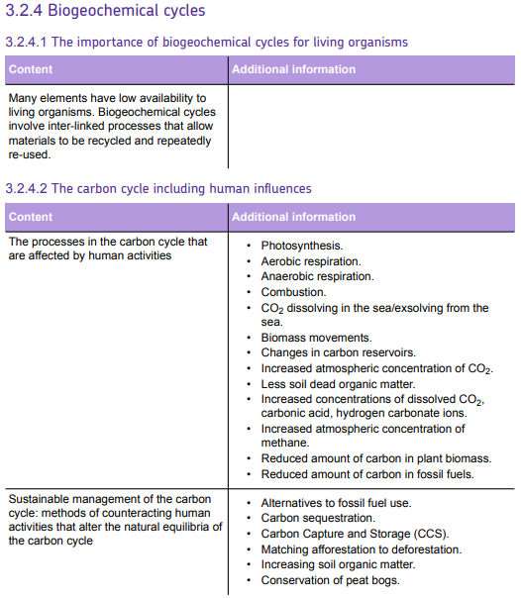

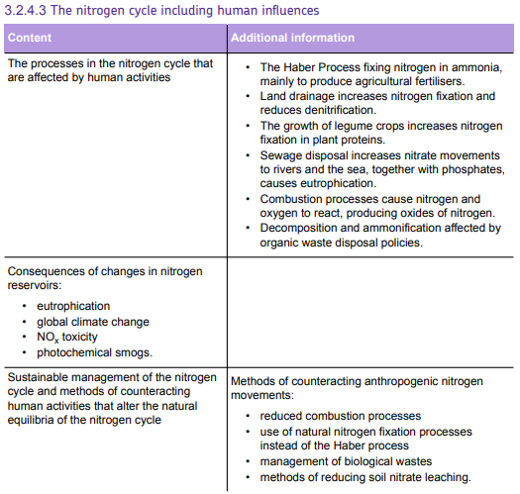

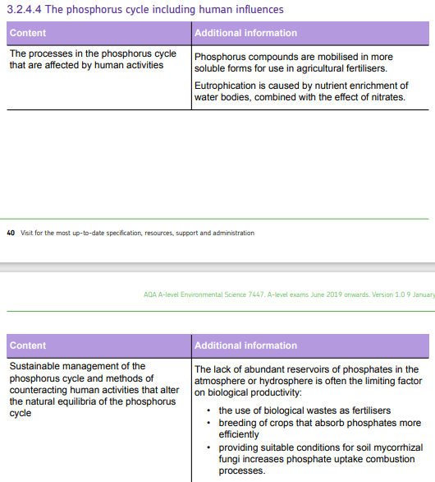

**Biogeochemical Cycles**

Many nutrients that living organisms need are processed, converted and recycled by physical processes and living organisms. The interlinked cyclical processes mean that a small quantity of material being continually recycled can support ecosystems over long time periods.

These biogeochemical cycles are the ways by which a chemical substance moves through both the biotic (biosphere) and abiotic (lithosphere, atmosphere, and hydrosphere) parts of the Earth.

Although they are called cycles, there are alternative pathways that atoms may take, with varying transfer rates.

**How do humans affect biogeochemical cycles?**

**1. ...............................................**

**2. …............................................**

**3. …............................................**

**The carbon cycle**

**Learning objectives:**

* List the principal reservoirs of carbon in the carbon cycle
* Describe the processes involved in moving carbon between the reservoirs in the carbon cycle
* Explain the effects of human activity on the carbon cycle and the significance of these changes

**The main reservoirs of the carbon cycle**

Candidates should know the principal reservoirs of carbon in the carbon cycle:

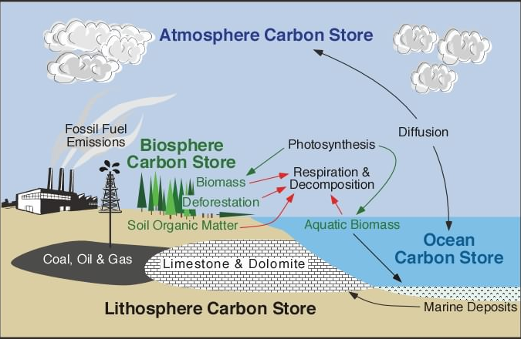

List the principal reservoirs (stores) you can see from this image:

**List all the forms of carbon on earth and put them into the category they are found in**

**In the atmosphere**:

Which compounds is carbon found in the atmosphere?

1.________________________________________________________

2.________________________________________________________

3.________________________________________________________

**In water**:

Which compounds is carbon found in the hydrosphere

1.________________________________________________________

2.________________________________________________________

**In the Biosphere**

Which compounds is carbon found in the biosphere?

1.________________________________________________________

2.________________________________________________________

3.________________________________________________________

**In the lithosphere**

Which compounds is carbon found in the lithosphere?

1.________________________________________________________

2.________________________________________________________

**The main processes in the carbon cycle**

Candidates should know the physical, chemical and biological processes involved in moving carbon between the reservoirs in the carbon cycle.

Put the correct term with the process description

1. **________________________**

The capture of light energy by pigments such as chlorophyll and the conversion of low-energy substances such as carbon dioxide and water into high-energy carbohydrates which can be stored if necessary. Oxygen is a by-product.

Write the balanced equation: _________________________________________________________

1. _____________________________

The release of energy from high-energy substances, such as carbohydrates, to drive metabolic processes.

Aerobic respiration can break down organic compounds more fully and release much more energy than anaerobic respiration. Balanced equation: _________________________________________

Anaerobic respiration allows some organisms to survive and use food sources in oxygen-deficient environments. Balanced equation: ___________________________________________________

1. _____________________________________

Some of the carbohydrates, proteins, and lipids produced by plants are eaten by herbivores, which may then be eaten by carnivores. These feeding relationships combine to make food webs.

1. ____________________________________

The incomplete decomposition of organisms, often under anaerobic conditions, leading to the deposition of fossil fuels.

The absorption of carbon dioxide by marine organisms, its storage in their skeleton and subsequent sedimentation of limestone and chalk on the seabed.

1. ______________________________________

The release of carbon dioxide by the burning of organic substances such as wood and fossil fuels.

1. _____________________________________

The breakdown of organic matter by microorganisms, releasing gases such as carbon dioxide under aerobic conditions and methane under anaerobic conditions.

**How humans affect the carbon cycle**

Many human activities alter the rates of movement of carbon through the cycle. This can unbalance the dynamic equilibria of the carbon cycle and change the amount of carbon in the reservoirs of the cycle.

On the following page draw the carbon cycle and annotate it fully with how human actions can impact these cycles.

Include information on how humans impact the following processes:

**Photosynthesis**

**Aerobic and anaerobic respiration**

**Carbonic acid concentration in the sea**

**Methane releases from fossil fuels**

**Combustion**

**Biomass movements**

**Reservoirs:**

Carbon can be stored as sinks or reservoirs of carbon, these can be living or non-living.

List the living reservoirs of carbon:

___________________________________________________________________________________________________________________________________________________________________________________________________________________________________________________List the non-living reservoirs of carbon:

___________________________________________________________________________________________________________________________________________________________________________________________________________________________________________________Why are the oceans so important in the carbon cycle?

___________________________________________________________________________________________________________________________________________________________________________________________________________________________________________________Describe dynamic equilibrium in relation to the carbon cycle:

___________________________________________________________________________________________________________________________________________________________________________________________________________________________________________________

**Sustainable management of the carbon cycle**

The consequences of human impacts on the carbon cycle are serious, especially those that contribute to climate change. A range of strategies exists to counteract these impacts.

**List all the ways humans effect the carbon cycle:**

___________________________________________________________________________________________________________________________________________________________________________________________________________________________________________________

**Conservation of biomass carbon stores**

__________________________________________________________________________________________________________________________________________________________________

**The use of alternatives to fossil fuels**

List some alternatives to fossil fuels which do not add as much carbon dioxide to the atmosphere as fossil fuels.

__________________________________________________________________________________________________________________________________________________________________

**Carbon sequestration** What is this and how do trees act as a carbon reservoir?

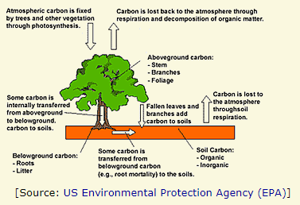___________________________________________________________________________________________________________________________________________________________________________________________________________________________________________________

___________________________________________________________________________________________________________________________________________________________________________________________________________________________________________________

**Carbon Capture and Storage (CCS)**

This involves capturing carbon, usually as CO2, so that it is not released into the atmosphere. A range of technologies is being developed.

**1. Post-combustion technology**

Carbon dioxide can be removed from the exhaust gases of fossil fuel combustion using

several methods:

* _____________________________________
* _____________________________________
* _____________________________________
* _____________________________________

None of these methods is fully developed and the costs for large-scale CO2 removal are uncertain. The costs are increased because only about 20% of the gases produced by combustion in air is CO2.

**2. Pre-combustion technology**

In the space below explain how the pre-combustion technology can be used for CCS.

___________________________________________________________________________________________________________________________________________________________________________________________________________________________________________________

___________________________________________________________________________________________________________________________________________________________________________________________________________________________________________________

___________________________________________________________________________________________________________________________________________________________________________________________________________________________________________________

__________________________________________________________________________________________________________________________________________________________________

**3. Storage**

Explain how CO2 is stored after it has been captured.

______________________________________________________________________________________________________________________________________________________________________________________________________________________________________________________________________________________________________________________________________________________________________________________________________________________________________________________________________________________________________

**The nitrogen cycle**

* The nitrogen cycle is an excellent example of how interconnected natural processes can make a natural resource which is not very abundant continually satisfy the needs of living organisms by recycling what has already been used.
* Many of these processes are carried out by living organisms, especially bacteria, where the waste products released by one group are the raw materials for another group.
* Nitrogen is essential for living organisms as it is a component of many essential biological molecules.

Which biological molecules need Nitrogen?

__________________________________________________________________________________________________________________________________________________________________

**The main reservoirs of the nitrogen cycle**

Candidates should know the principal reservoirs of nitrogen in the nitrogen cycle:

|  |  |
| --- | --- |
| Reservoir | Chemical form |
| Atmosphere |  |
| Biosphere |  |
| Lithosphere |  |
| Hydrosphere |  |

**The main processes in the nitrogen cycle**

A range of physical and biological processes combine to produce the natural nitrogen cycle.

Ionisation: processes such as lightning and meteor trails provide the energy for atmospheric nitrogen and oxygen to react and produce oxides of nitrogen.

**Fixation**: _________________________________________________________________________

_________________________________________________________________________________

**Food chains**: ______________________________________________________________________

**Nitrification**: ______________________________________________________________________

_________________________________________________________________________________

_________________________________________________________________________________

**Denitrification**: ____________________________________________________________________

_________________________________________________________________________________

_________________________________________________________________________________

**Leaching**: _________________________________________________________________________

_________________________________________________________________________________

_________________________________________________________________________________

**Root absorption**: ___________________________________________________________________

_________________________________________________________________________________

Annotate the diagram below with the form of the Nitrogen in each reservoir and the processes which link each reservoir.

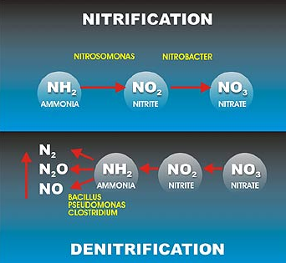

Atmospheric nitrogen

Nitrogen in animals

Nitrogen in plants

Nitrate ions

Nitrite ions

Ammonia

Ammonium ions

**Human Impacts on the Nitrogen cycle**

Some human activities alter the rates of natural processes in the nitrogen cycle, while others create new processes. These alter the natural dynamic equilibria of the cycle.

**Haber process**

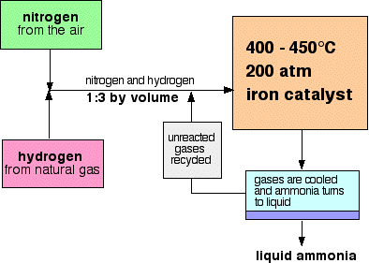___________________________________________________________________________________________________________________________________________________________________________________________________________________________________________________**_______________________________________________________________**

___________________________________________________________________________________________________________________________________________________________________________________________________________________________________________________

**Agriculture**

**Complete the blanks using some of the following key words:**

Denitrifying ploughing Nitrate Leguminous aerobic decomposition anaerobic nitrifying

The use of _________ fertilisers may increase the problems caused by leaching, especially if application is followed by heavy rain or if fertilisers are used close to rivers.

Drainage of fields makes the soil more _______________. This increases the number of aerobic _______________ bacteria and reduces the number of anaerobic __________________ bacteria.

Soil disturbance by _________________ increases the rate _______________ of of dead organic matter which releases more nitrogen oxides into the atmosphere.

_____________________ plants such as peas, beans, and clover may be grown to increase the levels of nitrogen compounds in the soil, which later crops can absorb.

**Pollution**

Oxides of nitrogen (NOx ) are released into the atmosphere by combustion processes and may subsequently increase the quantity of nitrates washed into the soil by rain.

**Sustainable management of the nitrogen cycle**

Human activities can be changed to ensure that resources containing nitrogen are available while environmental problems involving nitrogen are controlled.

**Control of combustion processes**

______________________________________________________________________________________________________________________________________________________________________________________________________________________________________________________________________________________________________________________________________________________________________________________________________________________________________________________________________________________________________

**Control of NOx releases**

___________________________________________________________________________________________________________________________________________________________________________________________________________________________________________________

**Management of biological wastes**

______________________________________________________________________________________________________________________________________________________________________________________________________________________________________________________________________________________________________________________________________________________________________________________________________________________________________________________________________________________________________

**Eutrophication**

___________________________________________________________________________________________________________________________________________________________________________________________________________________________________________________

**Organic fertilisers**

______________________________________________________________________________________________________________________________________________________________________________________________________________________________________________________________________________________________________________________________________________________________________________________________________________________________________________________________________________________________________

**Management of soil processes**

Farming practices can be changed to maximise advantageous processes that increase soil nitrate levels, for example, by:

1. _________________________________________________________________________

2. _________________________________________________________________________

3. _________________________________________________________________________

4. _________________________________________________________________________

5. _________________________________________________________________________

6. _________________________________________________________________________

7. _________________________________________________________________________

8. _________________________________________________________________________

9. _________________________________________________________________________

**The phosphorus cycle**

* The movement of phosphorus between terrestrial and oceanic stores.
* Phosphorus is more likely to be a limiting factor on biological processes than many other nutrients because most compounds of phosphorus have low solubility and there is no gaseous reservoir of phosphorus.

What is the biological importance of phosphorous?

______________________________________________________________________________________________________________________________________________________

**Main processes involves in the phosphorous cycle**

**Absorption by roots**

____________________________________________________________________________________________________________________________________________________________________________________________________________________________________________________________________________________________________________________________________

**Decomposition**

___________________________________________________________________________________________________________________________________________________________________________________________________________________________________________________

**Sedimentation**

___________________________________________________________________________________________________________________________________________________________________________________________________________________________________________________

**Mountain building and weathering**

___________________________________________________________________________________________________________________________________________________________________________________________________________________________________________________

Draw the phosphorous cycle below:

**Human impacts on the phosphorus cycle**

**Mining of phosphate rocks**

______________________________________________________________________________________________________________________________________________________________________________________________________________________________________________________________________________________________________________________________________________________________________________________________________________________________________________________________________________________________________

**Fertiliser use**

___________________________________________________________________________________________________________________________________________________________________________________________________________________________________________________

**Management of the phosphorus cycle**

______________________________________________________________________________________________________________________________________________________________________________________________________________________________________________________________________________________________________________________________________________________________________________________________________________________________________________________________________________________________________

______________________________________________________________________________________________________________________________________________________________________________________________________________________________________________________________________________________________________________________________________________________________________________________________________________________________________________________________________________________________________