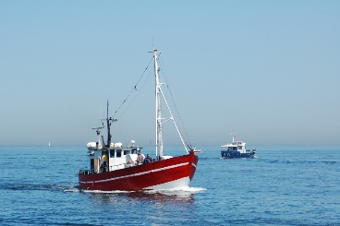

Aquatic Resources & Nutrients

Fisheries & Aquaculture

**Specification**

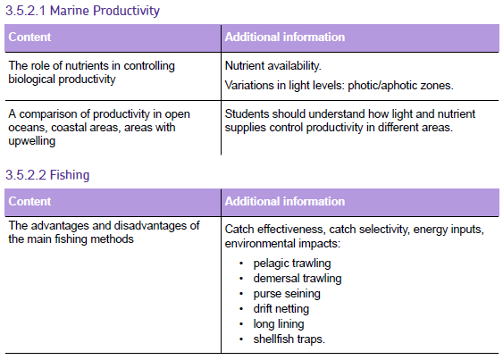

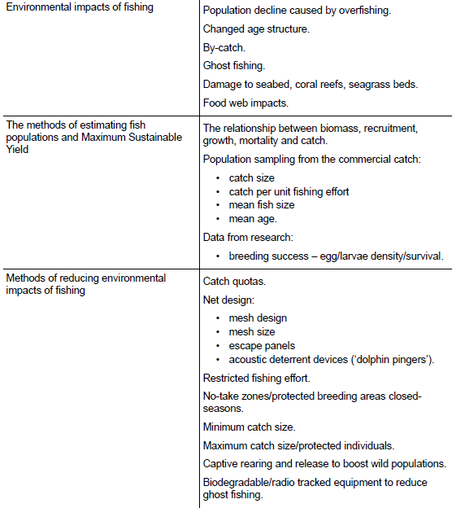

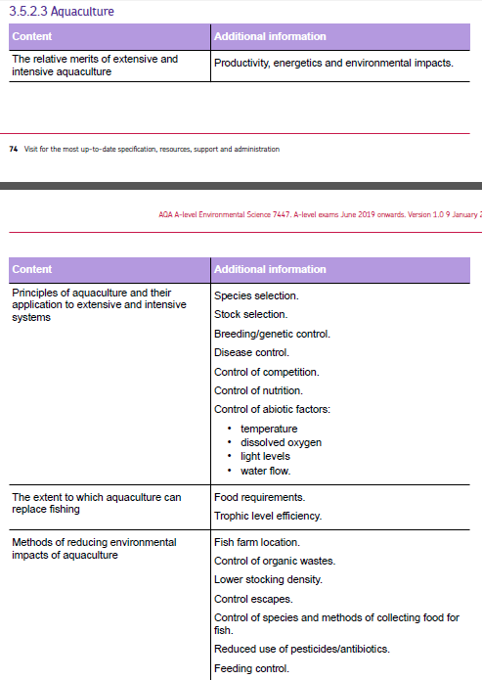

**Marine Productivity**

**Factors controlling marine productivity**

What is the ***productivity*** of a fishery?

Primary producers require the correct level abiotic conditions in order to grow:

|  |  |
| --- | --- |
| **Condition** | **Limitations in the sea** |
| Water |  |
| CO2 |  |
| Light |  |
| Nutrient salts |  |

**Questions**

1. 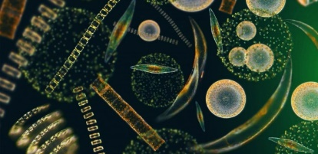Name the primary producers of marine food webs.
2. Why would you find primary producers such as large algae or seaweeds that are anchored to the ground in shallow seas?
3. When and where would you expect to find turbid water within the oceans?
4. What is an algal bloom and when would you expect to get algal blooms?

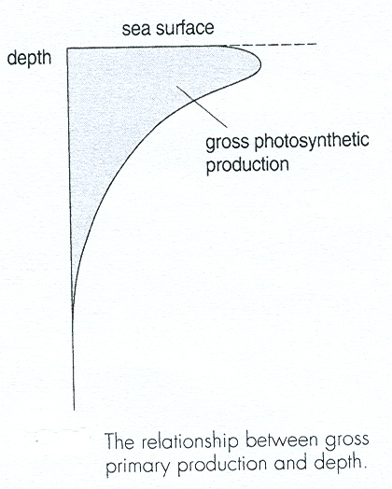Light can only penetrate to a certain depth in the sea. The graph below shows the relationship between gross primary productivity and depth

**Nutrients**

Which nutrients will limit the growth of autotrophs in the oceans?

In the sea where do these nutrients come from?

Diagrams to show how upwelling of nutrients can occur in the sea.

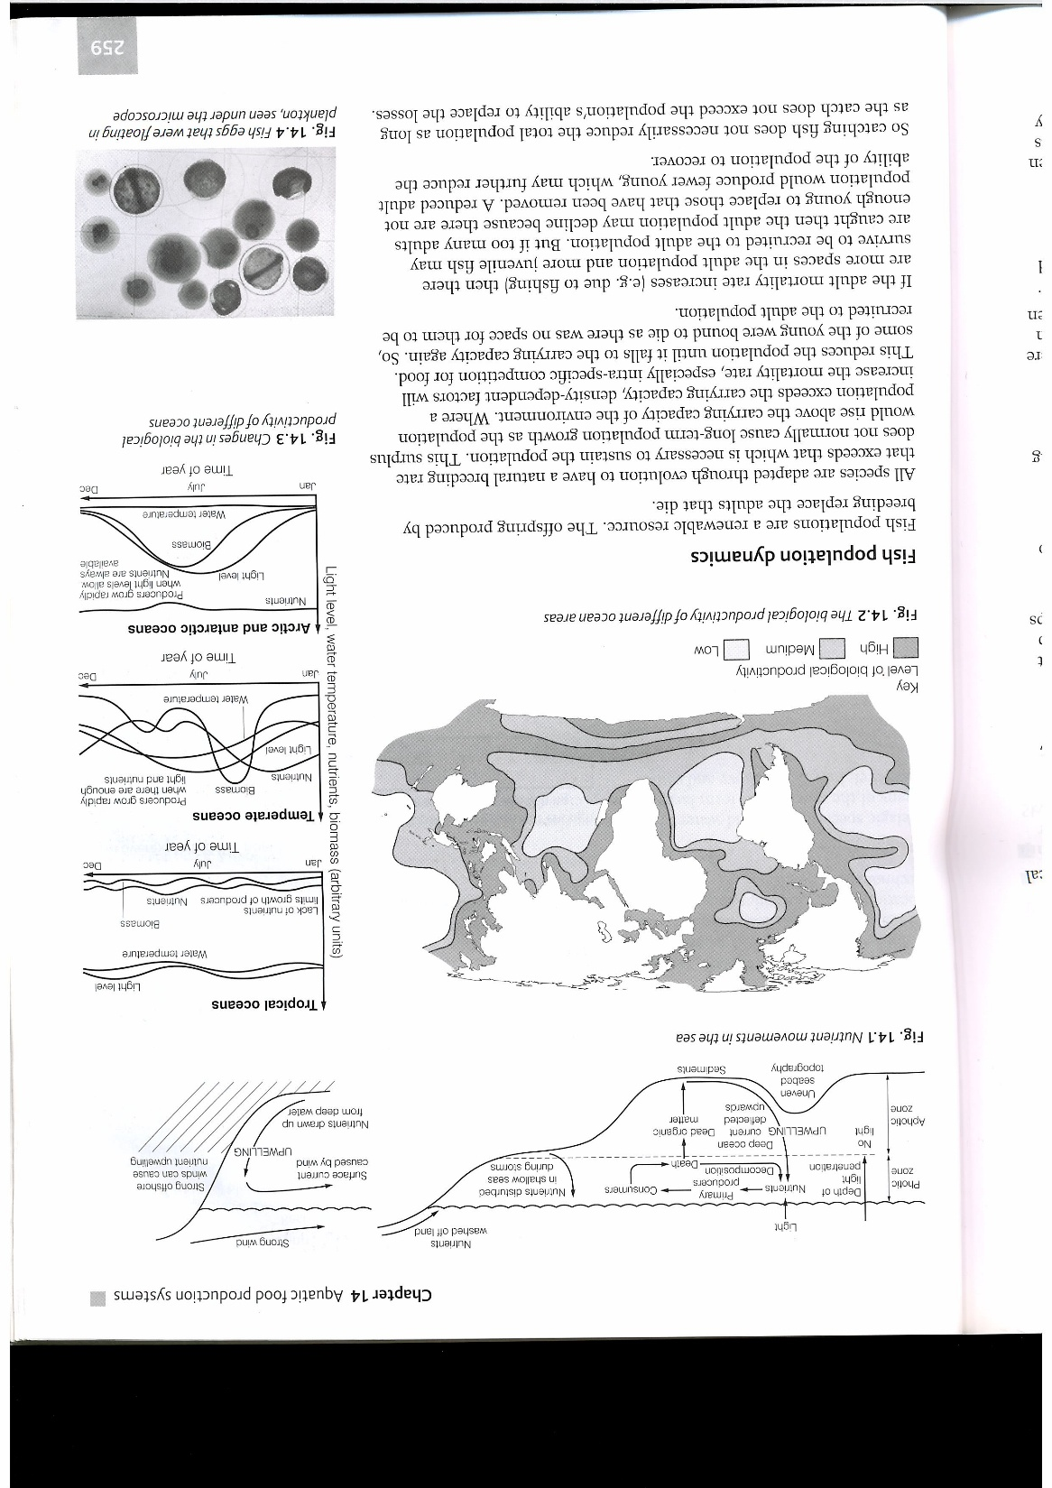

Using the diagram above, list and explain the different areas of the sea that have **high levels of nutrient salts**. For each example explain why the levels of nutrient salts are high

1

2

3

4

5

**Freshwater Productivity**

Water bodies on land receive nutrient runoff from land and receive high light levels so are very productive. However their productivity is limited due to the small total area of rivers and lakes

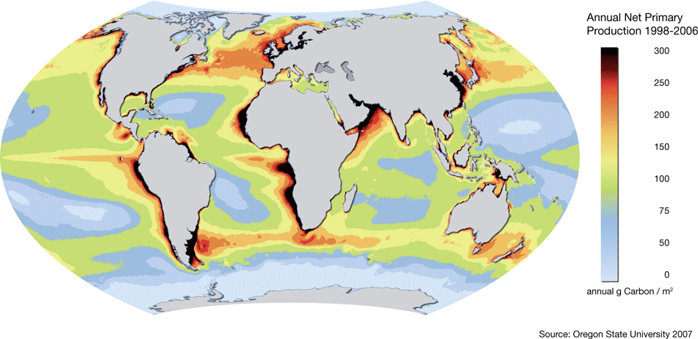

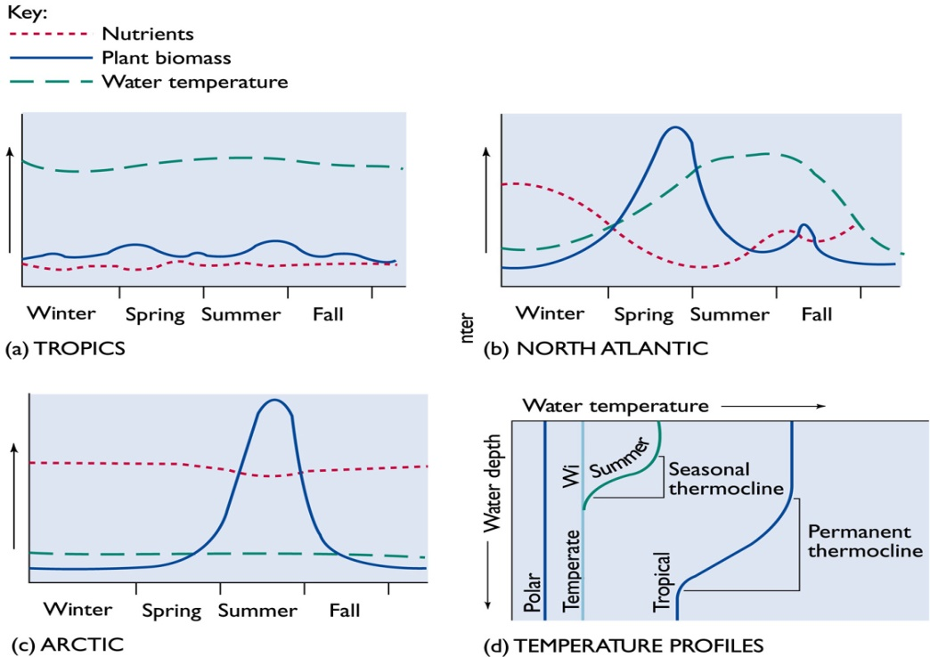**Graphs to show the changes in biological activity in different oceans.**

Describe and explain how productivity of plant biomass changes in these 3 different ocean areas. Make sure you make reference to nutrients, plant biomass and water temperature.

**1. Tropics**



**2. North Atlantic**



**3. Arctic**



**Population dynamics and monitoring fish population**

What factors will affect the population size of any species. Complete the diagram below.

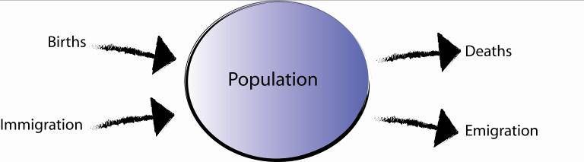

What is meant by reproductive capacity and why is this so high in fish?

What are density-dependent factors and give examples.

What are density-independent factors and give examples.

What is carrying capacity?

**MSY and Overfishing**

**Definition of MSY**

What happens if fishing rate is greater than the MSY?

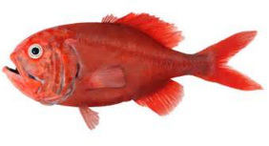Examples of fish that have been exploited above the MSY

1

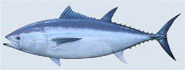2

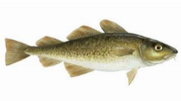3

**Russell Formula for calculating MSY**

**S2 = S1 + (A+G) – (C + M)**

Biomass needs to be estimated.

S1 =

S2 =

A =

G =

C =

M =

**Estimating** the MSY accurately is difficult because the data needed is hard to collect.

1

2

3

The number of young that will survive to enter the adult population is unpredictable

Fishermen are unaware of how many very young fish there are

Overfishing and poor recruitment combined can cause a rapid population decline

**An unexploited fish population**

Unavoidable mortality

**A population fished sustainably at the MSY**

Unavoidable mortality

**An overexploited fish population**

Unavoidable mortality

**Data from fishing catches**

Collecting data on populations at sea is difficult, data can be obtained from fish that are caught to give an indication as to the populations in the sea and whether fishing is over the MSY. However, the data collected can be misleading.

**Catch size**

**Catch per unit fishing effort**

**Mean fish size**

**Mean age**

**Scientific Research Data of Planktonic Fish Eggs and Larvae**

Survival rates of fish eggs and larvae can vary greatly in different years.

What could cause this difference in survival rates?

Data collected of planktonic fish egg and larval populations can help to predict numbers of young fish that are likely to be recruited into the adult population.

If data shows years of poor survival of eggs and larvae what can be done about the MSY?

**Questions**

1. Why would the MSY of a *slow growing fish* that does not breed until it is many years old (e.g. tuna, shark, orange roughy) be lower than *fast growing fish* that can breed after only a few years (e.g. herring, mackerel)?
2. What is the difference in terms of impact on fish populations if the allowed ‘take size’ is reached before the fish can breed rather than a catch size that has to be reached after the fish has attained breeding condition?

**Case Study: Newfoundland Cod Overfishing**

In the space below summarise the events that led to the Newfoundland cod fishery decline.

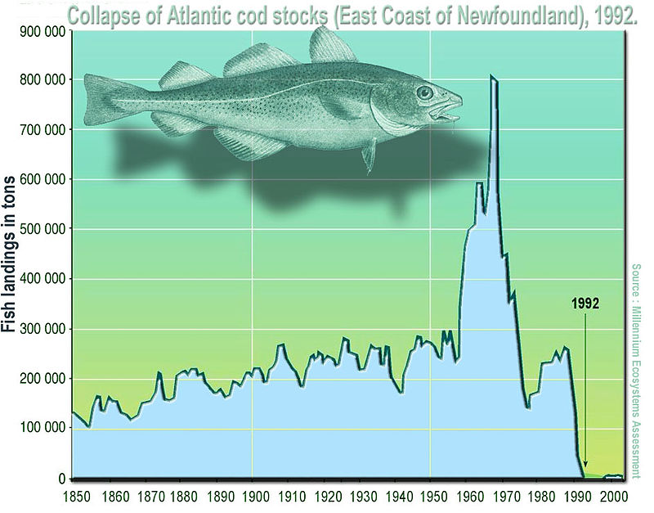

**Fishing techniques**

Explain the terms below giving examples of fish in the different areas.

**Pelagic Fishing:**

**Dermersal Fishing:**

**Task:** Using the factsheets from the presentations, complete the table below. You will need to summarise the fishing techniques and draw a diagram showing how the equipment needed

|  |  |  |
| --- | --- | --- |
| **Fishing Techniques: Demersal fishing** | | |
|  | **Description** | **Diagram** |
| **Dermersal long-lines**: |  |  |
| **Dermersal trawling**: |  |  |
| **Lobster and crab pots**: |  |  |

|  |  |  |
| --- | --- | --- |
| **Fishing Techniques: Pelagic fishing** | | |
|  | **Description** | **Diagram** |
| **Drift netting**: |  |  |
| **Purse seine**: |  |  |
| **Pelagic trawling**: |  |  |
| **Pelagic long-lines**: |  |  |

**Overfishing**

Summarise below the main ways in which fishing has become more efficient.

**Environmental impact of fishing**

Global demand for fishing has increased. More efficient techniques mean fish populations are falling and young fish are caught before they can breed. There has been a loss of diversity.

Summarise the key information in the table below. Use presentation on GOL or text book pg. 341-344.

|  |  |
| --- | --- |
| **Impact** | **Problems** |
| **Population decline by overfishing** |  |
| **Ghost fishing** |  |
| **By-catch** |  |
| **Habitat damage** |  |

**Management of marine production systems**

Complete the diagram by adding notes to the methods of reducing the environmental impacts of fishing

**Catch quotas**

**No-take zones (NTZ)**

**Escape panels**

**Mesh design**

**Mesh size**

**Restricted fishing methods**

**Restricted fishing effort**

**Fishing equipment & design**

**Ban on demersal trawling**

**Ban on drift nets**

**Biodegradable & radio tracked equipment**

**Night fishing**

**Sinkers**

**Decoys**

**Hook shape**

**Protected individuals**

**Maximum catchable size**

**Minimum catchable size**

**Closed seasons**

**Turtle bycatch**

**Captive rearing & release**

**Acoustic deterrent devices tracked equipment**

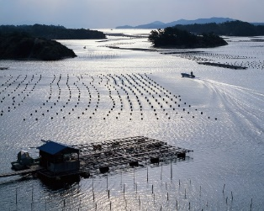Aquaculture

**Background to fish farming & aquaculture**

|  |
| --- |
| **Basic facts:**   1. Aquaculture has developed to support and provide food for growing populations. 2. Can be for freshwater or marine fish, crustaceans (e.g. lobsters) or molluscs (e.g. oysters & mussels); 3. MEDCs tend to breed high value species; 4. Like farming, competitors and diseases are controlled to some degree and conditions enhanced to increase production. 5. 90% of world aquaculture production is in Asia, especially carp in China |

Table to show the main species raised by aquaculture

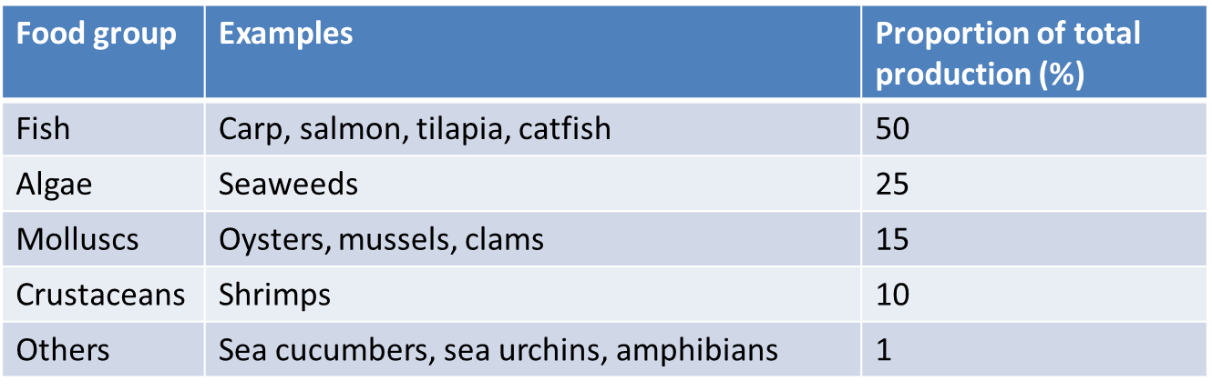

**Case Studies: Salmon and Shrimp Aquacultures**

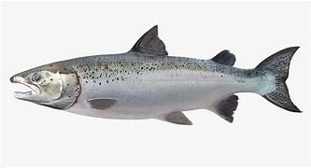

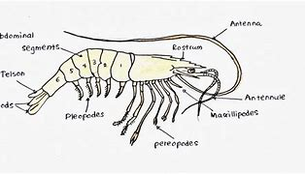

**Research:**

Find out details of the following and make notes on:

1. Natural life-cycle from egg to adult
2. Breeding and stocking of the aquaculture
3. What and how limiting factors are controlled
4. The environmental problems associated with the aquaculture
5. Any other relevant information

Make sure you use multiple sources of information, gather enough detail and be ready to explain your research this to someone in the class.

|  |
| --- |
| **Salmon Aquaculture** |
| **Breeding and stocking** |
| **Control of limiting factors** |
| **Environmental problems** |
| **Other relevant information** |
| **Shrimp Aquaculture** |
| **Breeding and stocking** |
| **Control of limiting factors** |
| **Environmental problems** |
| **Other relevant information** |

**The principles of aquaculture**

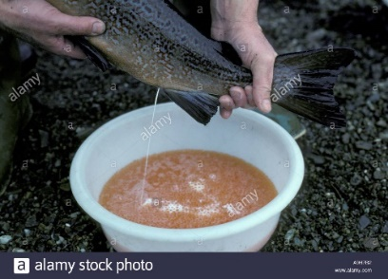**Selection of adults for breeding**

* Choose individuals with desirable characteristics e.g.

1.

2.

3.

* Eggs and milt are collected form mature individuals for fertilisation

**Gender Control**

* Gender (XX female or XY male) can be controlled by hormones regardless of the genetics in fish. If young fish are given female hormones they will all develop into females and vice versa but their genetics are unchanged.
* Gender choice depends on the species being cultivated

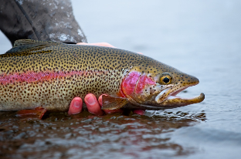**Rainbow Trout**

**Tilapia**

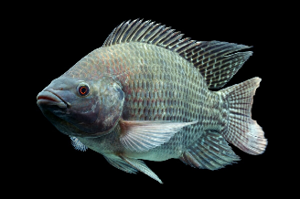

**Triploid fish**

**Control of pests & disease**

1.

2.

3.

4.

5.

**Control of competition and predation**

1.

2.

3.

**Nutrition**

1.

2.

**Control of abiotic factors**

Limiting factors can limit productivity:

1. Temperature –
2. Dissolved O2 –

1. Water flow rate –
2. Daylength –

**Types of Aquaculture**

|  |  |  |
| --- | --- | --- |
|  | **Extensive** | **Intensive** |
| ***Examples:*** |  |  |
| ***Inputs:*** |  |  |
| ***Selective breeding:*** |  |  |
| ***Control of the Environment:*** |  |  |

**Can aquaculture replace fishing?**

Could large-scale aquaculture replace fish needed when global fish catches are declining?

**Trophic level efficiency**

**Food requirements**

**Stock collection**

**Table summarising the environmental impacts of aquaculture and how these impacts can be reduced**

|  |  |  |
| --- | --- | --- |
| **Environmental impacts** | | **How impacts can be reduced** |
| **Impact** | **Details** |  |
| Food supply impacts |  |  |
| Habitat loss |  |  |
| Pesticide pollution |  |  |
| Development of antibiotic resistant bacteria |  |  |
| Control of wild predators |  |  |
| Impacts of controlling lice |  |  |
| Wild gene pool impacts |  |  |
| Introduction of non-indigenous species |  |  |
| Organic waste pollution |  |  |

**Other Types of Aquaculture**

For each type of aquaculture below. Describe the following:

* 1. How the aquaculture works
  2. Detail of any limiting factors that are controlled
  3. Environmental effects of this type of aquaculture
  4. Benefits of the aquaculture compared to other fishing techniques

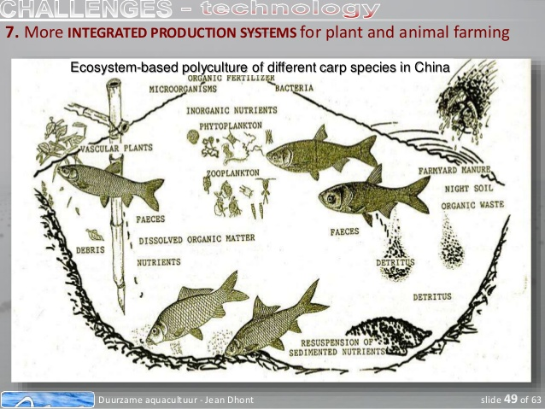**Polyculture**

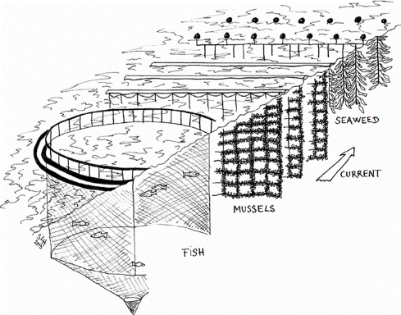**Integrated Multi-Trophic Aqauaculture (IMTA)**

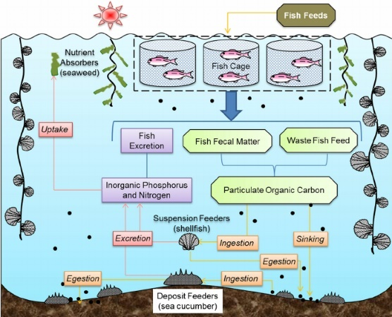

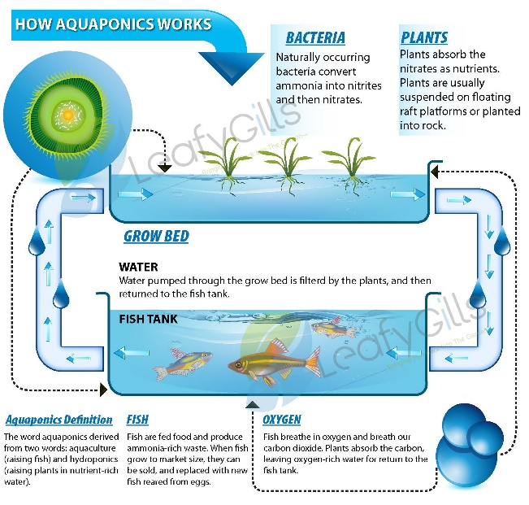**Aquaponics**