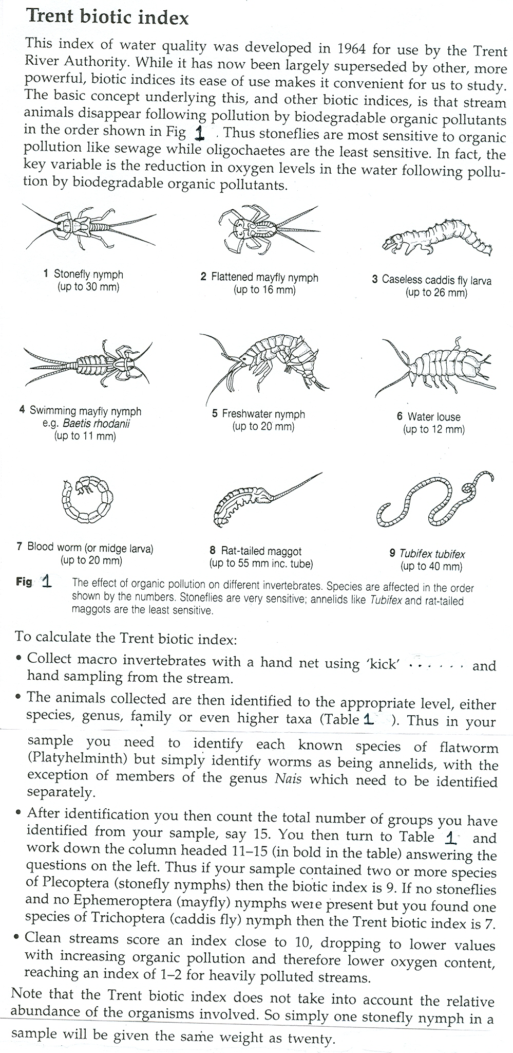

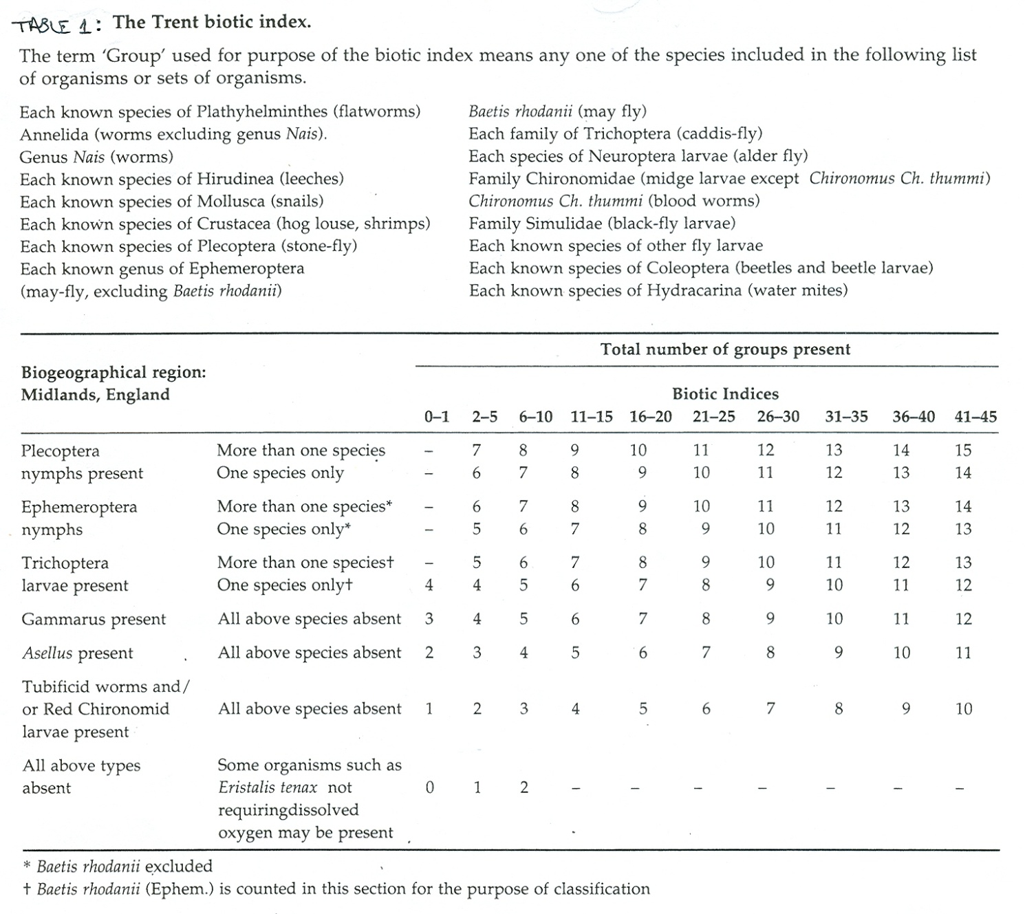

**Extension question:**

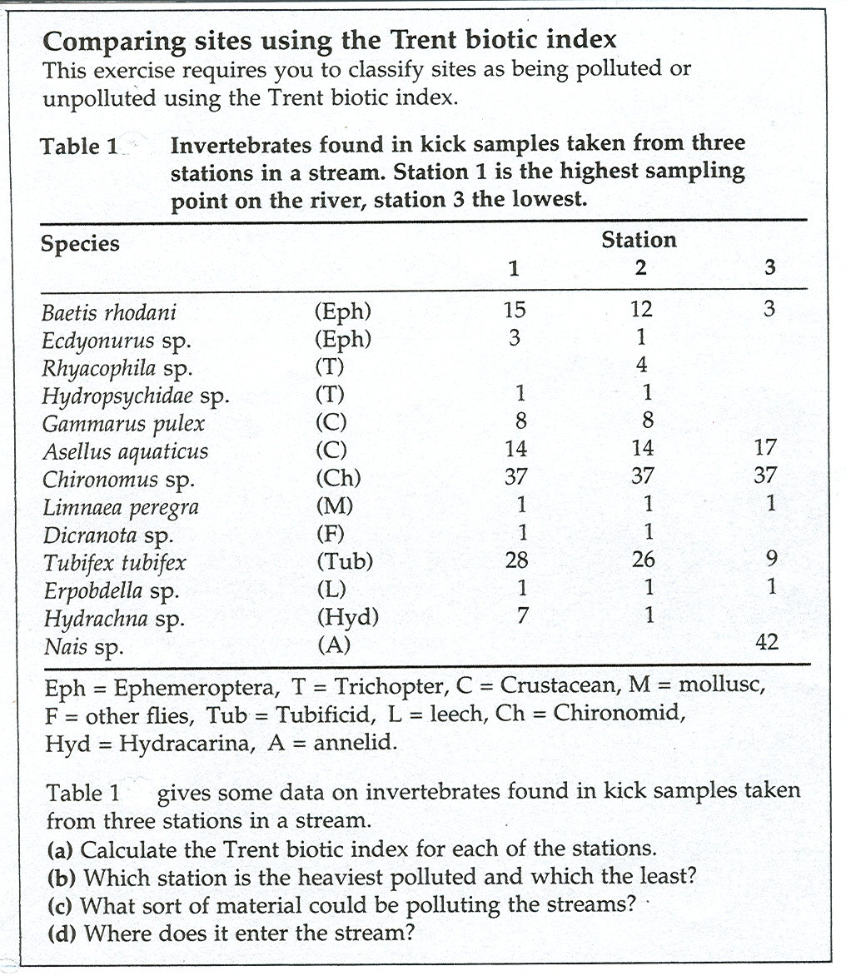

(a)…

Station 1 =

Station 2 =

Station 3 =

(b) …..

(c) …..

(d) ….

**4. Advantages & disadvantages of chemical, physical and biological water pollution monitoring**

***Reading:*** (1) Genn p. 196 – 198 (parts); (2) the passage below

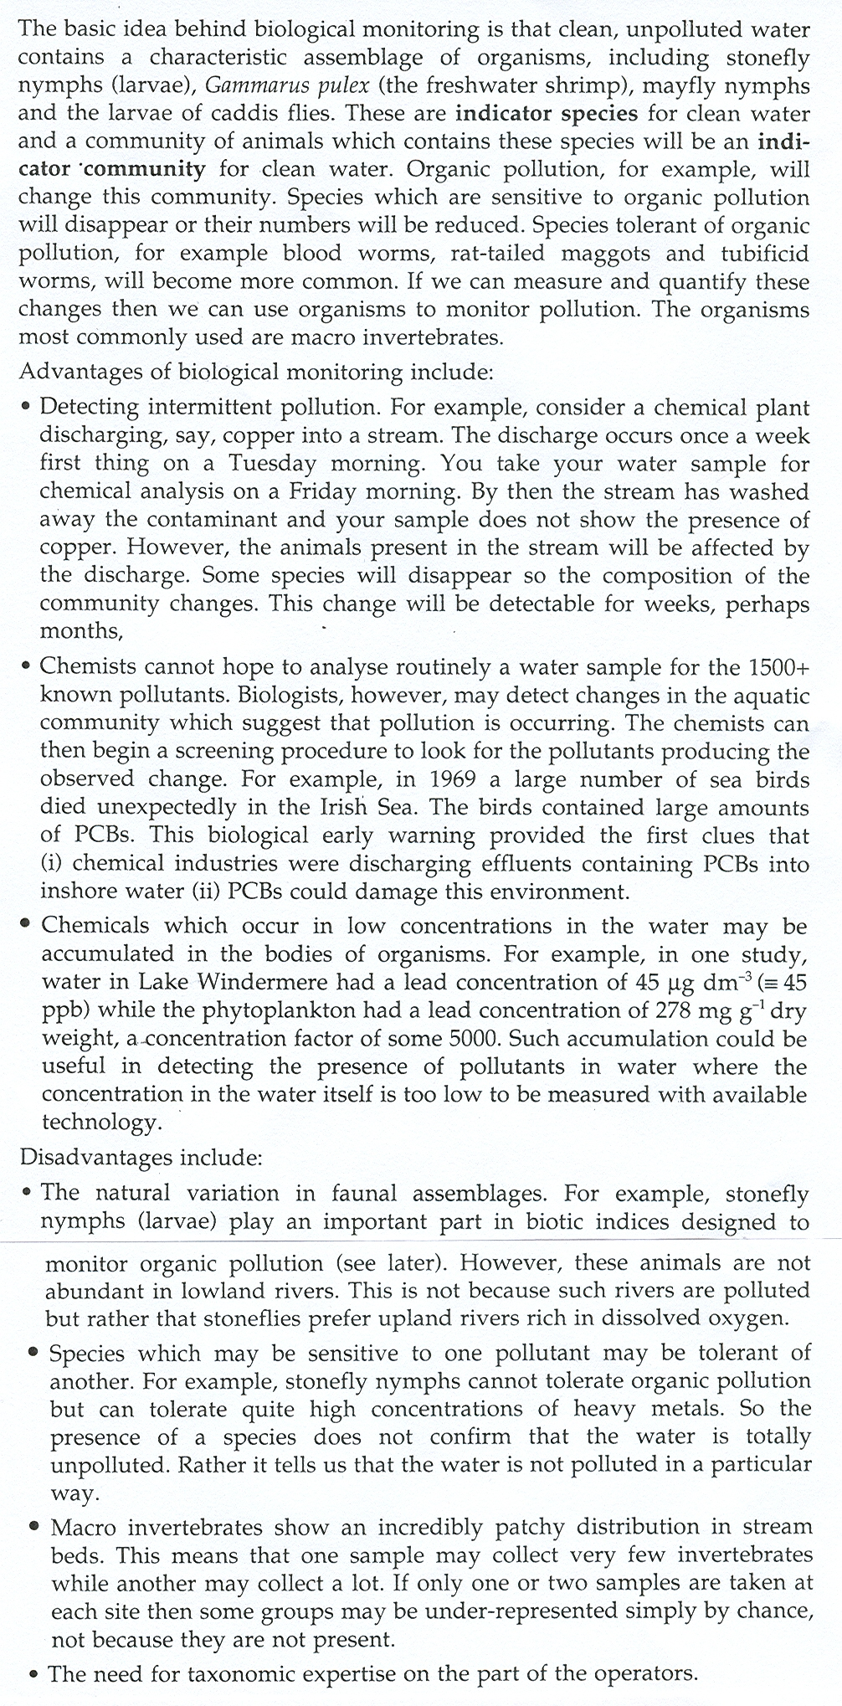

4.1 Complete the table below:

|  |  |  |
| --- | --- | --- |
| Method | Advantages: | Disadvantages: |
| Physical test methods: |  |  |
| Chemical  test methods: |  |  |
| Biological  test methods: | (at least 5) | (at least 6) |

5 Details of water testing methods:

5**.1 Use of the *oxygen dissolved spectrophotometer*:**

Study the extract usage notes and then answer the questions that follow:

1. What are the principles used to measure dissolved oxygen with a *oxygen dissolved spectrophotometer* ?

2. When using the *oxygen dissolved spectrophotometer* explain what precautions it is necessary to observe when handling sample cuvettes:

3. What it meant and what could or should you do if the LCD display indicates:

* **- - -**
* **S I P**
* **Z E R O**

4. It is important not to shake the cuvet and cause bubbles to generate in the sample; why is this?

5. What are the units that the concentration of dissolved oxygen are measured in?

6. Draw out flow chart to show how you would test a water sample for dissolved oxygen using a *oxygen dissolved spectrophotometer*