**Management & Leadership case studies: Richer Sounds**

Richer Sounds founder hands over control of hi-fi and TV firm to staff

**Chain joins John Lewis in employee ownership as staff get £1,000 for each year they have worked**

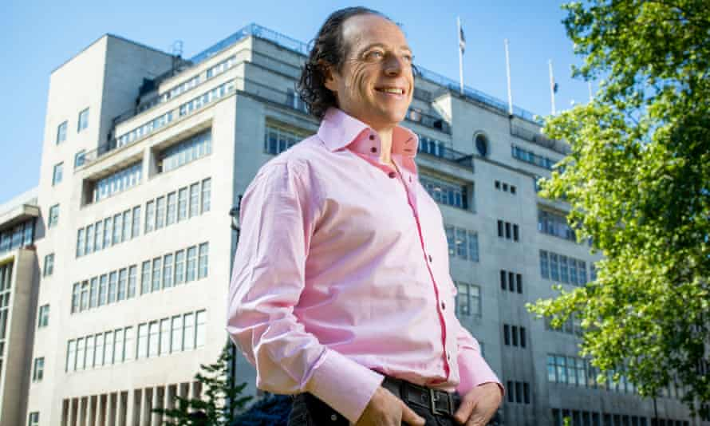

<https://www.theguardian.com/business/2019/may/14/richer-sounds-staff-julian-richer>

<https://www.ft.com/content/3ff0250a-e8ea-11e9-85f4-d00e5018f061>

The founder of [Richer Sounds](https://www.theguardian.com/society/2001/nov/05/11) is handing control of the hi-fi and TV retail chain to staff, in a move that will also give employees large cash bonuses.

Julian Richer will announce to staff on Tuesday that he has transferred 60% of his shares into a John Lewis-style trust. Richer, who recently turned 60, said the “time was right” to pass the baton to the chain’s 531 employees.

“My father dropped down dead at 60 so I am very keen for this to happen in my lifetime,” explained Richer. “I felt the time was right, rather than leaving it until I’m not around, to ensure the transition goes smoothly and I can be part of it. I still really, really care but it is time for the next generation.”

The company will pay Richer an initial £9.2m for the stake but the businessman is giving £3.5m of that back to staff, who will receive £1,000 for every year they have worked for the retailer.

Advertisement

The average payout will be £8,000 but there are 39 employees with more than 20 years’ service who stand to receive substantial windfalls. The company’s nine directors, who Richer said earn six-figure salaries, are not included in the bonus pool: “This is to thank loyal, hardworking colleagues.”

With annual sales of nearly £200m, Richer Sounds is one of the biggest UK companies to embrace employee ownership in recent years.

The Employee Ownership Association (EOA) says more than 350 businesses have now adopted the model, with at least 50 more preparing to follow suit. Recent converts include [Riverford, the organic vegetable box company](https://www.theguardian.com/business/2018/apr/07/riverford-organic-veg-employee-ownership-plan) and [Aardman](https://www.theguardian.com/film/2018/nov/10/wallace-gromit-producers-hand-stake-in-business-to-staff), the Bristol-based animation studio behind [Wallace & Gromit](https://www.theguardian.com/tv-and-radio/wallace-and-gromit).

An unorthodox business figure, with his long hair and sideline as the drummer in funk band Ten Millennia, Richer is lauded for the success of Richer Sounds which he founded in 1978 at the age of 19. His business philosophy, set out in his 2001 management book The Richer Way, champions providing secure, well-paid jobs with a happy workforce as being key to business success over the long term.

Richer Sounds, which has 53 stores, refuses to use zero-hours contracts and is one of the 14% of companies with a pay gap that favours women. Employee perks include access to company holiday homes around the world, including in European cities such as Paris, Venice and Barcelona. It donates 15% of profits, which last year stood at £9.6m, to charity.

Richer will stay on as managing director for the time being. Day-to-day operations are already overseen by the chief executive, Julie Abraham, who will eventually succeed him. Richer and the retailer’s chairman David Robinson are two of four trustees of the newly established Richer Sounds Trust.

Robinson, who has worked for the company for 35 years, said the ownership change would make colleagues feel even more connected to the company: “They have a real stake in the success of the business and can take pride in knowing they are shareholders, building for the future.”

Richer, who has no children, had written the plan into his will but began preparations two years ago to avoid his wife Rosie having to oversee the process. “I think it’s the adult thing to do and, psychologically, passing control is important because I’ve been on this gold-plated treadmill for 40 years,” he said.

The trust will operate according to a set of principles designed to ensure it continues to follow the course set by Richer over the past 40 years. A colleague advisory council will be established to represent the interests of employees and shape the company’s future.

Richer said the arrangement meant the company would avoid an “aggressive” outside investor “changing the strategy”.

If Richer Sounds continues to be successful Richer will receive additional payments over a 15 year period but would have raked in more cash if he had hoisted a for sale sign. His 100% ownership accounted for just over half his £160m fortune in the annual Rich List survey.

Business email signup

“I feel an incredible loyalty to my hard working colleagues and they should receive any benefit from running the business once my time is up as opposed to just selling to the highest bidder,” said Richer. “They know the business, and especially our rather unusual culture, extremely well, and the business is therefore far more likely to flourish under their own steam because of this.”

The changes at Richer Sounds do not mean the Yorkshire-based entrepreneur, who is currently advising Marks & Spencer on how to change its dysfunctional business culture, is about to retire.

He is financing [Taxwatch](https://www.theguardian.com/business/2018/may/27/julian-richer-crusade-expose-tax-avoiders-richer-sounds), a non-profit organisation which pores over the opaque finances of multinational companies, and is considering funding a test case against zero-hours contracts.

The EOA chief executive, Deb Oxley, suggested employee ownership was reaching a tipping point: “We’re delighted to see Richer Sounds secure its future independence with a focus on its people and an eye on the future world – a world with a more inclusive economy and where more businesses are a force for good.”

## What is employee ownership?

Employee-owned businesses are entirely or significantly owned by their workforce. Shares can be held by individuals or collectively through an employee trust – or a mixture of both. A company will also have a mechanism to represent their views, such as a council, board or employee representative. Decisions are still made by a board but employees have a say on operational and strategic matters. The model is said to allow companies to plan investment and growth over a longer horizon rather than having to satisfy the short-term demands of external shareholders.

## Other examples of employee-owned companies

The [John Lewis Partnership](https://www.theguardian.com/business/johnlewis), which owns the eponymous department stores and Waitrose, is the UK’s biggest employee-owned business with 83,900 employees or “partners”. Pioneering businessman John Spedan Lewis signed away his ownership rights in 1929 to allow future generations to take forward an “experiment in industrial democracy”.

[Riverford Organic Farmers](https://www.theguardian.com/business/2018/apr/07/riverford-organic-veg-employee-ownership-plan) made the switch last year when founder Guy Singh-Watson gave over a 76% stake to a trust. Its 650 employees will share 10% of annual profits generated by the £60m turnover business, which delivers nearly 50,000 boxes of produce a week. The company is paying Singh-Watson £6m over four years.

Last year the [owners of Aardman](https://www.theguardian.com/film/2018/nov/10/wallace-gromit-producers-hand-stake-in-business-to-staff), the Bristol-based animation studio behind [Wallace & Gromit](https://www.theguardian.com/tv-and-radio/wallace-and-gromit), Shaun the Sheep and [Morph](https://www.theguardian.com/tv-and-radio/2015/jul/28/how-we-made-morph-peter-lord-david-sproxton), used a trust to pass a 75% stake to 140 employees and freelancers. The move was designed to protect the company’s independence and its animators will continue to receive a share of profits.

Employees of 134 year-old Essex jam-maker Wilkin & Sons own almost half the company through a trust. Many staff live in company accommodation on the estate surrounding the Tiptree factory, with trading profits used to buy back shares for the trust. Profits also go to support local projects including sports and arts organisations.