**Ryanair boss may be flying by the seat of his pants in row with pilots**

Funnily enough, Michael O’Leary did not preach a gospel of peace, love and goodwill to all pilots at Thursday’s annual meeting. Even by his standards the [Ryanair](https://www.theguardian.com/business/ryanair) chief executive’s belligerence was extraordinary.

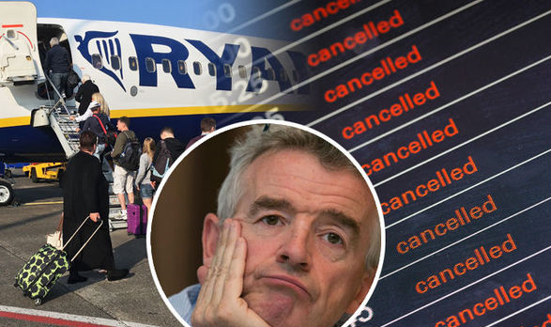Pilots do not have a difficult job, [shareholders were told](https://www.theguardian.com/business/2017/sep/21/ryanair-boss-holiday-plans-michael-oleary-flight-cancellations). Some are “precious about themselves” and “full of their own self-importance”. To manage Ryanair’s crisis over [cancelled flights](https://www.theguardian.com/business/2017/sep/16/ryanair-cancels-up-to-50-flights-a-day-to-improve-punctuality), O’Leary may force a few to re-arrange their own holidays. And, while he may have a few incentives in his back pocket, “if pilots misbehave, that will be the end of the goodies”.

O’Leary, one assumes, is confident the current storm will pass but you have to wonder whether his approach can possibly make long-term commercial sense. First, even if they enjoy a comfortable life, pilots are trained professionals in a regulated industry and probably don’t like being addressed as over privileged schoolchildren. Second, the planes can’t take off without them. Third, even Willie Walsh, when he was in full cost-cutting mode at British Airways, knew better than to pick a fight with the pilots.

O’Leary, one senses, feels he will prevail because he isn’t dealing with a union. “I don’t even know how there would be industrial action in Ryanair,” he said at the meeting. Yet that analysis skirts around the fact that some of the pilots would like to unionize, as they do at most other European airlines. At the very least, they may see this crisis as a one-off opportunity to secure permanently higher pay and better conditions. They may also to want to escalate matters by attracting regulators and politicians to the drama.

A conventional chief executive would be looking to turn down the heat. That’s not O’Leary’s style, which makes events unpredictable. The City’s lack of concern, seen in a share price that has barely moved, remains baffling. Bloody-mindedness can be a great strategy until it isn’t.

# Ryanair chief claims he can force pilots to give up a week of leave

Michael O’Leary says pilots do not have a ‘difficult job’ but admits he cannot rule out further flight cancellations into November

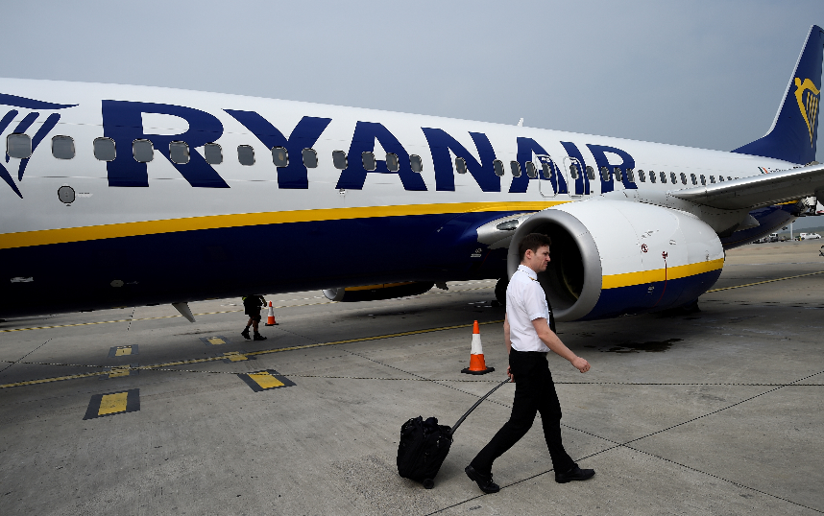

The [Ryanair](https://www.theguardian.com/business/ryanair) chief executive, Michael O’Leary, has escalated the airline’s dispute with pilots, saying they do not have a “difficult job” and claiming he can force them to defer their time off.

O’Leary is scrambling to prevent more disruption to Ryanair’s schedule after cancelling up to [50 flights a day](https://www.theguardian.com/business/2017/sep/16/ryanair-cancels-up-to-50-flights-a-day-to-improve-punctuality) due to a rota “mess-up” that left it short of pilots.

Speaking at the airline’s AGM in Dublin on Thursday, he dismissed suggestions of industrial action from [disgruntled pilots seeking improved employment terms](https://www.theguardian.com/business/2017/sep/20/more-ryanair-cancellations-likely-as-pilots-reject-offer-to-work-on-days-off).

“I don’t even know how there would be industrial action in Ryanair,” O’Leary said. “There isn’t a union.”

He said the airline had “some goodies” to discuss with pilots, but warned: “If pilots misbehave, that will be the end of the goodies.”

On Wednesday, a group of pilots [turned down an offer](https://www.theguardian.com/business/2017/sep/20/more-ryanair-cancellations-likely-as-pilots-reject-offer-to-work-on-days-off) of up to £12,000 to keep flying during their scheduled leave, many of them putting their names to a letter demanding full employment contracts instead.

Ryanair said in an email to pilots earlier this week that it needs them to fly more hours to avoid more flights being scrapped.

But it now says that any new cancellations would be due to unforeseen reasons such as bad weather and would not be related to its staffing issues.

O’Leary appeared unwilling to give any ground in the standoff, instead threatening to cancel pilots’ time off and questioning the extent of their talents.

He said any that were due a four-week break in the next few months could be forced under the terms of their contract to delay one of those weeks until January, in exchange for double pay during that week.

He also accused some pilots of being “precious about themselves” and “full of their own self-importance”.

“Once you are trained and skilled at doing it … I would challenge any pilot to explain how this is a difficult job or how it is they are overworked, or how anybody who by law can’t fly more than 18 hours a week could possibly be suffering from fatigue,” he said.

Two pilots told the Guardian that they and many of their colleagues were angered by O’Leary’s claims about their employment conditions. One said the figure of 18 hours quoted by O’Leary appeared to have been calculated by dividing the maximum permitted 900 hours flight time per year by 52 weeks. He said this did not reflect the number of flight hours in a normal working week and also omitted many hours of time before and after flights.

“During my time working at Ryanair I worked on more than a few occasions over 50 hours per week,” said the pilot, who asked not to be named in case it affected his job.

“It frustrates many of my colleagues and myself to see such incorrect statements being made,” he added.

Another pilot who left Ryanair recently after more than five years said: “It’s very much in character for [O’Leary] to denigrate the job of what is traditionally a highly respected profession.” A letter from pilots to Ryanair had signatories from bases across [Europe](https://www.theguardian.com/world/europe-news) turning down the airline’s offer of a tax-free cash bonus and warning that they are prepared to “work to rule”. If pilots make good on the threat, they will refuse to do anything outside their contractual obligations, such as turning up early to avoid delays or answering phone calls on days off.

O’Leary said: “There isn’t a bad relationship between Ryanair and our pilots. We asked on Monday for volunteers to work days off ... We have had huge cooperation and support from pilots.”

Referring to pilots’ pay, he said: “Maybe we have got it a bit on the low side,” adding that increases might be needed in areas where recruitment is harder, such as London Stansted, Dublin, Frankfurt and Berlin. He said the airline has hired 125 new pilots in the past fortnight to help solve its rota problem.

The outspoken chief executive repeated apologies to about 315,000 passengers and admitted the airline had made a “major boo boo”.

But his contrition did not appear to have appease all investors, some of whom voted against the company’s remuneration report and the re-election of board members.

While nearly 89% of the votes cast were in favour of its pay deal for directors, US pension funds Calstrs and Calpers voted against, while Calstrs also voted against the re-election of nearly the entire board, including O’Leary.

Their fellow shareholder NN Investment Partners said in a recent report that it had “growing concern about how the airline pays its staff and interacts with unions”.

# Further Ryanair cancellations likely as pilots reject cash to work on days off

Airline faces fresh trouble as pilots turn down bonus offer to work on holidays and starting early

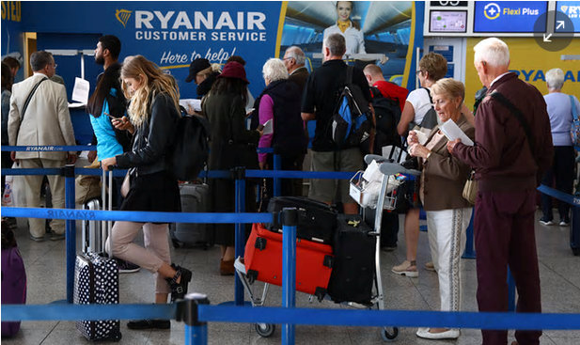

Ryanair customers face the threat of a fresh wave of flight cancellations as the airline’s pilots prepare to reject [an offer of a cash bonus](https://www.theguardian.com/business/2017/sep/19/ryanair-offers-pilots-12000-bonus-to-tackle-cancelled-flights-fiasco) if they give up days off.

The Guardian has obtained a draft letter signed by Ryanair pilots from across Europe, rejecting the offer and warning they will now “work to rule” - refusing to work beyond their basic contractual obligations. [Ryanair](https://www.theguardian.com/business/ryanair) had told pilots earlier this week that if they declined the £12,000 payment more flights might have to be scrapped.

The no-frills carrier is scrambling to cope with a public relations disaster after it [announced plans to cancel up to 50 flights a day](https://www.theguardian.com/business/2017/sep/18/ryanair-cancelled-flights-compensation) until 31 October, citing a “mess-up” in how it schedules time off for pilots. The move has affected 315,000 customers.

**Why is Ryanair cancelling flights?**

The letter circulating at Ryanair bases across [Europe](https://www.theguardian.com/world/europe-news) states: “We would like to advise that with immediate effect the pilot workforce at the bases [airports] listed below rescind the goodwill that has been extended toward the company for many years, including working days off and turning up early. In short, we shall now ‘work to rule’.”

Working to rule would mean pilots refusing to help the airline by going beyond the terms of their contracts, which would involve working days off, arriving for shifts early or even answering company calls when they are not at work.

The pilots have been spurred on by colleagues flying for rival European airlines, amid concern that Ryanair is leading a “race to the bottom” that has seen terms and conditions watered down across the industry.

The draft letter is a response to Ryanair’s chief operations officer, Michael Hickey, who this week offered a tax free bonus of up to £12,000 to pilots willing to give up time off in an effort “to avoid further cancellations”. The letter takes issue with Hickey’s offer on six separate grounds, including that pilots must have worked 800 flight hours in a year to be eligible for the tax-free bonus. “Pilots have checked their logbooks and many have never achieved 800 flight hours in a single 12-month period ever,” it says.

The pilots also object to “ambiguity” surrounding the offer’s conditions, including the number of days off they would be required to work to get the bonus and whether enough days would even be allocated by Ryanair. Ryanair pilots at the airline’s bases across Europe are discussing whether to put their names to the letter, but several are understood to have done so already.

**The airline’s 4,200 pilots –** [**many of whom work as agency contractors**](https://www.theguardian.com/commentisfree/2017/sep/20/ryanair-treat-pilots-better-crisis-long-haul) **– are not unionised, and could face the risk of being fired for taking such action.**

But one pilot familiar with the discussions said the airline, which has seen more than 700 pilots quit in the past year, is too short of experience to take such drastic action. “They are not in a position to fire pilots because it would exacerbate their problem,” they said.

The letter also makes reference to pilots’ strong bargaining position, saying: “The company faces a pilot shortage and even if this is only for a short period of time, the reputational damage that could result [...] could be extremely long lasting both in terms of customer and shareholder confidence.” Ryanair pilots are being encouraged and offered advice by their peers at airlines across Europe. “There has been a race to the bottom in terms and conditions which is led by Ryanair and it’s having an impact throughout Europe,” the pilot said.

“It’s sucking guys out of Europe to the Middle East and China where terms and pay are better.” Pilots are expected to demand that Ryanair agree to offer them local contracts offering full employee rights under the employment law in the country where they are based. “The continued erosion of the pilots terms and conditions over the past 10 to 15 years has to be not only stopped but reversed,” the letter says.

Ryanair has not yet returned a request for comment.

The airline said on Wednesday that it hoped to have made new arrangements for more than 175,00 customers on other Ryanair flights and processed 63,000 refunds, taking on extra customer service staff to deal with the problem.

But consumer group Which? said the information it had offered to passengers about compensation “falls woefully short”. “The airline must now automatically compensate eligible passengers without them having to go through the additional hassle of making a claim.”

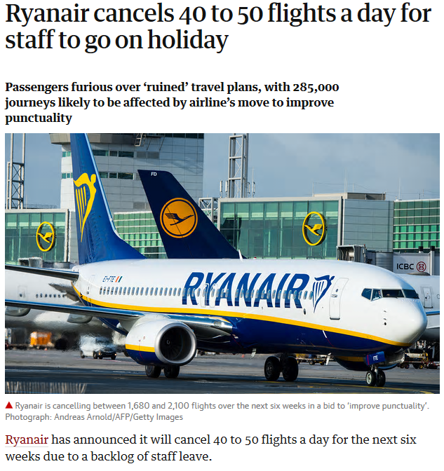

The budget airline says the measure is designed to improve punctuality, which has fallen below 80% in the first two weeks of September.

Some customers have reacted furiously to the cancellations, claiming holiday plans have been ruined by the decision.

The airline is changing its internal calendar as part of increases in holiday allowances for pilots and cabin staff, which has contributed to the backlog.

A Ryanair spokesperson said: “We have operated a record schedule (and traffic numbers) during the peak summer months of July and August but must now allocate annual leave to pilots and cabin crew in September and October (while still running the bulk of our summer schedule).

“This increased leave at a time of ATC [air traffic control] capacity delays and strikes has severely reduced our on-time performance over the past two weeks to under 80%. By cancelling less than 2% of our flying programme over the next six weeks, (until our winter schedule starts in early November) we can improve the operational resilience of our schedules and restore punctuality to our annualised target of 90%.

“We apologise sincerely to the small number of customers affected by these cancellations, and will be doing our utmost to arrange alternative flights and/or full refunds for them.”

If the airline cancelled 40 flights per day for six weeks at a load factor of 90%, approximately 285,000 journeys would be affected.

# Ryanair's UK cabin crew to be represented by union for first time

**Unite signs recognition agreement with airline that could cover about 650 staff**

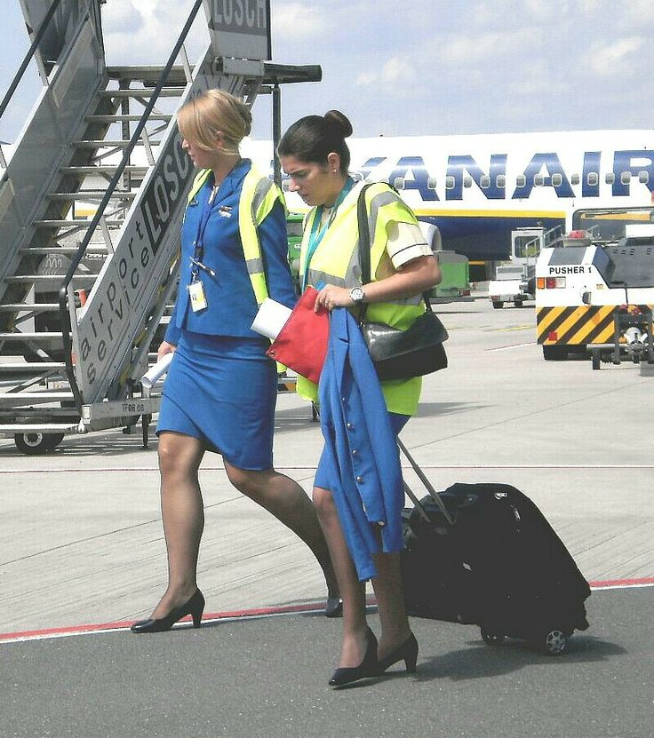Cabin crew at Ryanair in the UK will be represented by a union for the first time after [Unite](http://www.unitetheunion.org/) signed a recognition agreement with the airline.

About 650 staff working from Ryanair’s UK bases could be covered by the deal, with the union able to represent them in talks on pay, hours and holidays.

Read more

The news follows similar agreements with two Italian cabin crew unions five days ago, when the airline said it hoped to sign more recognition deals in the coming weeks.

The rights for crew came after months of talks following Ryanair’s announcement late last year that it [would recognise unions](https://www.theguardian.com/business/2017/dec/19/first-pilots-now-cabin-crew-ryanair-recognises-other-unions) – a move prompted by a shortage of pilots that caused a [wave of cancellations](https://www.theguardian.com/business/2017/sep/18/ryanair-flight-cancellation-passengers-holiday). It has struck deals with pilots’ unions across Europe, including [Balpa in the UK](https://www.theguardian.com/business/2018/jan/30/ryanair-deal-uk-pilots-union-balps), but securing similar agreements for crew has taken longer.

Many crew members remain indirectly employed via agencies such as Crewlink and will not come under the remit of the [Unite](https://www.theguardian.com/uk-news/unite) deal.

Working conditions at the airline have been scrutinised, with aspiring crew members having to pay [thousands of pounds](https://www.theguardian.com/business/2013/oct/26/ryanair-cabin-crew-training-fees) to train to work for Ryanair, as well as facing sanctions for not hitting sales targets onboard.

Unite, which represents more than 25,000 cabin crew across airlines operating from the UK, said it had secured full consultation rights and collective bargaining for Ryanair’s employees, from whom three union representatives will be drawn, with paid time off for union duties.

The Unite general secretary, Len McCluskey, said it was a “historic agreement and a significant step by Ryanair”, and urged all crew to join the union.

“For the first time ever, Ryanair’s UK cabin crew will have a recognised union in their corner to deal with workplace issues and collectively bargain on pay,” he said.

Sign up to the daily Business Today email or follow Guardian Business on Twitter at @BusinessDesk

“I’d urge all UK-based [Ryanair](https://www.theguardian.com/business/ryanair) cabin crew to join Unite and be part of one the biggest trade unions in the world representing airline workers.”

McCluskey said the union would be pursuing similar agreements with the agencies that indirectly employ the rest of Ryanair’s UK cabin crew. “Unite looks forward to building a positive relationship with Ryanair that benefits passengers and workers alike,” he said.

The International Transport Workers’ Federation welcomed the union recognition, but said it did not yet mean Ryanair’s working practices had been reformed.

“We welcome this historic first step from Ryanair to talk to Unite the union on behalf of all UK workers. However, there is a still long way to go to resolve all the issues that their workforce have raised with our affiliates across the Ryanair network,” said the ITF general secretary, Stephen Cotton.

Ryanair’s chief people officer, Eddie Wilson, said the Unite agreement was a further sign of the progress the airline was making with trade unions since its decision to recognise them. “We are confounding those sceptics who claimed that our decision was not real or genuine,” he said

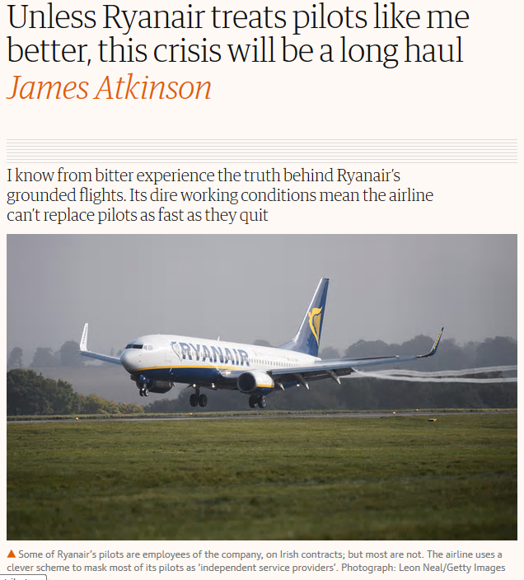 [Ryanair has cancelled many hundreds of flights over the past two weeks,](https://www.theguardian.com/business/2017/sep/18/ryanair-cancelled-flights-compensation) and that number will soon run into the thousands. The airline has scrambled to explain the cancellations, and these explanations grow more colourful each day. A new regulation on pilot flight time limitations? French air traffic control? Bad weather in Italy? Pilots “on holiday” or my own favourite: to “[improve](http://www.itv.com/news/2017-09-16/ryanair-to-cancel-up-to-50-flights-a-day-to-improve-punctuality/) the operational resilience of our schedules and restore punctuality”.

I was a captain for Ryanair from 2006 to 2014, and these cancelled fights do not surprise me. What I witnessed in those eight years left me shaking my head, and the [current estimate that more than 700 Ryanair pilots have quit the airline in the last financial year](https://www.theguardian.com/business/2017/sep/19/ryanair-offers-pilots-12000-bonus-to-tackle-cancelled-flights-fiasco) does not surprise me either.

# Ryanair offers pilots £12,000 bonus to tackle cancelled flights fiasco

But there’s an underlying problem at Ryanair, which is quite simply that the company cannot replace pilots as fast as they quit. The head of the company, Michael O’Leary, openly insults his pilots, and has consistently maintained a policy of heading off any attempt to achieve a collectively bargained contract. Ryanair’s strategy of control is based on very old divide-and-conquer tactics, keeping contracts and even methods of employment diverse among personnel in the same job. Ryanair’s pilots are spread out over more than 80 bases from Lithuania to Morocco, and from Cyprus to Shannon, another impediment to cohesion.

Meanwhile, the fatigue of flying for Ryanair is quite real. When I was there, I was regularly sent out of my base to fly on my days off, and without pay – to distant Ryanair bases that had a staffing shortage. I would take connecting flights and sometimes overnight layovers to arrive (hotel paid by me, and not reimbursed). Once there, I would report for duty, fly a heavy flight schedule for five consecutive days, then face the arduous journey back to my home base. If it was summer, I’d usually have only three days back at home before embarking on another such trip. It was a soul-destroying experience.

Some of Ryanair’s pilots are employees of the company, on Irish contracts; but most are not. The airline uses a clever scheme to mask most of its pilots as “independent service providers”. These “contractors” wear the same uniform, have the same company ID and fly the same general schedule as employee pilots do, but are employees of no one. They sign contracts with one of just a few agencies supplying pilot services exclusively to Ryanair, and these contracts are written as take-it-or-leave-it offers, subject to no bargaining of any kind.

Employee pilots have somewhat better working conditions than contractors, and they have a small pension scheme; but they are far behind even their peers at easyJet (unionised), to say nothing of pilots at legacy airlines such as Lufthansa or KLM/Air France. People have trouble believing it, but it’s absolutely true: no pilot or other staff member at Ryanair is entitled to even a free bottle of water while working. If you want it, you buy it.

Hordes of pilots quit Ryanair while they are still young, accepting offers in the United Arab Emirates or China, or staying in Europe if they are lucky. I went to China, where I regularly receive calls from old Ryanair colleagues asking me how to apply.

To keep a reliable inflow of pilots, Ryanair has in place a sophisticated “cadet programme”, where it takes new pilots who have passed all their theory exams and have just a couple of hundred hours’ experience in simulators and light aircraft. At their own expense, they are quickly trained to be Boeing 737 co-pilots. In four years’ time, they will upgrade to captain or their contract will not renew. While this programme offers a bright future to many young people wishing to jump-start a flying career, the brightness of that future is dimming now, as other airlines in Europe are forced by competitive realities to emulate Ryanair’s employment terms.

What might we hope will come from this crisis at Ryanair, leaving as it will hundreds of thousands of travellers stranded all over Europe? I remain hopeful that in crisis there is opportunity, and that there will be an opportunity here for Ryanair pilots to be heard. I hope that they will finally achieve what they deserve: a collectively bargained work agreement that affords a better life for them, and helps the airline by stemming their attrition.

• James Atkinson is a former captain at Ryanair and is now a pilot in China

**Ryanair says**

27/09/17: Ryanair contacted the Guardian after publication to say it disagreed with a number of the claims in this story, which it says are incorrect. Ryanair has a waiting list of pilots waiting to join the airline. There is a shared responsibility for fatigue management between [*Ryanair*](https://www.theguardian.com/business/ryanair) and its crews and Ryanair’s Flight Time Limitations Scheme is fully in line with EU law, audited and approved by the Irish Aviation Authority. Ryanair’s pilots have a fixed roster, which is published 1 month in advance and which consists of 5 days of early duty followed by 4 days off and 5 days of late duty followed by 4 days off. While a majority of first officers are on contract, a majority of captains are direct employees.