**Ryanair Pilots Dispute Case Study – practice Activity 1 & 2**

**Activity 1 (independent work)**

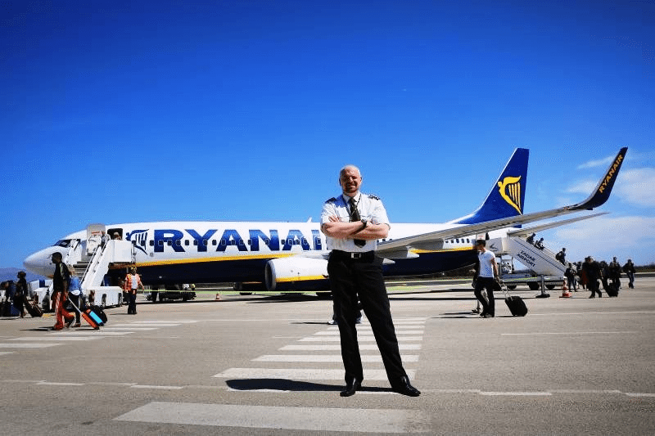You are working for an outside agency which has been called in to analyse the Management and Leadership situation at Ryanair.

Having investigated pilots complaints regarding their pay and conditions, write a report to the Board of Directors which explains:

1. What the issue with the pilots is about
2. What the outcome has been to date
3. What you would recommend Ryanair should do in the future

**The report** should be written paragraphs, concise and with relevant and up to date facts/data used to support points made. The first half of the report should be an **analysis** of the situation (**not** a retelling of the story), the second half should be your recommendations. Business theory and terms **should** be used throughout.

**Activity 2 (in groups)**

The Board of Directors have read your report and now understand the issues at stake. They would like you to advise them on how deal with the pilots in the future and have asked you to produce a 6 slide PowerPoint presentation on the following:

1. What motivation is and what motivational issues you have discovered at Ryanair
2. Why the current motivational approach is not working
3. What motivational theory you recommend should be considered to improve relations in the future.

**The presentation** should be six simple slides with supporting information in the notes sections. As before, the analysis of the situation should be concise, using facts, theory and data where relevant. 2-3 slides should cover this.

The main body of the presentation should be the proposal based on your knowledge of motivational theory and your research into the Ryanair crisis. 3-4 slides.