**POLICY AND HISTORY**

**Using your wider knowledge and the timeline on the next page complete this table:**

|  |  |  |
| --- | --- | --- |
| **Which policies could be used to explain differences in educational achievement based on CLASS?** | **Which policies could be used to explain differences in educational achievement based on GENDER?** | **Which policies could be used to explain differences in educational achievement based on ETHNICITY?** |
|  |  |  |

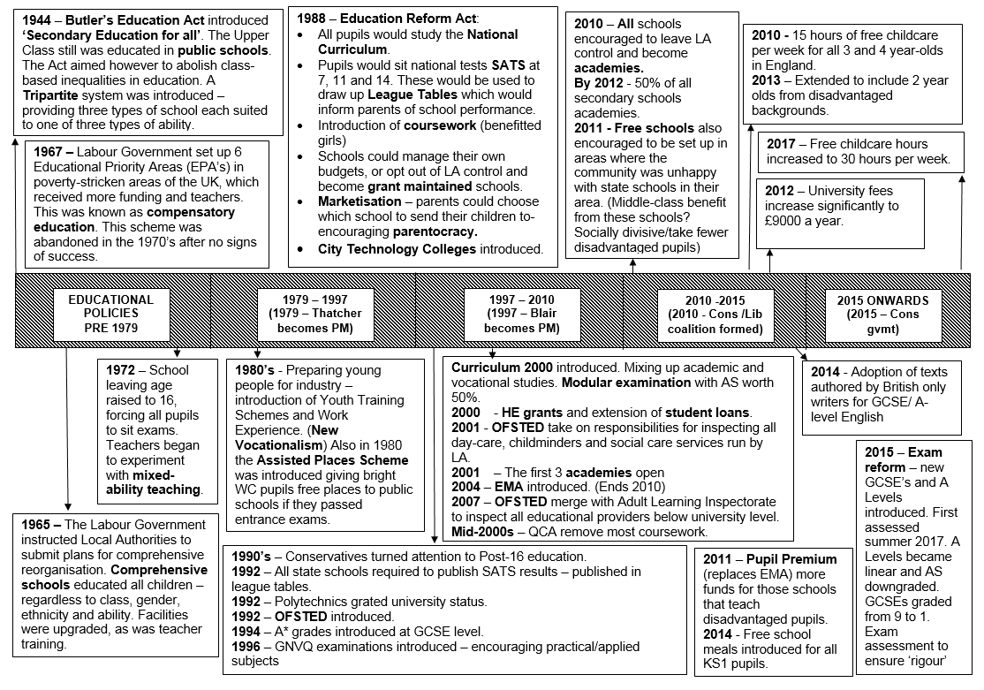

**2018** – Free Schools are the only expansion of schools at present. There may be an expansion of grammar schools