**Summer Work 2021**

**Global Destinations; Learning Outcome B**

**Potential advantages and disadvantages of travel routes and transport providers**

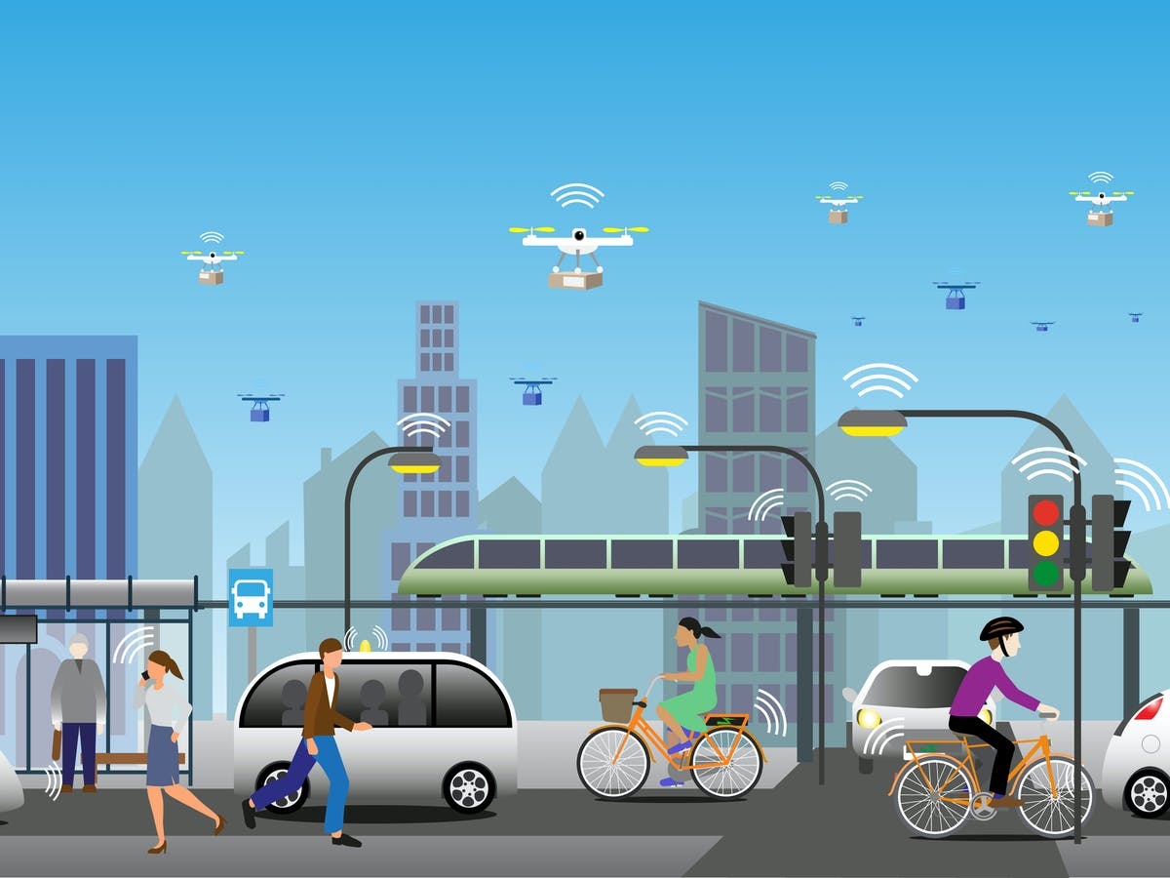

**Complete the following booklet over the summer holidays in preparation for the first lesson in September. For guidance with your answers read the online text book on GOL, Unit 2.**

[**https://ebookcentral.proquest.com/lib/godalming-ebooks/detail.action?docID=5977547&query=travel+and+tourism**](https://ebookcentral.proquest.com/lib/godalming-ebooks/detail.action?docID=5977547&query=travel+and+tourism)

**Name:**

**Travelling by Air**

Complete the following table on air travel providers

|  |  |  |
| --- | --- | --- |
| **Type of airline** | **Description** | **Examples** |
| National flag carrier (scheduled) |  |  |
| Scheduled airline |  |  |
| Charter airline |  |  |
| Budget airline |  |  |
| Luxury airline (scheduled) |  |  |
| Private airline |  |  |

Research some of the following airlines and complete the table:

|  |  |  |
| --- | --- | --- |
| **Airline** | **Primary Hub** | **Route Examples** |
| Air France |  |  |
| British Airways |  |  |
| Cathay Pacific |  |  |
| Qantas |  |  |
| KLM |  |  |
| Emirates |  |  |
| Thai |  |  |

What are the main advantages and disadvantages of air travel in general compared to other methods of travel?

|  |  |
| --- | --- |
| **Advantages** | **Disadvantages** |
|  |  |

Now think about the advantages and disadvantages of each of the following types of airline against each other:

|  |  |  |
| --- | --- | --- |
| **Airline** | **Advantages** | **Disadvantages** |
| Schedule airline |  |  |
| Charter airline |  |  |
| Budget airline |  |  |
| Private airline |  |  |

**Travelling by Road**

Road travel relates to vehicles using major and minor roads including motorways and road tunnels. It is most suitable for domestic tourism and shorter trips, but can also be used to make longer and international journeys.

Complete the following table describing the main advantages and disadvantage of each method of road travel:

|  |  |  |  |
| --- | --- | --- | --- |
| **Mode of travel** | **Examples** | **Advantages** | **Disadvantages** |
| Car |  |  |  |
| Coach operators |  |  |  |
| Bus companies |  |  |  |
| Local public transport services |  |  |  |
| Taxi |  |  |  |
| Safari and expeditions |  |  |  |

Look at the following website: <https://www.eurolines.de/en/home/>

What is Eurolines?

Find out the cost of travelling from London to Rome on Eurolines?

What services can you expect on board the coach?

How long does the journey take?

How many stops does the service take en-route?

What do you think are the different advantages and disadvantages of taking a coach to Rome over flying from the UK?

|  |  |
| --- | --- |
| **Advantages** | **Disadvantages** |
|  |  |

Which type of traveller/tourist would you expect to use this kind of service and why?

**Travelling by Rail**

Travelling by rail can be a holiday experience in its own right and provide a wide range of different services for different markets of tourists.

What are the main advantages and disadvantages of rail travel in general compared to other methods of travel?

|  |  |
| --- | --- |
| **Advantages** | **Disadvantages** |
|  |  |

Complete the following table describing the main advantages and disadvantage of each method of road travel:

|  |  |  |  |
| --- | --- | --- | --- |
| **Type of rail service** | **Examples** | **Advantages** | **Disadvantages** |
| Long distance |  |  |  |
| Scheduled train services |  |  |  |
| Heritage |  |  |  |
| Luxury |  |  |  |

Find out who operates scheduled rail services in the following countries and if they are publicly or privately owned.

|  |  |  |
| --- | --- | --- |
| **Country** | **Operator(s)** | **Ownership** |
| Australia |  |  |
| India |  |  |
| Thailand |  |  |
| Netherlands |  |  |
| France |  |  |
| England |  |  |

What are the advantages and disadvantages of rail operators being privately owned?

|  |  |
| --- | --- |
| **Advantages** | **Disadvantages** |
|  |  |

**Travelling by Sea**

Complete the following table of all different types of sea travel:

|  |  |  |
| --- | --- | --- |
| **Type of Sea Travel** | **Description** | **Operators** |
| Ferry |  |  |
| International Cruise |  |  |
| National Cruise |  |  |
| Regional Cruise |  |  |
| Local Cruise |  |  |
| River Cruise |  |  |

**Research**

Liverpool Cruise Terminal was awarded ‘Best UK Port of Call’ by Cruise Critic in 2016, but was overtaken by Guernsey in 2017 and 2018. Research some examples of cruises that originate and stop at Guernsey and find out what sort of facilities are offered.

Which UK port currently holds the award?

What brands, how many ships and how many destinations do the following cruise companies visit? Complete the table:

|  |  |  |
| --- | --- | --- |
| **Carnival Corporation** | **Royal Caribbean Cruise Lines** | **Norwegian Cruise Line** |
| List the Brands: | List the Brands: | List the Brands: |
| No of Ships: | No of Ships: | No of Ships: |
| No of destinations: | No of destinations: | No of destinations: |

Norwegian Cruise Lines introduced a more informal style of cruising known as ‘Freestyle Cruising’. Find out what this style of cruising offers the customer.

Research Cruise Lines International Association (CLIA). Who are they and what do they do?