Testing for poisons

Testing for heavy metal poisoning

Task
A young woman has been found dead at a party. She is young and fit. A pathologist has sent you three samples to test as he suspects heavy metal poisoning Using flame tests you are going to identify the heavy metal found in her system.
Method
- Take splint out of the solution and hold into a blue Bunsen flame. .
- Make a note of the colour of the flame
- Put splint into a beaker of water
- Repeat steps 1-3 and test the other two samples

Sample | Colour | Heavy Metal
1 Lithium

2 Sodium

3 Potassium

4 Caesium

5 Calcium

6 Strotium

Unknown samples obtained from the victim
Sample | Colour | Heavy Metal
X

Y

Z

Once the colour of the flame has been noted try and identify the colour of the flame using the colour chart below
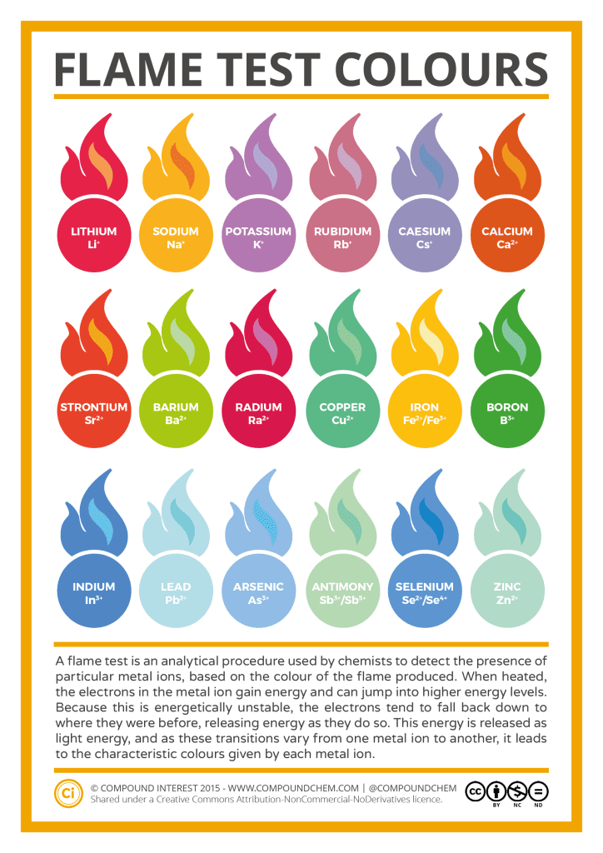

Testing stomach contents for alcohol and aspirin

Task
A man in his 20s has been found dead on Angel Gate in Guildford. The Pathologist has sent you a sample of the man’s stomach contents and would like you to determine what substances are present.
- You will need to first separate out the stomach contents. You have been provided with the following equipment to do this:
- Funnel
- Filter paper
- Conical flask
What precautions will you have to take in order to make sure that you are safe and no contamination of the sample occurs?
…………………………………………………………………………………………………………………………………………………………
……………………………………………………………………………………………………………………………………………………………
…………………………………………………………………………………………………………………………………………………………….
- You will need to split you stomach contents into 6 test tubes in order to test for different substances.

- Follow the methods for each test and complete the table

Test for: | Method | Safety precautions | Observation and conclusion
Alcohol | - Add 1 drop of sodium dichromate and 10 drops of sulphuric acid to the test tube  - Warm test tube in beaker with hot water for 10 minutes  - If the solution goes brown alcohol is present. | Sodium dichromate:  …………………………………………………………………………………………………………………………………………………………  Sulphuric acid  …………………………………………………………………………………………………………………………………………………………  Hot water bath  …………………………………………………………………………………………………………………………………………………………
Reducing sugars | - Add 5 drops of Benedict’s solution  - Warm test tube in hot water for 10 minutes  - If a red/brown solid forms then reducing sugars are present (however if the reducing sugars are in a low concentration the solution will go green) | Benedict’s solution  …………………………………………………………………………………………………………………………………………………………
Protein | - Add 10 drops of Biuret’s solution  - If protein is present solution will go a darker blue | Biuret’s solution  …………………………………………………………………………………………………………………………………………………………
Aspirin | - Add 1 drop of Iron Chloride  - If aspirin is present solution will turn purple | Iron Chloride  …………………………………………………………………………………………………………………………………………………………
Starch | - Add 1 drops of iodine solution  - If starch is present solution will go blue/black | Iodine solution  …………………………………………………………………………………………………………………………………………………………
Acid | - Using the small end of the spatula add a very small amount of sodium carbonate  - If acid is present it will fizz | Sodium Carbonate  …………………………………………………………………………………………………………………………………………………………

