# Logo longerline

**BTEC Applied Science Extended Certificate**

[](https://www.google.co.uk/url?sa=i&rct=j&q=&esrc=s&source=images&cd=&ved=2ahUKEwjEtLzg9qnjAhUPdxoKHeS0BocQjRx6BAgBEAU&url=https%3A%2F%2Fwww.asianscientist.com%2F2016%2F07%2Ffeatures%2Fgrand-challenges-for-science-21st-century-ntu-singapore%2F&psig=AOvVaw0cmFv_8MiPn-pKkAwe76Qo&ust=1562833342386194)

**Handbook**

## Welcome to BTEC Applied Science!

We have a committed team that will support and work with you on this course to provide you with the best opportunities to achieve your best.

**For your part we expect you to:**

* **Attend all lessons on time**
* **Complete all homework set**
* **Hand in work on time – deadlines are crucial to you being a successful student.**

Keep this handbook in a safe place as it has all the information you need throughout the two years**!**

If you have any queries about the course please email [harrietbroughton@godalming.ac.uk](mailto:harrietbroughton@godalming.ac.uk)

Contents

The BTEC Course 3

Course Structure 3

Grades 4

Coursework (assignments in unit 2 and 12) 5

Before you submit the assignment 5

Deadlines 6

To keep work safe you need to do the following: 6

Plagiarism Policy 7

Plagiarism and how to avoid it by referencing your work 7

Direct Quote and Paraphrasing 7

What you will need for your lessons 9

FAQs 9

What happens if I miss a deadline? 9

Can I resubmit my work to improve on my grade? 9

Can I achieve a merit in a unit if I achieve all the merit criteria but miss out on one pass? 9

Content for units in year 1 10

Unit 1: the fundamentals of science 10

Unit 2: working in the science industry 13

# The BTEC Course

Pearson/Edexcel provides the following qualifications:

Two year qualification - **BTEC Extended Certificate in Applied Science**

One year qualification - **BTEC Certificate in Applied Science**

Both courses are designed to provide a practical work-related qualification, to either prepare you for employment or progression to higher education.

The course provides opportunities for you to focus on the development of the major key skills in a science context.

## Course Structure

You will study 2 units during each year (4 units in total for the two year course).

The first year comprises of

* **Unit 1: Principles and applications of Science**

This unit covers biology, chemistry and physics. It builds on your knowledge from secondary school. It will be assessed in an exam at the end of the year (June 2017)

* **Unit 2: Working in the science industry**

This is a practical based chemistry unit. It will investigate titrations, cooling curves and chromatography. This unit will be assessed throughout the year through 4 assignments.

If you decide to leave the course are the first year you will gain the **BTEC Certificate which is roughly equivalent to one AS-level.**

The second year comprises of:

* **Unit 3: Science investigation skills**

This is a large practical based unit which covers practicals in biology, chemistry and physics. It will be assessed in a practical based exam at the end of the second year (June 2018)

* **Unit 12: Diseases and infections**

This unit is biology based and is interested in how diseases work, how they are spread, and how they can be prevented. It will be internally assessed in coursework throughout the second year.

After you finish the second year you will have gained a **BTEC Extended Certificate which is equivalent to one A-level.**

# Grades

For each internally assessed unit (unit 2 and 12) you will conduct a number of assignments. Each assignment will be graded as a pass, merit or distinction (P, M D). This goes towards your grade for that particular unit.

E.g. For unit 2 there are 4 assignments, you will be required to gain all of the pass and merit levels in both of those assignments to gain a merit for unit 4.

**In order to pass a unit you must achieve all the pass criteria**, otherwise you will fail this unit and potentially the course.

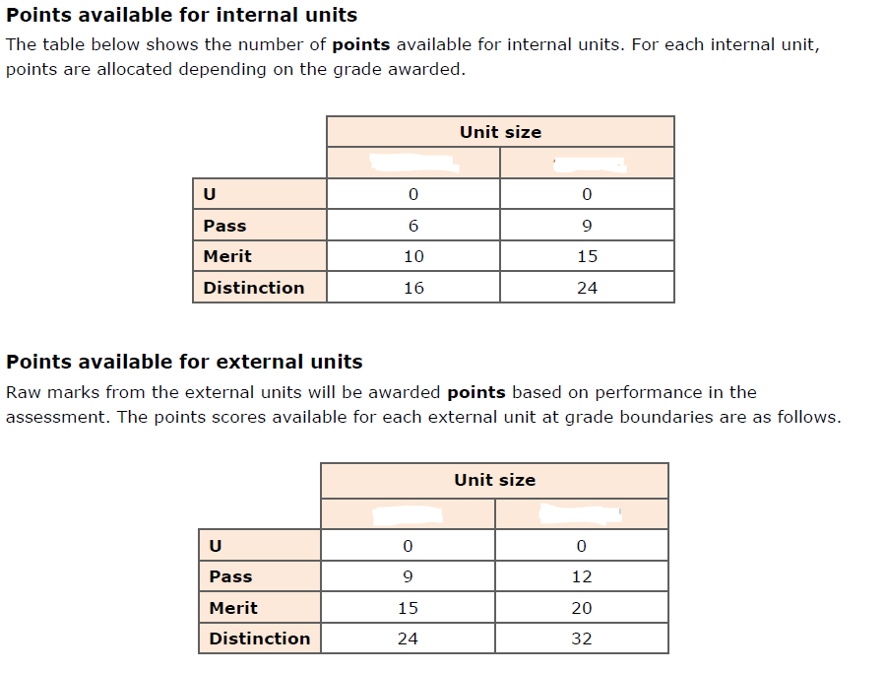

First year

Unit 1

Second year

Unit 3

Second year

Unit 12

First year

Unit 2

**Grade boundaries**

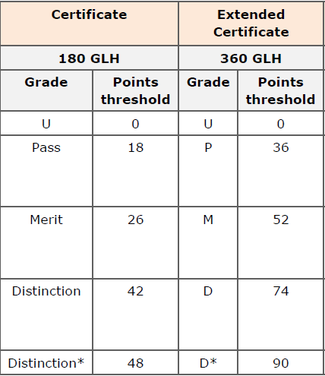

# Coursework (assignments in unit 2 and 12)

Before each assignment you will be taught about the unit content through experiments, group work, class activities and homework. At the end of each topic you will be set an assignment. **It is imperative that you complete all the work set as this will help you to achieve your best on the assignments.**

You will receive assignments throughout the year. If you are disorganised and do not complete the work to the highest standard by the deadline it may mean that for your next deadline you have other work due in for other teachers. **It is in your interest to complete the work as thoroughly as possible so you do not have to resubmit.**

**You will be expected to do a lot of independent research and study. This means you need to be self-disciplined, and organised to meet deadlines.**

It is also your responsibility to keep your work safe. If you miss a deadline because you have not saved your work correctly it will not be accepted as an excuse and you will fail that assignment.

When your teacher thinks you are ready you will be given the assignment. It will reflect tasks that you have been working on previously and you will be expected to work **independently** to complete it. You may use any of your classwork to help you.

Before you submit the assignment:

* Check that the work actually addresses the criteria accurately.
* Check; spelling, punctuation and grammar.
* Check your work is appropriately labelled with your name and sign the plagiarism declaration.

Once your work has been submitted it will be marked. If you have not been successful in achieving the criteria in the assignment you *may* be allowed ONE resubmission but this will depend on the following:

1. You handed the **first submission in on time**.
2. You will be able to achieve the criteria **without any further help**.
3. You **submit the resubmission within the timeframe the teacher allows.**
4. The **lead internal verifier** all the above with your teacher.

A spreadsheet of your marks will be shown to you regularly so you can monitor your progress and maintain good grades.

# Deadlines

Unit 2 and 12 will be assessed through completing 4 assignments each.

Each assignment has it’s own final deadline – which will be shown on the front cover of the assignment.

To be successful it is very important that you meet these deadlines.

**If you miss a deadline you cannot achieve a grade for that work.**

Final work will be kept by the teacher.

If you have not submitted at pass level we cannot mark the merit and then distinction work so those criteria cannot be achieved.

## To keep work safe you need to do the following:

1. Set up a ‘BTEC Applied Science’ folder on your home drive on a college computer. This will mean you can access your work from college or home.

2. You can back up data on a USB stick, however do not rely on this as they can become corrupt.

3. If another student loses your work YOU will be held accountable so keep your work safe and secure at all times.

4. Do not delete any work until you finish the qualification.

# Plagiarism Policy

Plagiarism is the presentation of another person’s words or thoughts as if they were your own. This includes; work from another student, internet sources or work copied from text books. **This is an offence that the exam board take very seriously, and may lead to withdrawal from the course**. The college also has a strict disciplinary procedure that will be undertaken.

Remember – all assignments submitted must be written in your own words and include your own ideas and judgements.

If you are including someone else’s ideas or words it must be acknowledged using correct referencing procedures.

Unfortunately plagiarism has in the past resulted in students’ marks being lowered, which has in in turn prevented them from progressing onto the second year of the course.

### **Plagiarism and how to avoid it by referencing your work**

In order to have an accurate record of what you have researched and therefore an accurate reference, it is important that you write down the details of your sources as you study. When you use a new source, clearly record the following information for future reference.

When you reference a source for the first time, you must provide full bibliographic information (information about the source). This includes:

* author(s) initial(s) and surname(s)
* name of the article, book or journal
* editors (if applicable)
* publisher name and location
* year published

You should give exact page numbers if your reference is a direct quotation, a paraphrase, an idea, or is otherwise directly drawn from the source.

## Direct Quote and Paraphrasing

When paraphrasing, use the same referencing style and conventions as you would for direct quotes, but with the material from the source put into your own words, and the inverted commas omitted. Below is a comparative example of the direct quote versus paraphrasing.

**Direct quote and paraphrasing from a source**

The DfEE suggest that each year ‘some have estimated the cost to the country of poor literacy and numeracy skills to be as high as £10 billion’1.

**OR - paraphrase**

The effect of low levels of adult numeracy and literacy skills could be costing Britain around £10 billion each year1.

1Department for Education and Employment (DfEE), (2001) *Skills for life: The national strategy for improving adult literacy and numeracy skills*, Nottingham: DfEE Publications.

**Paraphrasing** and **summarizing** are very similar. Both involve taking ideas, words or phrases from a source and crafting them into new sentences within your writing. In addition, summarizing includes condensing the source material into just a few lines. Whether paraphrasing or summarizing, credit is always given to the author.

Below is a passage taken from Raymond S. Nickerson's "How We Know - and Sometimes Misjudge -What Others Know” *Psychological Bulletin* 125.6 (1999): p737.

“In order to communicate effectively with other people, one must have a reasonably accurate idea of what they do and do not know that is pertinent to the communication. Treating people as though they have knowledge that they do not have can result in miscommunication and perhaps embarrassment. On the other hand, a fundamental rule of conversation, at least according to a Gricean view, is that one generally does not convey to others information that one can assume they already have.”

**Here is an example of what would be considered plagiarism of this passage:**

For effective communication, it is necessary to have a fairly accurate idea of what our listeners know or do not know that is pertinent to the communication. If we assume that people know something they do not, then miscommunication and perhaps embarrassment may result (Nickerson, 1999).

The writer in this example has used too many of Nickerson's original words and phrases such as "effective communication," "accurate idea," "know or do not know," "pertinent," "miscommunication," and "embarrassment." Also note that the passage doesn't have an opening tag to indicate where use of the Nickerson's material begins. A citation at the end of a paragraph is not sufficient to indicate what is being credited to Nickerson.

**Here is an example that would be considered acceptable summarizing of this passage:**

Nickerson (1999) argues that clear communication hinges upon what an audience does and does not know. It is crucial to assume the audience has neither too much nor too little knowledge of the subject, or the communication may be inhibited by either confusion or offense (p. 737).

Notice that the writer both paraphrases Nickerson's ideas about effective communication and compresses them into two sentences. Like paraphrasing, summarizing passages is a tricky endeavour and takes lots of practice.

# What you will need for your lessons

1. A ring binder
2. Stationary
3. Calculator

# FAQs

## What happens if I miss a deadline?

You must make every effort to meet a deadline. If you cannot meet a deadline you must talk to your teacher or course leader BEFORE the work is due in, they will explain what happens next.

## Can I resubmit my work to improve on my grade?

You will be allowed one resubmission if you meet the criteria outlined on page 5. But no further guidance will be given and **it may mean that you will have several deadlines for different teachers in the same week**

## Can I achieve a merit in a unit if I achieve all the merit criteria but miss out on one pass?

No. you must achieve all pass and all merit criteria in order to gain a merit for the unit overall.

# Content for units in year 1

## Unit 1: the fundamentals of science

**A Periodicity and properties of elements**

A1 Structure and bonding in applications in science

* Understand the electronic structure of atoms:
  + electronic orbitals
  + Aufbau principle
  + Bohr theory.
* Understand ionic bonding:
  + strong electrostatic attraction between oppositely charged ions
  + effects ionic radius and ionic charge have on the strength of ionic bonding
  + formation of ions in terms of electron loss or gain
  + electronic configuration diagrams of cations and anions.
* Understand covalent bonding:
  + strong electrostatic attraction between two nuclei and the shared pair(s) of electrons between them
  + dot and cross diagrams to show electrons in simple covalent molecules, including
  + those with multiple bonds and dative covalent (coordinate) bonds
  + the relationship between bond lengths and bond strengths in covalent bonds
  + tetrahedral basis of organic chemistry.
* Understand metallic bonding:
  + de-localised electrons
  + positive metal ions
  + regular layer structure.
* Understand the following intermolecular forces:
  + van der Waals
  + dipole-dipole
  + hydrogen bonding.
* Understand the following:
  + balanced equations
  + relative atomic mass
  + atomic number and relative molecular mass
  + moles, molar masses and molarities.
* Understand the quantities used in chemical reactions:
  + mass, volume of solution, concentration
  + reacting quantities
  + percentage yields.

A2 Production and uses of substances in relation to properties

* Understand the periodic table:

o Periods 1, 2, 3 and 4

o groups – s block, p block, d block

o layout of periodic table in relation to s, p, d notation

o electronic arrangement of elements using s, p, d notation.

* Understand the physical properties of elements:

o first ionisation energy

o reasons for trends in ionisation energy across Periods 2–4 and down groups 1, 2 and 7

o electron affinity

o atomic radius

o ionic radius

o electronegativity

o type of bonding in the element

o trends – melting point and boiling point

o physical properties of metals – electrical conductivity, thermal conductivity, malleability, ductility.

* Understand the chemical properties of elements:

o products and reactivity of all Period 2 and 3 elements with oxygen

o products and reactivity of metals with oxygen, water, dilute hydrochloric acid and dilute sulfuric acid

o position of metals in the reactivity series in relation to position in the periodic table

o oxidation

o reduction

o variable oxidation states of transition metal ions

o displacement reactions of metals/halogens

o uses and applications of substances produced within this learning aim.

**B Structure and functions of cells and tissues**

**B1 Cell structure and function**

* Know that cell theory is a unifying concept stating that cells are a fundamental unit of structure, function and organisation in all living organisms.
* Understand the ultrastructure and function of organelles in the following cells:

o prokaryote cells (bacterial cell) – nucleoid, plasmids, 70S ribosomes, capsule, cell wall

o eukaryotic cells (plant and animal cells) – plasma membrane, cytoplasm, nucleus, nucleolus, endoplasmic reticulum (smooth and rough), Golgi apparatus, vesicles, lysosomes, 80S ribosomes, mitochondria, centriole

o eukaryotic cells (plant-cell specific) – cell wall, chloroplasts, vacuole, tonoplast, amyloplasts, plasmodesmata, pits.

* Recognise cell organelles from electron micrographs and the use of light microscopes.
* Understand the similarities and differences between plant and animal cell structure and function.
* Understand how to distinguish between gram-positive and gram-negative bacterial cell walls and why each type reacts differently to some antibiotics.
* Calculate magnification and size of cells and organelles from drawings or images.

**B2 Cell specialisation**

* Understand cell specialisation in terms of structure and function, to include:
  + palisade mesophyll cells in a leaf
  + sperm and egg cells in reproduction
  + root hair cells in plants
  + white blood cells
  + red blood cells.

**B3 Tissue structure and function**

* Understand the structure and function of epithelial tissue, to include:
  + squamous as illustrated by the role of alveolar epithelium in gas exchange to include the effect of chronic obstructive pulmonary disease (COPD) in smokers
  + columnar as illustrated by goblet cells and ciliated cells in the lungs to include their role in protecting lungs from pathogens.
* Understand the structure and function of endothelial tissue, as illustrated by blood vessels in the cardiovascular system, including the risk factors that damage endothelial cells and affect the development of atherosclerosis.
* Understand the structure and function of muscular tissue, to include:
  + the microscopic structure of a skeletal muscle fibre
  + structural and physiological differences between fast- and slow-twitch muscle fibres and their relevance in sport.
* Understand the structure and function of nervous tissue, to include:
  + non-myelinated and myelinated neurones
  + the conduction of a nerve impulse (action potential) along an axon, including changes in membrane permeability to sodium and potassium ions and the role of the myelination in saltatory conduction
  + interpretation of graphical displays of a nerve impulse and electroencephalogram (EEG) recordings
  + synaptic structure and the role of neurotransmitters, including acetylcholine
  + how imbalances in certain, naturally occurring brain chemicals can contribute to ill health, including dopamine in Parkinson’s disease and serotonin in depression
  + the effects of drugs on synaptic transmission, including the use of L-Dopa in the treatment of Parkinson’s disease.

**C Waves in communication**

**C1 Working with waves**

* Understand the features common to all waves and use the following terms as applied to waves:
  + periodic time
  + speed
  + wavelength
  + frequency
  + amplitude
  + oscillation.
* Graphical representation of wave features.
* Understand the difference between the two main types of wave:
  + transverse
  + longitudinal.
* Understand concepts of displacement, coherence, path difference, phase difference, superposition as applied to diffraction gratings.
* Understand the industrial application of diffraction gratings, to include:

o emission spectra

o identifying gases.

* Be able to use the wave equation:

*v* = *f* λ

* Understand the concept and applications of stationary waves resonance.
* Musical instruments.
* Be able to use the equation:
  + 

**C2 Waves in communication**

* Understand the principles of fibre optics:

o refractive index

o total internal reflection

o calculation of critical angles at a glass–air interface:

* Understand the applications of fibre optics in medicine to include endoscopes.
* Understand the applications of fibre optics in communication, to include:

o analogue and digital signals: analogue-to-digital conversion, broadband.

**C3 Use of electromagnetic waves in communication**

* Understand that all electromagnetic waves travel with the same speed in a vacuum.
* Be able to use the inverse square law in relation to the intensity of a wave:
* Understand how the regions of the electromagnetic spectrum are grouped according to the frequency.
* Understand how the applications of electromagnetic waves in communications are related to frequency, including:

o satellite communication

o mobile phones

o Bluetooth®

o infrared

o Wi-Fi

## Unit 2: working in the science industry

**Learning aim A: Undertake titration and colorimetry to determine the concentration of solutions**

**A1 Laboratory equipment and its calibration**

* Equipment and glassware used in titration and colorimetry and the importance and processes involved in calibration of measuring equipment.
* Use of pH meters and probes:
  + calibration according to the manufacturer’s instructions.
* Use of balances and weighing:
  + electronic balances – rough balances (two decimal places), analytical balances (four decimal places)
  + checking calibration with certified weights
  + measurement of mass using increasingly accurate balances
  + suitable containers for weighing liquids and solids
  + density of water at different temperatures.
* Safe use of volumetric glassware:
  + bulb, graduated, automated and teat pipettes
  + burettes
  + glass and plastic filter funnels
  + volumetric flasks
  + accurate dilution
  + use of water as a standard for calibrating volumetric glassware.

**A2 Preparation and standardisation of solutions using titration**

* Processes involved in the preparation and standardisation of solutions using titration.
* Accurate determination of the end-point of titrations from:
  + the colour change of a suitable indicator
  + plots of pH versus volume
  + ΔpH/Δvolume versus volume.
* Calculation of concentrations:
  + use of molecular mass from periodic table.
* Use of primary and secondary titrimetric standards.

**A3 Colorimetry**

* Understanding and practical application of colorimetry techniques.
* Selection and use of a colorimeter or visible spectrometer – selection of filter (colorimeter)

or fixed wavelength (spectrometer).

* Measurement and use of absorbance readings.
* Use of Beer-Lambert law to determine the concentration of a transition metal ion solution.
* Accurate dilution of stock solutions to prepare a range of calibration standards with absorbance in the range 0 to 1.
* Use of blank solutions.
* Calibration plot.
* Determination of unknown solution concentration from reading from graph (graph paper)or from the equation of a linear trend line through the origin (Microsoft Excel).

**Learning aim B: Undertake calorimetry to study cooling curves**

**B1 Thermometers**

Types of thermometer, appropriate use and practical application of measurements of heat.

* The relationship between temperature and heat energy.
* Types of thermometer and how they are used to gain accurate readings:
  + electronic thermometers/temperature probes
  + liquid-filled thermometers.
* Checking the calibration of thermometers by using ice and boiling water.
* Accuracy of thermometers and temperature probes at different temperatures.

**B2 Cooling curves**

Construction and interpretation of cooling curves:

* temperature as a function of time
* rate of cooling from the gradient of the tangent to the cooling curve
* determination of melting point from the shape of a curve for a substance freezing
* super cooling
* shape of the curve and rate of cooling in relation to intermolecular forces and the state (solid or liquid) of the substance.

**Learning aim C: Undertake chromatographic techniques to identify** components in mixtures

**C1 Chromatographic techniques**

Theory, equipment and procedures used in chromatography.

* Terminology:
  + mobile and stationary phases
  + adsorption.
* Principles of paper chromatography.
* Principles of thin-layer chromatography (TLC):
  + nature of a TLC plate – glass, metal or plastic sheet with solid adsorbent layer.
* Use of capillary tubes to apply mixtures to paper or TLC plates.
* Choice of developing solvent and vessel.
* Preparative methods for samples:
  + solvent extraction
  + filtration
  + concentration by evaporation.
* The use of locating agents.

**C2 Application of chromatography**

* Separation of components of a mixture, to include plant pigments extracted from leaves/herbs with propanone (paper chromatography and TLC).
* Identification of unknown mixtures and pure substances using chromatography, to include amino acids (paper chromatography).
* Awareness of other types of chromatography – e.g. gas chromatography, ion-exchange chromatography – and that procedures and chromatogram interpretations are very different.

**C3 Interpretation of a chromatogram**

* Polarity of molecules/intermolecular forces in relation to solubility in the mobile phase.
* Polarity of molecules/intermolecular forces in relation to retention of molecules in the stationary phase.
* Size of molecules in relation to solubility and mobility.
* Calculation of Rf value.
* Interpretation of chromatograms in terms of the number of substances present and the Rf values of components.
* Awareness of common problems in technique resulting in difficulty interpreting a chromatogram,e.g. overloading samples, disturbing plate/paper during development or contamination of plate/paper.

**Learning aim D: Review personal development of scientific skills for laboratory work**

**D1 Personal responsibility**

Understanding of the personal responsibilities that must be accepted for successful work in science.

* Work to appropriate standards and protocols.
* Application of safe working practices.
* Accept responsibility for the quality of own work.
* Take responsibility for completing tasks and procedures as well as using judgements within defined parameters.

**D2 Interpersonal skills**

Understanding and development of skills for effective and efficient working with others:

* communication and co-operation in the scientific working environment
* give and receive constructive feedback
* behaviour for safe and efficient working in science.

**D3 Professional practice**

Understanding and personal development of standard practices applicable to working as a professional scientist:

* recognise problems and apply appropriate scientific methods to identify causes and
* achieve solutions
* identify, organise and use resources effectively to complete tasks
* maintain and enhance competence.