**Ionic, covalent and metallic bonding**

|  |  |  |  |  |
| --- | --- | --- | --- | --- |
| **Essential Content** | **Additional Guidance** | **☺** | **😐** | **☹** |
| * Understand ionic bonding: | * be able to predict whether a compound has ionic bonding from its name or formula * be able to predict the formula of an ionic compound from its elements ( for groups 1, 2, 3, 6 and 7) * understand how the physical properties of ionic substances, such as melting and boiling point, solubility and electrical conductivity, are affected by their bonding and structure |  |  |  |
| * strong electrostatic attraction between oppositely charged ions | * understand that ionic bonding is a result of strong electrostatic attraction between positive and negative ions * understand that electrostatic attraction between ions can occur in any direction * understand that a giant ionic structure is a lattice of many ions held together by electrostatic attraction |  |  |  |
| * effects ionic radius and ionic charge have on the strength of ionic bonding | * understand that the strength of electrostatic attraction increases with increasing ionic charge * understand that the strength of electrostatic attraction decreases with increasing size of ionic radius * understand why ionic radius increases down a group * understand how ionic radius changes across a period (for groups 1, 2, 3, 5, 6 and 7) * be able to predict differences in the strength of ionic bonding for different ionic compounds |  |  |  |
| * formation of ions in terms of electron loss or gain | * be able to describe the formation of positive ions (cations) by the loss of electron(s) from metal atoms * be able to describe the formation of negative ions (anions) by the gain of electron(s) by non-metal atoms * be able to draw dot-and-cross diagrams for ionic compounds of groups 1, 2, 3, 6 and 7 elements, showing outer electrons and correct charges |  |  |  |
| * electronic configuration diagrams of cations and anions | * be able to write the electronic structure (configuration) of cations and anions, using s, p and d subshell notation for the first 35 elements |  |  |  |
| * Understand covalent bonding: | * be able to predict if a compound has covalent bonding from its name or formula * understand how the physical properties of covalent substances, such as melting and boiling point, solubility and electrical conductivity, are affected by their bonding and structure (to include simple molecular and giant covalent structures) |  |  |  |
| * strong electrostatic attraction between two nuclei and the shared pair(s) of electrons between them | * understand that covalent bonding involves the sharing of a pair of electrons between two atoms and that there is strong electrostatic attraction between the nuclei and the electrons being shared * understand that electrostatic attraction between nuclei and the shared electrons is localised and in a specific direction * understand that a giant covalent structure is a lattice of many atoms bonded covalently |  |  |  |
| * dot and cross diagrams to show electrons in simple covalent molecules, including those with multiple bonds and dative covalent (coordinate) bonds | * be able to draw dot-and-cross diagrams for simple covalent molecules, showing outer electrons * know that multiple bonds involve two or more pairs of electrons being shared * know that a dative covalent (coordinate) bond is a covalent bond in which the pair of electrons being shared is donated by one atom |  |  |  |
| * the relationship between bond lengths and bond strengths in covalent bonds | * understand that as the number of shared pairs of electrons between two atoms increases, the bond length decreases * understand that as the number of shared pairs of electrons between two atoms increases, the bond strength increases * be able to represent covalent bonds in substances as 2D line diagrams |  |  |  |
| * tetrahedral basis of organic chemistry | * understand that electron pairs in bonds repel each other in order to be as far apart as possible around a central atom * know that carbon has four outer shell electrons so can form up to 4 single bonds/bonding electron pairs and will form tetrahedral shapes * know the bond angle associated with 4 bonding electron pairs around a central carbon atom is 109.5o * be able to represent covalent bonds in simple organic molecules as 3D line diagrams |  |  |  |
| * Understand metallic bonding: | * be able to predict if a substance has metallic bonding from its name or symbol * know that the structure of a metal is a lattice of positive metal ions surrounded by delocalised electrons * know that metallic bonding is the electrostatic attraction between the nuclei of the positive metal ions and the delocalised electrons * understand that delocalised electrons are formed by the loss and free movement of the outer shell electrons from the metal atoms * understand that electrostatic attraction between positive ions and delocalised electrons can occur in any direction * understand that a giant metallic structure is a lattice of many atoms held together in regular layers by metallic bonding * be able to describe or draw diagrams to show the structure of a metal and metallic bonding * understand how the chemical and physical properties of metals, such as melting and boiling point, malleability, ductility and electrical conductivity, are affected by their bonding and structure |  |  |  |

SUMMARY

Atoms are neutral because they contain the same number of +ve protons as –ve electrons

Ions are charged because they have gained or lost electrons. If the atom gains an electron it becomes a negative ion (called an anion). If the atom loses electrons it becomes a positive ion (called a cation)

Atoms gain or lose electrons to get 8 electrons in their outer shell. This makes a stable Nobel gas electron arrangement.

The strength of the ionic bond depends on the size of the ions and the charge of the ions.

Ions increase in size going down a group. As the ion has more shells of electrons

Negative ions are bigger than the atom, as they have gained an electron

Positive ions are smaller than the atom, because they have lost an electron.

Ionic compounds conduct electricity when they are dissolved in water (aqueous) or molten. This is because the ions are free to move.

Ionic Bonding

Many substances you will come across do not exist as elements but rather as compounds. These compounds can exist either as covalent or ionic substances dependant on if they can share electrons (covalent) or gain or lose electrons (ionic)

Note elements gain or lose ELECTRONS to form ions never protons

Ionic Bond

**DEFINITION**: An ionic bond is an **electrostatic attraction** between **oppositely charged** positive cations and negative anions. It is usually formed by **electron transfer** from a metal atom to a non-metal.

Typical ionic bonds are formed when **metals** in groups I and II react with **non-metals** in

Groups VI and VII.

When these atoms react, they tend to do so in such a way that they attain a noble gas configuration, which is stable. To achieve this, electrons are transferred from elements on the left hand side of the periodic table to those on the right hand side.

Example: **sodium chloride** (you will need to use a periodic table to find the atomic numbers)

* Show only outer shell electrons in the dot and cross diagrams.
* New exerciseUse dots and crosses for electrons from different atoms (even though all electrons are identical)

|  |  |  |
| --- | --- | --- |
| Electron configurations: | Na atom ............................. | Cl atom ................................ |
| Dot & cross diagrams: |  |  |
| Electron configurations: | Na+ ion: ................................. | Cl- ion: ................................. |
| Dot & cross diagrams: |  |  |

**Magnesium oxide**

|  |  |  |
| --- | --- | --- |
| Electron configurations: | Mg atom ............................. | O atom ................................ |
| Dot & cross diagrams: |  |  |
| Electron configurations: | Mg2+ ion: ................................. | O2- ion: ................................. |
| Dot & cross diagrams: |  |  |

Formula of magnesium oxide ………………………

**Sodium oxide**

|  |  |  |
| --- | --- | --- |
| Electron configurations: | 2 Na atoms ............................. | O atom ................................ |
| Dot & cross diagrams: |  |  |
| Electron configurations: | 2 Na+ ions: ............................... | O2- ion: ................................. |
| Dot & cross diagrams: |  |  |

Formula of sodium oxide ………………………

**Magnesium chloride**

|  |  |  |
| --- | --- | --- |
| Electron configurations: | Mg atom ............................. | 2 Cl atoms ............................... |
| Dot & cross diagrams: |  |  |
| Electron configurations: | Mg2+ ion: ................................. | 2 Cl- ions: ................................ |
| Dot & cross diagrams: |  |  |

Formula of magnesium chloride ………………………

**Calcium Fluoride**

|  |  |  |
| --- | --- | --- |
| Electron configurations: | Ca atom ............................. | 2 F atoms ............................... |
| Dot & cross diagrams: |  |  |
| Electron configurations: | Ca2+ ion: ................................. | 2 Fl- ions: ................................ |
| Dot & cross diagrams: |  |  |

The strength of the ionic bond depends on 2 factors

**SIZE & CHARGE**

So how strongly the ions stick together depends on the charge of the ions and the size of the ions.

Small highly charged ions stick together very strongly and it takes a lot of energy usually in the form of heat to pull them apart. So we expect strong ionic compounds to have **high melting points.**

Out of the following pairs which will have the strongest ionic bonding and hence the highest melting point and why

NaCl or KCl ………………………………………………………………………………………………………………………………………………………………………………………………………………………………………………………………………………………….

MgCl2 or CaCl2 ………………………………………………………………………………………………………………………………………………………………………………………………………………………………………………………………………………………….

NaCl or NaF ………………………………………………………………………………………………………………………………………………………………………………………………………………………………………………………………………………………….

MgO or MgCl2 ………………………………………………………………………………………………………………………………………………………………………………………………………………………………………………………………………………………….

AgBr or AgCl ………………………………………………………………………………………………………………………………………………………………………………………………………………………………………………………………………………………….

Use the following ideas to explain how sodium reacts with chlorine to form sodium chloride

|  |  |
| --- | --- |
| Called an ionic bond | Loses an electron to |
| Chloride ion | Negative |
| Chlorine atom | One electron in the outer shell |
| Full electron shell | Oppositely charged ions |
| Gains an electron | Positive |
| Gains an electron from | Seven electrons in the outer shell |
| Giant structure | Sodium atom |
| Ionic lattice | Sodium ion |
| Loses an electron | Strong electrostatic attraction |

Ionic compounds conduct electricity when dissolved in water (aqueous) or molten (melted). The ions become free to move and therefore can conduct electricity

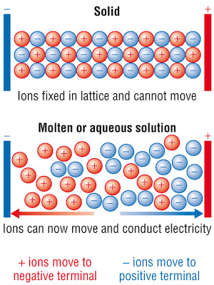

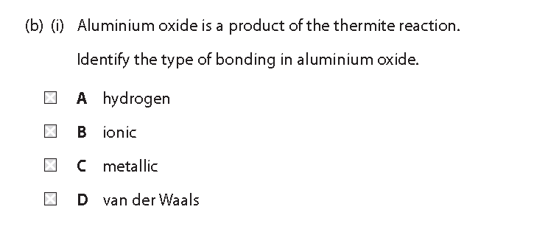

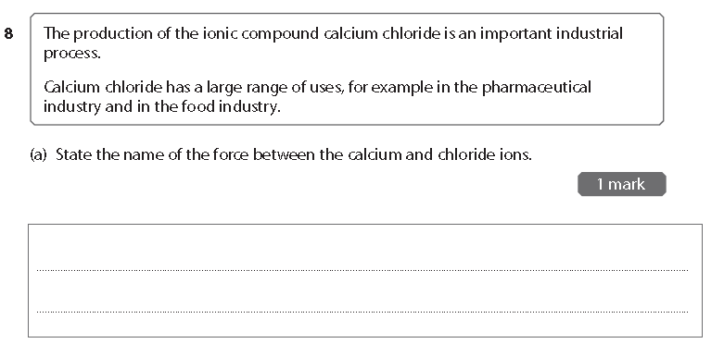

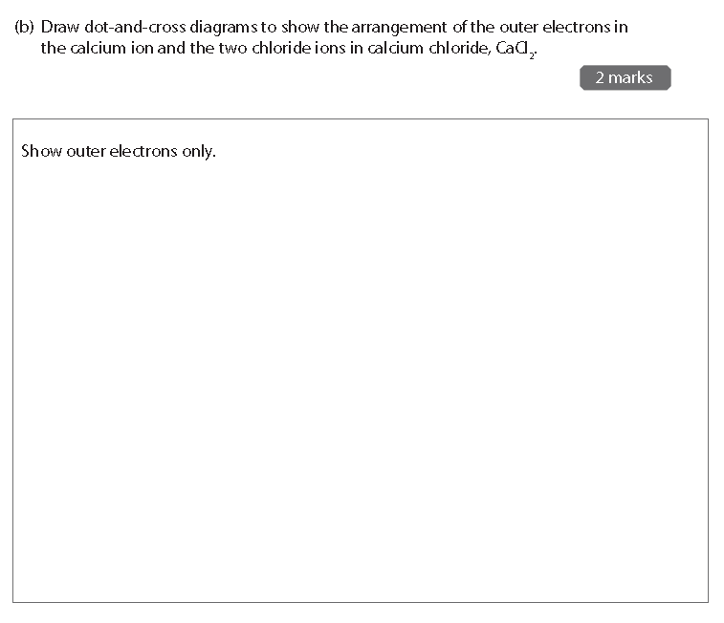

SUMMARY

Covalent bond form between Non metals

They share electrons to gain a full outer shell. This make a stable Nobel gas structure

If one pair of electrons is shared it is shown as a single line, this is called a single bond, a double line shows 2 pairs of electrons being shared this is a double bond, a triple line shows 3 shared pairs of electrons

The shorter the bond the stronger the bond, triple bonds are the shortest, then double then single

A dative covalent bond has one atom donating both electrons

Carbon, the basis of organic chemistry, always forms 4 bonds, the electrons in these bonds separate out to bond angle of 109.5 to form a tetrahedral shape

Simple covalent molecules like CO2 have low boiling points due to weak IMF between molecules

Giant covalent lattices like Diamond have high boiling points due to strong covalent bonds between atoms.

Covalent bonding

Some compounds find it more favourable to share electrons rather than gaining or loosing them. These tend to form covalent bonds.

**Covalent bonding** is the electrostatic attraction between the nuclei and the bonding pair of electrons which holds the 2 nuclei together.

**Dot and cross diagrams**

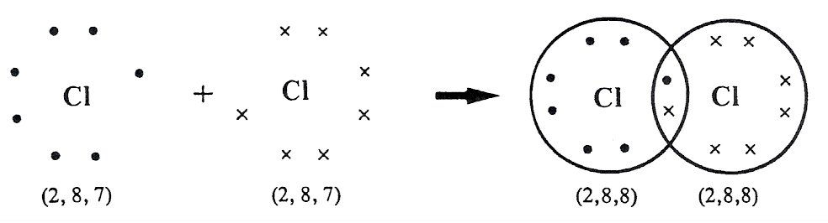Eg.Chlorine, Cl2

Electron configuration

What advantage has each chlorine atom gained from forming this covalent bond?

…………………………………………………………………………………………

Construct **dot and cross diagrams** for the following compounds from atoms of their constituent elements

H2O

NH3

HCl

CH4

C2H6

**EXAM QUESTION**

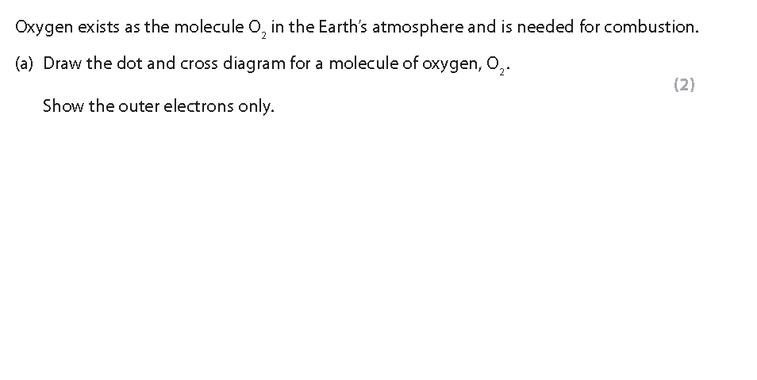

Class video

A **double** covalent bond is one in which two pairs of electrons are shared between two atoms.

Examples of double and triple bonds Video 1772 – [Double and triple bonds](http://estream.godalming.ac.uk/View.aspx?ID=1772)

Example (i) CO2

(ii) O2

(iii) C2H4

A **triple** covalent bond is one in which three pairs of electrons are shared between two atoms.

Example (i) N2

(ii) C2H2

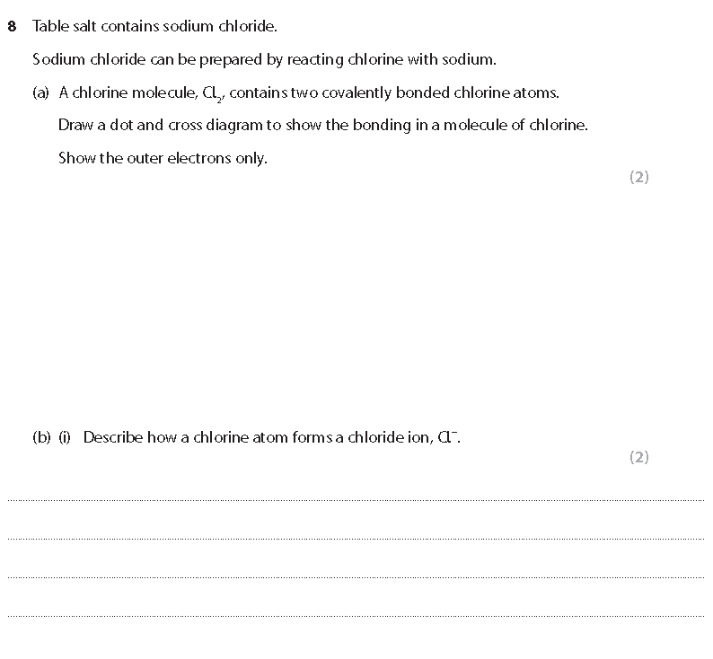

Again the strength of the covalent bond is liked to

SIZE AND CHARGE

This time the length of the covalent bond and if it is a single, double or triple. Generally triple bonds are stronger than doubles which are stronger than singles.

Shorter bonds = stronger bonds

Which out of the following is the strongest

Cl—Cl or F—F …………………………………………………………………………………………………………………………

P—P or N—N …………………………………………………………………………………………………………………………

C—O or C—H …………………………………………………………………………………………………………………………

O=O or O—O …………………………………………………………………………………………………………………………

N—H or H—H ………………………………………………………………………………………………………………………..

C=O or C—O ………………………………………………………………………………………………………………………….

As—As or P—P ………………………………………………………………………………………………………………………

There is a last type of covalent bond that you need to be aware of a dative covalent bond. In a ‘normal’ single covalent bond each atom provides one electron to the bond. But in the case of Dative covalent bonds one atom supplies both electrons

Draw out dot and cross diagrams below the formulae to represent the reaction:

NH3 + H+ 🡪

H

N

H

H

H

+

For the following circle the dative covalent bond

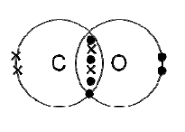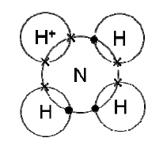

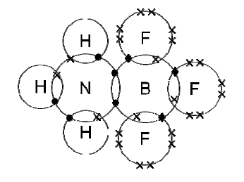

Organic Chemistry

Organic chemistry is the study of all organic matter, as all living things are made up of carbon containing compounds from DNA to Chloroplasts.

Carbon always forms 4 bonds, the electrons in these bonds separate out to maximise their separation. This forms a tetrahedral shape with a bond angle of 109.5

[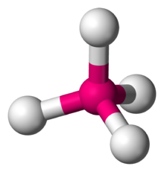](https://en.wikipedia.org/wiki/File:Tetrahedral-3D-balls.png)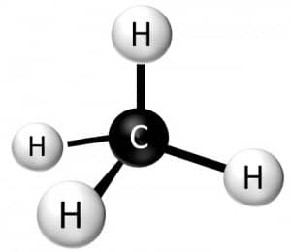

SUMMARY

Metallic bonding is between metal elements.

A regular lattice of positive ions are surrounded by a sea of delocalised electrons.

Metals conduct electricity because of their delocalised electrons

The strength of the metallic bond depends on the size of the ion and the number of delocalised electrons.

Smaller ions have stronger metallic bonds.

Higher charged ions have stronger metallic bonds because they delocalise more electrons.

Metallic bonding

Metals make up the largest part of the periodic table they form regular lattice structures of cations (positively charges ions) surrounded by a sea of delocalised electrons

**DEFINITION**: Metallic bonding is the electrostatic attractions between positive metal cations and the delocalized electrons.

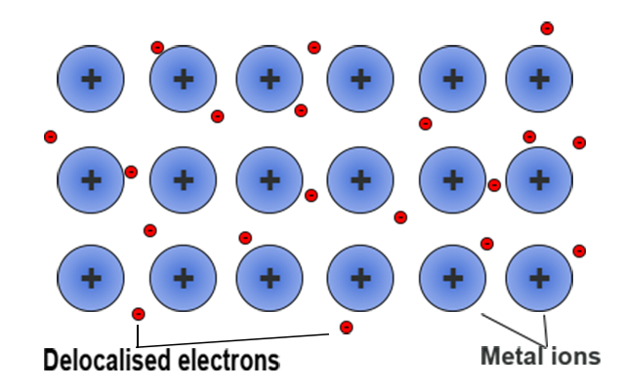

So metals have

1. A regular structure
2. Positive ions
3. Delocalised electrons
4. Conduct electricity (delocalised electrons)
5. Conduct heat (delocalised electrons)
6. High melting point (strong bonds)

Clips

<https://www.youtube.com/watch?v=QXT4OVM4vXI>

<https://www.youtube.com/watch?v=qFnh0dtH7eU>

Exam Questions

