Unit 1 Principles and Applications of Science

Structure and stuff

|  |  |  |  |  |
| --- | --- | --- | --- | --- |
| **Essential Content** | **Additional Guidance** | **☺** | **😐** | **☹** |
| **A1 Structure and bonding in applications in science** | Learners should: |  |  |  |
| * Understand the electronic structure of atoms: | * know that atoms have electron shells / energy levels which consist of subshells (s, p and d) * know the number and type of subshells in the first four energy levels * know how to place these subshells in order of increasing energy * be able to write the electronic structure (configuration) of the first 36 elements of the periodic table using s, p and d subshell notation |  |  |  |
| * electronic orbitals | * know that subshells contain electronic (atomic) orbitals * know that an orbital is a region of space where an electron is likely to be found * know that an orbital can hold up to 2 electrons * know the shapes and orientation of s and p orbitals * be able to interpret electron density plots for s and p orbitals * know the number and type of orbitals in each subshell for the first 36 elements |  |  |  |
| * Aufbau principle | * understand that to predict the electronic configuration of an atom, electrons fill the shells, subshells and orbitals of lowest energy first * understand that orbitals with the same energy must be filled singly before electrons are paired * understand that when electrons are paired, the spins of the two electrons are opposite to each other, in order to reduce repulsion * be able to use the electron-in-box model to show how electrons fill the orbitals in atoms of the first 36 elements |  |  |  |
| * Bohr theory | * understand that electrons occupy shells or energy levels, orbiting the nucleus of the atom * understand that an electron can move from its ground state energy level to a higher energy level by absorption of a quantum of radiation * understand that an electron can move from an excited state energy level to a lower energy level by emitting a quantum of radiation |  |  |  |
| * relative atomic mass | * know that the relative atomic mass of an element is the mean mass of the isotopes of an element compared to $\frac{1}{12}th$ of the mass of a carbon-12 atom * know that relative atomic mass has no units * be able to calculate the relative atomic mass of an element from the relative masses of the isotopes present and their percentage abundances |  |  |  |
| * atomic number and relative molecular mass | * be able to use the periodic table to find the atomic number or relative atomic mass for an element * be able to determine the number of protons or electrons in an atom or ion from the atomic number * be able to calculate relative molecular mass (or relative formula mass) of a compound from the sum of the relative atomic masses of all the atoms present |  |  |  |
| * Understand the periodic table: | * understand that elements are arranged in order of increasing atomic number * understand that elements are also arranged in columns called groups and rows called periods * know where metals and non-metals are located in the periodic table   **(NB Knowledge of metalloids is not required)** |  |  |  |
| * periods 1, 2, 3 and 4 | * understand that all elements in the same period have the same number of occupied shells in their atoms * be able to determine the period that an element belongs to from its electronic configuration or atomic number * understand periodic trends across the first four periods in terms of electronic configuration |  |  |  |
| * groups – s block, p block, d block | * understand that all elements in a group have the same number of electrons in the outermost shell of their atoms * be able to determine the group of an element by using its electronic configuration or atomic number * understand that elements in the same group have similar chemical behaviour * be able to explain the change in chemical reactivity of elements in a group using electronic configuration * know that the s block consists of group 1 and 2 elements, the p block consists group 3 – 8 elements, and that d block elements are located between the s and p blocks |  |  |  |
| * layout of periodic table in relation to s, p, d notation | * understand that the order of s, p and d blocks in the periodic table relates to the order in which s, p and d subshells are filled with electrons * know that the highest subshell occupied by electrons will determine which block of the periodic table an element is found in |  |  |  |
| * electronic arrangement of elements using s, p, d notation | * be able to represent the electronic arrangement of all elements in the first four periods using s, p and d subshell notation * understand that the electronic arrangement determines the chemical properties of an element |  |  |  |

**Part 1 Atomic Structure**

Everything we see around us, benches, computers and you! are made of atoms. At one time these atoms were part of something else. Some may have been in the soil, the air or even part of someone else. In other words one of the atoms that make up you could have been in your neighbour’s great grandad.

<https://ed.ted.com/lessons/the-2-400-year-search-for-the-atom-theresa-doud>

There are 92 naturally occurring types of atoms, we call these Elements.

**ELEMENT** ……………………………………..……………………………………………………………………..

……………………………………………………………………………………………………..

The simplest model of the **atom** is shown in the diagram below: We call this the Bohr model you can think of it like a multi story block of flats with the electrons sitting in shells (ie the floors) around the nucleus. The electrons can move up by absorbing energy and releasing energy to go down . Think about climbing stairs it takes energy to climb up the stairs but you release energy if you fall down the stairs.

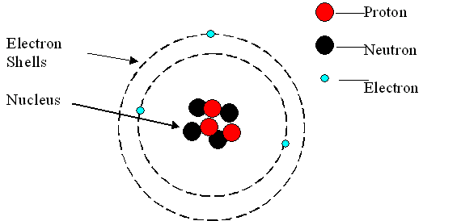

Atoms have a tiny central NUCLEUS containing:- PROTONS (positively charged) and NEUTRONS (neutral)

The nucleus is surrounded by a cloud of ELECTRONS (negatively charged)

These are arranged in **shells** having different energy levels

The diagram above is of a Lithium atom. How do we know this?

........................................................................................................................................................................................................................................................................................................

It is the number of protons in the nucleus which determines which element we are looking at. An atom with 6 protons would be the element carbon; the number of protons determines the element. This number is called the **ATOMIC NUMBER** of the element, the number of protons also determines its position in the Periodic Table

Changing the number of neutrons, or electrons does not change the element.

Find the element:-

|  |  |
| --- | --- |
| No of Protons | Name |
| 77 |  |
| 53 |  |
| 47 |  |
| 6 |  |
| 10 |  |
| 92 |  |

If the number of electrons surrounding the nucleus is equal to the number of protons inside it, the atom is neutral. If the number of **electrons does not equal the number of protons** it is no longer an atom it is now an ion (you will need this when we study ionic bonding)

Define:-

**ION** ……………………………………..………………………………………………………………………………………………………………………..

Almost all the **mass** of an atom is in the nucleus. Almost all the **volume** is in the electron cloud.

The mass of one proton approximately equals the mass of one neutron i.e. 1 u (atomic mass unit), but an electron is much lighter. ( ~ 1/2000 u).

New exerciseComplete the following table:

|  |  |  |  |
| --- | --- | --- | --- |
|  | proton | neutron | electron |
| Approximate mass /u |  |  |  |
| Charge |  |  |  |

Define:-

**MASS NUMBER** **(A)** …………………………..……………………………………………………………………………………………..

……………………………………………………………………………………………………..

**ATOMIC NUMBER** ……………………………………………………...

…………………………………………………………………………………………………….

This information is expressed:

##### Li

Mass Number

Atomic number

7

3

Elements are arranged on the periodic table according to:

* + - New exerciseIncreasing atomic number
    - The arrangement of electrons in shells.

Complete the following table for the atoms :

|  |  |  |  |  |  |
| --- | --- | --- | --- | --- | --- |
| Atom | Atomic  number | Mass  number | Number of  protons | Number of neutrons | Number of electrons |
| 12C  6 |  |  |  |  |  |
| 23Na  11 |  |  |  |  |  |
|  | 9 | 19 |  |  |  |
|  |  | 40 | 18 |  |  |
|  |  |  | 19 | 20 |  |
|  |  |  |  | 14 | 13 |
| 197Au  79 |  |  |  |  |  |
|  | 35 |  |  | 44 |  |
|  |  | 238 |  |  | 92 |

All atoms with the same atomic number are the same element but can have differnet numbers of neutrons as neutrons are neutral they are still atoms not ions but they have a different mass from each other

**ISOTOPES** of an element are atoms which

………………………………………………………………………………………………………………………………………………………

………………………………………………………………………………………………………………………………………………………

This is why on your periodic table the atomic number is always a whole number (because it is the number of protons) but the mass number is a decimal as it has to take into account the different masses of the ISOTOPES we call this the **relative** atomic mass.

**RELATIVE ATOMIC MASS (Ar)** ...............................................................…….................................................

………………………………………………………………………………………………………………………………………………………………

We can calculate the relative atomic mass from the amount of each isotope present

1. Silver (51.3% Ag-107, 48.7% Ag-109)

51.3 x 107) + (48.7 x 109)

100

= 107.974 = 108 (3sf)

W/s Relative atomic masses

The protons and neutrons are found in the nucleus at the centre of the atom. The electrons in shells or energy levels that surround the nucleus and it is these that we will now look at in the next section, Electronic Structure.

**PART 2 ELECTRONIC STRUCTURE**

You leant at GCSE that electrons are negatively charges and orbit the nucleus in shells. Each shell taking a maximum number of electrons

|  |  |
| --- | --- |
| **Shell number** | **Maximum number of electrons** |
| 1 (nearest nucleus) |  |
| 2 |  |
| 3 | 18 (not 8, but after 8 two electrons enter shell 4 before filling shell 3) |

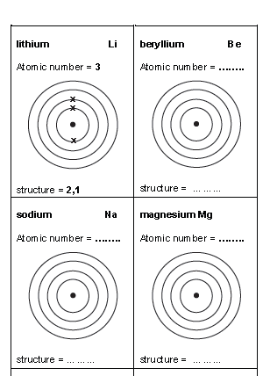We can show this electron arrangement on dot cross diagrams

However it is not quite this simple, the electrons cannot occupy the same space, or the same energy so we break the shells down, into first sub-shells the orbitals

Shell Town Godalming

Sub Shell Street Tusley Lane

Orbital No of House Godalming College

Like an address each line gives more information on the location of the electron

Shell 1 2 3 4 etc

Sub Shell s, p, d

Orbital (a bit more complex)

Draw the dot cross diagram for Na Sodium

1s 2s 2p 3s 3p 4s

|  |  |  |  |  |  |  |  |  |  |  |  |  |  |  |  |  |
| --- | --- | --- | --- | --- | --- | --- | --- | --- | --- | --- | --- | --- | --- | --- | --- | --- |
| Na |  |  |  |  |  |  |  |  |  |  |  |  |  |  |  |  |

Draw the Dot cross diagram for Fluorine

1s 2s 2p 3s 3p 4s

|  |  |  |  |  |  |  |  |  |  |  |  |  |  |  |  |  |
| --- | --- | --- | --- | --- | --- | --- | --- | --- | --- | --- | --- | --- | --- | --- | --- | --- |
| F |  |  |  |  |  |  |  |  |  |  |  |  |  |  |  |  |

|  |  |  |
| --- | --- | --- |
| Shell | Sub Shell | No electrons |
| 1 | s | 2 |
| 2 | s  p | 2  6 |
| 3 | s  p  d | 2  6  10 |

Each box represents a single orbital. The Aufbau principle states that electrons fill the orbital of the lowest energy first (1s) . This gives the most stable electron configuration. If there are more than one electron in a sub shell they will fill the orbitals singly only when all the orbitals in that sub shell have 1 electron in them do they pair up.

Have a go at these

1s 2s 2p 3s 3p 4s

|  |  |  |  |  |  |  |  |  |  |  |  |  |  |  |  |  |
| --- | --- | --- | --- | --- | --- | --- | --- | --- | --- | --- | --- | --- | --- | --- | --- | --- |
| Mg |  |  |  |  |  |  |  |  |  |  |  |  |  |  |  |  |

|  |  |  |  |  |  |  |  |  |  |  |  |  |  |  |  |  |
| --- | --- | --- | --- | --- | --- | --- | --- | --- | --- | --- | --- | --- | --- | --- | --- | --- |
| O |  |  |  |  |  |  |  |  |  |  |  |  |  |  |  |  |

|  |  |  |  |  |  |  |  |  |  |  |  |  |  |  |  |  |
| --- | --- | --- | --- | --- | --- | --- | --- | --- | --- | --- | --- | --- | --- | --- | --- | --- |
| C |  |  |  |  |  |  |  |  |  |  |  |  |  |  |  |  |

|  |  |  |  |  |  |  |  |  |  |  |  |  |  |  |  |  |
| --- | --- | --- | --- | --- | --- | --- | --- | --- | --- | --- | --- | --- | --- | --- | --- | --- |
| P |  |  |  |  |  |  |  |  |  |  |  |  |  |  |  |  |

|  |  |  |  |  |  |  |  |  |  |  |  |  |  |  |  |  |
| --- | --- | --- | --- | --- | --- | --- | --- | --- | --- | --- | --- | --- | --- | --- | --- | --- |
| N |  |  |  |  |  |  |  |  |  |  |  |  |  |  |  |  |

**SHORTENED ‘ELECTRONIC CONFIGURATIONS’**

When considering the **electronic structure of an atom** we now need to state:-

the shell

the subshells

and finally the number of electrons in each subshell.

superscript = the number of electrons in the subshell

This is written using the following notation:-

1s2

the shell

the subshell

Each subshell needs to be defined and so the full electronic structure can be written:-

For sodium Na = 1s2 2s2 2p6 3s1

Write out the full electronic structure for atoms of:-

K = ............................................................

N = ............................................................

O = ...........................................................

F = ............................................................

P = ............................................................

Mg = ..........................................................

It is the electron arrangement that determines the chemical properties of an element.

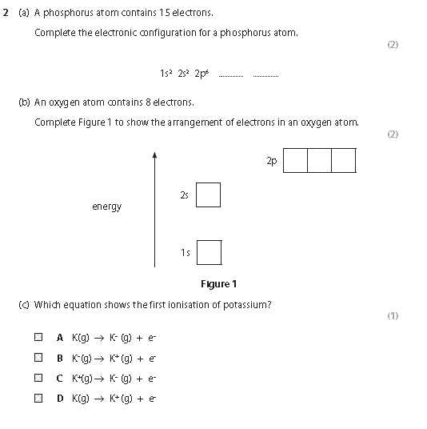

These orbitals have different shapes S orbitals are spheres, P sub shells look like dumb bells

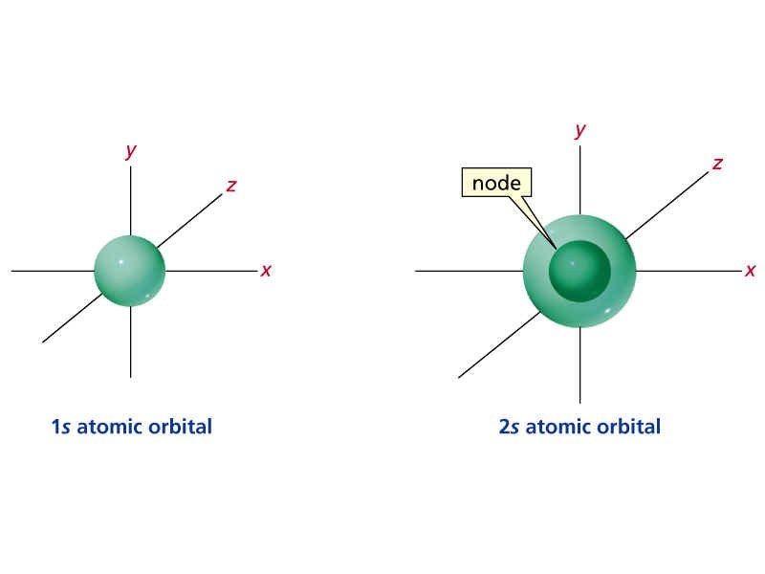

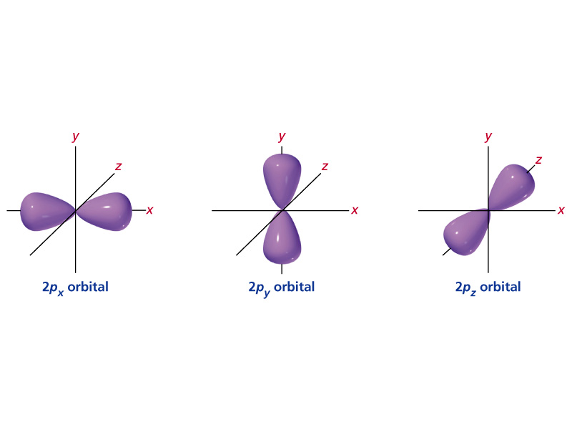

But you need to remember that an orbital is a place where there is a probability of finding an electron so another way to represent the orbital is as an electron density 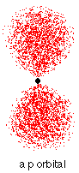

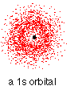

**PART 3 THE PERIODIC TABLE**

The periodic table organises the elements into periods and groups according to the **atomic number** of the element starting at 1 (Hydrogen) and ending at, well at the moment the periodic table stands at 118 Oganesson.

The periodic table is divided up into periods that go across the table and groups which go down

<https://ed.ted.com/lessons/solving-the-puzzle-of-the-periodic-table-eric-rosado>

Elements in the same group share some of the same characteristics for example all group 1 elements are reactive metals, all group 0 are all unreactive gases, this is because they have the same number of electrons in their outer shell

Below is an outline of the periodic table. Label the Periods 1,2,3 & 4 (use different colours)

|  |  |  |  |  |  |  |  |  |  |  |  |  |  |  |  |  |  |
| --- | --- | --- | --- | --- | --- | --- | --- | --- | --- | --- | --- | --- | --- | --- | --- | --- | --- |
|  |  |  |  |  |  |  |  |  |  |  |  |  |  |  |  |  |  |
|  |  |  |  |  |  |  |  |  |  |  |  |  |  |  |  |  |  |
|  |  |  |  |  |  |  |  |  |  |  |  |  |  |  |  |  |  |
|  |  |  |  |  |  |  |  |  |  |  |  |  |  |  |  |  |  |
|  |  |  |  |  |  |  |  |  |  |  |  |  |  |  |  |  |  |
|  |  |  |  |  |  |  |  |  |  |  |  |  |  |  |  |  |  |
|  |  |  |  |  |  |  |  |  |  |  |  |  |  |  |  |  |  |

The s block consists of group 1&2 elements

The p block consists of group 3-8 elements

The d block elements are between the s ad p block

The highest subshell occupied by electrons will determine which block of the periodic table an element is in. So for example N is in p block because its highest energy electron is in 2p Mg is an s block element because its highest energy electron is in 3s.

Colour in the periodic table

S block

P block

D block

|  |  |  |  |  |  |  |  |  |  |  |  |  |  |  |  |  |  |
| --- | --- | --- | --- | --- | --- | --- | --- | --- | --- | --- | --- | --- | --- | --- | --- | --- | --- |
|  |  |  |  |  |  |  |  |  |  |  |  |  |  |  |  |  |  |
|  |  |  |  |  |  |  |  |  |  |  |  |  |  |  |  |  |  |
|  |  |  |  |  |  |  |  |  |  |  |  |  |  |  |  |  |  |
|  |  |  |  |  |  |  |  |  |  |  |  |  |  |  |  |  |  |
|  |  |  |  |  |  |  |  |  |  |  |  |  |  |  |  |  |  |
|  |  |  |  |  |  |  |  |  |  |  |  |  |  |  |  |  |  |
|  |  |  |  |  |  |  |  |  |  |  |  |  |  |  |  |  |  |

The element sodium is an s block element because ……………………………………………………………………………………………………………………………………………….

The element Carbon is a p block element because ……………………………………………………………………………………………………………………………………………….

The element Vanadium is a d block element because ……………………………………………………………………………………………………………………………………………….

The element Magnesium is an s block element because ……………………………………………………………………………………………………………………………………………….

The element Sulfur is a p block element because ……………………………………………………………………………………………………………………………………………….

The element iron is a d block element because ……………………………………………………………………………………………………………………………………………….

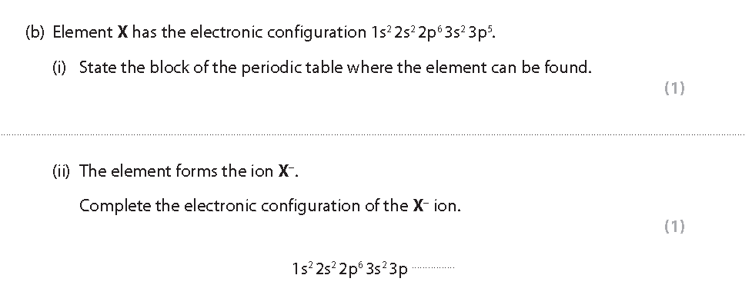

**Transition metals**

Within the d block there are a special group of elements called the Transition metals.

The definition of a transition metal is …………………………………………………………………………………

…………………………………………………………………………………………………………………………………………….

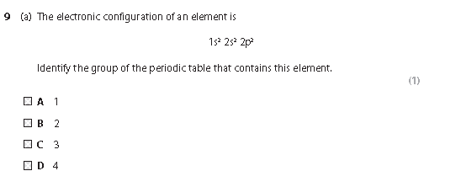

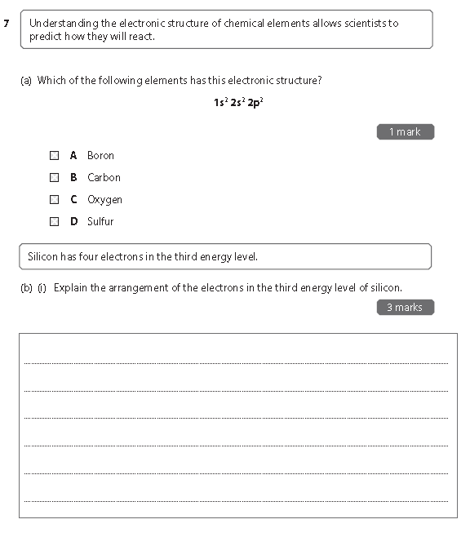

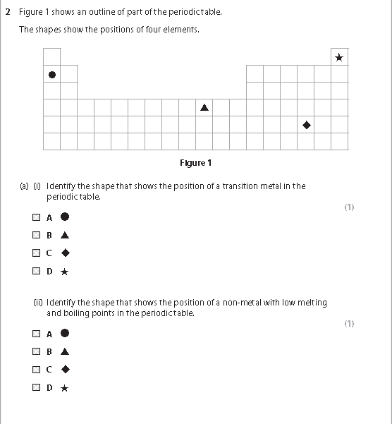

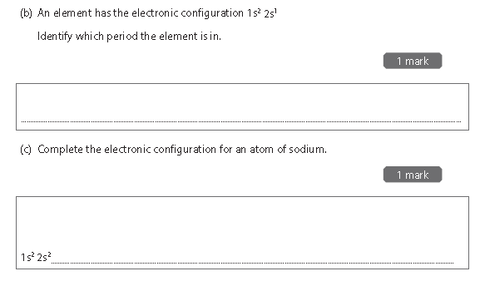

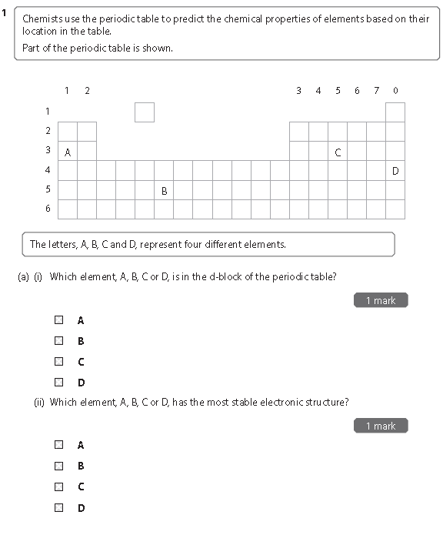

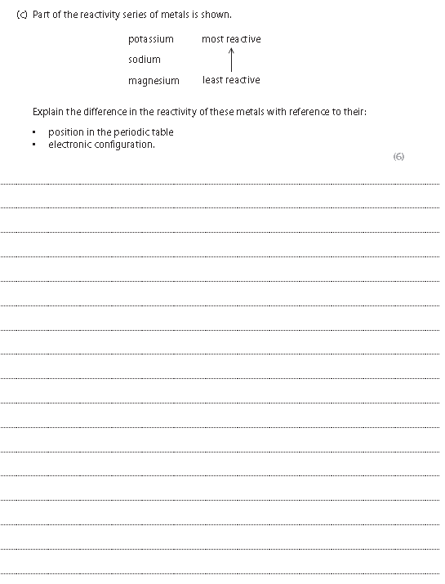Extension – Have a go at answering this question. We will come back to some of these ideas in later topics