A2 Chemical properties Intermolecular Forces

|  |  |  |  |  |
| --- | --- | --- | --- | --- |
| **Essential Content** | **Additional Guidance** | **☺** | **😐** | **☹** |
| * Understand the following intermolecular forces | * know that simple covalent molecules are held together by relatively weak intermolecular forces * know the three main types of intermolecular forces and their relative strengths * be able to predict the intermolecular forces present in given molecules or monatomic substances to include hydrogen and elements of group 5, 6, 7 and 0 and the hydrides of group 4, 5, 6 and 7 elements and explain how they arise * be able to explain differences in physical properties (such as melting point, boiling point and density) for different molecules or monatomic substances, in terms of the intermolecular forces present |  |  |  |
| * van der Waals | * understand that van der Waals forces is the term used for intermolecular forces that involve dipole attraction between molecules * understand that temporary diploes in molecules can form due to the uneven distribution of electrons * understand that an induced dipole can be created in a neighbouring molecule and a weak attraction between the molecules can occur * understand that the size and strength of the temporary dipole - induced dipole attraction depends upon the number of electrons * understand how molecular size and shape also affects the strength of the temporary dipole – induced dipole |  |  |  |
| * dipole-dipole | * know that permanent dipole – permanent dipole attraction can occur in polar molecules and is stronger than temporary dipole – induced dipole attraction in the same molecule * understand that permanent dipoles arise from a difference in electronegativity between the two atoms bonded * understand that the greater the difference in electronegativity between the two atoms, the greater the strength of the permanent dipole |  |  |  |
| * hydrogen bonding | * know that hydrogen bonding is a relatively strong intermolecular force compared to dipole-dipole attraction, but much weaker than covalent bonding * understand that hydrogen bonding occurs in polar molecules which have N-H, O-H or H-F bonds * be able to explain how hydrogen bonding occurs * be able to draw examples of molecules with hydrogen bonding, such as H2O, NH3, HF, and organic molecules with an O-H group |  |  |  |

Intermolecular forces

Hydrogen, ammonia, methane and water are simple molecules with covalent bonds. All have **very strong bonds between the atoms**, but much **weaker forces holding the molecules** together. When one of these substances melts or boils, it is these weak 'intermolecular forces' that break, not the strong covalent bonds. Simple molecular substances are gases, liquids or solids with low melting and boiling points.

There are three types of intermolecular forces

1. van der Waals’ (also called London forces)
2. permanent dipole-dipole force
3. Hydrogen Bonding

We will look at each

1. van der Waals’

van der Waals’ forces are dependent upon the number of electrons and the shape of the molecule

They are caused by the uneven distribution of electrons, this creates a temporary dipole which induces a dipole in an adjacent molecule and weak attraction between the molecules occurs

1. Permanent dipole-dipole force

These are caused by a difference in electronegativities of the atoms in the bond, these then attract the opposite dipole on an adjacent molecule. This is a permanent dipole and stronger than the temporary dipoles.

1. Hydrogen bonding

A stronger version of Permanent dipole-dipole force. This involves N, O or F directly bonded to a H. The large difference in electronegativity means that the Hydrogen bonding is the strongest form of intermolecular force.

Solids liquids and gases

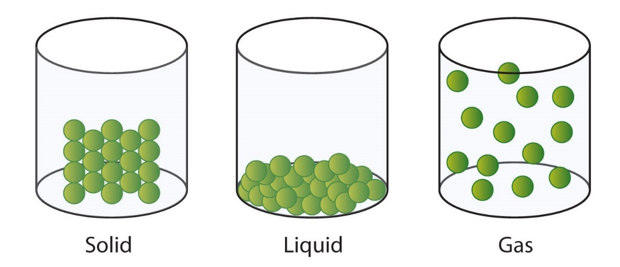

Define

|  |  |
| --- | --- |
| Solid |  |
| Liquid |  |
| Gas |  |

When substances move from one state to another the forces of attraction between the particles have to be overcome. In ionic bonding this involves a large amount of energy as the strong ionic bonds between the ions have to be broken. In metals this also involves a large amount of energy as the strong metallic bonds between the ions and delocalised electrons have to be broken

In simple covalent molecules we do NOT break the strong covalent bonds but rather the weak INTERMOLECULAR forces between the molecules.

In this topic we will look at these intermolecular forces.

van der Waals’

They are caused by the uneven distribution of electrons, this creates a temporary dipole which induces a dipole in an adjacent molecule and weak attraction between the molecules occurs

van der Waals’ are dependant largely on the number of electrons in the molecule, and the shape. The more branched the molecule the lower the boiling point.

More electrons = Stronger van der Waals’

Less branches = Stronger van der Waals’

Which of these have the strongest van der Waals’

1. CH4 or C2H6
2. CO2 or H2O
3. PCl5 or PI3
4. CH3COOH or CH3CH2CH3

Permanent dipole-dipole force

Permanent dipole-dipole forces are largely dependent on the difference in electronegativity

Electronegativity is the ability of an atom to attract a bonding pair of electrons in a covalent bond. Fluorine is the most electronegative element (4.0)

Bigger difference = stronger permanent dipole-dipole force

Which of these have the largest dipole, you will need the sheet on electronegativities

1. HCl or HI

Electronegativity differences H-Cl = …………………………. H-I =……………………………..

Therefore the stronger forces of attraction are between …………… molecules

1. HI or HBr
2. PI3 or PCl5
3. NO2 or CO2

Hydrogen Bonding

Hydrogen bonding is a special type of Permanent dipole-dipole force It only involves N, O or F **directly** bonded to a Hydrogen. The large delta positive H on one molecule is attracted to the lone pair on the O, N or F of another molecule.

The three common compounds that contain H-bonds are H2O, NH3, and HF

H2O

NH3

HF

Alcohols also show hydrogen bonding

Ethanol CH3CH2OH

Which of the following have hydrogen bonding

1. H2O or H2S
2. HF or HCl
3. NH3 or PH3
4. HF or CH3F

Remember hydrogen bonding is the strongest type of intermolecular force and if a substance has Hydrogen bonding it will have a higher boiling point than expected, this explains the relatively high boiling point of substances like water and ammonia

Molecules are attracted to each other by weak intermolecular forces. There are three types of intermolecular force;

* Van der Waals
* Dipole-dipole forces
* Hydrogen bonding

For each group of molecules below, identify the strongest type of intermolecular force present in each molecule (1 mark) and then use this information to order the molecules according to their boiling point, from lowest to highest (1 mark).

**1.** CH4 SiH4 SnH4

**2.** NH3 PH3 AsH3

**3.** HF HCl HBr

**4.** CH3F CH3Cl CH4

**5.** HF H2O NH3

