C1 Working with waves

|  |  |  |  |  |  |
| --- | --- | --- | --- | --- | --- |
| **C1 Working with waves** |  | | **☺** | **😐** | **☹** |
|  | **Understand the features common to all waves and use the following terms as applied to waves**: | |  |  |  |
| * periodic time | * know that a period of a wave, vibration or oscillation is the time required to complete a full cycle, e.g. the time taken to produce a complete wave or complete one full oscillation * know that the symbol T is used to represent periodic time/time period and the unit for T is the second (s) * know that time period, T and frequency (f) are linked by the equation T = 1/f * be able to substitute a value for either T or f into this equation and calculate a value of the other term * be able to use the term period T, the unit (s), for this quantity and the equation T= 1/f | |  |  |  |
| * speed | * know that the speed of a wave is also referred to as wave speed or wave velocity * know that wave speed is the distance in metres (m) travelled by the wave in one second (s) * be able to use information about the distance travelled by a wave in a given amount of time to calculate wave speed/velocity in ms-1 | |  |  |  |
| * wavelength | * know that the wavelength of a wave is the distance between two points on a wave that have the same amplitude and are moving in the same direction, e.g. between two consecutive crests or troughs * be able to determine the wavelength of a wave from a graphical representation of the wave * know that wavelength is given the symbol λ (lambda) and has the unit metre (m) | |  |  |  |
| * frequency | * know that the frequency of a wave is the number of waves produced in one second (s) or the number of waves that pass a point each second * be able to use the unit hertz (Hz) or s-1 for frequency * be able to use information about the number of waves produced in a given amount of time to calculate frequency in hertz (Hz) | |  |  |  |
| * amplitude | * know that the amplitude of a wave is its maximum displacement from its undisturbed position * be able to determine the amplitude of a wave from a graphical representation of the wave | |  |  |  |
| * oscillation | * know that an oscillation is a regular repetitive motion, e.g. a weight on a spring bouncing up and down, a pendulum swinging backwards and forwards or a string on a guitar vibrating to and fro * understand that one complete oscillation is a vibration of a particle or wave or source through one complete cycle, e.g. for a pendulum to swing from its maximum displacement on the left to its maximum displacement on the right AND back to the maximum displacement on the left | |  |  |  |
| * Graphical representation of wave features | * be able to identify and/or determine displacement, amplitude, wavelength, period and frequency of waves or oscillations from information supplied on graphs and diagrams | |  |  |  |
| * Understand the difference between the two main types of wave: | * be able to describe the differences between transverse and longitudinal waves in terms of the motion of their particles * understand the production of transverse and longitudinal waves using a slinky * be able to identify examples of transverse and longitudinal waves | |  |  |  |
| * transverse | * know examples of transverse waves including all electromagnetic waves, seismic S-waves and surface water waves * be able to describe the motion of the particles in a transverse wave | |  |  |  |
| * longitudinal | * know examples of longitudinal waves including sound, ultrasound and seismic P-waves * be able to describe the motion of the particles in a longitudinal wave * know the term and use the terms compression and rarefaction to describe longitudinal waves * understand the applications of longitudinal waves, to include ultra sound in diagnostic medicine and echo-location | |  |  |  |
| * Understand concepts of displacement, coherence, path difference, phase difference, superposition as applied to diffraction gratings | * understand the principle of superposition of waves, i.e. the net displacement of the medium at any point in space or time, is simply the sum of the individual wave displacements * understand that phase difference is the amount by which one wave leads or lags (falls behind) another wave * phase difference can also be measured in degrees i.e. 1/4λ = ¼ x 3600 = 900 * understand constructive and destructive superposition (interference) * understand that constructive interference occurs when waves are in phase (e.g. a peak meets a peak and they add to give a peak with twice the amplitude) and waves destructively interfere (i.e. cancel each other out) when they are 180° out of phase. (e.g. a peak meeting a trough with the same amplitude gives zero wave displacement) * know that displacement is a vector quantity which refers to the distance moved by a wave or particle or medium from its original position * know that sources of waves are coherent if they have the same frequency and are in phase or have a constant phase difference * know that a path difference of one wavelength gives constructive interference (as a peak will always coincide with another peak and a trough will always coincide with another trough, i.e. the waves arrive in phase with each other) and a path difference of half a wavelength gives destructive interference (as a peak will always coincide with a trough, i.e. the waves have a phase difference of ½λ or 1800) | |  |  |  |
| * Understand the industrial application of diffraction gratings, to include: | | |  |  |  |
| * emission spectra | | * know that an (atomic) emission spectra is the range of frequencies of light emitted by an element * understand that an emission spectrum is produced by an element due to energy level changes of electrons * know that as the electrons lose energy when returning to a lower energy level they emit light of a specific frequency |  |  |  |
| * identifying gases | | * know that the emission spectrum of each element is unique and so can be used to identify the element * understand that elements such as mercury, sodium, lithium, potassium and other heavy metals can be vapourised to form gases that can then be energised to emit (atomic) emission spectra |  |  |  |
| * Be able to use the wave equation: | | * know that v is the velocity ( or speed) of the wave in ms-1 * know that f is the frequency of the wave in Hz (s-1) * know that λ is the wavelength of the wave in m * be able to substitute values for any two of velocity, v or frequency, f or wavelength, λ into this equation and calculate a value for the other term * be able to re-arrange/transform the equation, i.e. change the subject of the equation |  |  |  |
| * Understand the concept and applications of stationary waves, resonance | | * know that a standing wave arises from a combination of reflection of a wave and interference between the original (incident) and the reflected wave * know that in strings the amplitude of the standing wave is twice that of the incident or reflected wave as constructive interference takes place * know that a point of maximum vibration in a standing wave is called an antinode * know that a point of zero vibration in a standing wave is called a node * be able to identify nodes and antinodes in standing waves * know that the separation of adjacent nodes is half a wavelength, λ/2 * know that the separation of adjacent antinodes is half a wavelength, λ/2 * be able to identify fundamental frequencies and harmonics from diagrams of standing waves * use information from diagrams of standing waves to determine wavelengths and frequencies of waves * understand resonance, including vibration in strings, air in pipes or tubes and percussion instruments * understand that stationary waves are also referred to as standing waves |  |  |  |
| * Musical instruments | | * understand the principles of stationary waves and resonance when applied to a range of musical instruments * understand the principles of how a standing wave is produced in vibrating strings, vibrating columns of air or percussion instruments |  |  |  |

**Waves**

Wave motion transfers ____________ from one place to another.

<https://www.youtube.com/watch?v=KMfxwQWrBgY>

Eg

Microwaves – Transfer energy to food

Sound Waves – Make things vibrate or move (air particles)

Radio Waves – Transfer Information

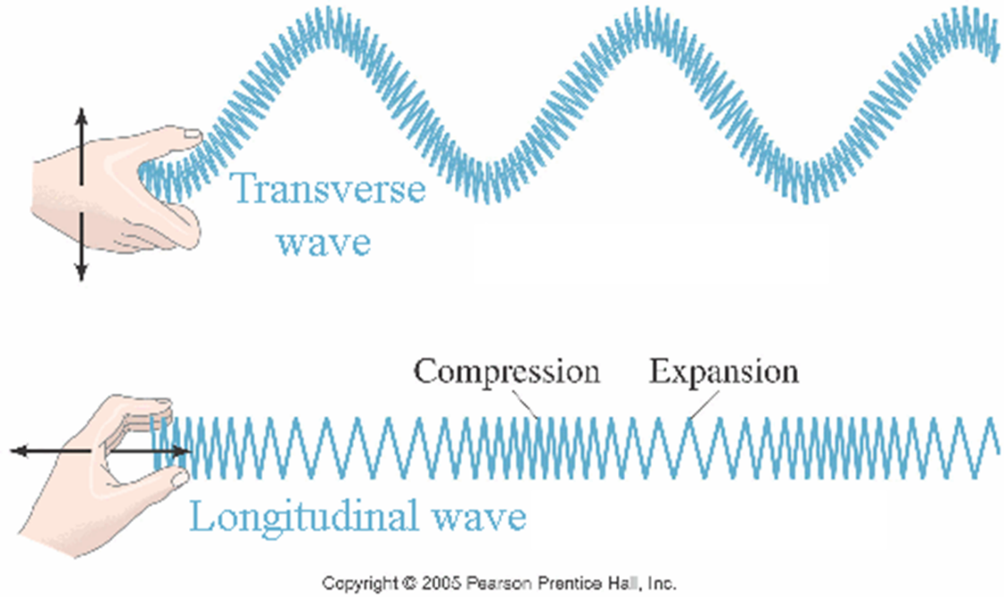

Add arrows to show the direction of energy transfer, and the direction of vibration.

Give some examples of where you might encounter transverse waves?

……………………………………………………………………………………………….

**Longitudinal waves**

The ____________ are ___________ to the ___________ of ____________ transfer.



A column full of gas particles. What happens in the plunger is pushed in and then out again?

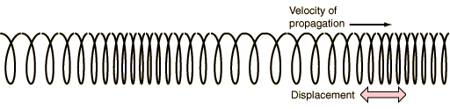

How could you measure the wavelength? Sketch this on the diagram.

Can you think where you might encounter longitudinal waves everyday?

………………………………………………………………………………………………….

**Wave measurements**

**Amplitude** – A

Label the maximum displacement from the mean on this.

**Wavelength** – λ

The length of one complete wave.

Label some wavelengths on the diagram above

**Frequency** – f = 1/T

The number of oscillations in one second. Measured in Hertz.

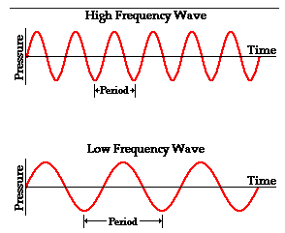

**Wave speed** – v

The speed at which the wave fronts pass a stationary observer.

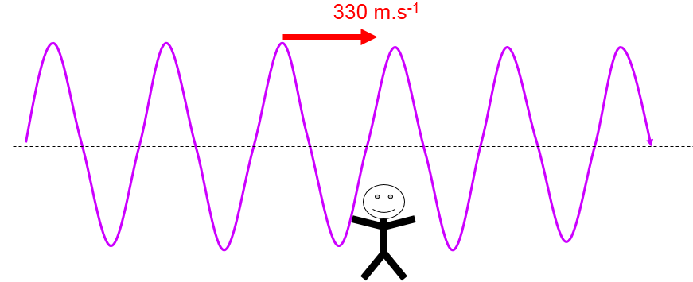

**Period Time (Time)**

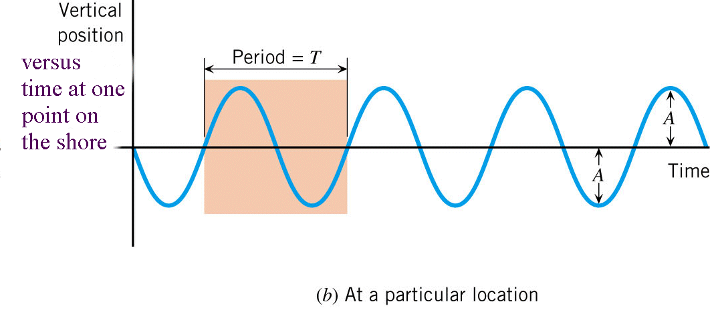

Time taken for one complete wave

**Oscillation**

Wave energy takes time to travel, one wavelength takes one cycle, that is one periodic time.

The Wave Equation

Speed = distance/time

For wave speed, the wavelength, λ, is the distance travelled in one complete cycle and time to complete one cycle is the period, *T*.



This means that:

Wave speed = wavelength = λ

Period T

Since f=1/T we can substitute this into the above equation and then

Wave speed = frequency (Hz) x wavelength (m)

v = fλ

**v = speed of wave (m/s)**

**f = frequency of wave (Hz)**

**λ = wavelength (m)**

Practice

Calculate the following:

1. The speed of a wave with a frequency of 10kHz and a wavelength of 2m.
2. The speed of a wave with a wavelength of 50cm and a frequency of 4kHz
3. The frequency of a wave travelling at 500m/s with a wavelength of 25m
4. The speed of a radio wave with a wavelength of 3000m and a frequency of 100kHz
5. The speed of a wave with a frequency of 30MHz and wavelength of 10m
6. The wavelength of a wave travelling at 11km/s with a frequency of 5.5kHz
7. The frequency of the wave below, which is travelling at 9km/s

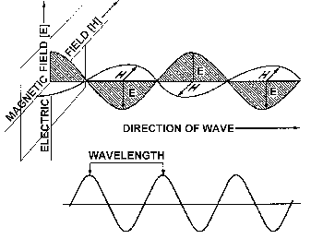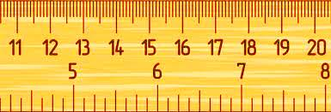

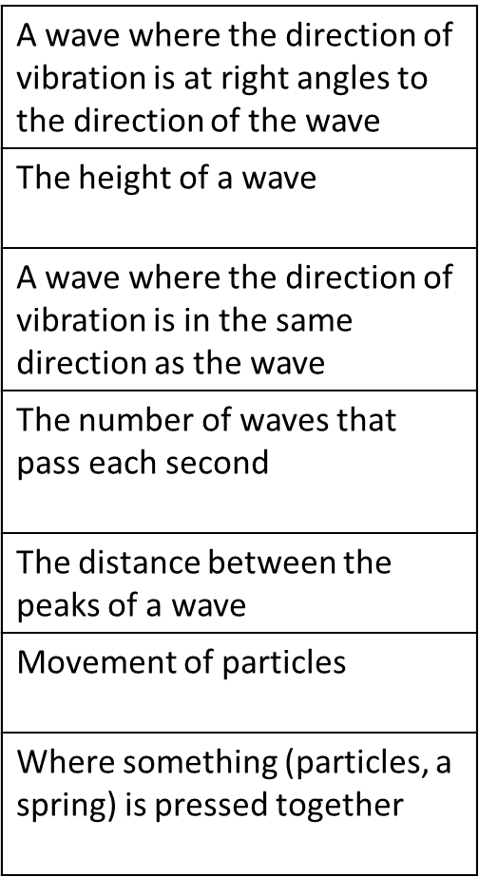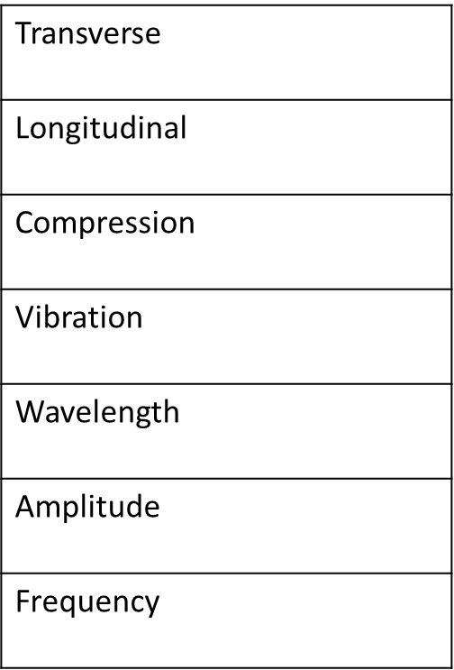

Match the keyword to the definition

Keywords you need to know the meaning of for this topic section:

|  |  |
| --- | --- |
| Oscillation |  |
| Frequency |  |
| Periodic Time |  |
| Speed |  |
| Amplitude |  |
| Wavelength |  |

All waves transfer energy and information without transferring matter

Exam Questions

**Q1.**

A student uses a cathode ray oscilloscope (CRO) to investigate the properties of waves produced by a signal generator.

The student obtains the following output.

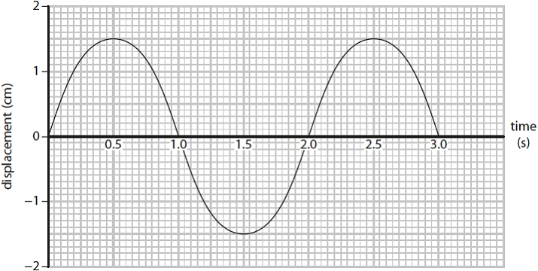

Give the amplitude of the wave.  
  
Amplitude = ........................................................... cm

Give the periodic time of the wave.

.............................................................................................................................................

The student investigates a different water wave.

The wavelength is 0.05 m and the wave speed is 0.075 m/s.

Calculate the frequency of the water wave.

Show your working.

Frequency = ........................................................... Hz

**Q2**

A diffraction experiment makes use of coherent light waves.

The light that produces one of the lines on the screen has a wavelength of 588.2 nm.

Calculate the frequency of this light.

Speed of light in air = 3.0 × 108 ms–1

Show your working.

**(4)**

frequency = ........................................................... Hz

**Q3.**

Various parts of the electromagnetic spectrum are used for communication.

An electromagnetic wave has a frequency of 4.5 × 109 Hz.

The speed of light is 3 × 108 m/s.

Show that the wavelength of the electromagnetic wave is approximately 7.0 cm.

Show your working.

........................................................... cm

**(Total for question = 3 marks)**

All Waves can be reflected, refracted and diffracted. We will look at reflection and refraction in C2

When a waves meets an obstical (or new material) its direction of travel can change.

1. Waves might be reflected ie the waves rebound off the surface eg a mirror
2. Waves might be refracted they go through the material but because they change speed they change direction

Or…

They can be diffracted ie bend round the edges and through gaps causing the waves to spread out. This allows waves to travel round corners eg sound waves.

The amount of diffraction depends on the size of the gap relative to the wavelength

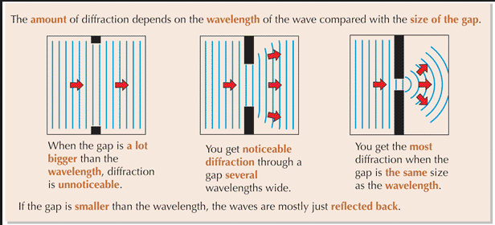

Gap much bigger than wavelength NO diffraction

Gap several wavelengths SOME diffraction

Gap same size as wavelength MAX diffraction

<https://www.youtube.com/watch?v=9m74yZySDe4>

Double Slit experiments

Instead of having one slit if we have two which the wave has to pass through we get what is called an interference pattern

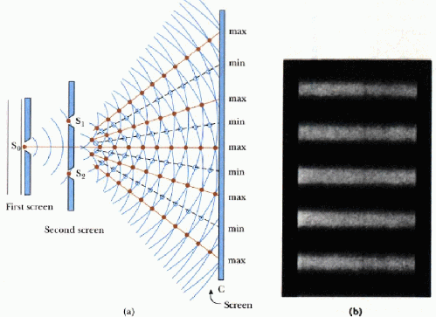

The light passes through small gaps in the diffraction grating, as the light waves pass through each slit they interfere with each other.

Lines appear

A bright region is produced on the screen because the distance between the screen and the slit gives a path difference of a whole number of wavelengths. So a peak and a peak or trough and a trough meet. This causes constructive interference and a bright line is produced on the screen.

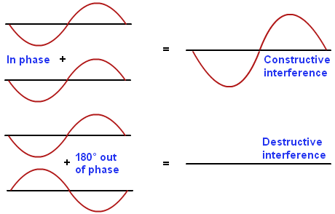

A dark region is produced on the screen because the distance between the screen and the slits gives a path difference of half a wavelength, so a peak meets a trough and the waves cancel out. We get destructive interference



For a clear diffraction patter to be produced on the screen, the light passing through the diffraction grating has to have **coherence.** For this to happen waves must have the same frequency and wavelength and have a constant phase difference.

When waves from 2 or more sources overlap this is called **superposition**

The difference in the distance travelled to a fixed point is called the **path difference**

Diffraction gratings can be used in identifying gases and looking at emission spectra.

**Exam questions**

**Q7.**

A diffraction experiment makes use of coherent light waves.

what is meant by the term **coherent light waves**.

**(2)**

.............................................................................................................................................

.............................................................................................................................................

.............................................................................................................................................

.............................................................................................................................................

**(Total for question = 2 marks)**

**Q10.**

A diffraction experiment makes use of coherent light waves.

A technician wants to identify the gas in a discharge tube.

The technician uses a diffraction grating to produce emission spectra for the gas.

Each spectrum consists of a series of light and dark lines on a screen.

Explain how the diffraction grating produces the light and dark lines on the screen.   
You may draw diagrams to support your answer.

**(Total for question = 6 marks)**

.............................................................................................................................................

.............................................................................................................................................

.............................................................................................................................................

.............................................................................................................................................

.............................................................................................................................................

.............................................................................................................................................

.............................................................................................................................................

.............................................................................................................................................

.............................................................................................................................................

.............................................................................................................................................

.............................................................................................................................................

.............................................................................................................................................

.............................................................................................................................................

.............................................................................................................................................

.............................................................................................................................................

.............................................................................................................................................

.............................................................................................................................................

.............................................................................................................................................

.............................................................................................................................................

**Q16.**

Figure 5 shows rays of light passing through part of a diffraction grating.

The diffraction grating produces a bright line on the screen.

The distance travelled from the diffraction grating to the screen is different for each ray of light.

This is called the path difference.

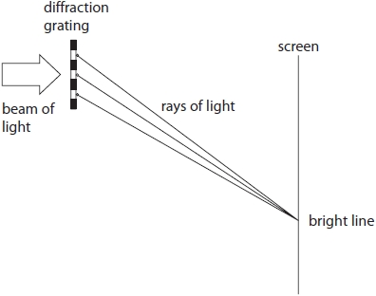

**Figure 5**

Which path difference between the rays of light gives the bright line?

**(1)**

   **A**    quarter of a wavelength

   **B**    half a wavelength

   **C**    three quarters of a wavelength

   **D**    one wavelength

**Q17.** Light from a sodium-vapour lamp passes through the slits in a diffraction grating and creates a pattern on a screen.

This pattern is called an emission spectrum.

Which property of light produces the pattern on the screen?

   **A**    absorption

   **B**    interference

   **C**    reflection

   **D**    refraction

**Emission spectra and Identifying elements**

Each element has a unique emission spectra, a unique set of colours

<https://www.youtube.com/watch?v=n_KyYFYNvpI>

We can use this to identify the element,

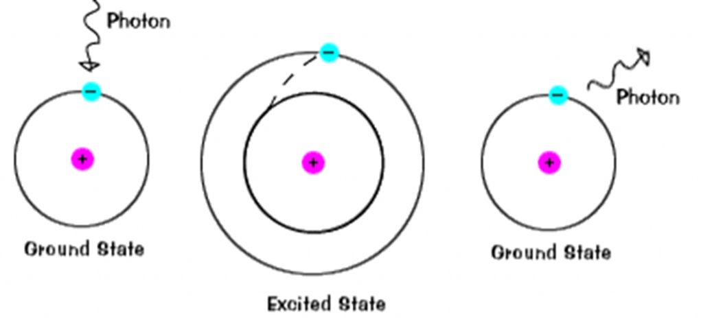

Step 1 Heat your element, this promotes an electron to a higher energy state

Step 2 The electron returns to its ground state

Step 3 Emitting a photon of light.

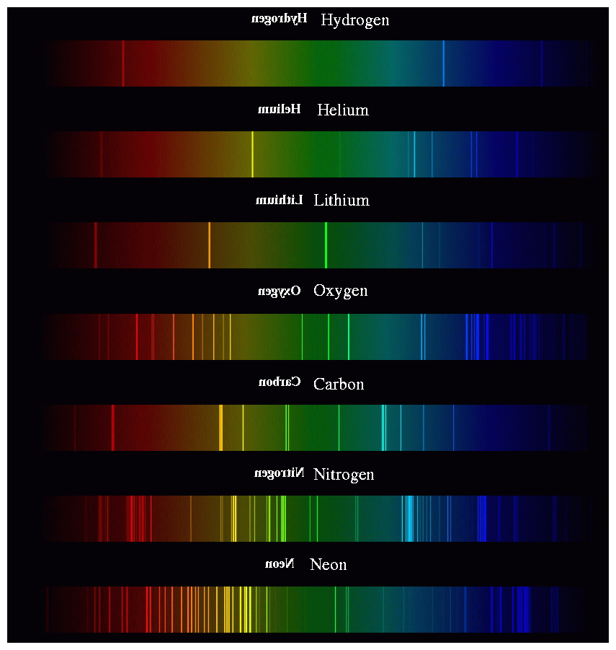

When we heat lithium salts in a flame we only see one colour. To get the full spectra we need to pass the light through a diffraction grating.

The light is of made up of different frequencies so the angle through which it will diffract is different for the different colours.

Constructive interference occurs when the path difference, (ie the distance between the slit and the screen) is a whole number of wavelengths. So each colour will form a bright line at a different place.

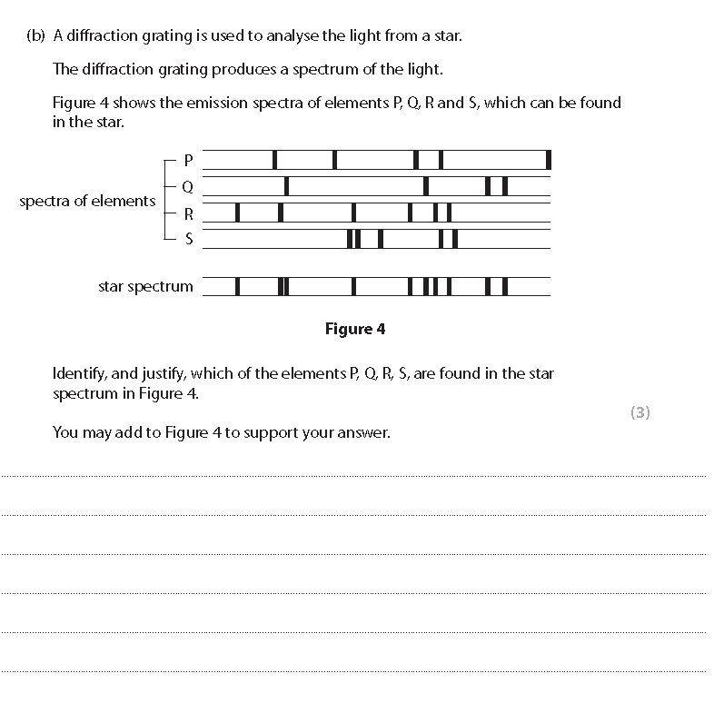

**Q9.**

Light from a sodium-vapour lamp passes through the slits in a diffraction grating and creates a pattern on a screen.

This pattern is called an emission spectrum.

Explain how the diffraction grating produces an emission spectrum.

You can use a labelled diagram to help your explanation.

.............................................................................................................................................

.............................................................................................................................................

.............................................................................................................................................

.............................................................................................................................................

.............................................................................................................................................

.............................................................................................................................................

.............................................................................................................................................

.............................................................................................................................................

**(Total for question = 4 marks)**

**Stationary waves**

In a stationary (standing) wave energy is stored rather than transferred to other locations.

They are formed when 2 coherent waves (is they have the same frequency and wavelength and a constant phase difference) pass through each other in opposite directions. So superposition occurs and we see both constructive and destructive interference. This nodes and antinodes

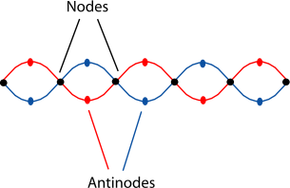

Both stringed and wind instruments depend on stationary waves to produce notes. However these standing waves can only be seen at certain frequencies, this is what gives a musical instrument it’s notes

A string has a series of natural frequencies corresponding to a number of half wavelengths. A stationary wave is only produced when the frequency of the vibration generator produces waves of those wavelengths.

<https://www.youtube.com/watch?v=tRb1GIhvwUk>

Investigate how a flute and a guitar produce standing waves and hence their sounds

<https://www.youtube.com/watch?v=w6EGyFAGpXU>

Exam questions

**Q4.**

Musical notes are sound waves.

Plucking strings or forcing air through pipes can produce sound waves.

Compare the types of wave formed on strings and formed in pipes when musical notes are produced.

You may use diagrams to support your answer.

**(6)**

.............................................................................................................................................

.............................................................................................................................................

.............................................................................................................................................

.............................................................................................................................................

.............................................................................................................................................

.............................................................................................................................................

.............................................................................................................................................

.............................................................................................................................................

.............................................................................................................................................

.............................................................................................................................................

.............................................................................................................................................

.............................................................................................................................................

.............................................................................................................................................

.............................................................................................................................................

.............................................................................................................................................

.............................................................................................................................................

.............................................................................................................................................

.............................................................................................................................................

.............................................................................................................................................

**(Total for question = 6 marks)**

**Q5.**

A flute is a musical instrument. It is used to play a note into a microphone connected to a cathode ray oscilloscope (CRO). The CRO displays the output of the note played. This is shown in diagram A.

A tuning fork is also used to produce the same note. The CRO display of this note is shown in diagram B.

The CRO display settings are the same for both.

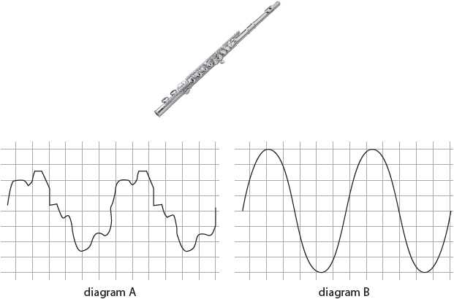

Describe how the vibrating air inside the flute produces a stationary wave.

.............................................................................................................................................

.............................................................................................................................................

.............................................................................................................................................

.............................................................................................................................................

.............................................................................................................................................

.............................................................................................................................................

**(Total for question = 3 marks)**

Identify **two** differences between the note displayed in diagram A and the note displayed in diagram B.

.............................................................................................................................................

.............................................................................................................................................

.............................................................................................................................................

.............................................................................................................................................

**(Total for question = 2 marks)**

Waves on a string and in a pipe

|  |  |
| --- | --- |
| **Waves on a string** | **Waves in a pipe** |
| Use Oscillations/vibrations | Use oscillations/vibrations |
| Set up standing/stationary waves | Set up standing/stationary waves |
| Produce sound due to resonance | Produce sound due to resonance |
| Pitch/Frequency can be changed | Pitch/Frequency can be changed |
| Harmonics can be formed to vary the quality of the note. | Harmonics can be formed to vary the quality of the note. |
| String vibrates | Air vibrates |
| Wave is transverse | Wave is longitudinal |
| Standing wave has a node at each end | **Closed** pipe (eg clarinet) which is closed at one end (the reed) has a node at the closed end and an antinode at the open end.  **Open** pipes (eg trumpet) there is an antinode at both ends and a node in the middle |
| Lowest frequency is where the wavelength is 2L , where L is the length of the string | Lowest frequency in a **closed** pipe is where the wavelength is 4L, where L is the length of the pipe.  Lowest frequency in an **open** pipe is where the wavelength is 2L, where L is the length of the pipe. |
| Frequency/pitch can be changed by altering the length, tension or mass per unit length of the string | Frequency/pitch can be changed by altering the pressure of the air or the length of the air column using stops |

Calculation of speed.

It is strange to think of calculating the speed of a wave when the wave is stationary, but remember the wave just looks stationary because the 2 waves are travelling in opposite directions. So the speed is the speed the wave *would* have travel along the string

For a stationary wave we use the equation

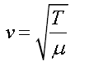

V= Speed

T = tension

µ = linear density (mass per unit length of the string)

Calculate the speed of a stationary wave where the tension in the string is 2N and the linear density is 0.1 Kg/m

Calculate the speed of a stationary wave where the tension is 1.5 N and the linear density is 0.2 Kg/m

Calculate the speed of a stationary wave where the tension in the string is 3N and the linear density is 0.15 Kg/m

**Questions**

**Q1.**

Figure 1 shows a stationary wave on a vibrating string.

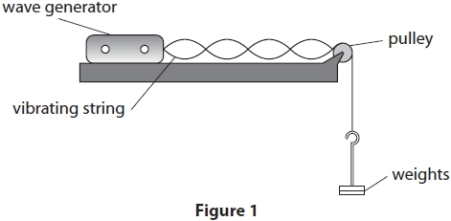

(i)  Give the number of complete wavelengths shown on the string in Figure 1.

**(1)**

number of complete wavelengths = ...........................................................

(ii)  Add a letter X to Figure 1 to show the position of **one** antinode.

**(1)**

(iii)  Which process causes the stationary wave on the string in Figure 1?

**(1)**

   **A**    compression

   **B**    diffraction

   **C**    regeneration

   **D**    resonance

(iv)  The string in Figure 1 is 1.0 m long.

The string has a mass of 2.1 g.

The tension in the string is 3.6 N.

Calculate the speed, *v*, of the wave on the string in Figure 1.

Use the equation: 

Show your working.

**(4)**