C3 Use of EM waves in communication

|  |  |
| --- | --- |
| **C3 Use of electromagnetic waves in communication** |  |
| * Understand that all electromagnetic waves travel with the same speed in a vacuum | * understand that the speed of light in a vacuum (approx. 3 x 108 ms-1) is the same as the speed for all other electromagnetic waves in a vacuum, e.g. radio-waves, microwaves, ultraviolet and infra-red |
| * Be able to use the inverse square law in relation to the intensity of a wave: | * understand that:   + *k* is a constant for a particular source of a wave   + the intensity of a wave will reduce as the square of the distance from the source of the wave increases, e.g. if the distance from a source is doubled, the intensity at the new distance will be 1/ (22) or ¼   be able to re-arrange/transform the equation, i.e. change the subject of the equation   * know that the equation can also be written as *I1xD12=I2xD22*   where:  *I*1 = intensity at position 1  *I*2 =intensity at position 2  *D1*= distance of position 1 from source  *D2*= distance of position 2 from source |
| * Understand how the regions of the electromagnetic spectrum are grouped according to the frequency | * know that the properties of the different regions of the electromagnetic spectrum are related to their frequencies or wavelengths * know that each region of the electromagnetic spectrum is not specifically defined * know that there is an overlap in frequency and wavelength between each region of the electromagnetic spectrum * know the order in terms of increasing frequency or wavelength of the different regions of the electromagnetic spectrum |
| * Understand how the applications of electromagnetic waves in communications are related to frequency, including: | * know that frequency can be expressed in MHz (megahertz, 106Hz), GHz( gigahertz,109 Hz) and THz, (terahertz, 1012 Hz) * understand the factors that make different regions of the electromagnetic spectrum suitable for specific applications * know that microwaves are used for mobile phone networks, because their high frequency gives greater bandwidth which allows large amounts of data to be transmitted * know that there is little or no interference because microwaves can be divided into separate channels * know that reception/the quality of the signal is affected by wet weather as microwaves are strongly absorbed by water * know that terrain also affects reception as the short wavelength/ high frequency reduces the amount of diffraction of the waves. |
| * satellite communication | * know that upload and download signals are transmitted at different frequencies * know that the signals are high power, transmitted over long distances and in the radio-wave/ microwave region of the electromagnetic spectrum * know that microwaves can pass through the ionosphere to high orbit satellites * know that radio waves are reflected by the ionosphere and so can be used for terrestrial communication to receivers beyond the horizon * know that radio waves can be used for communication with low orbit satellites |
| * mobile phones | * know that mobile phones are used on a system of networks * understand that mobile phone providers are allocated a band of frequencies in the radio/microwave region * understand that base stations transmit and receive signals over a limited distance |
| * Bluetooth® | * know that Bluetooth devices are low power devices which work over short distances to link one device to another e.g. from a mobile phone to hands-free headset * know that Bluetooth devices in mobile phones and tablets have a range of up to 10 m * know that Bluetooth uses short wavelength radio signals and so does not need ‘line of sight’. * know that Bluetooth devices can connect to more than one device * understand that Bluetooth© uses a system of ’frequency–hopping’ to reduce interference with Wi-Fi as this uses similar frequencies * understand that frequency-hopping limits data loss |
| * infrared | * know that infrared is used in low power devices such as remote controls * understand that infrared operates over short distances and in ‘line of sight’ * understand that infrared does not work well in bright sunlight * understand that atmospheric moisture reduces the range of the infrared signal * understand that infrared is a high frequency signal and can potentially transmit large amounts of data |
| * Wi-Fi | * know that Wi-Fi allows computers, smart phones and other devices to connect to the internet via a router * understand that Wi-Fi uses medium power in the radio/microwave frequency region * understand that Wi-Fi has a range of up to 100 m * understand that Wi-Fi can pass through walls to allow signals to be received in different rooms in a house * understand that Wi-Fi signals can also be transmitted through both optical fibres and electrical wiring |

The Electromagnetic spectrum is a continuous spectrum of all the possible frequencies of electromagnetic radiation

The different parts of the EM spectrum have different frequencies and wavelengths

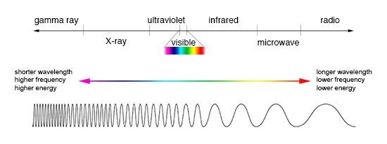

One thing they all have in common is that the all have the same speed (app 3 x 108 m/s) in a vacuum. (Learn the order)

Rabid Radio Long wavelengths/Low frequency  
Monkeys Microwaves  
In Infrared  
Velvet Visible  
Underpants Ultraviolet  
eXcrete  X- Rays  
Gummy bears Gamma ray Short wavelengths/High frequency

The properties of the different regions of the electromagnetic spectrum are related to their frequencies or wavelengths. Radio waves for example have long wavelengths, lower frequencies and therefore carry less energy. Radio waves can be used safely for communication and for whole body scans

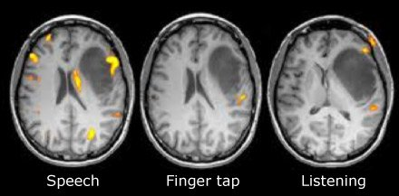

This is a picture of an MRI scan of a brain. It uses radio waves to look inside, without damaging the brain tissue

Each region of the electromagnetic spectrum is not specifically defined, there is a large overlap between each region

Different regions of the electromagnetic spectrum are suitable for specific applications.

Microwaves

Microwaves are used for mobile phone networks, because their high frequency gives greater bandwidth which allows large amounts of data to be transmitted also there is little or no interference because microwaves can be divided into separate channels, however the reception/the quality of the signal is affected by wet weather as microwaves are strongly absorbed by water also the terrain affects reception as the short wavelength/ high frequency reduces the amount of diffraction of the waves. Therefore they cannot bend round obstacles.

Mobile phones are used on a system of network where the mobile phone providers are allocated a band of frequencies in the radio/microwave region. The base stations transmit and receive signals over a limited distance. Therefore you need lots of masts as only line of sight transmission is possible

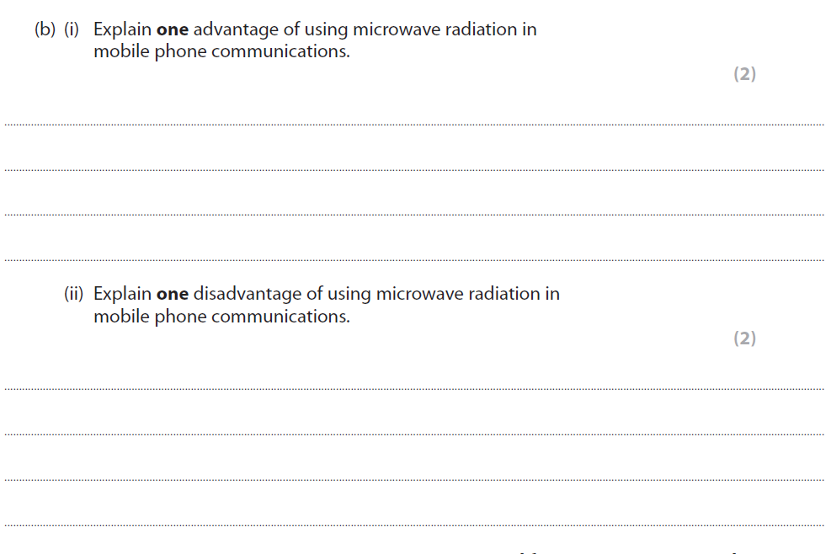

Satellite communication

Satellite communication either uses radio waves or microwaves where the upload and download signals are transmitted at different frequencies the signals are high power and transmitted over long distances

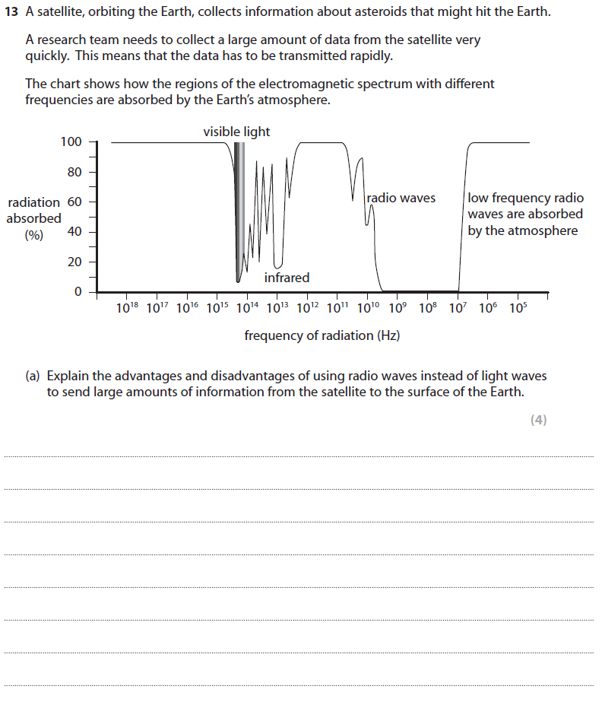

Microwaves can also be used in satellite communication, because they can pass through the ionosphere to high orbit satellites, however radio waves are reflected by the ionosphere and so can be used for terrestrial communication to receivers beyond the horizon

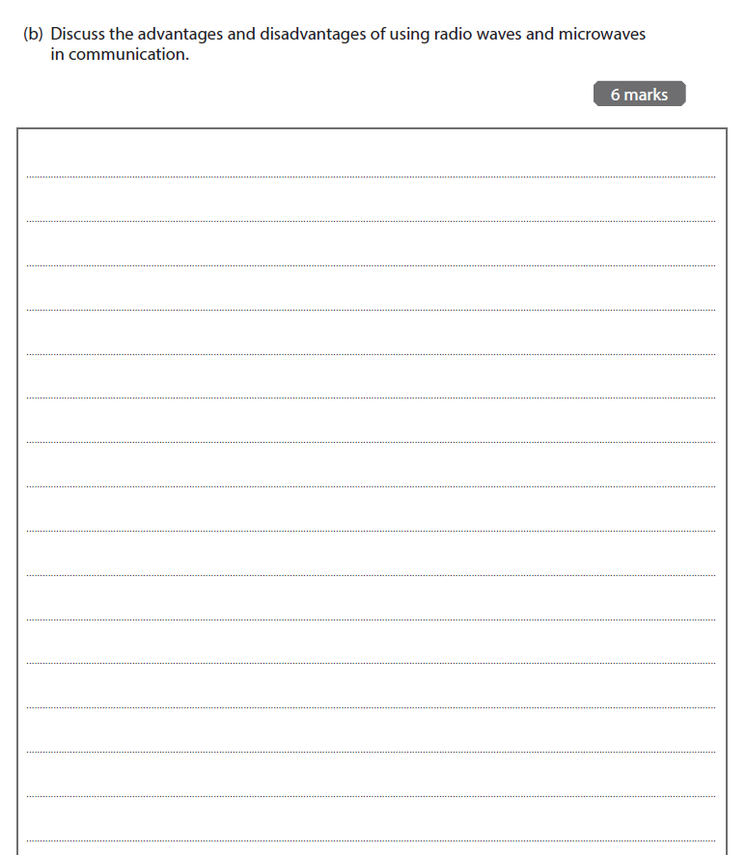

Infrared

Infrared is used in remote controls, it only operates over short distances and needs line of sight, it also does not work well in bright conditions and any moisture in the atmosphere will reduce its range. However it has a higher frequency signal than radio waves and can therefore transmit a large amount of data.

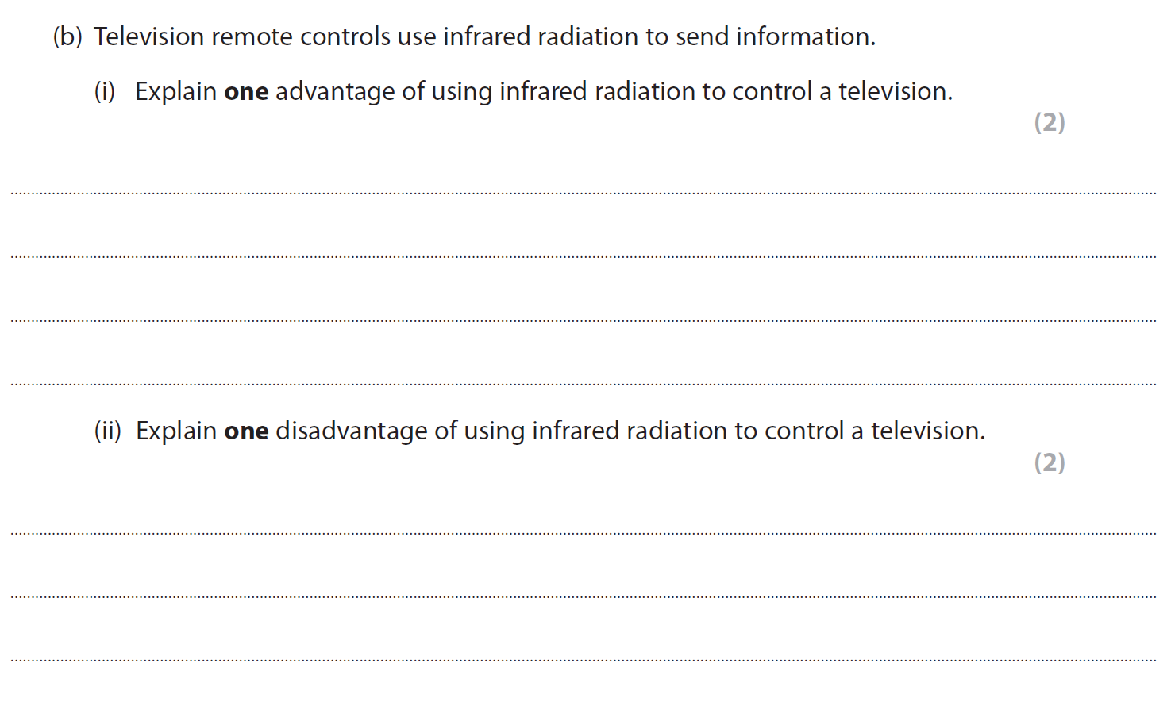

Bluetooth

Bluetooth are low power devices that work over short distances up to 10m to link devices, they use short wavelength radio waves so do not need line of sight. They can connect to more than one device at a time and uses a system of ‘frequency hopping’ to limit data loss and reduce interference

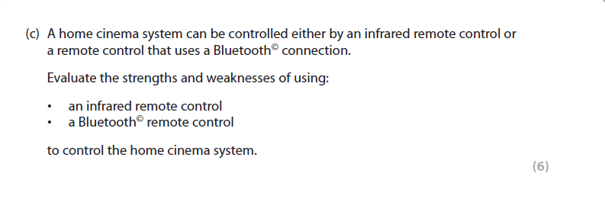

Wi-Fi

Wi-Fi allows computers, smart phones and other devices to connect to the internet via a router it uses medium power in the radio/microwave frequency region and has a range of up to 100 m. It can pass through walls to allow signals to be received in different rooms in a house.

Wi-Fi signals can also be transmitted through both optical fibres and electrical wiring (see previous C2 notes for optical fibres)

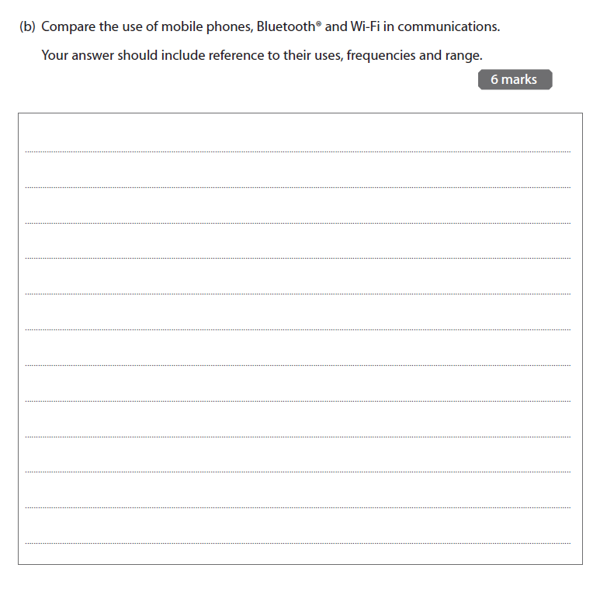

Section Two LIGHT

White light contains all frequencies of visible light from red (700 nm) to blue (400 nm). If light is split by a diffraction grating (see c1 notes) it can tell us something about where the light has come from. Individual elements give off a unique pattern that can be used to identify the element

Demo Flame Colours

Our eyes only see one colour, but if the colour is passed through a diffraction grating we can see the different lines

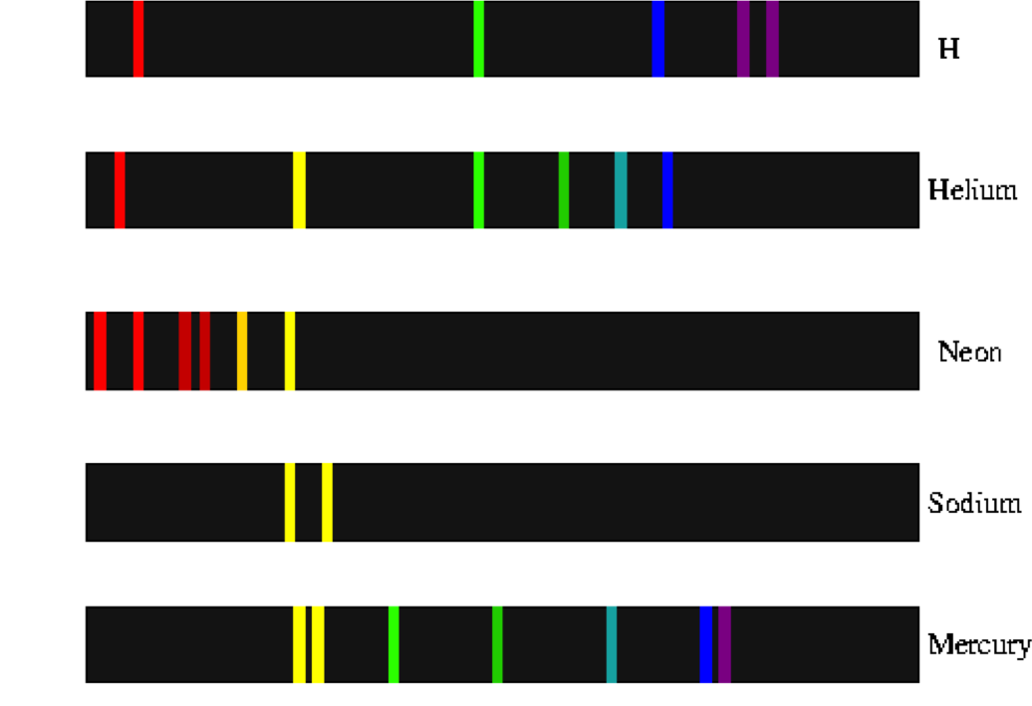

Each spectra is unique. This is because each element is unique. We can use these spectra to show which elements are present in stars far away

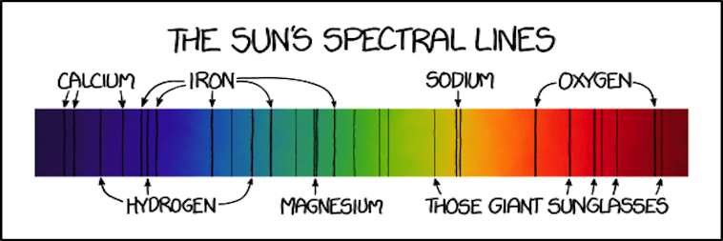

Each element generates their specific frequency of light by the same method

1. When an element is heated the electron is excited and moves UP an energy level
2. As it drop back DOWN it releases energy in the form of light
3. The size of the drop is equal to the frequency of the light

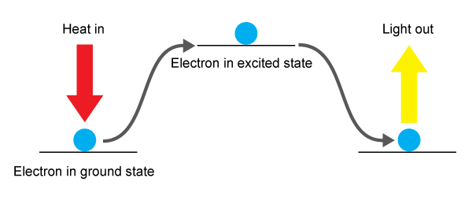

Intensity of light

The intensity of the light (or any other EM wave) decreases the further it gets away from its source by a fixed amount

Where

I = intensity of the light

k = a constant

r = distance from source

It can also be written as

*I1 x D12 = I2 x D22*

I1 = intensity at point 1

D1 = distance from source to point 1

I2 = intensity at point 2

D2 = distance from source to point 2

Q1 The intensity of a radio signal is 0.120 *W/m2* at a distance of 16.0 *m* from a small transmitter. What is the intensity of the signal 4.00 *m* from the transmitter?

