Unit 1 Principles and Applications of Science

Tissue Structure and Function Part 1

Epithelial and Endothelial

|  |  |  |  |  |
| --- | --- | --- | --- | --- |
| **B3 Tissue Structure and function** | Learners should: | **☺** | **😐** | **☹** |
| * Understand the structure and function of epithelial tissue, to include: |  |  |  |  |
| * squamous as illustrated by the role of alveolar epithelium in gas exchange to include the effect of chronic obstructive pulmonary disease (COPD) in smokers | * know and understand the structural and functional significance of squamous tissue features, to include:   + simple squamous epithelium makes up the walls of the alveoli   + alveoli are sites where oxygen and carbon dioxide are exchanged   + oxygen from air to the blood in the capillaries in alveoli   + carbon dioxide as a waste product from blood into air in the capillaries in alveoli * chronic obstructive pulmonary disease (COPD), to include: emphysema and chronic bronchitis   chronic bronchitis   * + inflammation of airways in lungs   + squamous epithelium thickens   + excessive secretion of mucus - cough   + blocked airways – difficulty breathing   emphysema   * + smoking is the main cause   + damage to the air sacs in the lungs   + destruction of the alveoli walls /membranes   + abnormally large air spaces in the lungs   + decreased surface area for gas exchange   + destruction of elastin means alveoli do not recoil – difficulty exhaling   causes respiratory problems and difficulty breathing |  |  |  |
| * columnar as illustrated by goblet cells and ciliated cells in the lungs to include their role in protecting lungs from pathogens | * know and understand the structural and functional significance of columnar epithelium and goblet cells features, to include:   + single layer of cells lining the trachea   + cilia cover free surfaces of cells   + epithelium contains goblet cells   + goblet cells secrete mucus   + cilia produce rapid wave-like motions   + cilia move mucus and trapped foreign bodies (e.g. pathogens) up and out of the respiratory system |  |  |  |
| * Understand the structure and function of endothelial tissue, as illustrated by blood vessels in the cardiovascular system, including the risk factors that damage endothelial cells and affect the development of atherosclerosis | * know and understand the structural and functional significance of endothelial tissue features, to include:   + epithelium and endothelium are both types of lining tissue   + epithelium covers outer surfaces   + endothelium covers inner surfaces   + single layer of squamous endothelium lines the inner surfaces of arteries, veins and capillaries   arteries and veins   * + endothelium reduces friction and allows for smooth   + damaged endothelial cells release substances that cause blood vessels to constrict   + regulates blood flow and pressure   capillaries   * + single layer of endothelium   + easy exchange of nutrients and oxygen into the tissues and the removal of waste products   atherosclerosis   * + plaque in artery wall   + risks: smoking, diet and high blood pressure   + effect of white blood cells reduction of lumen diameter   + can lead to rupture of protective membrane over plaque   + formation of blood clot (thrombus) |  |  |  |

# Tissue

* A tissue are collections of similar specialised cells, performing a specific function/set of functions, to include epithelial, skeletal muscle and nervous tissue
* Organs are collections of tissues performing specific physiological functions
* Organs are organised into systems, to include cardiovascular, respiratory, muscular, nervous systems

## 

## In this topic we will look at specific types of tissue epithelial tissue and endothelial tissue

|  |  |
| --- | --- |
|  | Where are they found? What are the similarities/differences? What is their function? |
| Similarities |  |
| Differences |  |
| Function | Epithelium  Endothelium |

## Epithelial tissue

This type of tissue is found on the **linings** of organs throughout the body, they cover outer surfaces. There are two different types of epithelial tissue. Research the two types and find out how they are structured and what their function is in the body:

|  |  |  |
| --- | --- | --- |
| Epithelial tissue type | Structure | Function |
| **Squamous** |  |  |
| **Columnar**  Image result for ciliated columnar diagram |  |  |

Exam question

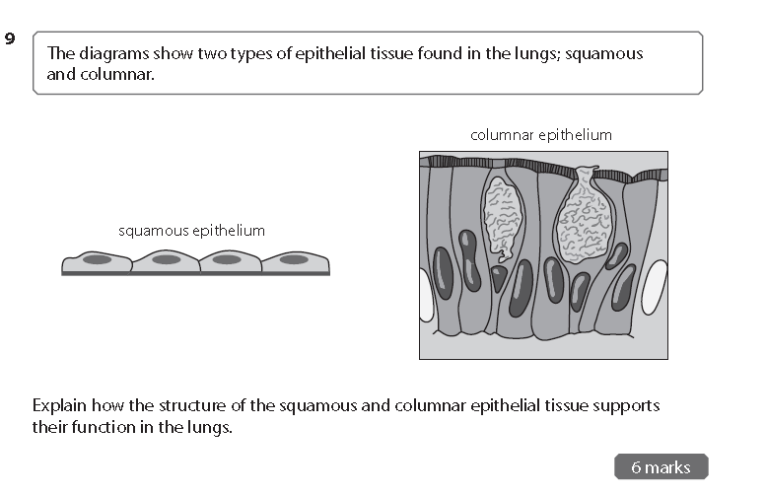

Squamous epithelium cells

Simple squamous epithelium makes up the walls of the alveoli, alveoli are sites where oxygen and carbon dioxide are exchanged. Oxygen from the air diffuses into the blood in the capillaries in the alveoli. Carbon dioxide as a waste product diffuses from the blood into the air sacks in the capillaries in the alveoli.

Damage to these cells such as Bronchitis or Emphysema can have long term health consequences.

Research these two diseases and produce a report as either a PowerPoint or poster detailing

1. What causes these diseases
2. What are the symptoms of these diseases
3. How can they be prevented

Answer the exam question

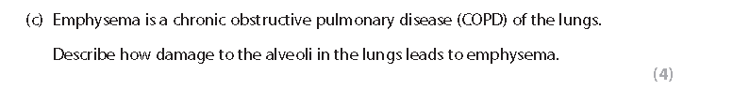

## Endothelial tissue

Endothelial tissue covers inner surfaces eg arteries veins and capillaries. In arteries and veins, the endothelium reduces friction and allows the blood to flow smoothly. Damage to these cells release substances that cause the blood vessels to constrict. This can lead to a heart attack if a clot forms and blocks an artery in the heart or a stroke if the clot forms in the brain.

In capillaries, a single layer of endothelium allows easy exchange of nutrients and oxygen into the tissue and removal of waste products.

|  |  |  |
| --- | --- | --- |
|  | Structure | Function |
| Image result for endothelial tissue |  |  |

Atherosclerosis

Atherosclerosis is a disease where arteries become clogged up with fatty deposits (sometimes known as plaques). It is a disease of the cardiovascular system (heart and arteries etc.)

Produce a report on Atherosclerosis

Research what is Atherosclerosis? What causes it? What are its symptoms? What if any are the cures?

Now answer the exam question

