Tissue Structure and Function Part 2

Nerves

## B3 Tissue structure and function

|  |  |
| --- | --- |
| * Understand the structure and function of nervous tissue, to include: |  |
| * non-myelinated and myelinated neurones | * know the structure of myelinated motor neurone * know that action potentials are conducted along non-myelinated and myelinated axons * know that the speed of conduction of nerve impulses in non-myelinated is slower than in myelinated neurones |
| * the conduction of a nerve impulse (action potential) along an axon, including changes in membrane permeability to sodium and potassium ions and the role of the myelination in saltatory conduction | * know and understand the conduction of a nerve impulse (action potential) along an axon, including changes in membrane permeability to sodium and potassium ions and the role of the myelination in saltatory conduction, to include:   + resting membrane potential (c -70mV)   + concentration gradients for K+ and Na+   + conduction/ propagation   + changes in membrane permeability to Na+ which leads to depolarisation and the generation of an action potential,   + threshold potential and the all-or-nothing principle   + voltage-gated ion channels   + repolarisation owing to K+ diffusion out of cell   + hyperpolarisation   + refractory period   + factors affecting the speed of conductance such as myelination and saltatory conduction between Nodes of Ranvier |
| * interpretation of graphical displays of a nerve impulse and electrocardiogram (ECG) recordings | be able to interpret graphical displays of a nerve impulse and electrocardiogram (ECG) recordings, to include:   * + threshold, depolarisation, repolarisation and hyperpolarisation, refractory period, and resting state phases of a nerve impulse   + identify the PQRST points on ECG recording |
| * synaptic structure and the role of neurotransmitters, including acetylcholine | * understand synaptic structure and the role of neurotransmitters, including acetylcholine, to include:   + presynaptic knob/membrane   + postsynaptic neurone/membrane   + synaptic cleft   + exocytosis of neurotransmitter, role of calcium ions   + diffusion of neurotransmitter across the synaptic cleft   + receptors on post synaptic membrane   + depolarisation of post synaptic membrane, triggers action potential   + breakdown, reuptake and recycling of neurotransmitters   + acetylcholine at the neuromuscular junction   + acetylcholine receptors on the muscles   + propagation of action potential |
| * how imbalances in certain, naturally occurring brain chemicals can contribute to ill health, including dopamine in Parkinson’s disease and serotonin in depression | * understand:   + how varying concentrations of dopamine and serotonin contribute to ill health   + the effect of the imbalances of dopamine in Parkinson’s disease   + the effect of the imbalances of serotonin in depression |
| * the effects of drugs on synaptic transmission, including the use of L-Dopa in the treatment of Parkinson’s disease | * know the types of neurotransmitters   + inhibitory - decrease the likelihood of an action potential   + excitatory - increase the likelihood of an action potential * understand antagonist and agonist effects of drugs on synaptic transmission, including:   + L-Dopa as precursor of Dopamine, raises levels of Dopamine, reduces muscle tremor and other motor problems   + Antagonist – blocks action of transmitter on its receptors (e.g. atropine or curare)   + Agonist – mimics action of transmitter on its receptors (e.g. nicotine or muscarine) |

## Neurons

There are three types of neuron

The sensory neuron

The motor neuron

The intermediate neuron

* The sensory neurone – transmit nerve impulses from a receptor to an intermediate or motor neurone. They have one dendron, which is often very long, carries the impulse towards the cell body and one axon which carries the impulse away from the cell body
* The motor neurone – transmit nerve impulse from an intermediate to an effector. Have long axon and short dendrites
* The intermediate (relay) neurone – transmit impulses between neurones. They have short processes

## Nervous tissue

Nervous tissue is made up of neurons. The neuron can either be myelinated (insulated) or non-myelinated (not insulated). Look at the diagrams below and label the main parts of the neuron, state the difference between this myelinated neuron to a non-myelinated:

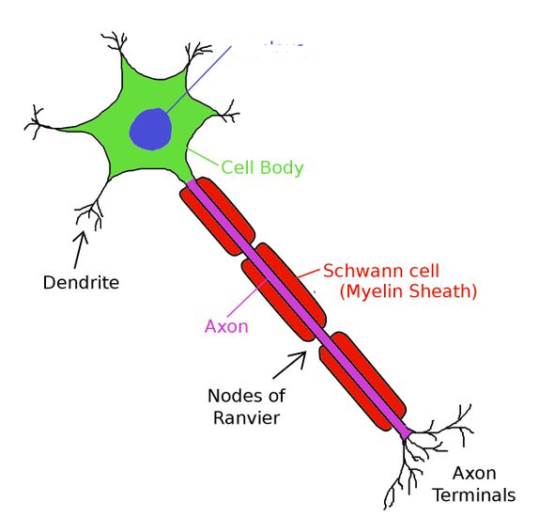

Use Khan academy – Anatomy of a Neuron to label the above

Main differences between myelinated and non myelinated neurons, including where they are found and the structure of the myelin sheath.

……………………………………………………………………………………………………………………………………………………………………………………………………………………………………………………………………………………………………………………………………………………………………………………………………………………………………………………………………………………….………………………………………………………………………………………………………………………………………………………………………………………………………………………………………………………………………………………………………………………………………………………………………………………………………………………………………………………………………………………………………………………………………………………………………………………………………………………………………………………………………………………………………………………………………………………………………………………………………………….…………………………………………………………………………………………………………………………………………………………….………………………………………………………………………………………………………………………………………………………………………………………………………………………………………………………………………………………………………………………….…………………………………………………………………………………………………………………………………………………………….………………………………………………………………………………………………………………………………………………………………………………………………………………………………………………………………………………………………………………………….…………………………………………………………………………………………………………………………………………………………….

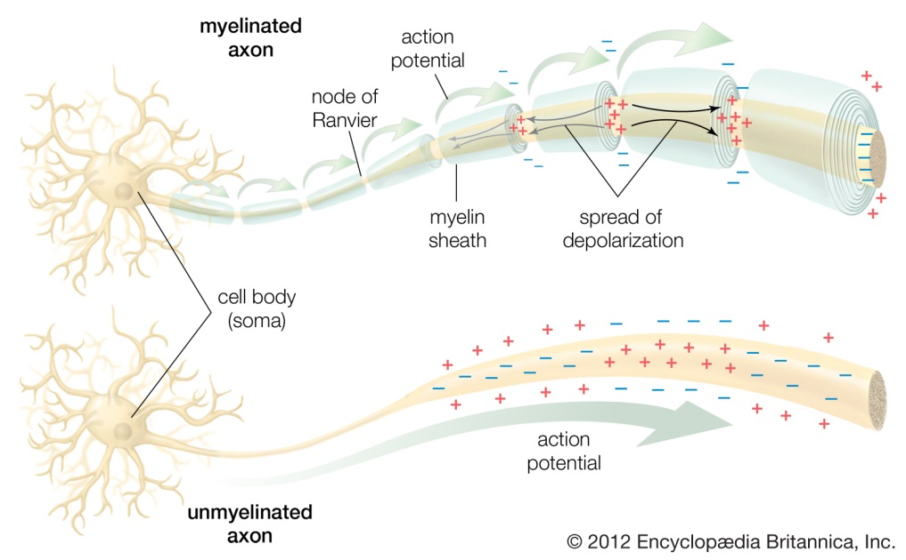

## 

……………………………………………………………………………………………………………………………………………………………………………………………………………………………………………………………………………………………………………………………………………………………………………………………………………………………………………………………………………………….………………………………………………………………………………………………………………………………………………………………………………………………………………………………………………………………………………………………………………………………………………………………………………………………………………………………………………………………………………………………………………………………………………………………………………………………………………………………………………………………………………………………………………………………………………………………………………………………………………………………………………………………………………………………………………………………………………………………………………

## The nerve impulse

* A nerve impulse can be defined as a self propagating wave of electrical activity that travels along the axon membrane.
* It is a temporary reversal of the electrical potential difference across the axon membrane. The reversal is between the two states, the **resting potential** and the **action potential.**

## Conduction of a nerve impulse

An impulse is generate by a neuron and travels from the axon body to the axon terminals. This impulse is generated by a difference in the amount of positive ions on the outside of the cell compared with the inside.

At rest sodium ions (Na+) move outside of the cell very fast, and potassium ions (K+) move inside the cell slowly.

What does this mean about the charge on the outside of the cell compared with the inside now?

…………………………………………………………………………………………………………………………………………………………

………………………………………………………………………………………………………………………………………………………..

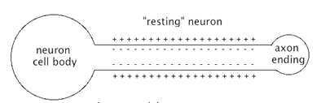

When an impulse is passed along the cell **depolarisation** occurs. This means that the membrane allows many sodium (Na+) ions to flood in.

What does this mean about the charge on the inside and outside of the cell now?

…………………………………………………………………………………………………………………………………………………………

………………………………………………………………………………………………………………………………………………………..

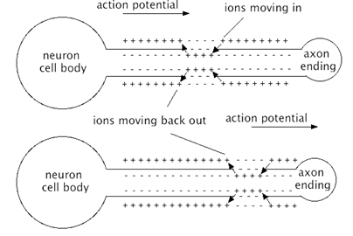

After this Potassium ions are let out of the neuron and sodium ions are no longer allowed back into the cell which **repolarises** the cell into it’s ‘**resting potential**’.

## Graph showing the voltage across the cells

The graph below shows what is happening to the potential across a nerve impulse as it occurs.

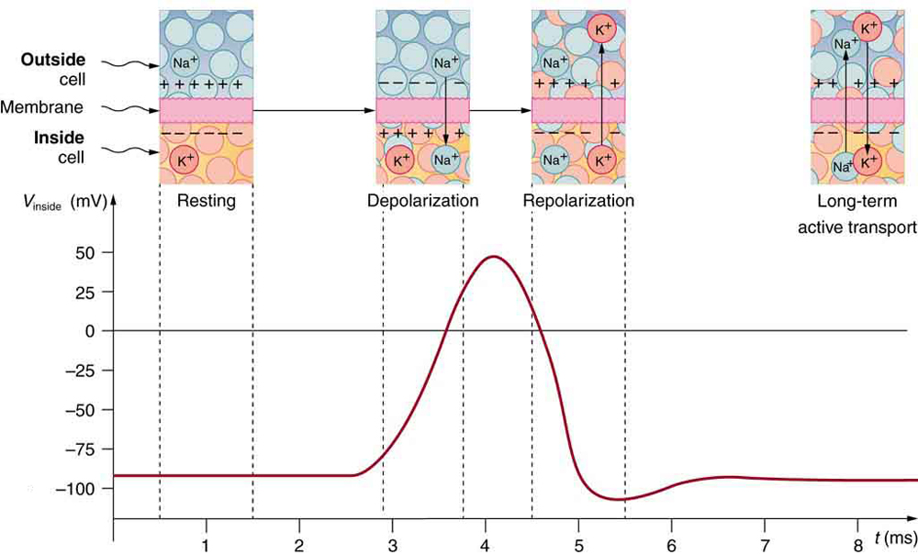

## 

## 

## Speeding up cell impulses

The speed at which the impulse travels along the cell depends on the degree of myelination. Look at the diagrams below and decide which cell (myelinated or non-myelinated) will make an impulse travel fast and why (try to include the words **‘salta**

**y conduction’**):

…………………………………………………………………………………………………………………………………………………………..

………………………………………………………………………………………………………………………………………………………….

…………………………………………………………………………………………………………………………………………………………..

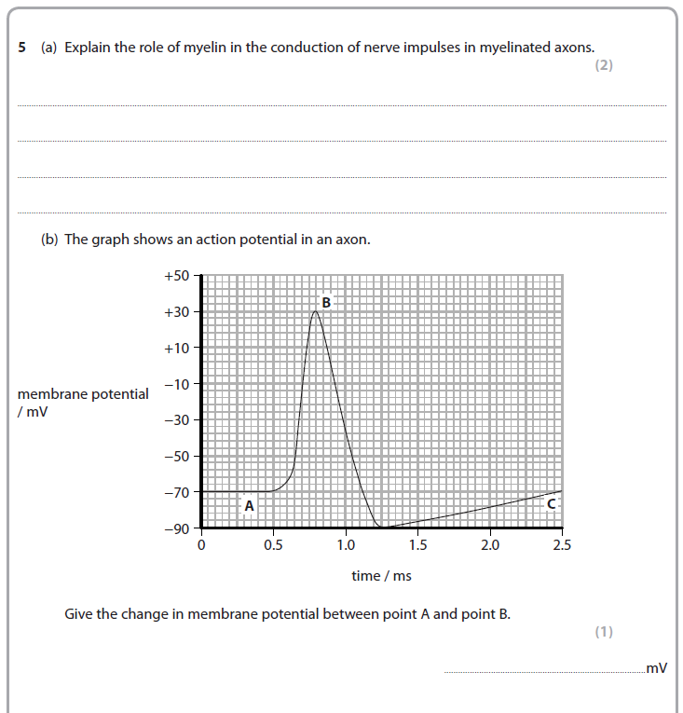

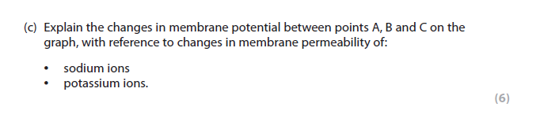

………………………………………………………………………………………………………………………………………………………………………………………………………………………………………………………………………………………………………………………………………………………………………………………………………………………………………………………………………………………………………………………………………………………………………………………………………………………………………………………………………………………………………………………………………………………………………………………………………………………………………………………………………………………………………………………………………………………………………………………………………………………………………………………………………………………………………………………………………………………………………………………………………………………………………………………………………………………………………………………………………………………………………………………………………………………………………………………………………………………………………………………………………………………………………………………………………………………………………………………………………………………………………………………………………………………………………………………………………………………………………………………………………………………………………………………………………………………………………………………………………………………………………………………………………………………………………………………………………………………………………………………………………………………………………………………………………………………………………………………………………………………………………………………………………………………………………………………………………………………………………………………………………………………………………………………………………………………………………………………………………………………………………………………………………………………………………………………………………………………………………………………………………………………………………………………………………………

## Electrocardiography (ECG or EKG[[a]](https://en.wikipedia.org/wiki/Electrocardiography#cite_note-4)) is the process of recording the electrical activity of the [heart](https://en.wikipedia.org/wiki/Heart) over a period of time using [electrodes](https://en.wikipedia.org/wiki/Electrode) placed over the skin. These electrodes detect the tiny electrical changes on the skin that arise from the [heart muscle](https://en.wikipedia.org/wiki/Cardiac_muscle)'s pattern of [depolarizing](https://en.wikipedia.org/wiki/Depolarization) and [repolarizing](https://en.wikipedia.org/wiki/Repolarization) during each [heartbeat](https://en.wikipedia.org/wiki/Cardiac_cycle). It is very commonly performed to detect any cardiac problems.

An ECG will give a trace of a healthy heart that looks like the graph below. Each trace is a single heartbeat and therefore lasts about 0.8 seconds.

The main features of the trace are labelled as P, Q, R, S and T according to convention.

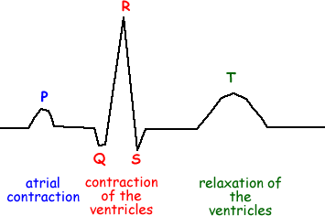

The **"P" wave** corresponds to **atrial depolarisation and contraction**.

The **"QRS" complex** relates to the **depolarisation and contraction of the ventricles**.

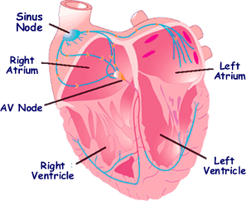Cardiac muscle cells have a special property: they spontaneously depolarize at various rates (i.e. the charge of their membranes changes at a given rate without external stimuli).

**Timing is important – it shows whether the heartbeat is normal of not**!

## Nerve impulses across synapses

Although you can get some very long nerves, it is unlikely that they are going to reach from your little toe to the brain. So the impulse needs to be able to travel across a **synapse** (where two nerve cells meet). Where the cells meet they don’t actually touch one another, there is about a 0.00000002m gap between them. This means a chemical signal needs to go across the synapse in order to start off a nerve impulse in the neighbouring cell.

At the synapse, the neuron passes on a chemical to the neighbouring (post-synaptic) cell to initiate it’s impulse. Use the diagram below to construct a flow diagram of the synaptic transmission.

#### Mechanism of synaptic transmission

[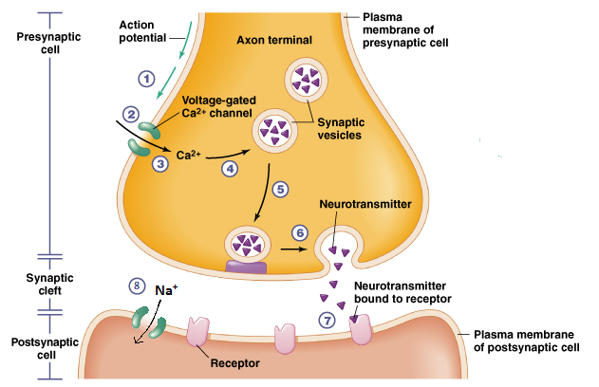](http://1.bp.blogspot.com/--PtvzLhICYA/V1adKQvTKFI/AAAAAAAAb3M/S8dmlJlGBf4pNYOds_Z6Atg_RA44wJGuQCK4B/s1600/synaptic+transmission.png)

## Neurotr

## Neurotransmitters

There are many different neurotransmitters which can be released at a synapse.

Acetylcholine is one of the neurotransmitters used in the body. Acetylcholine is released at the presynaptic membrane and passes to the post synaptic membrane which then initiates a nerve impulse. Once this nerve impulse has occurred another chemical is needed to stop the Acetylcholine from making another impulse be sent. What is the name of the enzyme which breaks down acetylcholine?

…………………………………………………………………………………………………………………………………………………………

What would happen if this enzyme was not present?

…………………………………………………………………………………………………………………………………………………………

…………………………………………………………………………………………………………………………………………………………

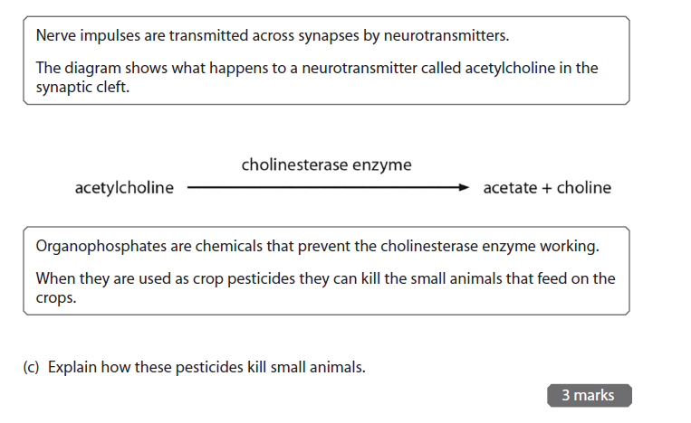

## Parkinson’s and Dopamine

In the brain there are many nerves and neurotransmitters, one of which is dopamine. Research into dopamine and explain the occurrence of it in Parkinson’s disease, the symptoms and how Parkinson’s can be managed:

### Why do people get Parkinson’s

### Symptoms of Parkinson’s

### How can Parkinson’s be managed?

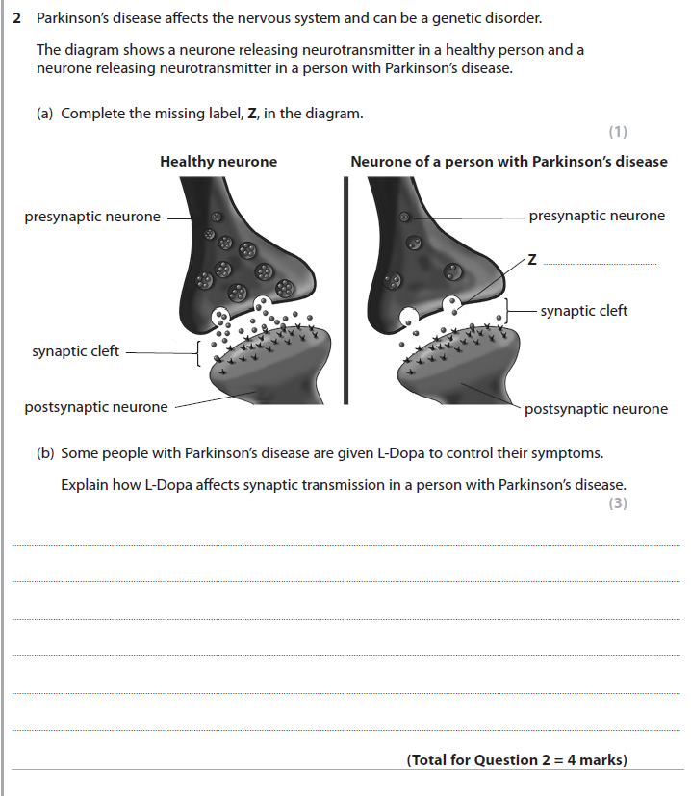

## Depression and serotonin

Another neurotransmitter is serotonin; imbalances in serotonin have been shown to cause depression. Research into how serotonin and depression are linked, you might want to included how serotonin can be used to treat depression:

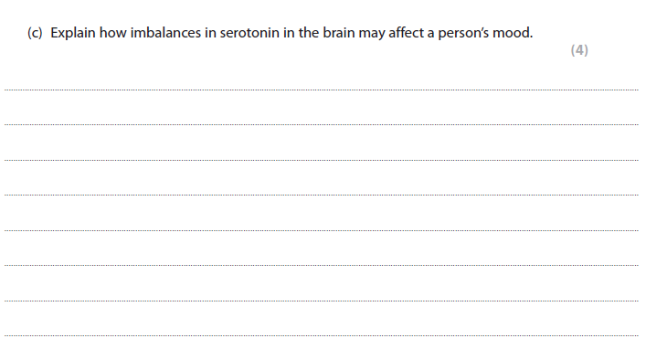

* Drugs which impact the synaptic transmission can work in one of three ways

Pre-drugs eg L-Dopa as a precursor of Dopamine, raises levels of Dopamine, reduces muscle tremor and other motor problems.

Antagonist blocks action of transmitter on its receptors. Find an example of an Antagonistic drug and how it works

Agonist mimics action of transmitter on its receptors Find an example of an Agonist drug and how it works.