Tissue Structure and Function Part 2

Muscle

|  |  |  |  |  |
| --- | --- | --- | --- | --- |
| **B3 Tissue Structure and function** | Learners should: | **☺** | **😐** | **☹** |
| * Understand the structure and function of muscular tissue, to include: |  |  |  |  |
| * the microscopic structure of a skeletal muscle fibre | * know and understand the microscopic structural and functional significance of skeletal muscular tissue features, to include:   + muscle fibres   + multi nucleated   + striated appearance   + myofibrils   + sarcomere   + sarcolemma   + sarcoplasmic reticulum   + mitochondria   + neuromuscular junctions   + T tubules   + sliding filament theory - actin and myosin, troponin, tropomyosin, calcium ions, ATP * recognise the microscopic structure of skeletal muscle fibre from diagrams and photomicrographs |  |  |  |
| * structural and physiological differences between fast- and slow-twitch muscle fibres and their relevance in sport | * understand the structural and physiological differences between fast- and slow-twitch muscle fibres and their relevance in sport , to include   + rate of contraction   + rate of fatigue   + suitability for activity   + mitochondria   + glycogen   + sarcoplasmic reticulum   + respiratory enzymes   + myoglobin   + appearance   + blood supply |  |  |  |

## Muscle tissue

There are 3 different types of muscular tissue, fill in the table to explain the three

|  |  |
| --- | --- |
| Type | Structure and function |
| **Skeletal** |  |
| **Cardiac** |  |
| **Smooth** |  |

## Skeletal muscle fibre

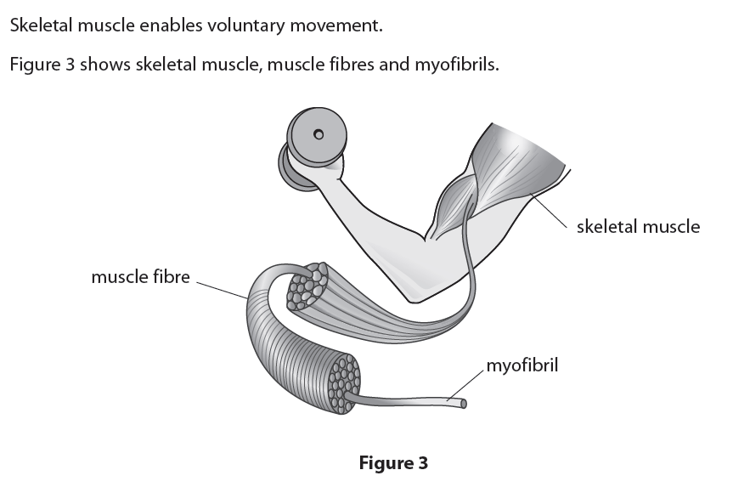

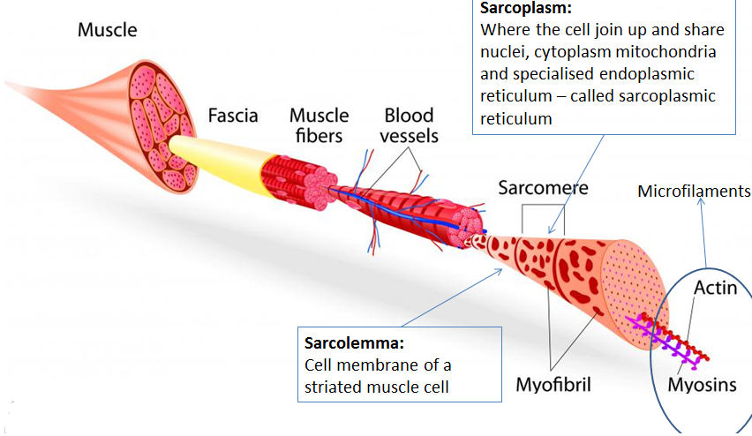

* Muscles are made up of millions of tiny muscle fibres called myofibrils which contain two proteins **Actin** and **Myosin**
* They are lined up parallel to one another just like threads in a rope.
* These myofibrils (threads) are grouped into a single muscle fibre (string), which are further grouped into bundles of muscle fibres (small ropes) which are further grouped into muscle tissue (larger ropes)

The muscle cells are **fused** together (fibres) and share nuclei and cytoplasm called **sarcoplasm**

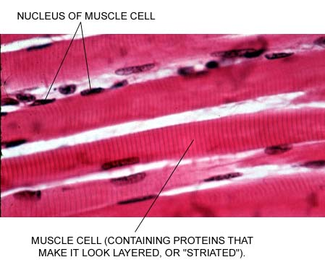Muscle cells look layered or striated due to the proteins

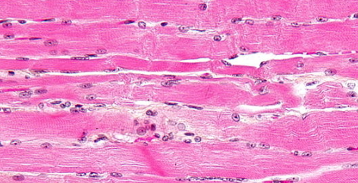

## Myofibril

During contraction the THIN actin filaments over and overlap with the thick myosin, shortening the distance from one z-disk to the next (this is the sarcomere).

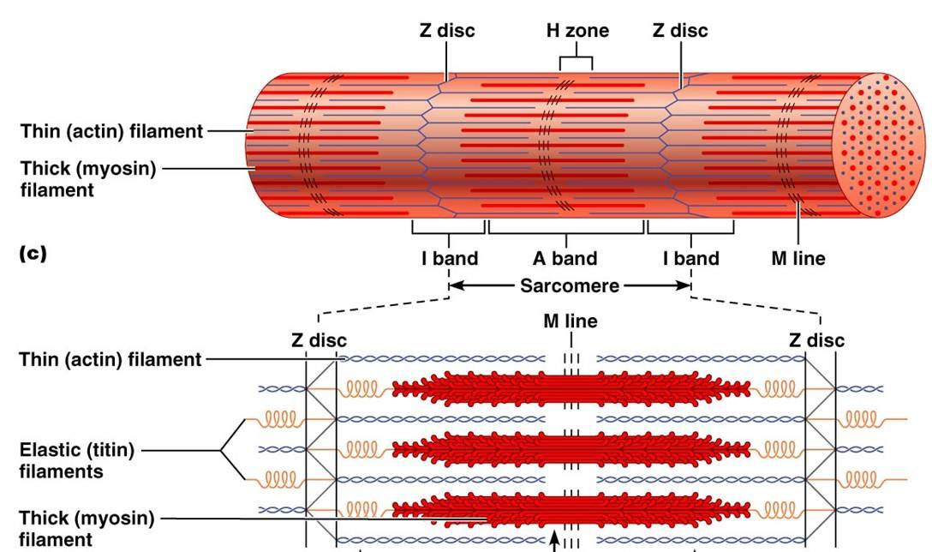

Contraction

Contraction

* know and understand the microscopic structural and functional significance of skeletal muscular tissue features, to include:

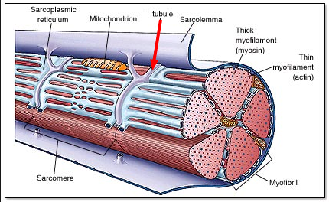

[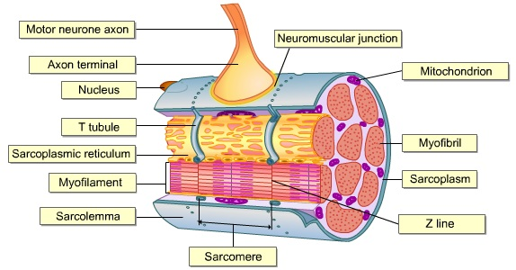](https://www.easynotecards.com/print_list/86344)

|  |  |
| --- | --- |
| * + muscle fibres |  |
| * + multi nucleated |  |
| * + striated appearance |  |
| * + sarcomere |  |
| * + myofibrils |  |
| * + sarcolemma |  |
| * + neuromuscular junctions |  |
| * + sarcoplasmic reticulum |  |
| * + T tubules |  |
| * + mitochondria |  |

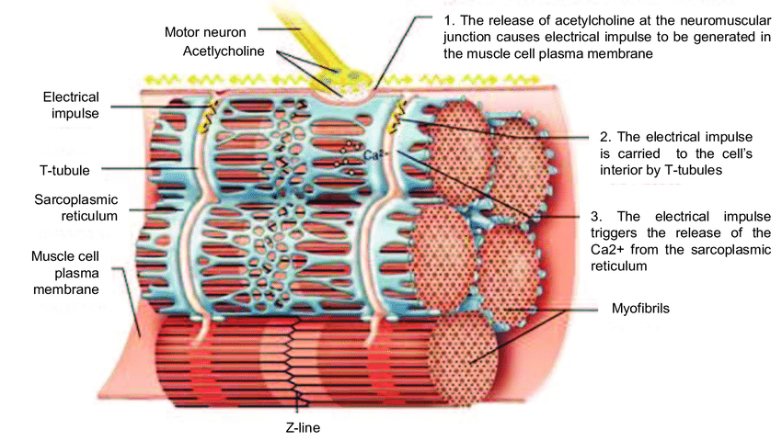

* + Neuromuscular Junction, Calcium ions, sarcoplasmic reticulum and T Tubules

Explain how the neuromuscular junction works

Sliding filament model

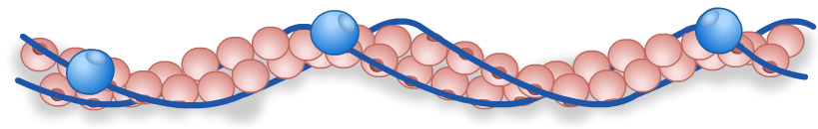

**Troponin**

**Tropomyosin –** long thin threads that are wound around the actin filament

**myosin head binding site**

**actin sub-unit**

Explain the sliding filament model using these words, Actin, Myosin, Tropnin, Tropomyosin, Calcium ions, ATP

|  |  |
| --- | --- |
|  | Ca2+ turns ATP to ADP providing energy for the myosin head to return to its original position. |
|  | Ca2+ cause tropomyosin molecules to pull away from the binding sites on the actin filament |
|  | An action potential travels into the T-tubules within the muscle fibre. |
|  | The myosin head (with ADP) reattaches further along the actin filaments and the cycle is repeated as long as there is Ca2+. |
|  | ADP molecules attached to myosin heads allow them to bind to the actin filament and form a cross-bridge |
|  | The action potential opens Ca2+ channels on the sarcoplasmic reticulum and Ca2+ diffuse into sarcoplasm. |
|  | An ATP attaches to the myosin head causing it to detach from the actin. |
|  | Once attached the myosin heads changes angle, pulling the actin filament along and releases an ADP molecule. |

Slow and Fast twitch muscles

There are two types of muscle fibres, these vary from muscle to muscle and person to person. The two broad types are called slow twitch and fast twitch

Long Distance runners tend to have larger amounts of slow twitch muscles Sprinters have fast twitch muscles.

|  |  |  |
| --- | --- | --- |
|  | Fast | Slow |
| Rate of Contraction |  |  |
| Rate of Fatigue |  |  |
| Suitability for activity |  |  |
| Mitochondria |  |  |
| Glycogen |  |  |
| Sarcoplasmic reticulum |  |  |
| Respiratory enzymes |  |  |
| Myoglobin |  |  |
| Appearance |  |  |
| Blood supply |  |  |