# Unit 2: Practical Scientific Procedures and Techniques

## Calibration of instruments

Before you go about using scientific instruments you need to make sure that they are very accurate. So you need to calibrate them. Follow the list and methods below in order to calibrate the equipment you are going to use for titrations. You will also learn how to calibrate a colorimeter and a pH meter later on.

#### Balance

The chemistry balances are calibrated every year by an outside company. They bring in a mass which has been very accurately measured and put it onto our balances to see if they are reading the correct value. If not they change the reading on the balance to what it should be.

As we do not have access to the company and their accurate masses you will be using a mass given to see how accurate our balances are. Record the following in the table

|  |  |  |  |
| --- | --- | --- | --- |
| Actual mass given | …………………………g | …………………………g | …………………………g |
| Mass recorded on balance 1 | ………………..………g | ………………..………g | ………………..………g |
| Mass recorded on balance 2 | ………..………………g | ………..………………g | ………..………………g |

What is the error on the balance? Does it differ?

* The balances recorded different masses for the same mass – this means we should always try to use the same balance when recording masses in an experiment so the error is the same every time
* The error on a 2 decimal point balance is ±0.005, which means if I am to try and weigh out 1g, I could weigh anything between 0.995g and 1.005g!

What did you have to be careful of when recording the masses, what was difficult?

* Make sure there is no breeze, and you are not leaning on the bench as a change in air pressure changes the reading on the scales
* Make sure there is nothing else on the scales – make sure they’re clean

#### Measuring cylinders

Measuring cylinders are used for measuring out a certain volume of a liquid, but how do we know this is true? We can use water and our knowledge of its density in order to do this.

1. Measure out 25cm3 of water into a measuring cylinder as carefully as you can
2. Let the water out into a pre-weighed beaker
3. Weigh the beaker
4. Repeat for different sizes of measuring cylinders

|  |  |  |  |  |
| --- | --- | --- | --- | --- |
|  | 100cm3 cylinder | 50cm3 cylinder | 25cm3 cylinder | 10cm3 cylinder |
| Mass of empty beaker | …………………g | ..……………g | ..……………g | ..……………g |
| Mass of beaker with 25cm3 of water | …………………g | ………………g | ………………g | ………………g |
| Mass of water | …………………g | ………………g | ………………g | ………………g |
| Actual volume of water: | ………………cm3 | ………………cm3 | ………………cm3 | ………………cm3 |
| Difference | ………………cm3 | ………………cm3 | ………………cm3 | ………………cm3 |

What have you found out about measuring cylinders?

Different sized measuring cylinders have different errors on them. This means you must use the measuring cylinder which fits best to the volume you want to measure eg, if you want to measure 20ml, use a 25ml cylinder, not a bigger or smaller one.

You can find the error of the measuring cylinder at the top of it.

You need to make sure the bottom of the meniscus is on the line you want to measure.

#### Pipette

The pipettes in college are said to read 25cm3, but how do we know this is true? We can use water and our knowledge of its density in order to do this.

1. Take up 25cm3 of water into a pipette as carefully as you can
2. Let the water out into a pre-weighed beaker
3. Weigh the beaker

|  |  |
| --- | --- |
| Mass of empty beaker | ………………………………………………………g |
| Mass of beaker with 25cm3 of water | ………………………………………………………g |
| Mass of water | ………………………………………………………g |
| Actual volume of water: | ………………………………………………………cm3 |
| Difference | ………………………………………………………cm3 |

What is the error on the pipette?

The error on a B pipette (which we have in the labs) is ±0.06cm3. So when we measure out 25cm3, it could be 24.94 or 25.06cm3.

What did you have to be careful of when doing this calibration?

When calibrating you need to check the temperature of the water, as the density of the water changes at different temperatures. This means that it’s volume changes slightly at different temperatures.

You must make sure the bottom of the meniscus is on the line

You must read at eye level

You must make sure to put the tip of the pipette to the side of the flask to let out the final drop.

#### Other equipment

There are a few other pieces of equipment you need to be used to on this course. Use the methods you have been using to complete the table and see which pieces of equipment are most accurate

|  |  |  |  |
| --- | --- | --- | --- |
|  | Beaker | Volumetric flask | Burette |
| Mass of empty beaker | …………………g | ..……………g | ..……………g |
| Mass of beaker with **250cm3** or **25 cm3** of water | …………………g | ………………g | ………………g |
| Mass of water | …………………g | ………………g | ………………g |
| Actual volume of water: | ………………cm3 | ………………cm3 | ………………cm3 |
| Difference | ………………cm3 | ………………cm3 | ………………cm3 |

Burettes can be hard to control. Make sure to slow down at near the end point

Always read the bottom of the meniscus at eye level.

Make sure you don’t have bubbles in the solution.

## How to prepare a standard solution

Look at the [process of quantitative transfer](http://www.dartmouth.edu/~chemlab/techniques/q_transfer.html) and [use of volumetric flasks](http://www.dartmouth.edu/~chemlab/techniques/vol_flasks.html).

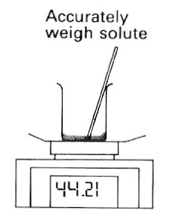A solution of known concentration can be made up if a solid substance is weighed out, dissolved in water, and made up to a known volume.

Accurately weigh solute

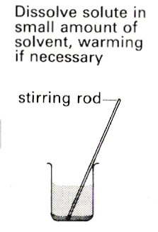

Dissolve solute in a small amount of solvent, warming if necessary

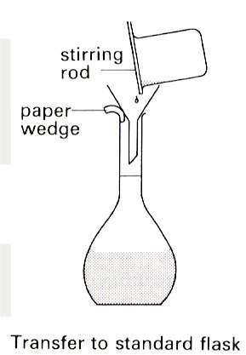

Transfer to a volumetric flask of **known volume**

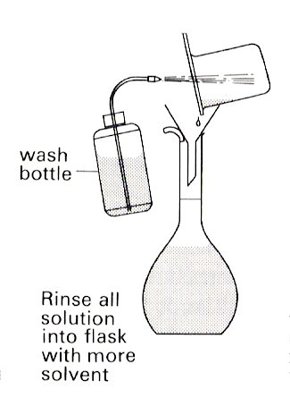

Rinse all solution into flask with more solvent.

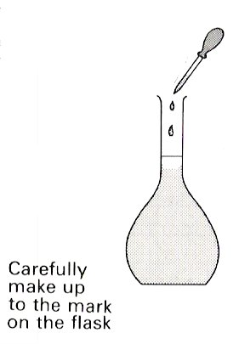

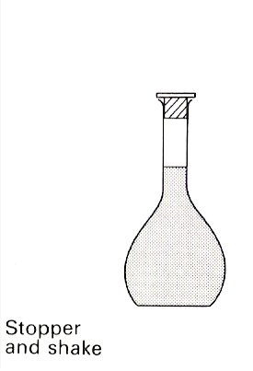

Carefully make up to the mark on the flask.

Stopper and invert 5 times to mix

This can be used to make a [standard solution](http://en.wikipedia.org/wiki/Standard_solution) if the chemical is very pure, does not gain moisture from the air and has a relatively high molar mass so weighing errors are minimised.

## Making a standard solution of sodium chloride

You have been asked to make a standard solution of sodium chloride which has a concentration of 0.1M. This means it will have 0.1 moles of sodium chloride in every litre of it.

A mole is a rather large number (6.022x1023), so if you have 0.1 moles you will have 6.022x1022 molecules of sodium chloride in every litre!

#### Working out how much sodium chloride to weigh:

1. **Find out how many moles you need in the 250ml volumetric flask**:

$$moles=\frac{250}{1000}×concentration \left(0.1M\right)$$

= 0.025

1. **Find the RMM/Mr** of sodium chloride (NaCl) – this is the mass of one mole of it:

= 23 (for Na) + 35.5 (for Cl) = 58.5

1. **Turn moles into a mass:**

$$mass \left(g\right)=moles ×RMM of Sodium Chloride(NaCl)$$

$$=0.025 \left(moles\right)×58.5\left(RMM\right)=1.46g$$

Then follow the procedure on page 5 to make up your very accurate standard solution

## How to carry out a titration

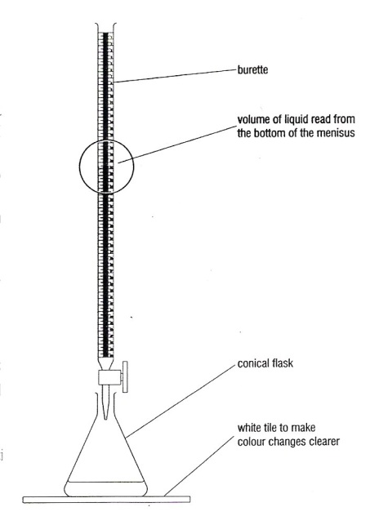This is a form of **quantitative analysis** when a **solution of known concentration** is used to find the concentration of another solution with which it reacts. It is possible to achieve extremely accurate results by a careful methodical approach. A step by step guide is shown [here](http://www.dartmouth.edu/~chemlab/techniques/titration.html).

ALWAYS WEAR SAFETY SPECTACLES

ALWAYS label beakers containing colourless solutions.

ONLY TAKE small quantities – do not waste solutions.

NEVER return solutions to the stock bottles.

RINSE the burette with a small quantity of the solution you are going to use to fill it.

Place a plastic filter funnel in the top of the burette.

ENSURE the tap on the burette is closed.

FILL the burette with the solution you are using (In general avoid using alkaline solutions in the burette if possible as they corrode joints).

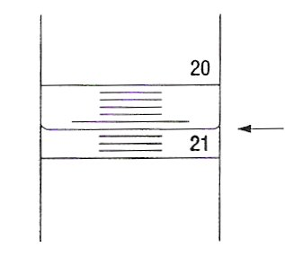Run a little bit of solution through the burette into a waste beaker so that the space beneath the tap is full of solution too.

THERE IS NO NEED FOR THE BURETTE TO READ EXACTLY ZERO.

20.60

Read the BOTTOM of the meniscus at eye level. Burettes can be read to 0.05 cm3 and EVERY READING must be recorded to 2 decimal places. Readings should be recorded as soon as they are taken.

RINSE the pipette with a small quantity of the solution you are going to use – USE A SAFETY FILLER.

FILL the pipette with the solution – the bottom of the meniscus should be on the fill line. Pipettes are ± 0.05 cm3.

Transfer the solution to a clean (rinse with distilled water) conical flask – touch the tip to the side of the flask to remove the last drop.

Place a white tile under the conical flask.

If you do not know the indicator colours do preliminary tests.

Add 2/3 drops of indicator – just sufficient to clearly show any colour.

HOLD the conical flask in your right hand and swirl gently whilst manipulating the tap with your left hand. (Reverse if necessary).

DO THE FIRST RUN QUICKLY TO OBTAIN A ROUGH GUIDE FOR THE TOTAL VOLUME REQUIRED.

For later titrations, add the solution drop by drop as the end point approaches.

If in doubt about the endpoint, take a reading and add two more drops – then decide.

Repeat until you have two readings within 0.20 cm3 – these are the readings you should average and use in any calculation.

Rinse all the glassware with tap water.

RINSE THE BURETTE WITH DISTILLED WATER AND LEAVE IT UPSIDE DOWN IN THE STAND WITH THE TAP OPEN .

To determine the end point of a titration we use an indicator. An **indicator** is a chemical which is one colour in acid and another in alkali.

|  |  |  |  |
| --- | --- | --- | --- |
| Indicator | Colour in acid | Endpoint | Colour in alkali |
| Methyl orange | Pink | Orange | Yellow |
| Methyl red | Pink | Orange | Yellow |
| Phenolphthalein | Colourless | Pale pink | Pink |
|  |  |  |  |

# Calibrating

## Pipette

To calibrate the pipette you need to measure out 25ml of water into the pipette and weigh the water into a beaker. From this you use the density of water at 20®C to then calculate the mass of water:

|  |  |
| --- | --- |
| Mass of 25cm3 of water from pipette |  |
| Actual volume of water: $$=\frac{mass of water}{density of water at 20℃ (0.9982g{cm}^{-3})}$$ |  |
| Difference |  |

## Titration 1: Finding the concentration of a solution of HCl

In this experiment the amount of hydrochloric acid in solution is estimated by neutralizing it with an alkali in the presence of an indicator. The same technique can be used to find the concentration of any acid in solution.

### Method

You will be following the general titration procedure outlined on a previous page.

The burette will be filled with the acid solution.

The pipette will be filled with 0.1 M sodium hydroxide solution.

The indicator you will be using is phenolphthalein.

**1.** Put a small amount of the sodium hydroxide solution in a test tube. Add a drop of indicator. Note the colour in the table below. Add the acid solution. Note the colour at the end-point when the acid has neutralized the alkali - and the colour in acid solution in the table below.

**2.** Fill the burette with acid following the procedure given. Note the burette reading.

**3.** Using a safety filler pipette 25 cm3 0.1 M NaOH (aq) into a conical flask. Add 2/3 drops of indicator until the colour can clearly be seen.

**4.** Carry out the titration. Repeat until you have at least two readings within 0.20 cm3.

**5.** Clear away – you *must rinse out the burette* with distilled water before upending to dry.

**RESULTS**

|  |  |
| --- | --- |
| Colour of phenolphthalein in alkali |  |
| Colour of phenolphthalein at end-point |  |
| Colour of phenolphthalein in acid |  |
| Solution in conical flask |  |
| Solution in burette |  |

|  |  |  |  |  |  |
| --- | --- | --- | --- | --- | --- |
|  | Titration 1 | Titration 2 | Titration 3 |  |  |
| Burette reading (final) |  |  |  |  |  |
| Burette reading (initial) |  |  |  |  |  |
| Titre/cm3 |  |  |  |  |  |

Average volume added using titres **within 0.20 cm3** =

**ANALYSIS/CALCULATION**

ALWAYS begin the calculation with the substance for which you know BOTH the volume and the molarity. USE the equation for the reaction.

The balanced equation for the reaction of hydrochloric acid with sodium hydroxide is:

…………………………………………………………………………………………………………………………………………………………….

The substance for which you know both the volume and the molarity in this case is the sodium hydroxide solution – you used 25 cm3 0.1 M NaOH (aq)

1. Number of moles of NaOH(aq) $= \frac{volume of NaOH}{1000}×concentration of NaOH$

=

From the equation the molar ratio of NaOH **:** HCl = **:**

Therefore number of moles of HCl(aq) =

So ……….cm3 of HCl(aq) contains ……………… moles

Therefore concentration of the HCl solution = $moles of HCl×\frac{1000}{Volume of HCl ({cm}^{3})}=$

**Evaluation of technique.**

How do your results compare with:-

Your partner?

The class average?

Can you think of any reasons for this?

LOOK AT PAGES 7 AND 5 TO SEE IF YOU FOLLOWED THE PROCEDURE CORRECTLY, AND COMMENT ON WHETHER YOU DID OR NOT, WHAT DID YOU DO CORRECTLY AND WHAT DIDN’T YOU DO CORRECTLY?

Which aspects of the titration did you find most difficult?

## Titration 2: Standardising a sample of HCl in order to use it for a titration

The trouble with working with chemicals is that they sometimes behave in unwanted ways.

If you want to accurately know the concentration of the solution you are going to use you have to standardise it.

We are going to standardise a sample of HCl as it is not possible to make up an accurately known solution of it, why?

It has been a day since the solution was made up which means the HCl could have reacted with other things, or most likely escaped from being in solution, this will mean there are less HCl molecules in solution and so the concentration will have gone down slightly.

In order to accurately determine the concentration of HCl, a titration needs to be carried out.

### Standardisation Method

* Weigh a small beaker, record its mass. Weigh the required mass of anhydrous sodium carbonate into the beaker and record the mass of beaker and sodium carbonate.
* Follow the procedure described for making up a solution (see page 3) using a 250cm3 volumetric flask.
* Pipette a 25cm3 sample of sodium carbonate into a conical flask and add 2 drops of methyl orange indicator.
* Fill the burette with the acid to be standardised.
* Carry out the titration. Repeat until you have 2 readings within 0.2 cm3.

### Results

|  |  |
| --- | --- |
| Colour of methyl orange in alkali |  |
| Colour of methyl orange at end-point |  |
| Colour of methyl orange in acid |  |
| Mass of empty beaker/g |  |
| Mass of beaker and Na2CO3 /g |  |
| Mass of Na2CO3/g |  |

|  |  |  |  |  |  |
| --- | --- | --- | --- | --- | --- |
|  | Titration 1 | Titration 2 | Titration 3 |  |  |
| Burette reading (final) |  |  |  |  |  |
| Burette reading (initial) |  |  |  |  |  |
| Titre/cm3 |  |  |  |  |  |

Average volume added using titres within 0.20 cm3 =

**ANALYSIS**

Calculate the moles of Na2CO3 used =

Equation for reaction between HCl and Na2CO3:

…………………………………………………………………………………………………………………………………………………………

Ratio of acid to sodium carbonate =

Therefore moles of acid in average titration volume =

Concentration of sulfuric acid in mol dm-3 =

# Calibrating

## Pipette

To calibrate the pipette you need to measure out 25ml of water into the pipette and weigh the water into a beaker. From this you use the density of water at 20®C to then calculate the mass of water:

|  |  |
| --- | --- |
| Mass of 25cm3 of water from pipette |  |
| Actual volume of water: |  |
| Difference |  |

## Balance

Use the perfect mass given to record the weight given by the balance

|  |  |
| --- | --- |
| Actual mass given | …………………………g |
| Mass recorded on balance | ………………..………g |
| Difference | ………………..………g |

## Making a standard solution of sodium chloride

You have been asked to make a standard solution of sodium carbonate which has a concentration of 0.05M. This means it will have 0.05 moles of sodium carbonate in every litre of it.

#### Working out how much sodium chloride to weigh:

1. **Find out how many moles you need in the 250ml volumetric flask**:
$$moles=\frac{250}{1000}×concentration \left(0.05M\right)$$

2. **Find the RMM/Mr** of sodium chloride (Na2CO3) – this is the mass of one mole of it:
3. **Turn moles into a mass:**

$$mass \left(g\right)=moles ×RMM of Sodium Carbonate({Na}_{2}{CO}_{3})$$

Then follow the procedure on page 5 to make up your very accurate standard solution

### Standardisation Method

* Weigh the **required mass** of anhydrous sodium carbonate into the beaker.
* Follow the procedure described for making up a solution (see page 3) using a 250cm3 volumetric flask.
* Pipette a 25cm3 sample of sodium carbonate into a conical flask and add 2 drops of methyl orange indicator.
* Fill the burette with the acid to be standardised.
* Carry out the titration. Repeat until you have 2 readings within 0.2 cm3.

### Results

|  |  |
| --- | --- |
| Colour of methyl orange in alkali |  |
| Colour of methyl orange at end-point |  |
| Colour of methyl orange in acid |  |
| Mass of Na2CO3/g |  |

|  |  |  |  |  |  |
| --- | --- | --- | --- | --- | --- |
|  | Titration 1 | Titration 2 | Titration 3 |  |  |
| Burette reading (final) |  |  |  |  |  |
| Burette reading (initial) |  |  |  |  |  |
| Titre/cm3 |  |  |  |  |  |

Average volume added using titres within 0.20 cm3 =

**ANALYSIS**

Calculate the moles of Na2CO3 used:

Equation for reaction between HCl and Na2CO3:

…………………………………………………………………………………………………………………………………………………………

Ratio of acid to sodium carbonate:

|  |  |
| --- | --- |
| Na2CO3 | HCl |
|  |  |
|  |  |

Therefore moles of acid in average titration volume =

Concentration of HCl mol dm-3 :

## pH TITRATION CURVES

When an alkali is added to an acid the pH changes rapidly at neutralisation. By drawing a graph of pH (y axis) against volume of alkali added (x axis), the change in pH during the titration can be monitored and the **equivalence point** found.

**The equivalence point** is the point at which: no. moles H+(aq) = no. moles OH-(aq)

The graph can also be used to find the molarity of a solution of hydrochloric acid, given 0.1 M sodium hydroxide .

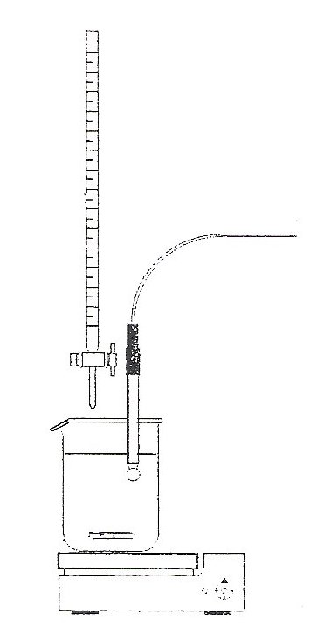

0.1M NaOH

to pH meter

acid and water

pH electrode

magnetic stirrer

X

X

X

X

### Method

1) Calibrate the pH electrode:-

* Rinse the electrode with distilled water before and after each operation.
* Place in buffer pH = 7, adjust ‘pH’ screw **very carefully**

They are **very expensive** to replace if you over tighten the screw!

* Rinse in distilled water
* Place in buffer pH = 4, adjust ‘slope’ screw **very carefully**
* Store in buffer pH = 4 when not in use.

2) Set up the apparatus as shown in the diagram. Pipette 25.0cm3 hydrochloric acid into a 250cm3 beaker. Add the minimum volume of distilled water to cover the bulb of the electrode. Mix gently with the magnetic stirrer. Take care that you do not damage the fragile bulb.

3) Fill the burette with sodium hydroxide solution.

Add the alkali from the burette to the acid a little at a time, (l cm3), recording both the pH and the volume accurately after each addition. When the pH changes rapidly, add the alkali **drop by drop, in order to record sufficient points** to be able to draw an accurate graph. Continue to add the alkali until the pH is relatively steady.

4) Draw a graph of volume of alkali added (x axis) against pH (y axis).

Title your graph and label the axes.

## Results

|  |  |  |  |  |  |
| --- | --- | --- | --- | --- | --- |
| **1st titration** | | **2nd titration** | | **3rd titration** | |
| **Volume added** | **pH** | **Volume added** | **pH** | **Volume added** | **pH** |
|  |  |  |  |  |  |
|  |  |  |  |  |  |
|  |  |  |  |  |  |
|  |  |  |  |  |  |
|  |  |  |  |  |  |
|  |  |  |  |  |  |
|  |  |  |  |  |  |
|  |  |  |  |  |  |
|  |  |  |  |  |  |
|  |  |  |  |  |  |
|  |  |  |  |  |  |
|  |  |  |  |  |  |
|  |  |  |  |  |  |
|  |  |  |  |  |  |
|  |  |  |  |  |  |
|  |  |  |  |  |  |
|  |  |  |  |  |  |
|  |  |  |  |  |  |
|  |  |  |  |  |  |
|  |  |  |  |  |  |
|  |  |  |  |  |  |
|  |  |  |  |  |  |
|  |  |  |  |  |  |
|  |  |  |  |  |  |
|  |  |  |  |  |  |
|  |  |  |  |  |  |
|  |  |  |  |  |  |
|  |  |  |  |  |  |
|  |  |  |  |  |  |
|  |  |  |  |  |  |

1. On your graph, mark in the equivalence point of the titration (halfway up the vertical portion of the graph). Use it to deduce:-

To neutralise 25cm3 HCl(aq), volume of NaOH(aq) = ………….

1. Concentration of HCl from page 12 (when you standardised it) = …………………
$moles of HCl=\frac{volume used (25ml)}{1000}×concentration of HCl=$

2. Equation for the reaction between HCl and NaOH:

…………………………………………………………………………………………………………………………………………..

1. Ratio of acid to sodium hydroxide:

|  |  |
| --- | --- |
| HCl | NaOH |
|  |  |
|  |  |

1. Therefore moles of NaOH at end point= ………………………………..
2. Concentration of NaOH in mol dm-3 :

Evaluation

Write down your own thoughts of what has gone well when carrying out titration and what has not. Think about your own technique, what is good and what you need to improve, and also discuss the limitations of the equipment you are using.

Look at pages 5 and 7 to see if you were following the procedure correctly

………………………………………………………………………………………………………………………………………………………….

………………………………………………………………………………………………………………………………………………………….

………………………………………………………………………………………………………………………………………………………….

………………………………………………………………………………………………………………………………………………………….

………………………………………………………………………………………………………………………………………………………….

………………………………………………………………………………………………………………………………………………………….

………………………………………………………………………………………………………………………………………………………….

………………………………………………………………………………………………………………………………………………………….

………………………………………………………………………………………………………………………………………………………….

………………………………………………………………………………………………………………………………………………………….

………………………………………………………………………………………………………………………………………………………….

………………………………………………………………………………………………………………………………………………………….

………………………………………………………………………………………………………………………………………………………….

## pH TITRATION CURVES

## Hydrochloric acid and potassium hydroxide

You are going to standardise a solution of HCl, using a standard solution of Na2CO3. Then once you know the concentration of the HCl you will use it to find the concentration of potassium hydroxide (KOH).

# Calibrating

## Pipette

To calibrate the pipette you need to measure out 25ml of water into the pipette and weigh the water into a beaker. From this you use the density of water at 20®C to then calculate the mass of water:

|  |  |
| --- | --- |
| Mass of 25cm3 of water from pipette |  |
| Actual volume of water: |  |
| Difference |  |

## Balance

Use the perfect mass given to record the weight given by the balance

|  |  |
| --- | --- |
| Actual mass given | …………………………g |
| Mass recorded on balance | ………………..………g |
| Difference | ………………..………g |

# pH meter

How do you calibrate a pH meter?

……………………………………………………………………………………………………………………………………………………….

……………………………………………………………………………………………………………………………………………………….

……………………………………………………………………………………………………………………………………………………….

……………………………………………………………………………………………………………………………………………………….

……………………………………………………………………………………………………………………………………………………….

……………………………………………………………………………………………………………………………………………………….

……………………………………………………………………………………………………………………………………………………….

## Making a standard solution of sodium carbonate

You have been asked to make a standard solution of sodium carbonate which has a concentration of 0.05M. This means it will have 0.05 moles of sodium carbonate in every litre of it.

#### Working out how much sodium carbonate to weigh:

1. **Find out how many moles you need in the 250ml volumetric flask**:
$$moles=\frac{250}{1000}×concentration \left(0.05M\right)$$

2. **Find the RMM/Mr** of sodium chloride (Na2CO3) – this is the mass of one mole of it:
3. **Turn moles into a mass:**

$$mass \left(g\right)=moles ×RMM of Sodium Carbonate({Na}_{2}{CO}_{3})$$

Then follow the procedure on page 5 to make up your very accurate standard solution

## Safety considerations

#### Glassware (eg pipette and burette)

#### Handling chemicals

#### Electrical things

## Standardising solution of HCl with sodium carbonate

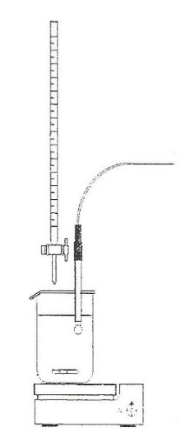

HCl

to pH meter

25ml Sodium carbonate

pH electrode

magnetic stirrer

1. Pipette 25cm3 Sodium carbonate into a 150 cm3 beaker and place on a stirrer, switch on at a sensible speed.
2. Position the pH electrode in the beaker not touching the base.
3. Fill the burette with HCl to the zero mark and move it so the tip is above the beaker.
4. Add the acid slowly and record the pH in the table on excel.
5. Draw a graph of volume of acid added (x axis) against pH (y axis).

On your graph, mark in the equivalence point of the titration (halfway up the vertical portion of the graph). Use it to deduce:-

To neutralise 25cm3 sodium carbonate, volume of HCl(aq) = ………….

$moles of sodium carbonate=\frac{volume used (25ml)}{1000}×concentration (0.05M)=$

1. Equation for the reaction between hydrochloric acid and sodium carbonate:

…………………………………………………………………………………………………………………………………………..

1. Ratio of acid to sodium hydroxide:

|  |  |
| --- | --- |
| Na2CO3 | HCl |
|  |  |
|  |  |

1. Therefore moles of HCl at end point= ………………………………..
2. Concentration of HCl in mol dm-3 :

## Using concentration of HCl to determine concentration of KOH



0.1M KOH

to pH meter

acid and water

pH electrode

magnetic stirrer

1. Pipette 25cm3 HCl into a 150 cm3 beaker and place on a stirrer, switch on at a sensible speed.
2. Position the pH electrode in the beaker not touching the base.
3. Fill the burette with KOH to the zero mark and move it so the tip is above the beaker.
4. Add the acid slowly and record the pH in the table on excel.
5. Draw a graph of volume of acid added (x axis) against pH (y axis).

On your graph, mark in the equivalence point of the titration (halfway up the vertical portion of the graph). Use it to deduce:-

To neutralise 25cm3 HCl, volume of KOH needed(aq) = ………….

$moles of HCl=\frac{volume used (25ml)}{1000}×concentration of HCl (from previous experiment)=$

1. Equation for the reaction between hydrochloric acid and potassium hydroxide:

…………………………………………………………………………………………………………………………………………..

1. Ratio of acid to sodium hydroxide:

|  |  |
| --- | --- |
| HCl | KOH |
|  |  |
|  |  |

1. Therefore moles of KOH at end point= ………………………………..
2. Concentration of KOH in mol dm-3 :

### Evaluation

What was the ACTUAL concentration of KOH?................................

How close were you? What could have gone wrong?

……………………………………………………………………………………………………………………………………………………………

……………………………………………………………………………………………………………………………………………………………

……………………………………………………………………………………………………………………………………………………………

……………………………………………………………………………………………………………………………………………………………

……………………………………………………………………………………………………………………………………………………………

……………………………………………………………………………………………………………………………………………………………

……………………………………………………………………………………………………………………………………………………………

……………………………………………………………………………………………………………………………………………………………

……………………………………………………………………………………………………………………………………………………………

……………………………………………………………………………………………………………………………………………………………

……………………………………………………………………………………………………………………………………………………………

……………………………………………………………………………………………………………………………………………………………

……………………………………………………………………………………………………………………………………………………………

……………………………………………………………………………………………………………………………………………………………

……………………………………………………………………………………………………………………………………………………………

……………………………………………………………………………………………………………………………………………………………

……………………………………………………………………………………………………………………………………………………………

……………………………………………………………………………………………………………………………………………………………

……………………………………………………………………………………………………………………………………………………………

……………………………………………………………………………………………………………………………………………………………

……………………………………………………………………………………………………………………………………………………………

……………………………………………………………………………………………………………………………………………………………

……………………………………………………………………………………………………………………………………………………………

## Problems you encountered and improvements you could make

……………………………………………………………………………………………………………………………………………………………

……………………………………………………………………………………………………………………………………………………………

……………………………………………………………………………………………………………………………………………………………

……………………………………………………………………………………………………………………………………………………………

……………………………………………………………………………………………………………………………………………………………

……………………………………………………………………………………………………………………………………………………………

……………………………………………………………………………………………………………………………………………………………

……………………………………………………………………………………………………………………………………………………………

……………………………………………………………………………………………………………………………………………………………

……………………………………………………………………………………………………………………………………………………………

……………………………………………………………………………………………………………………………………………………………

……………………………………………………………………………………………………………………………………………………………

……………………………………………………………………………………………………………………………………………………………

……………………………………………………………………………………………………………………………………………………………

……………………………………………………………………………………………………………………………………………………………

……………………………………………………………………………………………………………………………………………………………

……………………………………………………………………………………………………………………………………………………………

……………………………………………………………………………………………………………………………………………………………

……………………………………………………………………………………………………………………………………………………………

……………………………………………………………………………………………………………………………………………………………

……………………………………………………………………………………………………………………………………………………………

# Colourimetry

You have been given some copper sulphate solution of an unknown concentration ‘X’ M. You have to find the concentration.

You have also been given some other concentrations of copper sulphate. You are going to use a colorimeter in order to determine the concentration

Using the Colorimeter

1. Select the colour filter which is opposite (on the colour wheel) to the colour of your solution
2. ‘Calibrate’ the machine by putting water in the cuvette and turning the dial until it reads 100%
3. Then record the transmissions for you different solutions.

**\*\*\*\*Make sure you do not get water on the colorimeter \*\*\*\***

|  |  |
| --- | --- |
| Concentration (mol dm-3) | Percentage transmission (%) |
|  |  |
|  |  |
|  |  |
|  |  |
|  |  |
| Unknown (X) |  |

Now plot your results on a graph – Concentration on the X (horizontal) axis and transmission on the Y (vertical) axis.

Draw a line of best fit through your results.

Now look at the percentage transmission of ‘X’ and read off the concentration from your line of best fit.

Concentration of X =



## Evaluation

Write down your own thoughts of what has gone well when carrying out colorimetry and what has not. Think about your own technique, what is good and what you need to improve, and also discuss the limitations of the equipment you are using.

When you made up your standard solution did you follow all of the steps correctly?

Did you put the lid on?

Did you calibrate it beforehand?

Did you wipe the sides so there weren’t’ any fingerprints or solution on the outside?

Did you thoroughly mix up your solutions?

What did you do to ensure you were being accurate – repeats, were there any anomalies?

Is your graph as good as it could be?

……………………………………………………………………………………………………………………………………………………….

………………………………………………………………………………………………………………………………………………………….

………………………………………………………………………………………………………………………………………………………….

………………………………………………………………………………………………………………………………………………………….

………………………………………………………………………………………………………………………………………………………….

………………………………………………………………………………………………………………………………………………………….

………………………………………………………………………………………………………………………………………………………….

………………………………………………………………………………………………………………………………………………………….

………………………………………………………………………………………………………………………………………………………….

………………………………………………………………………………………………………………………………………………………….

………………………………………………………………………………………………………………………………………………………….

………………………………………………………………………………………………………………………………………………………….

………………………………………………………………………………………………………………………………………………………….

Calorimetry answers

## Thermometers

There are several types of thermometer, you are going to investigate the accuracy of two – a liquid filled thermometer and an electronic thermometer.

Use the thermometers to measure the different samples of water:

|  |  |  |  |
| --- | --- | --- | --- |
|  | Trial | Electronic thermometer recording | Liquid filled thermometer recording |
| Ice | 1 |  |  |
| 2 |  |  |
| 3 |  |  |
| Average |  |  |
| Boiling water | 1 |  |  |
| 2 |  |  |
| 3 |  |  |
| Average |  |  |

Think about the advantages and disadvantages of using each of the thermometers and write your thoughts in the table below:

|  |  |  |
| --- | --- | --- |
|  | Electronic thermometer | Liquid filled thermometer |
| Advantages | Gives to 1 decimal place  Most accurate  Easy to use  No reading errors | No electricity  Easy to set up |
| Disadvantages | Lots of equipment  expensive | Reading errors (look up parallax error)  Least accurate  No decimal places |

# Cooling curve of 2-methyl propan-2-ol

You are going to investigate what happens when 2-methyl propan-2-ol is cooled over time:

1. Warm solvent in a water bath (or if water from kettle)
2. Insert temperature probe into sample and make sure sample covers the bulb at the end of the probe
3. Record temperature every minute
4. Plot a graph with time on the x-axis and temperature on the y-axis

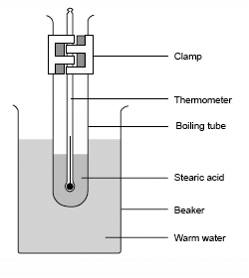

|  |  |
| --- | --- |
| Time (min) | Temperature of …………………. (°C) |
|  |  |
|  |  |
|  |  |
|  |  |
|  |  |
|  |  |
|  |  |
|  |  |
|  |  |
|  |  |
|  |  |
|  |  |
|  |  |
|  |  |
|  |  |
|  |  |
|  |  |
|  |  |
|  |  |
|  |  |
| Time (min) | Temperature of …………………. (°C) |
|  |  |
|  |  |
|  |  |
|  |  |
|  |  |
|  |  |
|  |  |
|  |  |

## Evaluating the cooling curve of 2-methyl propan-2-ol

You will need to find 3 gradients on your graph. To find the gradients draw a straight line against the curve and turn it into a triangle (see below):

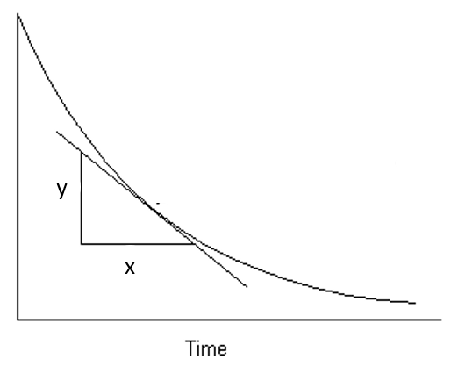

The gradient is calculated as:

$$gradient=\frac{change in x}{change in y}$$

Find some gradients on your curve and write them below:

When the line is flat, this means there is now temperature change over that amount of time, why is this? What is happening?

When the line is flat that is either the melting or boiling point.

At the melting point the temperature stays the same as although the molecules are losing heat energy they are making intermolecular forces with other molecules.

When intermolecular forces are made energy is given out, so this counteracts the energy lost as it is cooling and the temperature stays the same.

Once all the intermolecular forces have been made the temperature continues to decrease.

## Changes of state

What is happening to the molecules when they change state?

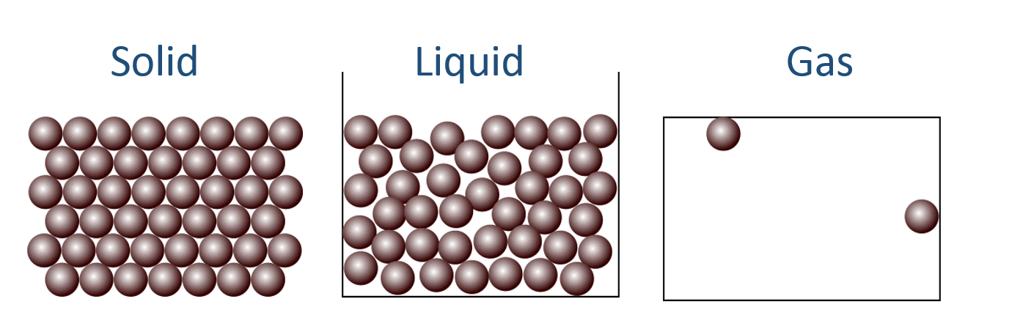

In a gas the molecules are moving around randomly and there are no intermolecular foces between the moelcules.

In a liquid the molcuules are still moving around randomly and quite a lot but they are much closer together and so there are a few forces between them

In a solid the molecules are still moving (molecules only stop moving at absolute zero (-273°C), and there are strong intermolecular forces between the molecules so they can’t move around as much and are packed closer together.

<http://www.bbc.co.uk/education/guides/zccmn39/revision>

## Intermolecular forces

#### London forces

These are in all molecules. When the electrons move to one side of the molecule it creates a slight negative charge, and a slight positive charge on the other side.

Diagram:

fluctuate1fluctuate1

How do you make London forces stronger?

Have more electrons and longer, less branched molecules so they can pack together tighter

#### Dipole-dipole forces

These are only in polar molecules, for example HCl. The slight positive side lines up with the slight negative side of another molecule.

Diagram

[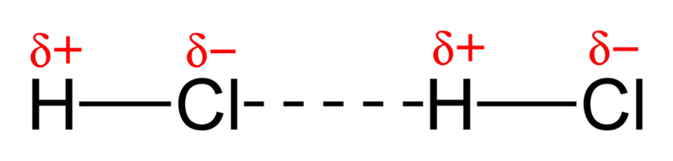](//upload.wikimedia.org/wikipedia/commons/5/59/Dipole-dipole-interaction-in-HCl-2D.png)

How do you make dipole-dipole forces stronger?

Have strong dipoles within the molecule

#### Hydrogen bonding

These forces only occur when there is a hydrogen bonded to an oxygen, nitrogen or fluorine. It creates a very strong type of dipole-dipole bond

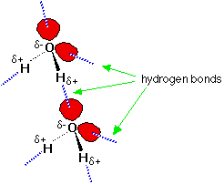Diagram

How do you make hydrogen bonds stronger?

Have more of them

# Cooling curve of paraffin wax

You are going to investigate another cooling curve, but this time you are devising your own experiment. The next few headings are to help you plan out your investigation and gives ideas you need to consider.

### What type of thermometer will you use and why?

Electric one as it is most accurate and less error when using it

### What will you need to do to the thermometer before you use it in your investigation?

Need to calibrate it in boiling and in ice water

### What equipment will you use – include a diagram:



### Method

1. Warm solvent in a water bath (or if water from kettle) until its boiling
2. Insert temperature probe into sample and make sure sample covers the bulb at the end of the probe
3. Record temperature every minute
4. Plot a graph with time on the x-axis and temperature on the y-axis

### Safety considerations

Things will be v hot so will need to use heat glove to handle hot things

Beeswax has no particular safety concern but will be hot at points

### Results table

### Graph of results

Make sure there are 3 titles on your graph and UNITS!

### Analysis of results – compare with actual melting point and class average

Find the gradient at 3 points

Find the melting point

Comment on how close you were to the class average and the actual melting point

### Evaluation

Did you stir it to ensure temperature was the same throughout the liquid?

Did you make sure the temperature probe was sufficiently covered to make sure it could record an accurate temperature?

Did you make sure you recorded the temp at the exact minute every time? Or if not did your write down the actual time?

Did you use the most accurate thermometer?

Did you calibrate the thermometer to make sure it was recording temp correctly?

What can change the temperature?

What could you have used in the future which may have been better?

Did you make sure there was the same amount of sample in the boiling tube so you can compare it to others?

# Supercooling

Most cooling curves follow a similar shape, the temperature goes down over time and changes of state (gas 🡪 liquid, and liquid 🡪 solid) are shown as lines, where the temperature does not change.

[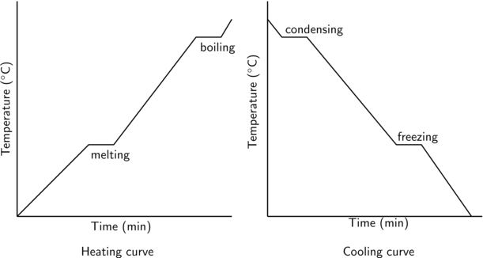](http://www.google.co.uk/url?sa=i&rct=j&q=&esrc=s&frm=1&source=images&cd=&cad=rja&uact=8&ved=0CAcQjRxqFQoTCNegg_z0oMgCFUxtFAodxYcM_w&url=http://everythingmaths.co.za/science/grade-11/04-intermolecular-forces/04-intermolecular-forces-02.cnxmlplus&psig=AFQjCNF5-52JlM2cWJ0Vnt5F4gl9CKb8KQ&ust=1443776545401970)

However there is an addition to this, when a substance is supercooled.

What does ‘supercooled’ mean?

It has been cooled beyond the melting/freezing point. Any movement of it will cause it all to solidify suddenly

On the graph below label what is happening on each section of the graph:

Boiling point

Melting point

Supercooling

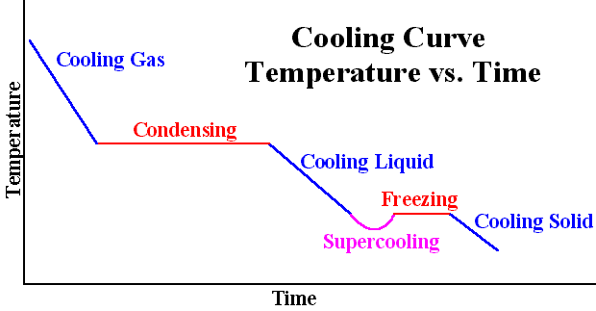

# **Chromatography**

Compare how far the acid moves up the paper with known amino acids, use ninhydrin to help you see the amino acids

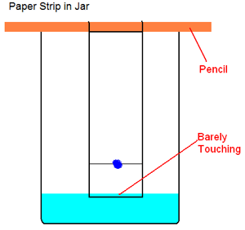

|  |  |  |  |  |
| --- | --- | --- | --- | --- |
| **Sample** | **Distance travelled by spot** | **Distance travelled by solvent** | **Rf Value**  **(distance of spot ÷ distance of solvent)** | **Amino acid** |
| Gylcine |  |  |  | Gylcine |
| Lysine |  |  |  | Lysine |
| Leucine |  |  |  | Leucine |
| Sample F |  |  |  |  |

## Extracting plant pigments using paper chromatography and TLC (thin layer chromatography)

Most leaves are green due to chlorophyll. This substance is important in photosynthesis (the process by which plants make their food). In this experiment, the different pigments present in a leaf are separated using paper chromatography.

### Method

1. Finely cut up some leaves and fill a mortar to about 2 cm depth.

2. Add a pinch of sand and six drops of propanone from the teat pipette.

3. Grind the mixture for at least three minutes.

4. On a strip of chromatography paper, draw a pencil line 3 cm from the bottom.

5. Use a fine glass tube to put liquid from the leaf extract onto the centre of the line. Keep the spot as small as possible.

6. Allow the spot to dry, then add another spot on top. Add five more drops of solution, letting each one dry before putting on the next. The idea is to build up a very concentrated small spot on the paper.

7. Put a small amount of propanone in a beaker and hang the paper so it dips in the propanone. Ensure the propanone level is below the spot.

8. Leave until the propanone has soaked near to the top.

9. Mark how high the propanone gets on the paper with a pencil and let the chromatogram dry.

## Results for paper chromatography

|  |  |  |  |
| --- | --- | --- | --- |
| **Sample colour** | **Distance travelled by spot** | **Distance travelled by solvent** | **Rf Value**  **(distance of spot ÷ distance of solvent)** |
|  |  |  |  |
|  |  |  |  |
|  |  |  |  |
|  |  |  |  |

### Questions

1. How many substances are on the chromatogram?

………………………………………………………………………………………………………………………………………………………

2.what is the stationary phase and mobile phase in this chromatography?

…………………………………………………………………………………………………………………………………………………..

## Results for TLC

|  |  |  |  |
| --- | --- | --- | --- |
| **Sample colour** | **Distance travelled by spot** | **Distance travelled by solvent** | **Rf Value**  **(distance of spot ÷ distance of solvent)** |
|  |  |  |  |
|  |  |  |  |
|  |  |  |  |
|  |  |  |  |

### Questions

1. How many substances are on the chromatogram?

………………………………………………………………………………………………………………………………………………………

2.what is the stationary phase and mobile phase in this chromatography?

…………………………………………………………………………………………………………………………………………………..

## Different types of Chromatography

On the following table, fill in the mobile and stationary phases for the different types of chromatography. Draw a sketch of the results which you might obtain and explain when it might be used:

|  |  |  |  |  |
| --- | --- | --- | --- | --- |
| Type | Mobile phase | Stationary phase | Diagram of results | What it is used for |
| Paper chromatography |  |  |  |  |
| Thin layer chromatography |  |  |  |  |
| Gas chromatography |  |  |  |  |
| Ion exchange chromatography |  |  |  |  |
| High performance liquid chromatography |  |  |  |  |

## Interpreting chromatograms

What does looking at a chromatogram tell us, try to think of a couple of things:

* ……………………………………………………………………………………
* …………………………………………………………………………………..

Why do you think some substances move further than others ?

…………………………………………………………………………………………………………………………………………………………..

……………………………………………………………………………………………………………………………………………………………

Chromatography is very handy to make comparisons between mixtures of substances, but it also gives us some idea about the types of intermolecular forces in the substances.

If the mobile phase is very polar, what type of substances will mix with the mobile phase and move further up the paper?

………………………………………………………………………………………………………………………………………………………….

If the stationary phase is non-polar what type of substances will stay with the stationary phase and not move very much?

……………………………………………………………………………………………………………………………………………………………

## Evaluation of chromatography

What are the difficulties you found when carrying out chromatography (think about both paper chromatography and TLC):

………………………………………………………………………………………………………………………………………………………….

………………………………………………………………………………………………………………………………………………………….

………………………………………………………………………………………………………………………………………………………….

………………………………………………………………………………………………………………………………………………………….

………………………………………………………………………………………………………………………………………………………….

………………………………………………………………………………………………………………………………………………………….

………………………………………………………………………………………………………………………………………………………….

………………………………………………………………………………………………………………………………………………………….

………………………………………………………………………………………………………………………………………………………….

………………………………………………………………………………………………………………………………………………………….

………………………………………………………………………………………………………………………………………………………….

………………………………………………………………………………………………………………………………………………………….

………………………………………………………………………………………………………………………………………………………….

# What skills you need to work in a lab?

### On a personal level, what must you make sure you do?

### What interpersonal skills must you have?

### What skills have you developed over all of the experiments you have done in this unit?

### What could you use these skills for?

### What do you think you need to improve upon?