Calorimetry answers

## Thermometers

There are several types of thermometer, you are going to investigate the accuracy of two – a liquid filled thermometer and an electronic thermometer.

Use the thermometers to measure the different samples of water:

|  |  |  |  |
| --- | --- | --- | --- |
|  | Trial | Electronic thermometer recording | Liquid filled thermometer recording |
| Ice | 1 |  |  |
| 2 |  |  |
| 3 |  |  |
| Average |  |  |
| Boiling water | 1 |  |  |
| 2 |  |  |
| 3 |  |  |
| Average |  |  |

Think about the advantages and disadvantages of using each of the thermometers and write your thoughts in the table below:

|  |  |  |
| --- | --- | --- |
|  | Electronic thermometer | Liquid filled thermometer |
| Advantages | Gives to 1 decimal place  Most accurate  Easy to use  No reading errors | No electricity  Easy to set up |
| Disadvantages | Lots of equipment  expensive | Reading errors (look up parallax error)  Least accurate  No decimal places |

# Cooling curve of 2-methyl propan-2-ol

You are going to investigate what happens when 2-methyl propan-2-ol is cooled over time:

1. Warm solvent in a water bath (or if water from kettle)
2. Insert temperature probe into sample and make sure sample covers the bulb at the end of the probe
3. Record temperature every minute
4. Plot a graph with time on the x-axis and temperature on the y-axis

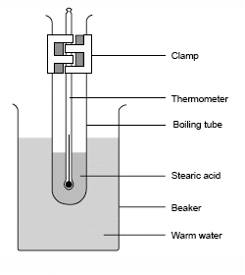

|  |  |
| --- | --- |
| Time (min) | Temperature of …………………. (°C) |
|  |  |
|  |  |
|  |  |
|  |  |
|  |  |
|  |  |
|  |  |
|  |  |
|  |  |
|  |  |
|  |  |
|  |  |
|  |  |
|  |  |
|  |  |
|  |  |
|  |  |
|  |  |
|  |  |
|  |  |
| Time (min) | Temperature of …………………. (°C) |
|  |  |
|  |  |
|  |  |
|  |  |
|  |  |
|  |  |
|  |  |
|  |  |

## Evaluating the cooling curve of 2-methyl propan-2-ol

You will need to find 3 gradients on your graph. To find the gradients draw a straight line against the curve and turn it into a triangle (see below):

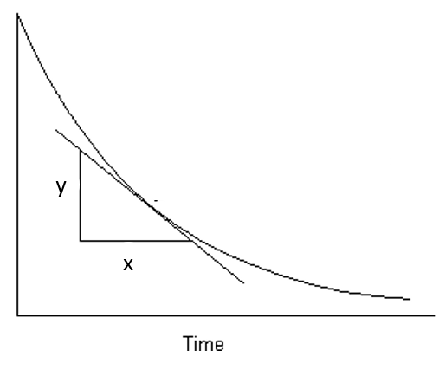

The gradient is calculated as:

Find some gradients on your curve and write them below:

When the line is flat, this means there is now temperature change over that amount of time, why is this? What is happening?

When the line is flat that is either the melting or boiling point.

At the melting point the temperature stays the same as although the molecules are losing heat energy they are making intermolecular forces with other molecules.

When intermolecular forces are made energy is given out, so this counteracts the energy lost as it is cooling and the temperature stays the same.

Once all the intermolecular forces have been made the temperature continues to decrease.

## Changes of state

What is happening to the molecules when they change state?

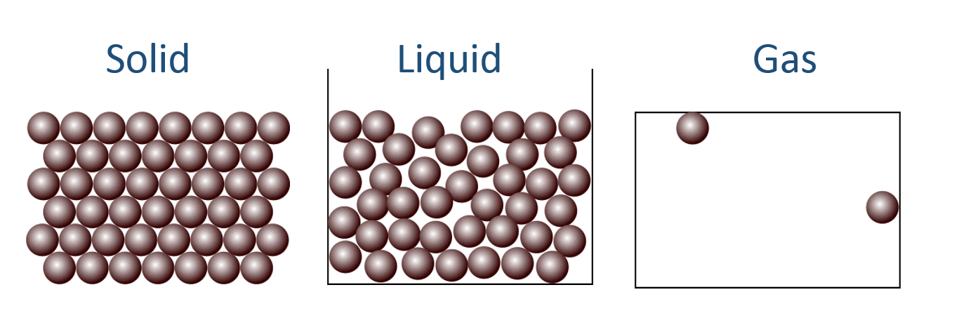

In a gas the molecules are moving around randomly and there are no intermolecular foces between the moelcules.

In a liquid the molcuules are still moving around randomly and quite a lot but they are much closer together and so there are a few forces between them

In a solid the molecules are still moving (molecules only stop moving at absolute zero (-273°C), and there are strong intermolecular forces between the molecules so they can’t move around as much and are packed closer together.

<http://www.bbc.co.uk/education/guides/zccmn39/revision>

## Intermolecular forces

#### London forces

These are in all molecules. When the electrons move to one side of the molecule it creates a slight negative charge, and a slight positive charge on the other side.

Diagram:

fluctuate1fluctuate1

How do you make London forces stronger?

Have more electrons and longer, less branched molecules so they can pack together tighter

#### Dipole-dipole forces

These are only in polar molecules, for example HCl. The slight positive side lines up with the slight negative side of another molecule.

Diagram

[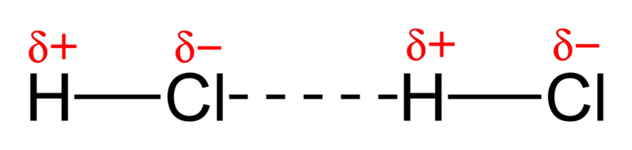](//upload.wikimedia.org/wikipedia/commons/5/59/Dipole-dipole-interaction-in-HCl-2D.png)

How do you make dipole-dipole forces stronger?

Have strong dipoles within the molecule

#### Hydrogen bonding

These forces only occur when there is a hydrogen bonded to an oxygen, nitrogen or fluorine. It creates a very strong type of dipole-dipole bond

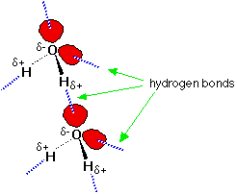Diagram

How do you make hydrogen bonds stronger?

Have more of them

# Cooling curve of paraffin wax

You are going to investigate another cooling curve, but this time you are devising your own experiment. The next few headings are to help you plan out your investigation and gives ideas you need to consider.

### What type of thermometer will you use and why?

Electric one as it is most accurate and less error when using it

### What will you need to do to the thermometer before you use it in your investigation?

Need to calibrate it in boiling and in ice water

### What equipment will you use – include a diagram:



### Method

1. Warm solvent in a water bath (or if water from kettle) until its boiling
2. Insert temperature probe into sample and make sure sample covers the bulb at the end of the probe
3. Record temperature every minute
4. Plot a graph with time on the x-axis and temperature on the y-axis

### Safety considerations

Things will be v hot so will need to use heat glove to handle hot things

Beeswax has no particular safety concern but will be hot at points

### Results table

### Graph of results

Make sure there are 3 titles on your graph and UNITS!

### Analysis of results – compare with actual melting point and class average

Find the gradient at 3 points

Find the melting point

Comment on how close you were to the class average and the actual melting point

### Evaluation

Did you stir it to ensure temperature was the same throughout the liquid?

Did you make sure the temperature probe was sufficiently covered to make sure it could record an accurate temperature?

Did you make sure you recorded the temp at the exact minute every time? Or if not did your write down the actual time?

Did you use the most accurate thermometer?

Did you calibrate the thermometer to make sure it was recording temp correctly?

What can change the temperature?

What could you have used in the future which may have been better?

Did you make sure there was the same amount of sample in the boiling tube so you can compare it to others?

# Supercooling

Most cooling curves follow a similar shape, the temperature goes down over time and changes of state (gas 🡪 liquid, and liquid 🡪 solid) are shown as lines, where the temperature does not change.

[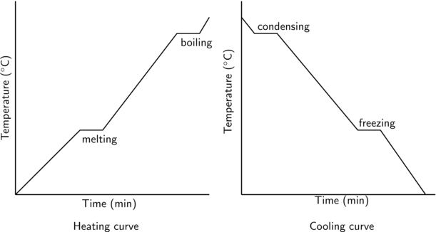](http://www.google.co.uk/url?sa=i&rct=j&q=&esrc=s&frm=1&source=images&cd=&cad=rja&uact=8&ved=0CAcQjRxqFQoTCNegg_z0oMgCFUxtFAodxYcM_w&url=http://everythingmaths.co.za/science/grade-11/04-intermolecular-forces/04-intermolecular-forces-02.cnxmlplus&psig=AFQjCNF5-52JlM2cWJ0Vnt5F4gl9CKb8KQ&ust=1443776545401970)

However there is an addition to this, when a substance is supercooled.

What does ‘supercooled’ mean?

It has been cooled beyond the melting/freezing point. Any movement of it will cause it all to solidify suddenly

On the graph below label what is happening on each section of the graph:

Boiling point

Melting point

Supercooling

