Calorimetry

## Thermometers

There are several types of thermometer, you are going to investigate the accuracy of two – a liquid filled thermometer and an electronic thermometer.

Use the thermometers to measure the different samples of water:

|  |  |  |  |
| --- | --- | --- | --- |
|  | Trial | Electronic thermometer recording | Liquid filled thermometer recording |
| Ice | 1 |  |  |
| 2 |  |  |
| 3 |  |  |
| Average |  |  |
| Boiling water | 1 |  |  |
| 2 |  |  |
| 3 |  |  |
| Average |  |  |

Think about the advantages and disadvantages of using each of the thermometers and write your thoughts in the table below:

|  |  |  |
| --- | --- | --- |
|  | Electronic thermometer | Liquid filled thermometer |
| Advantages |  |  |
| Disadvantages |  |  |

# Cooling curve of 2-methyl propan-2-ol

You are going to investigate what happens when 2-methyl propan-2-ol is cooled over time:

1. Warm solvent in a water bath (or if water from kettle)
2. Insert temperature probe into sample and make sure sample covers the bulb at the end of the probe
3. Record temperature every minute
4. Plot a graph with time on the x-axis and temperature on the y-axis

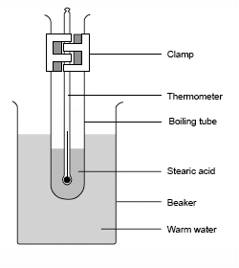

|  |  |
| --- | --- |
| Time (min) | Temperature of …………………. (°C) |
|  |  |
|  |  |
|  |  |
|  |  |
|  |  |
|  |  |
|  |  |
|  |  |
|  |  |
|  |  |
|  |  |
|  |  |
|  |  |
|  |  |
|  |  |
|  |  |
|  |  |
|  |  |
|  |  |
|  |  |
| Time (min) | Temperature of …………………. (°C) |
|  |  |
|  |  |
|  |  |
|  |  |
|  |  |
|  |  |
|  |  |
|  |  |
|  |  |
|  |  |
|  |  |
|  |  |
|  |  |
|  |  |
|  |  |
|  |  |
|  |  |
|  |  |
|  |  |

### Evaluating the cooling curve of 2-methyl propan-2-ol

You will need to find 3 gradients on your graph. To find the gradients draw a straight line against the curve and turn it into a triangle (see below):

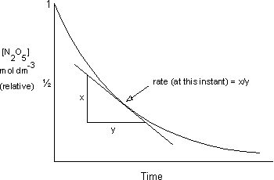

The gradient is calculated as:

Find some gradients on your curve and write them below:

When the line is flat, this means there is now temperature change over that amount of time, why is this? What is happening?

## Changes of state

What is happening to the molecules when they change state?

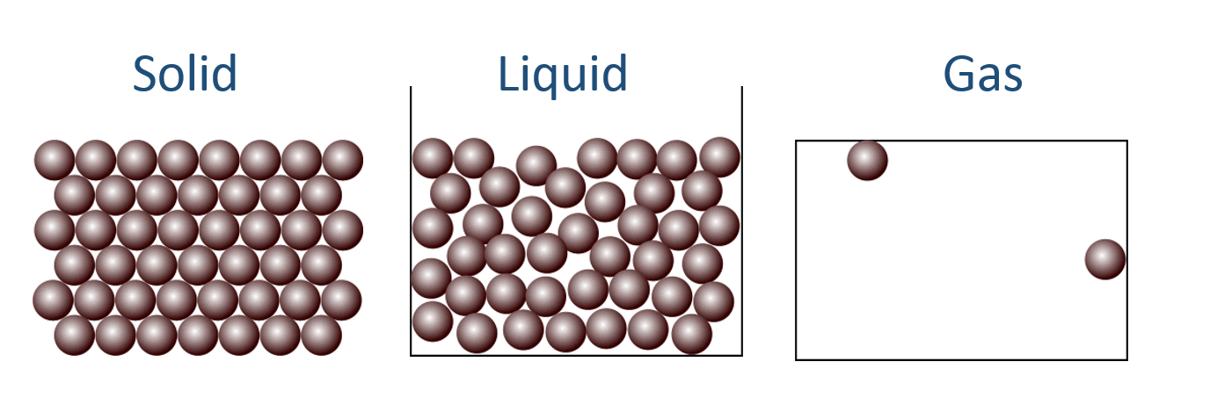

## Intermolecular forces

#### London forces

These are in all molecules. When the electrons move to one side of the molecule it creates a slight negative charge, and a slight positive charge on the other side.

Diagram:

How do you make London forces stronger?

#### Dipole-dipole forces

These are only in polar molecules, for example HCl. The slight positive side lines up with the slight negative side of another molecule.

Diagram

How do you make dipole-dipole forces stronger?

#### Hydrogen bonding

These forces only occur when there is a hydrogen bonded to an oxygen, nitrogen or fluorine. It creates a very strong type of dipole-dipole bond

Diagram

How do you make hydrogen bonds stronger?

# Cooling curve of paraffin wax

You are going to investigate another cooling curve, but this time you are devising your own experiment. The next few headings are to help you plan out your investigation and gives ideas you need to consider.

### What type of thermometer will you use and why?

### What will you need to do to the thermometer before you use it in your investigation?

### What equipment will you use – include a diagram:

### Method

### Safety considerations

### Results table

### Graph of results

### Analysis of results – compare with actual melting point and class average

# Supercooling

Most cooling curves follow a similar shape, the temperature goes down over time and changes of state (gas 🡪 liquid, and liquid 🡪 solid) are shown as lines, where the temperature does not change.

[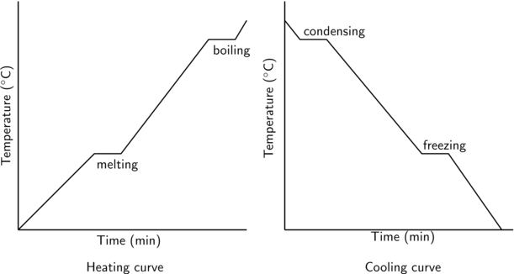](http://www.google.co.uk/url?sa=i&rct=j&q=&esrc=s&frm=1&source=images&cd=&cad=rja&uact=8&ved=0CAcQjRxqFQoTCNegg_z0oMgCFUxtFAodxYcM_w&url=http://everythingmaths.co.za/science/grade-11/04-intermolecular-forces/04-intermolecular-forces-02.cnxmlplus&psig=AFQjCNF5-52JlM2cWJ0Vnt5F4gl9CKb8KQ&ust=1443776545401970)

However there is an addition to this, when a substance is supercooled.

What does ‘supercooled’ mean?

…………………………………………………………………………………………………………………………………………………………

On the graph below label what is happening on each section of the graph:

