**Q1.**

The graph shows an analogue signal represented as a waveform. The analogue signal is being converted to a digital signal by an analogue to digital convertor (ADC).

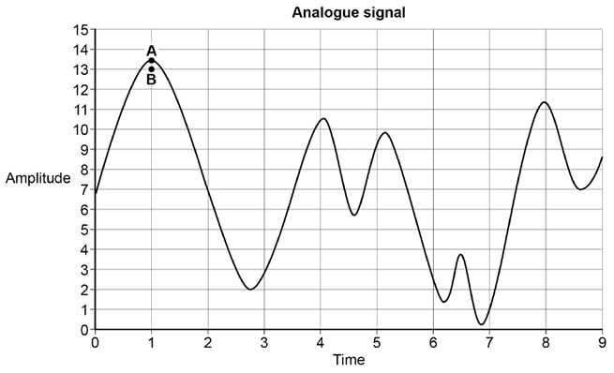

Points **A** and **B** in the graph indicate the amplitude of the waveform (**A**), at a point in time, and the value that was recorded for this measurement when the waveform was sampled (**B**).

(a)  The waveform’s amplitude is measured and recorded using a scale with 16 divisions, which are shown on the Y axis in the graph.

The recorded digital data indicates which division on the Y axis each measurement is closest to. For example, the closest division to measurement **A** is 13.

What sample resolution has been used?

___________________________________________________________________

___________________________________________________________________

**(1)**

(b)  The graph covers a time period of 0.01 seconds. During this time period, 10 samples have been recorded at the times indicated by the divisions on the X axis in the graph above.

What sample rate has been used?

___________________________________________________________________

___________________________________________________________________

**(1)**

(c)  Explain the impact of the difference between **A** and **B** and how this difference could be reduced by redesigning the sampling system.

___________________________________________________________________

___________________________________________________________________

___________________________________________________________________

___________________________________________________________________

**(2)**

(d)  A different analogue signal is being sampled. The highest frequency present in the signal’s waveform is 1200 Hz.

What is the minimum sample rate that must be used during sampling in order to preserve all of the frequencies in the waveform?

___________________________________________________________________

___________________________________________________________________

**(1)**

**(Total 5 marks)**

**Q2.**

The icon below is represented in a computer's memory as a bitmap image.

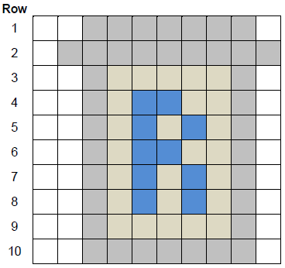

Four different colours have been used in the icon.

**Row 1** of the icon is represented in the computer's memory as the bit pattern:

|  |  |  |  |  |  |  |  |  |  |  |  |  |  |  |  |  |  |  |  |
| --- | --- | --- | --- | --- | --- | --- | --- | --- | --- | --- | --- | --- | --- | --- | --- | --- | --- | --- | --- |
| 1 | 1 | 1 | 1 | 0 | 0 | 0 | 0 | 0 | 0 | 0 | 0 | 0 | 0 | 0 | 0 | 0 | 0 | 1 | 1 |

(a)     What are the bit patterns that have been used to represent a grey pixel and a white pixel?

|  |  |  |
| --- | --- | --- |
| Grey pixel: ________ |  | White pixel: ________ |

**(1)**

(b)     State **one** possible 20-bit representation for **Row 4** of the icon.

|  |  |  |  |  |  |  |  |  |  |  |  |  |  |  |  |  |  |  |  |
| --- | --- | --- | --- | --- | --- | --- | --- | --- | --- | --- | --- | --- | --- | --- | --- | --- | --- | --- | --- |
|  |  |  |  |  |  |  |  |  |  |  |  |  |  |  |  |  |  |  |  |

**(1)**

(c)     Calculate the number of bytes required to represent all the pixel data in the icon as a bitmap.

Show your working.

___________________________________________________________________

___________________________________________________________________

___________________________________________________________________

___________________________________________________________________

Answer ___________________________

**(2)**

(d)     When the bitmap is saved as a file, the file size is bigger than the answer to (c). This is because metadata is saved in the file with the pixel data

State **one** item of metadata that would be stored in a bitmap file.

___________________________________________________________________

___________________________________________________________________

**(1)**

(e)     Run-length encoding (RLE) is an example of a compression method that could be used to reduce the amount of memory required to store the icon.

Describe the principle used by RLE to compress a file and explain why RLE is an appropriate compression method for compressing images such as icons.

___________________________________________________________________

___________________________________________________________________

___________________________________________________________________

___________________________________________________________________

___________________________________________________________________

___________________________________________________________________

**(3)**

**(Total 8 marks)**

**Q3.**

A band is recording and digitising a song to make available as a download from their website.

(a)     The song lasts 3 minutes. The sample resolution is 16 bits and a sample rate of 44 kHz has been used.

A sample rate of 1 Hz means that one sample has been taken every second.

Calculate the minimum amount of storage space, in megabytes (MB), needed to store the song in an uncompressed format.

You **must** show your working.

___________________________________________________________________

___________________________________________________________________

___________________________________________________________________

___________________________________________________________________

___________________________________________________________________

___________________________________________________________________

Answer _________________________________________

**(3)**

(b)     The song is being recorded using a microphone plugged into the sound card of the computer. The sound card contains an analogue to digital converter (ADC).

Describe the steps the ADC goes through in this process.

___________________________________________________________________

___________________________________________________________________

___________________________________________________________________

___________________________________________________________________

___________________________________________________________________

___________________________________________________________________

___________________________________________________________________

___________________________________________________________________

___________________________________________________________________

___________________________________________________________________

**(3)**

(c)     The band have been advised to save their song using lossless compression.

Explain why it might be appropriate for the band to save the song using lossless compression rather than using lossy compression.

___________________________________________________________________

___________________________________________________________________

___________________________________________________________________

___________________________________________________________________

___________________________________________________________________

___________________________________________________________________

___________________________________________________________________

**(2)**

**(Total 8 marks)**