Mark schemes
Q1.

(a) Mark is for AO1 (understanding)
64 / 2⁶;
1
(b) Mark is for AO2 (apply)
100;
1
(c) Mark is for AO2 (apply)
110;
A The response given to question part (b) with 10 added on.
1
(d) Mark is for AO2 (apply)
220;
A The response given to question part (c) multiplied by 2.
1
(e) All marks AO1 (understanding)
So that source code cannot be accessed by users;
So that it is more convenient for users to run it / / users do not need to have an interpreter;
So that the program will execute more quickly;
Max 2
2
(f) All marks AO1 (understanding)
1 mark: Can't know what type of processor will be in user’s computer / / Internet users have range of computers / devices with different processors; A References to just different types of computer / device rather than specifically processors
1 mark: A compiled program will only execute on a processor of specific type / family / with same instruction set / / A program run using an interpreter can execute on a computer with any type of processor;
R No compiler exists
2
[8]
Q2.
(a) All marks for AO2 (apply)
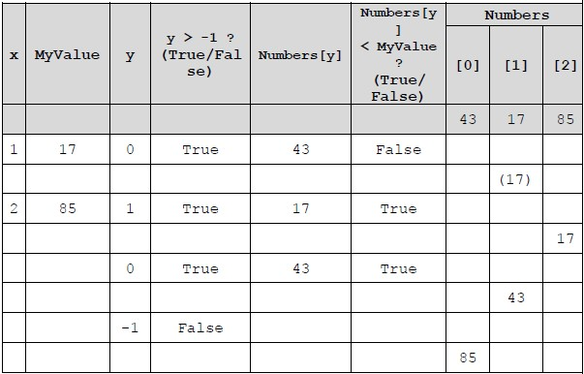
1 mark for correct x column and MyValue column;
1 mark for correct y column (0, 1, 0, -1);
1 mark for correct Boolean values in columns 4 and 6;
A. TRUE/true, FALSE/false, Yes/No, Y/N and any other suitable indicators
1 mark for final contents of Numbers correct;
4
(b) Mark is for AO2 (analyse)
sort from largest to smallest;
NE Sort on its own
A. bubble sort;
1
[5]
Q3.

(a) Data Protection (Act);
1
(b) Data should be kept securely;
1
(c) Data should be fairly and lawfully processed;
Data should be obtained for specified and lawful purposes. (A Data should be processed for limited purposes);
Data should be adequate, relevant and not excessive;
Data should be accurate // kept up to date;
Data should not be kept longer than necessary;
Data should be not transferred to other countries without adequate protection;
Data should be processed in accordance with the rights of the data subjects.
Max 1
(d) That data is not being encrypted // data is not being sent securely // that hackers might be able to see personal data;
A the protocol / it is not secure
R website not secure
HTTPS // HyperText Transfer Protocol Secure;
2
(e) Word processor : General purpose (application software);
Parent portal : Bespoke;
Web server : Special purpose (application software);
3
[8]
Q4.
Marks are for AO2 (apply) and AO3 (program)
Example Solution 1
LDR R1, 102
LDR R2, 103
loop:
startloop: AND R3, R0, #1
CMP R3, #1
BNE jump
ADD R2, R2, R1 // ADD R2, R1, R2
jump: LSR R0, R0, #1
LSL R1, R1, #1
CMP R0, #0
BEQ endloop
B startloop
endloop:
Alternative Answer 1:
LSL R1, R1, #1 could be replaced with ADD R1, R1, R1
Alternative Answer 2:
BNE jump could be replaced with:
BEQ doadd
B jump
doadd:
AO2 (analyse) – 2 marks
1 mark: Recognising that logical shift (LSR/LSL) is needed to perform integer division by 2 / multiplication by 2 even if the syntax used is incorrect.
1 mark: Recognise that two comparisons and two branch instructions are needed even if the syntax is incorrect or the wrong types of branch instructions are used.
AO3 (program) – 5 marks
1 mark: CMP R3, #1 before the jump: label and syntactically correct.
1 mark: BNE jump before the jump: label and syntactically correct.
1 mark: ADD R2, R2, R1 is before the jump: label and syntactically correct.
1 mark: LSR R0, R0, #1 and LSL R1, R1, #1 are after the jump: label and syntactically correct. I. order of commands
1 mark: CMP R0,#0 and BEQ endloop are after the jump: label, before B startloop and syntactically correct.
Max 4 marks for programming if any syntax incorrect or program does not work correctly under all circumstances
A. Answers that use hexadecimal or binary values
DPT Missing hash for immediate addressing
DPT incorrect use of commas, colons, semi-colons, line numbers, etc.
[7]

