# Worksheet 2A The Processor Answers

**Task 1**

1. Match the processor components with the correct descriptions:

|  |  |  |
| --- | --- | --- |
| Arithmetic-Logic Unit |  | A single memory location in which intermediate arithmetic and logic results are stored |
| System clock |  | Directs and coordinates the operation of the processor and controls the flow of data within the CPU |
| General purpose registers |  | Memory locations used to assist the operation of the processor in collecting and processing instructions and data |
| Dedicated registers |  | A continuously cycling signal that is used as a timing pulse for all processor components |
| Accumulator |  | Memory locations used to hold values and intermediate results whilst executing an instruction |
| Control Unit |  | Used to carry out the instructions received by the processor and produce the processed output |

**Task 2**

1. An incomplete diagram of processor components is shown below including possible data stored in various registers. The address 027FFF95 contains the instruction ADD R0, R1, #10. Complete the diagram by labelling the name of each component.

*Tip: Think about the contents and connections of each part.*

|  |  |  |
| --- | --- | --- |
| **Memory Address Register** | **General Purpose Registers** | **Control Unit** |
| **Memory Buffer Register** | **Current instruction Register** | **Program Counter** |

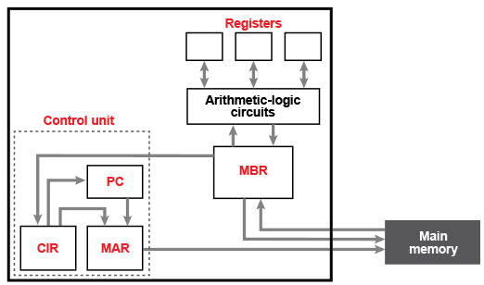

In the spaces below, justify your decisions:

* 1. Memory Address Register: Is passed the memory address of the instruction to be executed (by the PC) or the data to be fetched from memory (by the CIR), and is connected to the address bus so that specified memory can be accessed by the processor.
  2. Memory Buffer Register: Contains an instruction or data that has been retrieved from the specified memory location, or to be written to memory, via the data bus it is connected to. (Sometimes the MBR is called the Memory Data Register)
  3. Program Counter: Contains an address which is the location of the next instruction (and is not directly connected to the address bus).
  4. Current instruction Register: Contains an instruction but is not directly connected to the data bus.
  5. General Purpose Registers: Contain data that could be output from the ALU or read in from the MBR.
  6. Control Unit: Connected to all other components so must be the central point of control.