# Homework 6 Boolean Algebra Answers

1. Simplify the following Boolean expressions.

(a) [1]

A (since B + 1 = B)

(b) [1]

(applying de Morgan’s 2nd law)

(c) (AAB + ABB) [1]

AB + AB = AB (Since X X = X and X + X = X)

2. Simplify the following Boolean expressions, explaining each step.

(a) [3]

de Morgan’s first law

= Associative rule

=

= 1 + X = 1

(b) AB + A (B+C) + B (B + C) [4]

= AB + AB + AC + BB + BC Distributive rule

= AB + AC + BB + BC AB + AB = AB

= AB + AC + B + BC BB = B

= AB + AC + B (1 + C) Distributive rule

= AB + AC + B 1 + C = 1

= B (1 + A) + AC Distributive rule

= B + AC 1 + A = 1

3. (a) Write expressions for P, Q, R and S and T represented in the following logic circuit. [5]

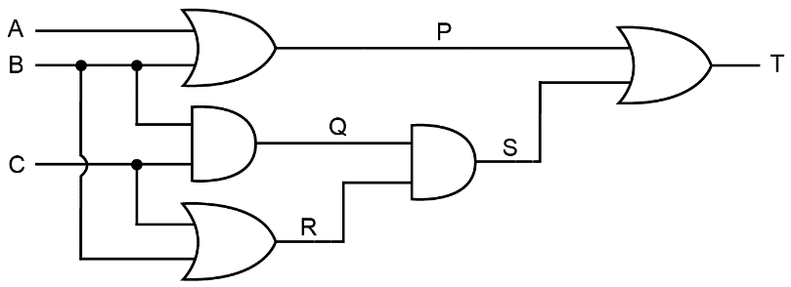

P = A + B (accept A OR B)

Q = BC (Accept B AND C, or B . C)

R = B + C (Accept B OR C)

S = BC (B + C) (Accept (B AND C) AND (B OR C)

T = (A + B) + BC (B + C)

(b) Simplify the expression T. [5]

T = (A + B) + BC(B + C)

= A + B + BBC + BCC

= A + B + BC + BC BB = B, CC = C

= A + B + BC BC + BC = BC

= A + B(1 + C) Distributive rule

= A + B 1 + C = 1

[Total 20 marks]